अनुक्रमणिका / INDEX

SL NO | CHAPTER | PAGE NO.
1 | RELATIONS & FUNCTIONS | 04 - 30
2 | INVERSE TRIGONOMETRIC FUNCTIONS | 31 - 52
3 | MATRICES | 53 - 75
4 | DETERMINANTS | 76 - 97
5 | CONTINUITY & DIFFERENTIABILITY | 98 - 110
6 | APPLICATION OF DERIVATIVES | 111 - 137
7 | INTEGRALS | 138 - 152
8 | APPLICATION OF INTEGRALS | 153 - 175
9 | DIFFERENTIAL EQUATIONS | 176 - 198
10 | VECTORS | 199 - 215
11 | THREE-DIMENSIONAL GEOMETRY | 216 - 234
12 | LINEAR PROGRAMMING PROBLEMS | 235 - 257
13 | PROBABILITY | 258 - 283

CHAPTER – 1
RELATIONS & FUNCTIONS

SYLLABUS:
Reflexive, Symmetric, Transitive and Equivalence relations. One to one and onto functions.

SL NO | QUESTION | MARK
 | MULTIPLE - CHOICE QUESTIONS
1 | Let A be the set of all human beings of a joint family living in TATA NAGAR.  Then the relation defined as: R = {(x, y) : x is wife of y} is ---------  (a) reflexive (b) symmetric (c) transitive (d) none of these | 1
2 | Let A be the set of all human beings living in a joint family in Cuttack.  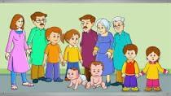  Then the relation in set A defined as:  R = {(x, y) : x is father of y} is -----------------  (a) reflexive (b) symmetric (c) transitive (d) none of these | 1
3 | Let L be the set of all lines in XY-plane and R be the relation in L defined as  R = {L₁, L₂): L₁ is parallel to L₂}.  Which of the following lines related to the line $3x-y - 1$=0.  (a) $6x-y+1=0$ (b) $6x-2y - 3=0$  (c) $3x+y+1=0$ (d) $9x+3y+5=0$ | 1
4 | Let A = {1, 2, 3}. Then number of equivalence relations containing (1, 2), (2,3)  and (1, 3) is ----------  (a) 1 (b) 2 (c) 3 (d) 4 | 1
5 | Consider a group consisting four friends.   Then the number of symmetric relations defined in that group is ---------------  (a) $2^{4}$ (b) $2^{10}$ (c) $2^{16}$ (d) $2^{12}$ | 1
6 | Jim and Jeny are solving some problems on relations and functions. Jim has a set A containing four natural numbers and Jeny has a set B containing three alphabets.  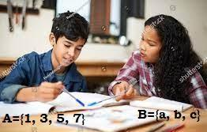  Jim wants to find the number of all possible onto functions from A to B. What will be his answer?  (a) $3^{4}$ (b) $4_{P_{3}}$ (c) 0 (d) 36 | 1
7 | The function f: N→N defined by f(x) = x – 1 and f(1) = f(2) = 1 for every x > 2 is  (a) One-one and onto (b) One-one but not onto  (c) Onto but not one-one (d) Neither one-one nor onto | 1
8 | Let A be the set of all 50 students of Class X in a school.  Let f : A $→$ N be function defined by f (x) = roll number of the student x.  (a) f is neither one-one nor onto (b) f is one-one but not onto  (c ) f is not one-one but onto (d) none of these | 1
9 | For real numbers $x$and $y$, define $xRy$ if and only if $x -y+√2$ is an irrational number. Then the relation R is ------------  (a) reflexive only (b) reflexive, symmetric but not transitive  (c) equivalence relation (d) neither reflexive nor symmetric nor transitive | 1
10 | Let A = {1, 2, 3}. Then, the number of relations containing (1, 2) and (1, 3) which are reflexive and symmetric but not transitive is-  a)1 b)2 c)3 d)4 | 1
11 | The relation 'R' in N × N such that (a, b) R (c, d) <=> a+d = b+c . R is  a) reflexive but not symmetric  b) reflexive and transitive but not symmetric  c) an equivalence relation  d) none of these | 1
12 | f : R ----> R given by f(x) = x + √x²  (a)Injective (b) surjective (c) bijective (d) none of these | 1
13 | The function f : R → R defined by f(x) = 2x + 2|x| is  (a) one-one and onto (b) many-one and onto  (c) one-one and into (d) many-one and into | 1
14 | The range of the function f (x) = ^{7-x}P_{x-3} is  (a) {1, 2, 3, 4, 5} (b) {1, 2, 3, 4, 5, 6} (c) {1, 2, 3, 4} (d) {1, 2, 3} | 1
15 | Which of the following functions from Z to itself are bijections?  (a) f(x) = x³ (b) f(x) = x + 2 (c) f(x) = 2x + 1 (d) f(x) = x² + x | 1
16 | if a function f : [2, ∞) → B defined by f(x) = x²- 4x + 5 is a bijection, then B =  - R  - [1, ∞)  - [4, ∞)  - [5, ∞) | 1
17 | The function $f:N→N$ is defined by $f\left(n\right)=\{\frac{n+1}{2};if n is odd. \frac{n}{2};if n is even.$ The function $f is.$  - Bijective  - One-one but not onto  - Onto but not one-one  - Neither one-one nor onto | 1
18 | The function $f:R→R$ is defined by $f\left(x\right)=2+x^{2}$ is  - Neither one-one nor onto  - Not One-one  - (C) One-one  - (D) Not onto. | 1
19 | Let L denotes the set of all straight line in a plane. Let a relation R defined by l R m if and only if l is perpendicular to m. R is  - Reflexive  - Symmetric only  - Non-Transitive  - None of these | 1
20 | Let R be a relation on the set N given by R = { (a,b) : a = b-2,b > 6} then,  - (2,4) $∈R$ (b) (3,8) $∈R$ (c) (6,8) $∈R$ (d) (8,7) $∈R$ | 1
21 | If A ={ a,b,c} then the relation R ={(b,c)} on A is  - Reflexive only (b) Symmetric only  (c) Transitive only (d) reflexive & transitive only | 1
22 | The relation S defined on the set R of all real number by the rule a S b iff a ≥ b is  - An equivalence relation  - reflexive & transitive but not Symmetric  - Symmetric, transitive & but not reflexive  - Neither transitive nor reflexive but symmetric | 1
23 | The maximum number of equivalence relations on the set A = { 1,2,3} is  - 1 (b) 2 (c) 3 (d) 5 | 1
24 | The function f: f:R $→$ R ,given by f(x)=cosx is  - One-one (b) many one (c) onto (d) neither one-one nor onto | 1
25 | Let R be the relation on N defined by x+2y=8. The domain of R is  - {2,4,8} (b) {2,4,6,8} (c) {2,4,6} (d) {1,2,3,4} | 1
26 | If A{1,2,3}, B={1,4,6,9} and R be the relation from A to B defined by “x greater than y”. The range of R is  - {1,4,6,9} (b) {4,6,9} (c) {1} (d) none of these | 1
27 | The relation $R$ on the set $A=\{a, b, c\}$ given by  $R=\{\left(a,b\right), \left(b,a\right), \left(c, c\right)\}$ is  - symmetric and transitive, but not reflexive  - reflexive and symmetric, but not transitive  - symmetric, but neither reflexive nor transitive  - an equivalence relation | 1
28 | The number of reflexive relations on a set $A$ consisting of $n$ elements is equal to  ${\left(a\right)2}^{n^{2}}$ (b) $n^{2}$ (c) $2^{n(n-1)}$ (d) $n^{2}-n$ | 1
29 | The number of symmetric relations on set $A=\{1, 2, 3, 4\}$ is  ${\left(a\right)2}^{10}$ (b) $2^{6}$ (c) $2^{12}$ (d) $2^{16}$ | 1
30 | Let $A=\{1, 2,3,……n\}$ and $B=\{a, b\}$. Then the number of surjections from $A$ into $B$ is  - ${ n}_{P_{2}}$ (b) $2^{n}-2$ (c) $2^{n}-1$ (d) none of these | 1
 | ANSWERS
1 | (c) transitive | 1
2 | (d) none of these | 1
3 | (b) $6x-2y - 3=0$ | 1
4 | (a) 1 | 1
5 | (b) $2^{10}$ | 1
6 | (d) 36 | 1
7 | (c) Onto but not one-one | 1
8 | (b) f is one-one but not onto | 1
9 | (a) reflexive only | 1
10 | a | 1
11 | c | 1
12 | d | 1
13 | c | 1
14 | d | 1
15 | b | 1
16 | b | 1
17 | C | 1
18 | A | 1
19 | D | 1
20 | C | 1
21 | c | 1
22 | b | 1
23 | d | 1
24 | d | 1
25 | c | 1
26 | c | 1
27 | c | 1
28 | c | 1
29 | a | 1
30 | b | 1
 | ASSERTION & REASON QUESTIONS
Choose the correct option in the following questions of Assertion – Reason Questions.
(a) Both A and R are correct; R is the correct explanation of A.
(b) Both A and R are correct; R is not the correct explanation of A.
(c) A is true but R is false
(d) A is false but R is true
1 | Assertion(A): If n (A) =p and n (B) = q then the number of relations from A to B is 2^{pq}.  Reason(R): A relation from A to B is a subset of A X B. | 1
2 | Assertion (A): Let A = {1,2,3} then the relation on A as R = {(1,2), (2,1)} R is not transitive relation.  Reason (R) :A relation R defined on a non-empty set A is said to be transitive relation if (a,b), (b,c) $ϵ$ R $⇒$ (a,c)$ϵ$ R | 1
3 | Assertion (A) if n (A) = 5 and n(B) = 4The number of relations from set A to B is 20.  Reason (R) The number of subsets of A X B is 2^{n(A)n(B)} | 1
4 | Assertion (A): The Greatest integer Function 𝑓: 𝑅→𝑅 is given by (𝑥)=[𝑥] is not onto.  Reason (R): A function 𝑓: 𝐴→𝐵 is said to be injective if 𝑓(𝑎)=𝑓(𝑏)⟹𝑎=𝑏 | 1
5 | Assertion (A): If the set A contains 5 elements and the set B contains 6 elements, then the number of one-one and onto mappings from A to B is 0.  Reason (R): If A and B are two non-empty finite sets containing m elements and n elements respectively, then the number of one-one and onto mappings from A to B is if m= n and 0 if 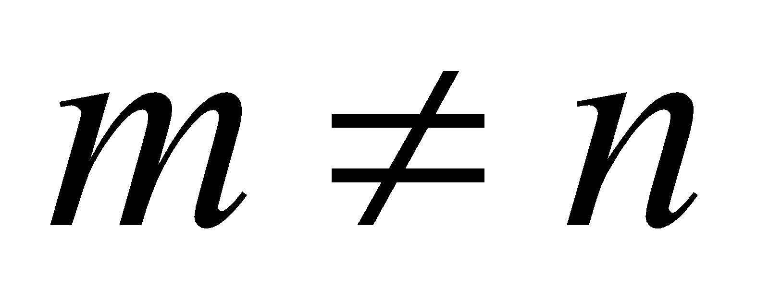 | 1
6 | Assertion (A): The relation R in the set {x $ϵ$ Z: -1 < x < 13} defined as R = {(a, b): a – b is an integer} is symmetric.  Reason (R): A relation R in a set A is called reflexive if every element of set A is related to itself. | 1
7 | Let R be the relation in the set of integers $Z$ given by R={(a, b):2 divides a-b}  Assertion (A): R is a reflexive relation  Reason (R): A relation is said to be reflexive if x R x,$xϵZ$ | 1
8 | Assertion (A): The relation R in the set {x $ϵ$ Z : -1 < x < 13} defined as R = {(a,b) : a – b is an integer} is symmetric.  Reason (R): A relation R in a set A is called reflexive if every element of set A is related to itself. | 1
9 | Assertion (A): A one – one function f: {1,2,3,4,5} $→$ {1,2,3,4,5} defined by f(x) = x is onto.  Reason (R): A one – one function from an arbitrary set X to itself is always onto. | 1
10 | Assertion (A): Every equivalence relation is reflexive.  Reason (R): Every reflexive relation is equivalence relation. | 1
 | ANSWERS
1 | (a) Both A and R are true and R is correct explanation of A | 1
2 | (a) Both A and R are true and R is correct explanation of A | 1
3 | (d)A is false but R is true | 1
4 | (b) Both A and R are correct; R is not the correct explanation of A. | 1
5 | (a) Both A and R are true and R is correct explanation of A | 1
6 | (d) A is false but R is true | 1
7 | (a) Both A and R are true and R is correct explanation of A | 1
8 | (b) Both A and R are correct; R is not the correct explanation of A. | 1
9 | (c) A is true but R is false | 1
10 | (c) A is true but R is false | 1
 | 2 MARKS TYPE QUESTIONS
1 | An equivalence relation R in A divides it into three equivalence classes A₁, A₂, A_{3.} What is the value of the following?  (i) $A_{1}∪A_{2}∪A_{3}$ (ii) $A_{1}∩A_{2}∩A_{3}$ | 2
2 | Let A = {a, b, c} and the relation R be defined on A as follows:  R = {(a, a), (b, c), (a, b)}. Then, write the minimum number of ordered pairs to be added in R to make R reflexive and transitive. | 2
3 | Given A = {2, 3, 4}, B = {2, 5, 6, 7}. Define a function from A to B such that the function is:  (a) an injective mapping from A to B  (b) a mapping from A to B which is not injective | 2
4 | Show that the function f:R→(x∈R:−1<x<1) defined by f(x)= x/(1+|x|), x∈R is one one and onto function. | 2
5 | Let f:R $→$R be defined by $\{3x , if x>3 x2 ,if 1<x≤3 x , if x≤1$ ,then find f(-2)+ f(0)+ f(2) +f(5) | 2
6 | Find the range of $f\left(x\right)= \frac{x-1}{x+1}$ | 2
7 | Show that the relation R in the set {1,2,3} given by  R = {(1, 1), (2, 2), (3, 3), (1, 2), (2, 3)} is reflexive but neither symmetric nor transitive. | 2
8 | Show that the modulus function $f$ : $R$→$R$, given by $f\left(x\right)=\left|x\right|$ is neither one-one nor onto.  $f$ : $R$→$R$, given by $f\left(x\right)=\left|x\right|$ | 2
9 | Prove that the function $f$ is surjective, where $f:N→N$ such that  $f\left(n\right)=\{\frac{n+1}{2}, if n is odd \frac{n}{2}, if n is even$ .  Is the function injective? Justify your answer. | 2
10 | Show that the function $f:R_{+}→[4, ∞)$ given by  $f\left(x\right)=x^{2}+4$ is a bijective function. | 2
 | ANSWERS
1 | (i) $A_{1}∪A_{2}∪A_{3}$=$A$ (ii) $A_{1}∩A_{2}∩A_{3}$=$∅$ | 1+1
2 | To make reflexive minimum two order pairs i.e. (b, b) and (c, c) must be added.  To make transitive (a,c) must be added.  So to make reflexive and transitive minimum three ordered pair must be added. Those are (b, b), (c, c)  and (a,c). | 2
3 | (a) an injective mapping from A to B.  Ex: $f=\{(a, b):b=a+3, for all a∈A and b∈B$ . Here $f=\{(2,5), (3, 6), (4, 7)\}$  (b) a mapping from A to B which is not injective.  Ex: $f=\{(a, b):b=a^{2}-6a+5, for all a∈A and b∈B$. Here (-3) is the image of both 2 and 4. | 2
4 | f:R⇒(x∈R:−1<x<1)  f(x)=x/(1+ |x|),x∈R  Lets check it for ±1/2∈(−1,1)  ⇒f(1/2)= (1/2)/(1+1/2)=1/3  And f=(-1/2)=(-1/2)/ (1 - 1/2) = −1  f(x) is different for each x∈(−1,1)⇒f is one - one. And f(x) exists and gives real value for ∀x∈(−1,1)⇒f is onto.  ⇒f is one-one onto. | 2
5 | f(-2)+ f(0)+ f(2) +f(5) = -2 + 0 + 2² + 3 * 5 = -2 + 4+ 15 =17 | 2
6 | R – {1} | 2
7 | Given R = {(1,1),(2,2),(3,3),(1,2),(2,3)} defined on  R : {1,2,3}→{1,2,3}  For reflexive: As (1, 1), (2, 2), (3, 3) $∈$ R. Hence, reflexive  For symmetric: (1, 2) ϵ R but (2, 1) ∉ R. Hence, not symmetric.  For transitive: (1, 2) ϵ R and (2, 3) $∈$ R but (1, 3) ∉ R.  Hence, not transitive. | 2
8 | Given $f$ : $R$→$R$, given by $f\left(x\right)=\left|x\right|$  Take $x=2$ and $x=-2$  then $f\left(2\right)=2$ and $f\left(-2\right)=2$ that is image of two distinct elements is same. Therefore $f$ is not one-one.  Also negative real numbers in co-domain have no pre-image in the domain. Therefore $f$ is not onto. | 2
9 | Surjectivity: Let $n$ be an arbitrary element of $N.$  If $n$ is an odd natural number , then $2n-1$ is also an odd natural number such that $f\left(2n-1\right)=\frac{2n-1+1}{2}=n.$  If $n$ is an even natural number , then $2n$ is also an even natural number such that $f\left(2n\right)=\frac{2n}{2}=n.$  Thus for every $n∈N$(whether even or odd) there exists its pre-image in $N.$ So $f$ is surjective.  Injectivity: 1, 2$∈N(domain)$ such that $f\left(1\right)=1=f\left(2\right).$  Hence $f$ is not injective. | 2
10 | One-One: Let $x_{1}$, $x_{2}∈R_{+} (Domain)$  $f\left(x_{1}\right)=f{(x}_{2})$ $⇒{x_{1}}^{2}+4={x_{2}}^{2}+4$  $$⇒{x_{1}}^{2}={x_{2}}^{2}$$  $⇒x_{1}=x_{2}$ [$x_{1}$ &$x_{2}$ are positive real numbers].  Hence $f$ is one-one function.  Onto: Let $y∈[4, ∞)$ such that $y=f\left(x\right)$ $∀ x∈R_{+}$  $⇒y=x^{2}+4$  $⇒x=\sqrt{y-4}$ [$x$ is a positive real number]  Obviously, $∀ y∈[4, ∞)$ , $x$ is a real number $∈R_{+} (Domain)$  i.e. all elements of codomain have pre-image in domain.  $⇒$ $f$ is onto.  Hence $f$ is a bijective function. | 2
 | 3 – MARKS TYPE QUESTIONS
1 | If R and S are equivalence relations on a set A, then prove that  $R∩S$ is also an equivalence relation? | 3
2 | Let $S$ be the relation in real number R defined by $(a, b) S (c, d) if ad=bc$ for $a, b, c, d ϵ R$ (set of real numbers).  Prove that $S$ is an equivalence relation. | 3
3 | Classify the function $f\left(x\right)=2^{x}+2^{\left|x\right|}$ as injection, surjection or bijections.  Justify your answer. | 3
4 | Show that the relation R in the set {1, 2, 3} given by R= {(1, 1), (2, 2), (3, 3), (1, 2), (2, 3)} is reflexive but neither symmetric nor transitive. | 3
5 | Prove the function f:R→R given by f(x)=cosx for all x∈R, is neither injective nor surjective.
6 | An electrician charges a base fee of Rs. 70 plus Rs. 50 for each hour of work. Create a table that shows the amount of the electrician charges for 1, 2, 3, & 4 hours of work. Let x represent the number of hours and y represent the amount charged for x hours. Is the relation a function? | 3
7 | Check whether the relation R in R defined by R ={(a,b³ ) : a$≤$ b³ ) is reflexive ,symmetric or transitive. | 3
8 | Show that the relation R in the set of real numbers, defined as R = {(a, b): a ≤ b²} is neither reflexive nor symmetric nor transitive. | 3
9 | Let A = R$-${3} and B = R$-${1}. Consider the function  $f$ : A→B defined by f(x) =$\frac{x-2}{x-3}$. Show that f is one-one and onto. | 3
10 | Let Z be the set of all integers and R be the relation on Z defined as  R = {(a, b) : a, b $∈$ Z, and (a$-$b) is divisible by 5}.  Prove that R is an equivalence relation. | 3
 | ANSWERS
1 | Given that R and S are reflexive, symmetric and transitive.  Reflexivity: Let $a∈A$ . So, $\left(a, a\right)∈R and (a, a)∈S$ (as R and S are reflexive)  $⇒(a, a)∈R∩S$ . So, $R∩S$ is reflexive.  Symmetricity: Let $a, b∈A$ and $(a, b)∈R∩S$  $⇒\left(a, b\right)∈R and (a, b)∈S$  $⇒\left(b, a\right)∈R and (b, a)∈S$ (as R and S are symmetric)  $⇒(a, b)∈R∩S$ . So, $R∩S$ is symmetric.  Transitivity: Let $a, b, c∈A$ and $(a, b)∈R∩S$ and $(b, c)∈R∪S$  $⇒\left(a, b\right)∈R and (a, b)∈S$ and $\left(b, c\right)∈R and (b, c)∈S$  $⇒\left(a, b\right)∈R$ , $\left(b, c\right)∈R$ and $\left(a, b\right)∈S$ , $\left(b, c\right)∈S$  $⇒\left(a, c\right)∈R$ and $\left(a, c\right)∈S$ (as R and S are transitive)  $⇒(a, c)∈R∩S$ . So, $R∩S$ is transitive.  Therefore, $R∩S$ is an equivalence relation. | 3
2 | Reflexivity: Let $a, b$ $∈R$ and $(a,b)∈R×R$ .  Since, $ab=ba$  $⇒\left(a, b\right)S(a, b)$ . So, $S$is reflexive.  Symmetricity: Let $a, b, c, d∈R$ and $(a, b), (c, d)∈R×R$  $Let \left(a, b\right) S (c, d)$  $⇒ad=bc$ $⇒bc=ad$ $⇒cb=da$  $⇒\left(c, d\right) S (a, b)$ . So, $S$ is symmetric.  Transitivity: Let $a, b, c, d, e, f∈R$ and $\left(a, b\right), \left(c, d\right), (e, f)∈R×R$  $Let \left(a, b\right) S (c, d)$ and $\left(c, d\right) S (e, f)$  $⇒ad=bc$ $and cf=de$  $⇒adcf=bcde$  $⇒af=be$  $⇒\left(a, b\right) S (e, f)$  So, $S$ is transitive.  Therefore, R is an equivalence relation. | 3
3 | $f\left(x\right)=2^{x}+2^{\left|x\right|}$=$\{2.2^{x} x≥0 2^{x}+2^{-x} x<0$  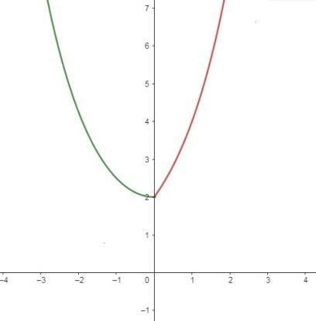  Case-1: $x≥0$  let $x_{1}, x_{2}≥0$ and $f\left(x_{1}\right)=f( x_{2})$  $⇒$ ${2.2}^{x_{1}}={2.2}^{x_{2}}$ $⇒$ $x_{1}=x_{2}$  Case-2: $x<0$  Let $x_{1}, x_{2}<0$ and $f\left(x_{1}\right)=f( x_{2})$  $⇒$ ${2^{x_{1}}+2}^{{-x}_{1}}={2^{x_{2}}+2}^{{-x}_{2}}$  $⇒$ $2^{x_{1}}-2^{x_{2}}=2^{{-x}_{2}}-2^{{-x}_{1}}=\frac{1}{2^{x_{2}}}-\frac{1}{2^{x_{1}}}$  $⇒$ $2^{x_{1}}-2^{x_{2}}=\frac{2^{x_{1}}-2^{x_{2}}}{2^{x_{2.}}{×2}^{x_{1}}}$  $⇒$ ${(2}^{x_{1}}-2^{x_{2}})(2^{x_{2.}}{×2}^{x_{1}})-2^{x_{1}}-2^{x_{2}}=0$  $⇒$ ${(2}^{x_{1}}-2^{x_{2}})\{(2^{x_{2.}}{×2}^{x_{1}})-1\}=0$  $⇒$ $2^{x_{1}}-2^{x_{2}}=0$ because ${(2}^{x_{2.}}{×2}^{x_{1}})-1=2^{{x_{1}+x}_{2.}}-1≠0$  $⇒$ $x_{1}=x_{2}$  Case-3: let $x_{1}≥0 and x_{2}<0$. Clearly, $x_{1}≠ x_{2}$  Now, $f\left(x_{1}\right)={2.2}^{x_{1}}≥2$ and $f\left( x_{2}\right)={2^{x_{2}}+2}^{{-x}_{2}}>2$  Therefore, $f\left(x_{1}\right)can be equal to f\left( x_{2}\right)for some x_{1}, x_{2}$.  So, f is a many-one function.  Again since the value of $f\left(x\right)=2^{x}+2^{\left|x\right|}$=$\{2.2^{x} x≥0 2^{x}+2^{-x} x<0$ for all $x∈R$can not be negative, so $f$ is not onto.  {From the graph, it is clear that Range is $[2, ∞)$ and co-domain=R}  Hence$f$ is many-one and onto. | 3
4 | R={(1, 1), (2, 2), (3, 3), (1, 2), (2, 3)}  Reflexive  If the relation is reflexive, then (a, a)∈R for every a∈(1, 2, 3).  Since (1, 1)∈R, (2, 2)∈R & (3, 3)∈R.  Therefore, R is reflexive  Symmetric  To check whether symmetric or not, If (a, b)∈R, then (b, a)∈R.  Here (1, 2)∈R, but (2, 1)∉R.  Therefore, R is not symmetric.  Transitive  To check whether transitive or not,  If (a,b)∈R & (b,c)∈R, then (a,c)∈R.  Here, (1, 2)∈R and (2, 3)∈R but (1, 3)∉R.  Therefore, R is not transitive.  Hence, R is reflexive but neither symmetric nor transitive | 3
5 | Injectivity: We know that f(0)=cos0=1 and f(2π)=cos2π=1.  So, different elements in R may have the same image. Hence, f is not an injection.  Surjectivity: Since the values of cosx lie between −1 and 1, it follows that the range of f(x) is not equal to its co-domain. So, f is not a surjection. | 3
6 | The table can be drawn as:  The relation is a function such that  Y= x * 50  Total = Y + 70  Also, Total = (x*50) + 70, where x number of hours  We can see that each x element has only one y-element as well as total number associated with it.  Hence, the relation is a function, since a function is a special type of relation where each input has exactly one output, and the output can be traced back to its input. | 3
  X (hour) | Y | Base Fee | Total
  1 | 50 | 70 | 120
  2 | 100 | 70 | 170
  3 | 150 | 70 | 220
  4 | 200 | 70 | 270
7 | Reflexive  R ={(a,b³ ) : a$≤$ b³ )  Here $\frac{1}{3}∈R$  $$\frac{1}{3}>\frac{1}{27}$$  ($\frac{1}{3},\frac{1}{3})$ $∉R$  Symmetric  Let (1,2) $∈R$  $1≤8 or 1 ≤$ 2³  but (2,1) $∈R$ and $8≥1$  it is not symmetric.  Transitive:  (10,3) $∈R$ and (3,2) $∈R$ but (10,3) doesnot belongs to R  Relation is not transitive. | 3
8 | For reflexive: Let a =$\frac{ 1}{2}$,  (a, a) ϵ R $⇒$ $\frac{1}{2}$ ≤ ($\frac{1}{2}$)² $⇒$ $\frac{1}{2}$ ≤ $\frac{1}{4}$, false, Hence, not reflexive.  For symmetric: Let (-1, 2) ϵ R as -1 ≤ (2)² is true.  Now (2,-1) ϵ R $⇒$ 2 ≤ (-1)² $⇒$ 2≤1 is false.  As (-1, 2) ϵ R $⇏$ (2,-1) ϵ R, Hence, not symmetric.  For transitive: Let (6,3),(3,2) ϵ R  (6,3) ϵ R $⇒$ 6 ≤ (3)² $⇒$ 6 ≤ 9, true  (3,2) ϵ R $⇒$ 3 ≤ (2)² $⇒$ 3 ≤ 4, true  We have to show, (6, 2) ϵ R  =>6 ≤ (2)² => 6 ≤ 4, false. So, not transitive. | 3
9 | Given, A = R$-${3}, B = R$-${1} and f(x) = $\frac{x-2}{x-3}$.  For one-one: Let for x₁, x₂ $∈$ A,  f (x₁) = f (x₂) $⇒$ $\frac{x_{1}-2}{x_{1}-3}$ = $\frac{x_{2}-2}{x_{2}-3}$  $⇒$ x₁x₂$-$2x₂$-$3x₁ $+$6 = x₁x₂$-$3x₂$-$2x₁$+$6  $⇒$ x₁ = x₂  As f (x₁) = f (x₂) $⇒$ x₁ = x₂. Hence, function is one-one.  For onto: Let y $∈$ B, there exists x $∈$ A such that y = f(x) => y = $\frac{x-2}{x-3}$  $⇒$ xy$-$3y = x$-$2  $⇒$ xy$-$x = 3y$-$2  $⇒$ x(y$-$1) = 3y$-$2  $⇒$ x = $\frac{3y-2}{y-1}$ $∈$ A. Hence, onto. | 3
10 | For reflexive:  For any a $∈$Z, we have a$-$a = 0, which is divisible by 5.  $⇒$ (a, a) $∈$ R  Thus, (a, a) $∈$ R for all a $∈$A.  So, R is reflexive.  For symmetric: Let (a, b) ϵ R. Then, (a, b) ϵ R  $⇒$ a$-$b is divisible by 5  $⇒-($ a$-$b) is divisible by 5  $⇒$ b$-a$ is divisible by 5  $⇒$ (b, a) ϵ R  So, R is symmetric.  For transitive: Let (a,b) ϵ R and (b,c) ϵ R, for a, b, c ϵ Z  $⇒$ (a-b) is divisible by 5 and (b-c) is divisible by 5  $⇒$ (a - b)+(b - c) = a-c is divisible by 5  $⇒$ (a, c) ϵ R  As (a,b) ϵ R and (b,c) ϵ R $⇒$ (a,c) ϵ R  Hence, R is transitive.  Since, R is reflexive, symmetric and transitive  $⇒$R is equivalence relation. | 3
 | 4 – MARKS TYPE QUESTIONS (CASE BASED QUESTIONS)
1 | In two different societies, there are some school going students including girls as well as boys. Satish forms two sets with these students, as his college project.  Let A$=\left\{a_{1,}{ a}_{2,}{ a}_{3,}a_{4, }{ a}_{5,}\right\}$ and B =$\left\{b_{1, }b_{2, }b_{3,}{ b}_{4,}\right\}$ where $a_{i}$’s and $b_{i}$’s are the school going students of first and second society respectively. Satish decides to explore these sets for various types of relations and functions.  Using the information given above, answer the following:  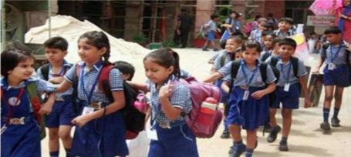  (i) Satish wishes to know the number of relations defined in set A. How many such relations are possible?  (ii) How many functions are possible from set A to set B?  (iii) Among all possible functions from B to A, how many are injections?  (iv) How many reflexive relations can be defined in set B? | 4
2 | In general election of Lok Sabha in 2019, about 911 million people were eligible to vote and voter turnout was about 67%, the highest ever. Let A be the set of all citizens of India who were eligible to exercise their voting right in general election held in 2019. A relation ‘R’ is defined on A as follows:  R = {(𝑉₁, 𝑉₂) ∶𝑉₁, 𝑉₂ ∈A and both use their voting right in general election – 2019}    Read the above passage and answer the following questions.  (I). Mr.’𝑋’ and his wife ‘𝑊’both exercised their voting right in general election -2019, Which of the following is true? (A). (X,W) ∈ R but (W,X) ∉ R  (B). (X,W) ∈ and (W,X) ∈ R  (C). (X,W) ∉ R and (W,X) ∉ R  (D). (W,X) ∈ R but (X,W) ∉ R  (II). Three friends F1, F2 and F3 exercised their voting right in general election-2019, then which of the following is true?  (A). (F1,F2 ) ∈R, (F2,F3) ∈ R and (F1,F3) ∈ R  (B). (F1,F2 ) ∈ R, (F2,F3) ∈ R and (F1,F3) ∉ R  (C). (F1,F2 ) ∈ R, (F2,F2) ∈R but (F3,F3) ∉ R  (D). (F1,F2 ) ∉ R, (F2,F3) ∉ R and (F1,F3) ∉ R  (III). Mr. John exercised his voting right in General Election – 2019, then Mr. John is related to which of the following?  (A). Eligible voters of India  (B). Family members of Mr. John  (C). All citizens of India  (D). All those eligible voters who cast their votes  (IV). The relation R = {(𝑉₁, 𝑉₂) ∶𝑉₁, 𝑉₂ ∈A and both use their voting right in general election – 2019} is -------  (A) symmetric but not reflexive  (B) reflexive, symmetric but not transitive  (C) equivalence relation  (D) neither reflexive nor symmetric nor transitive | 4
3 | Manikanta and Sharmila are studying in the same KendriyaVidyalaya inVisakhapatnam. The distance from Manikanta’s house to the school is same as distance from Sharmila’s house to the school. If the houses are taken as a set of  points and KV is taken as origin, then answer the below questions based on the given information; (M for Manikanta’s house and S for Sharmila’s house)    i. The relation is given by { ( Distance of point M from origin is  same as distance of point S from origin } is  a) Reflexive, Symmetric and Transitive  b) Reflexive, Symmetric and not Transitive  c) Neither Reflexive nor Symmetric  d) Not an equivalence relation  ii. Suppose Dheeraj’s house is also at the same distance from KV then  a) OM ≠ OS  b) OM ≠ OD  c) OS ≠ OD  d) OM = OS= OD  iii. If the distance from Manikanta, Sharmila and Dheeraj houses from KV are same, then the points form a  a) Rectangle  b) Square  c) Circle  d) Triangle  iv. Let {(0,3),(0,0),(3,0)} , then the point which does not lie on the circle is  a) (0,3)  b) (0,0)  c) (3,0)  d) None of these | 4
4 |   “When a computer reads a number, you type in, it converts the number to binary for internal storage, then it prints the number out again onto the screen that you see” – it’s utilizing an inverse function. Explain? | 4
5 | You work forty hours a week at a furniture store. You receive a $220 weekly salary, plus a 3% commission on sales over $5000. Assume that you sell enough this week to get the commission.    Given the functions f (x) = 0.03x and g(x) = x − 5000, which of (f ∘ g) (x) and (g ∘ f) (x) represents your commission? | 4
6 | Students of class 12, planned to plant saplings along straight lines, parallel to each other to one side of the school ground ensuring that they had enough play area.  Let us assume that they planted one of the row of saplings along the line $2x+y=6$. Let L be the set of all lines which are parallel on the ground and R be relation on L.  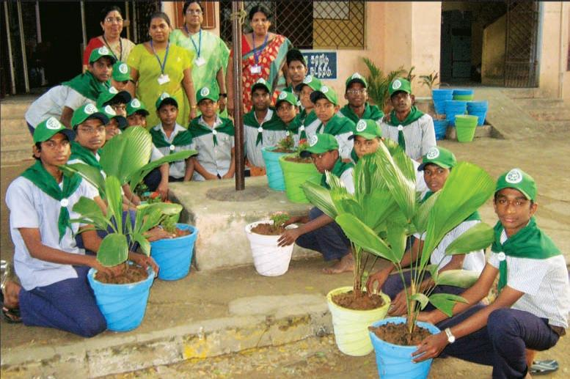  - Let Relation R be defined by R={($L_{1},L_{2}):L_{1}∥L_{2}$ where $L_{1},L_{2}∈$ L} what is the type of Relation R?  - Check whether the function $f:R→R$ defined by $f\left(x\right)=$6-2x is bijective or not. | 4
7 | Sherlin and Dhanju are playing Ludo at home during Covid-19. While rolling the dice, Sherlin’s sister Raji observed and noted the possible outcomes of the throw every time belongs to set $\left\{1 ,2, 3, 4, 5, 6\right\}.$ Let $A$ be the set of players while $B$ be the set of all possible outcomes.  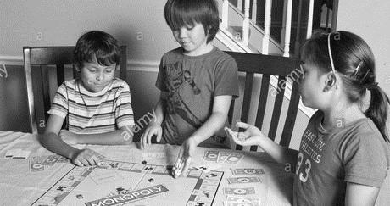  $$A=\left\{S, D\right\}, B=\left\{1 ,2, 3, 4, 5, 6\right\}.$$  Answer the following questions based on the given information:  - Let $R:B→B$ be defined by $R=\{\left(x, y\right):y is divisible by x\}$. Verify that whether $R$ is reflexive, symmetric and transitive.  - Raji wants to know the number of functions from $A$ to $B.$ Find the number of all possible functions.  - Let $R$ be a relation on $B$ defined by  $R=\left\{ \left(1,2\right), \left(2, 2\right), \left(1, 3\right), \left(3, 4\right), \left(3, 1\right), \left(4, 3\right), \left(5, 5\right)\right\}.$  Then $R$ is which kind of relation?  OR  Raji wants to know the number of relations possible  from $A$ to $B.$ Find the number of all possible relations. | 4
 | ANSWERS
1 | (i) $2^{25}$relations are possible on A.  (ii) $4^{5}$ functions are possible from A to B  (iii) $5_{P_{4}}$=120 one-one functions from B to A.  (iv)$2^{12}$ reflexive relations are possible on B. | 4
2 | (I) (B). (X,W) ∈ and (W,X) ∈ R  (II) (A). (F1,F2 ) ∈R, (F2,F3) ∈ R and (F1,F3) ∈ R  (III) (D). All those eligible voters who cast their votes  (IV) (C) equivalence relation | 4
3 | i) A ii) D iii) C iv) B | 4
4 | We all know that computer only reads binary numbers i.e., only 1 and 0.  In order for the computers to read any alphabets, all the alphabets, including numbers, special characters were assigned with a number which we call as ASCII value.  The ASCII value of a= 65  1=49  In binary form, a= 01000001  1= 00110001  Let us consider a function,  f(x) = {x: x belongs to the set of alphabets, numbers, special character}  g(x) = {y: y belongs to the set of binary numbers of alphabets, number, special character}  According to the question, let the number of two function be:  f(x) = {A, 1}  g(x) = {01000001, 00110001}  Let us consider the composition of function.,  So, (f ∘ g) (x) = f (g(x))  =f (01000001, 00110001)  = f (01000001), f (00110001)  = {A, 1}  On the other hand,  (g ∘ f) (x) = g (f (x))  = g (A, 1)  = g(A), g (1) = {01000001, 00110001}  We can see that, when we input alphabets to the computer (f(x)), the computer will read the data in binary form(g(x)) and the same alphabets will show in the screen.  Similarly, when we inverse the process of inputting the information, we can see that while inputting the binary digit to the computer (g(x)), the computer will convert the digit into alphabets (f(x)) and then show the alphabets to the screen.  Hence, even when we change the sequence of inserting the information, the result will be the same. This shows the inverse function. | 4
5 | Given the functions f (x) = 0.03x and g(x) = x − 5000  Well, (f ∘ g) (x) = f (g(x)) would mean that I would take my sales x, subtract  off the $5000 that didn't get the commission, and then multiply whatever is left by 3%.  i.e., (f ∘ g) (x) = f (g(x))  = f(x-5000)  = 0.03* (x-5000)  = 0.03* (220-5000)  = 0.03* - 4780  = 143.4  On the other hand,  (g ∘ f) (x) = g (f (x)) would mean that I would take my sales x, multiply by 3%, and then subtract $5000 from the result. Not only is this not how the commission is calculator, this could land me in negative numbers!  i.e., (g ∘ f) (x) = g (f (x))  = g (0.03x)  = 0.03*x - 5000  = 0.03 * 220 – 5000  = 6.6 – 5000  = - 4993.4  So (f ∘ g) (x) is the composition that does what I need it to do.  Hence, (f ∘ g) (x) represents my commission. | 4
6 | Given relation R is defined by R={($L_{1},L_{2}):L_{1}∥L_{2}$ where $L_{1},L_{2}∈$ L}  Reflexive:- let $L_{1}∈L$ since $L_{1}∥ L_{1}$ $⇒$ ($L_{1}, L_{1})∈$ R  Hence R is reflexive relation.  Symmetric:- let $L_{1}, L_{2}∈L$ and let $(L_{1}, L_{2})∈R$  since $L_{1}∥ L_{2}$ $⇒$ $L_{2}∥ L_{1}$ $⇒$ ($L_{2}, L_{1})∈$ R  Hence R is symmetric relation  Transitive Relation:- let $L_{1}, L_{2},L_{3}∈L$ and let $(L_{1}, L_{2})∈R$ and  ($L_{2}, L_{1})∈$ R  $∴$ $L_{1}∥ L_{2}$ and $L_{2}∥ L_{3}$  $⇒$ $L_{1}∥ L_{3}$ $⇒$ ($L_{1}, L_{3})$ $∈$ R  $∴$R is Transitive relation  .$∵$ R is Reflexive Symmetric and Transitive relation.  $∴$R is Equivalence relation. (1)  $(b)$ Given Function $f:R→R$ defined by $f\left(x\right)=6-2x$.  $Injective:-$ Let $x_{1}, x_{2}$ $∈$ R such that $x_{1}≠ x_{2}$  $⇒$ $6-2x_{1}≠6-2x_{2}$ $⇒$ $f\left(x_{1}\right)≠f\left(x_{2}\right)$  $∴$f is injective.  $Sujective:-$ Let y=$6-2x$ $⇒$ x =$\frac{6-y}{2}$  $for every y ∈R \left(co-domain\right) there exist$x=$\frac{6-y}{2} (co-domain)$  $ie$ co-domain =Range  $∴$f is Surjective. (2)  $∴$f is Bijective function. | 4
7 | - Given $R:B→B$ be defined by $R=\{\left(x, y\right):y is divisible by x\}$.  Reflexive: Let $x∈B,$ since $x$ is always divisible by $x$ itself.  Therefore $(x, x)∈R$  It is reflexive.  Symmetric: Let $x, y∈B$ and $\left(x, y\right)∈R$  $⇒$ $y$ is divisible by $x$  $⇒\frac{y}{x}=k_{1},$ where $k_{1}$ is an integer  $⇒\frac{x}{y}=\frac{1}{k_{1}}≠$ integer.  $∴$ $\left(y, x\right)∉R$  It is not symmetric.  Transitive: Let $x, y, z∈B$ and  let $\left(x, y\right)∈R⇒\frac{y}{x}=k_{1},$ where $k_{1}$ is an integer  and $\left(y, z\right)∈R⇒\frac{z}{y}=k_{2},$ where $k_{2}$ is an integer  $∴ \frac{y}{x}×\frac{z}{y}=k_{1}.k_{2}=k$ (integer)  $⇒\frac{z}{x}=k$ $⇒\left(x, z\right)∈R$  It is transitive.  Hence, relation is reflexive and transitive but not symmetric.  - We have,  $$A=\left\{S, D\right\}⇒n\left(A\right)=2$$  and$B=\left\{1 ,2, 3, 4, 5, 6\right\}⇒n\left(B\right)=6$  $∴$ Number of functions from $A$ to $B=6^{2}=36.$  - Given $R$ be a relation on $B$ defined by  $R=\left\{ \left(1,2\right), \left(2, 2\right), \left(1, 3\right), \left(3, 4\right), \left(3, 1\right), \left(4, 3\right), \left(5, 5\right)\right\}.$  Reflexive: $R$is not reflexive since $\left(1, 1\right), \left(3, 3\right), \left(4, 4\right)∉R.$  Symmetric: $R$is not symmetric since $(1, 2) ∈R$ but $\left(2, 1\right)∉R$.  Transitive: $R$is not transitive as $\left(1, 3\right)∈R and \left(3, 1\right)∈R$  but $\left(1, 1\right)∉R.$  $∴$ $R$ is neither reflexive nor symmetric nor transitive.  OR  Since $n\left(A\right)=2$ and $n\left(B\right)=6⇒n\left(A×B\right)=12.$  $∴$ Total number of possible relations from $A$ to $B=2^{12}.$ | 4
 | 5 – MARKS TYPE QUESTIONS
1 | Two integers a and b are said to be congruence modulo m  if a-b is divisible by m which is as $a≡b(m)$.  Show that the relation $a≡b(5)$ on the set Z of all integers is an equivalence relation. Also find equivalence class [2]. | 5
2 | Consider a function $f: R→R$ defined by $f\left(x\right)=x^{2}+5x-7$. Check whether$f$ is one-one or onto or both. If not, then what will be the domain and co-domain show that $f$ will be bijective? | 5
3 | If A = R-{3} and B = R-{1}. Consider the function f: A→B defined by f(x) x-2/ x-3 for all x∈A. Then show that f is bijective. | 5
 | ANSWERS
1 | Reﬂexive: For every integer $x, x-x = 0$ is divisible by 5.  So $x ≡ x(mod 5).$  Therefore, the relation congruence modulo 5 is reflexive.  Symmetric: Let $x ≡ y (mod 5)$ then $x - y$ is visible by 5. Let $x - y = 5k$,  Then $y-x=-5k$ which is also divisible by 5. Hence $y ≡ x (mod 5).$  Therefore, the relation congruence modulo 5 is symmetric  Transitive: Assume that $x ≡ y (mod 5)$ and $y ≡ z (mod 5)$.  $⇒$ $x-y = 5k$ and $y-z = 5l$.  $⇒$ $x-z = (x-y)+(y -z) = 5(k+l)$ is also divisible by 5.  Hence $x ≡ z (mod 5)$.  Therefore, the relation congruence modulo 5 is symmetric  As congruence modulo 5 is reflexive, symmetric and transitive, so it is an equivalence relation. | 5
2 | $f\left(x\right)=x^{2}+5x-7$. Check whether$f$ is one-one or onto or both. If not, then what will be the domain and co-domain show that $f$ will be bijective?  For Injective: let $x_{1}, x_{2}∈R$ and $f\left(x_{1}\right)=f( x_{2})$  $⇒{x_{1}}^{2}+5x_{1}-7={x_{2}}^{2}+5x_{2}-7$  $⇒{x_{1}}^{2}-{x_{2}}^{2}+5x_{1}-5x_{2}=0$  $⇒{(x}_{1}-x_{2}){(x}_{1}-x_{2}+5)=0$  $⇒{(x}_{1}-x_{2})=0 or {(x}_{1}+x_{2}+5)=0$  $⇒x_{1}=x_{2}{ or x}_{1}=x_{2}-5$  There fore f is not one-one. To be one-one $x_{1}+x_{2}+5$ should not be zero. It will happen only when $x_{1}, x_{2}∈[0,∞)$ . So to be injective, Domain must be $[0,∞).$  For Surjective: Let $x^{2}+5x-7=y$  $⇒x^{2}+5x-7-y=0$  $⇒$ $x=\frac{-5 ±\sqrt{25+4(y+7) }}{2}$  To be onto $x=\frac{-5 ±\sqrt{25+4(y+7) }}{2}≥0$  $⇒\sqrt{25+4(y+7) }≥5$  $⇒y≥-7$  Range = $[-7, ∞)≠$ Co-domain. So f is not onto.  Therefore, f will be surjective if Co-domain=Range= $[-7, ∞)$  So, f will be bijective if domain is $[0, ∞)$ and Co-domain is $[-7, ∞)$. | 5
3 | Given, function is f: A→B, where A= R-{3}  and B=R-{1}, such that f(x)= x-2/x-3.  For One-one  Let f(x1) = f(x2), for all x1, x2∈ A  ⇒x2-2/ x1-3= x2-2/ x2-3  ⇒(x1 - 2) (x2-3) = (x1-2)(x? - 3)  ⇒ x1x2 - 3x1 -2x2 + 6 = x1x2 - 3x1 - 2x2 +6  ⇒- 3x12x2 = - 3x1 - 2x2  - 3 (x1 - x2)+2 (x1 - x2) = 0  - (x1 - x2) = 0  Or, x1 - x2= 0  This implies, x1 = x2.  Since, f(x1) = f(x2)  ⇒ x1 = x2, for all x1, x2∈ A.  So, f(x) is a one-one function.  Onto  To show f(x) is onto, we show that range of f(x) and its codomain are same.  Now,  let. y =x-2 /x - 3  or, xy-3y=x-2  ⇒xy - x = 3y - 2  ⇒x(y-1) = 3y - 2  ⇒x=3y-2/y-1 ……Eqn (1)  Since, x ∈R-{3}, for all y ∈ R- {1}, the range of f(x)=R-{1}.  Also, the given codomain of f(x) = R-{1}  Therefore, Range = Codomain.  Hence, f(x) is an onto function.  Therefore, f(x) is a bijective function. | 5

CHAPTER – 2
INVERSE TRIGONOMETRIC FUNCTIONS

SYLLABUS:
Definition, range, domain, principal value branch. Graphs of inverse trigonometric functions

SL NO QUESTION MARK
MULTIPLE - CHOICE QUESTIONS
1 The domain of the function y = sin⁻¹(- x²) is
a)[0,1]
b)(0,1)
c)[-1,1]
d)(-1,1) 1
2 If x < 0, y < 0 such that xy = 1, then tan⁻¹ x + tan⁻¹ y equals
- $π$ /2
- $- π/2$
- $- π$
None of these 1
3 The positive integral solution of the equation tan⁻¹x + cos⁻¹$\frac{y}{\sqrt{1+y^{2} }}$ = sin⁻¹$\frac{3}{√10}$ is
- x =1, y =2
- x = 2, y =1
- x = 3, y =2
x = -2, y = -1 1
4 If tan⁻¹ x = $π/$10 for some x $∈$ R, then the value of cot⁻¹ x is
- $π/5$
- $2π/5$
- 3$\frac{π}{5}$
4$π/5$ 1
5 The greatest and least values of (sin⁻¹ x)² + (cos⁻¹ x)² are respectively
a)$π^{2}/8, {5π}^{2}/4$
b)$π^{2}/4, {5π}^{2}/8$
c)${5π}^{2}/4, π^{2}/8$
d)$5 π^{2}/8, π^{2}/4$ 1
6 The value of sin( 3$π/2$) – sin ( sec⁻¹ t + cosec⁻¹ t), when |t| $≥1$ is
- 0
- 1
- -1
-2 1
7 The principal value of cos⁻¹(1/2) + sin⁻¹( -1/$\sqrt{2})$ is
- $π/12$
- $π$
- $π$/3
$π$ /6 1
8 tan⁻¹($\frac{x}{y}$) – tan⁻¹($\frac{x-y}{x+y}$ )=__________
- $\frac{π}{2}$
- $\frac{π}{3}$
- $\frac{π}{4}$
-3$\frac{π}{4}$ 1
9 Value of Sin($π/3$ - sin⁻¹(-1/2)) is
a)1/2
b)1/3
c)1/4
d)1 1
10 Find the value of tan⁻¹$√3$-cot⁻¹$√3$ is;
(a)$\frac{π}{3}$ (b) $\frac{π}{4}$ (c) $\frac{π}{6 }$ (d) $\frac{3π}{2}$ 1
11 The value of cos⁻¹cos (1540⁰) is;
(a)1540⁰ (b)1490 ⁰ (c)100⁰ (d)none of these 1
12 The domain of the function f(x)=sin⁻¹(2x-3) is:
(a)xϵ[1,2] (b)xϵ(1,2) (c)xϵ[-1,1] (d)none of these 1
13 The graph of cot⁻¹x is:
(a) 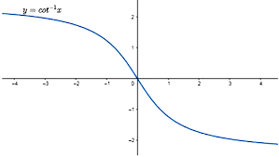(b) 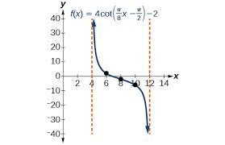(c) 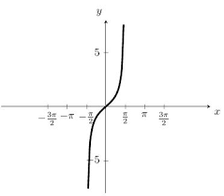 (d)none 1

14 The domain of sin^{–1}(2x) is
(a) [0, 1]
(b) [– 1, 1]
(c) [-1/2, 1/2]
(d) [–2, 2] 1
15 The value of the expression sin [cot–1 (cos (tan^{–1} 1))] is
(a) 0
(b) 1
(c) 1/√3
(d) √(2/3) 1
16 sin[π/3 – sin-1(-½)] is equal to:
(a) ½
(b) ⅓
(c) -1
(d) 1 1
17 If cos-1 x + sin-1 x = π, then the value of x is
(a)1/ √2
(b) 1/√3
(c) 3/√2
(d) 2/√3 1
18 If tan-1 (cot θ) = 2θ, then θ is equal to
(a) π/3
(b) π/4
(c) π/6
(d) None of these 1
19 The value of cos⁻¹[cos($\frac{7π}{6}$)] is
- $\frac{7π}{6}$
- $\frac{π}{6}$
- $\frac{5π}{6}$
$-\frac{7π}{6}$ 1
20 The minimum value of n for which
tan⁻¹($\frac{n}{π}$) > $\frac{π}{4}$ , n $∈$ N is
- 2
- 3
- 4
5 1
21 Domain of f (x) = sin ⁻¹x + cos x
- [ -1, 1 ]
- ( -1, 1 )
- R
R - ( -1, 1 ) 1
22 Write one branch of tan ⁻¹x other than principal value branch.
- [ - $\frac{3π}{2}$, - $\frac{ π}{2}$]
- ( - $\frac{3π}{2}$, - $\frac{ π}{2}$]
- (- $\frac{3π}{2}$, - $\frac{ π}{2}$)
[ - $\frac{3π}{2}$, - $\frac{ π}{2}$) 1
23 The value of sin⁻¹[sin (-$\frac{17π}{8}$) ] is
- $\frac{17π}{8}$
- $\frac{π}{8}$
- - -$\frac{π}{8}$
$\frac{13π}{8}$ 1
24 The value of sin ( cot⁻¹ x) is
- 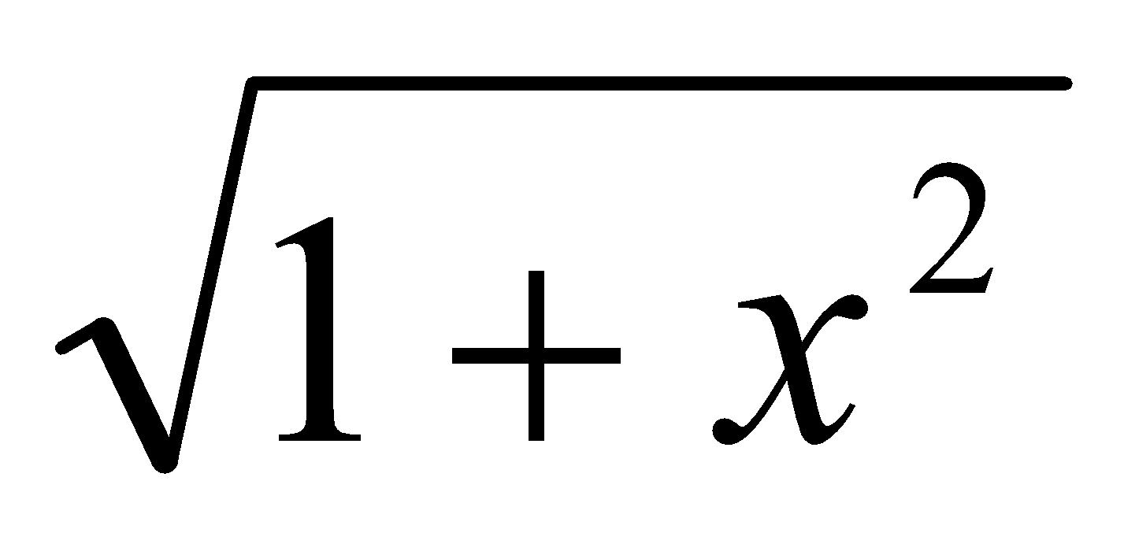
- x
- 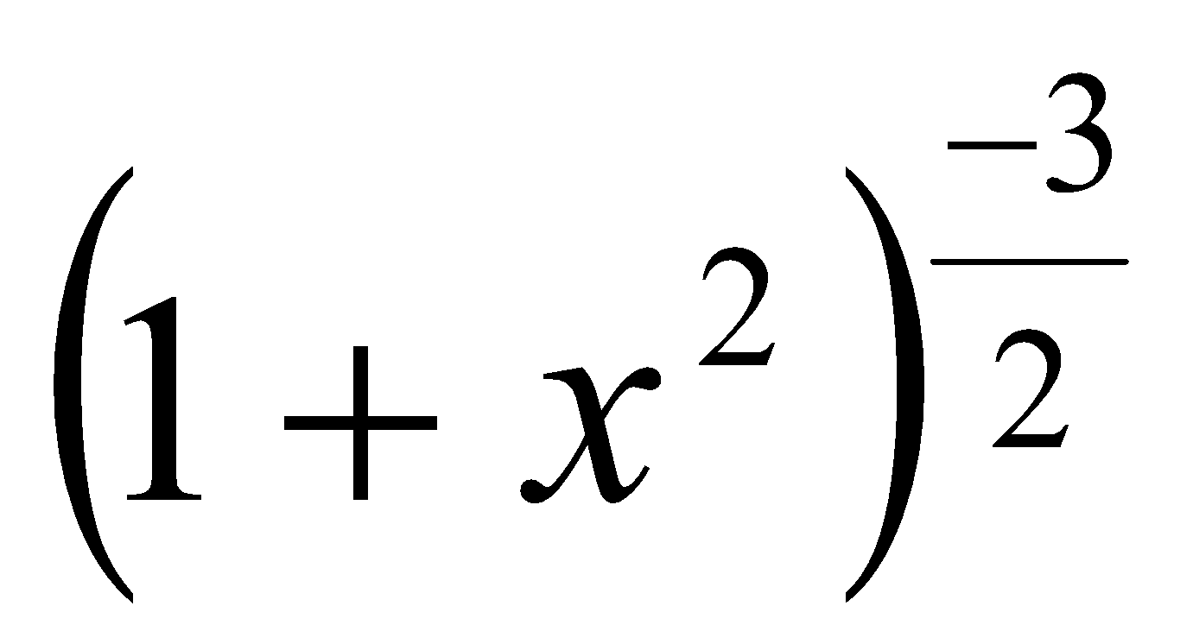
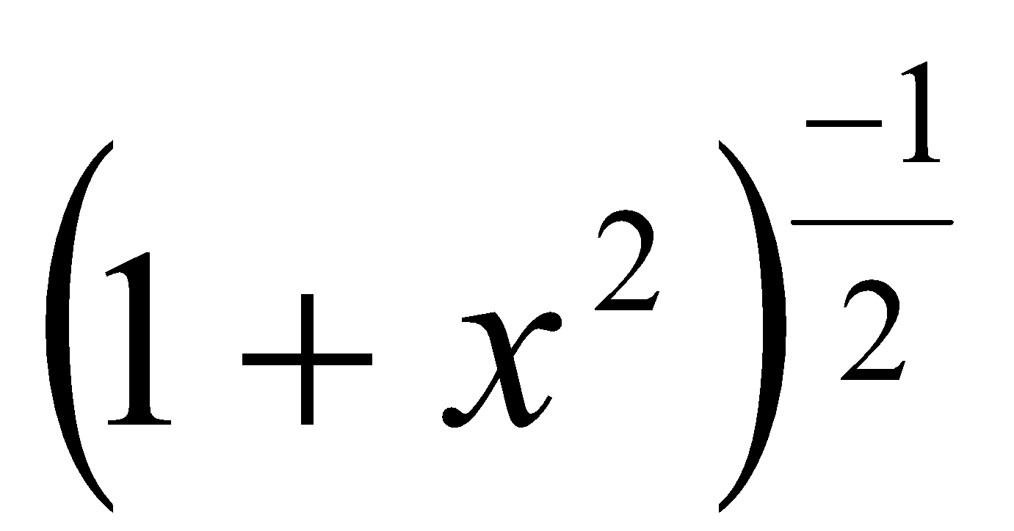
25 If sin⁻¹x $>$ cos⁻¹x, then x should lie in the interval
- 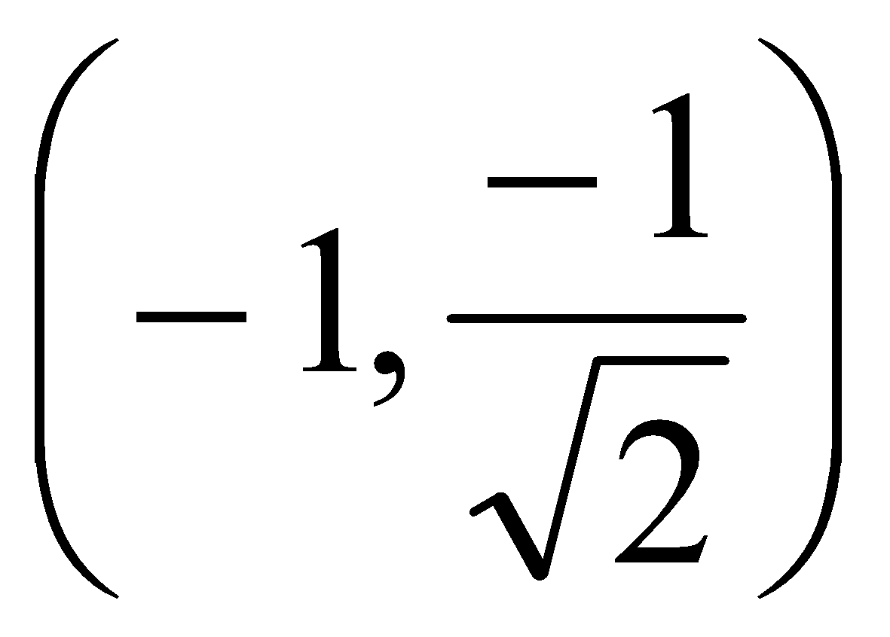
- 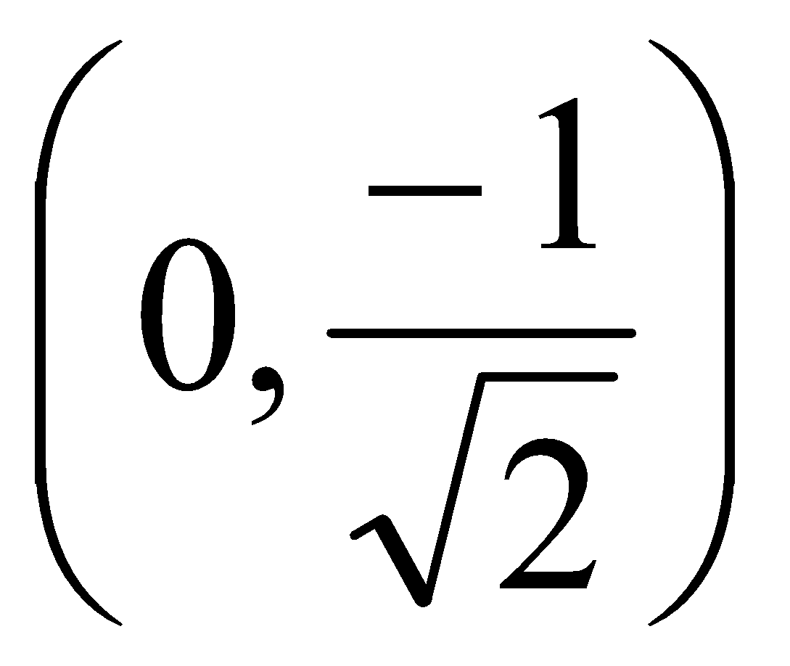
- 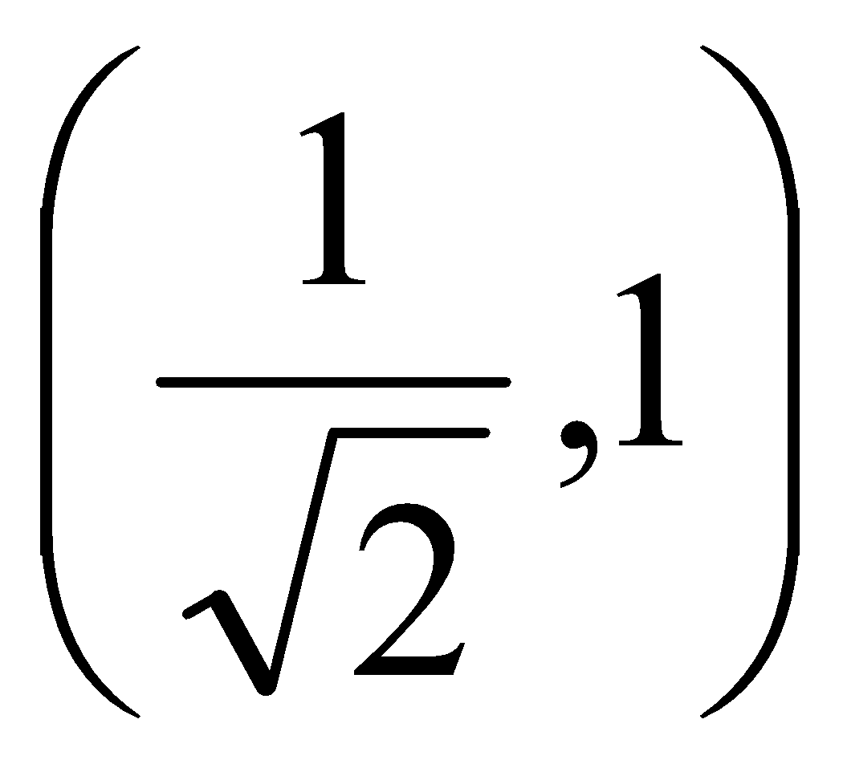
- 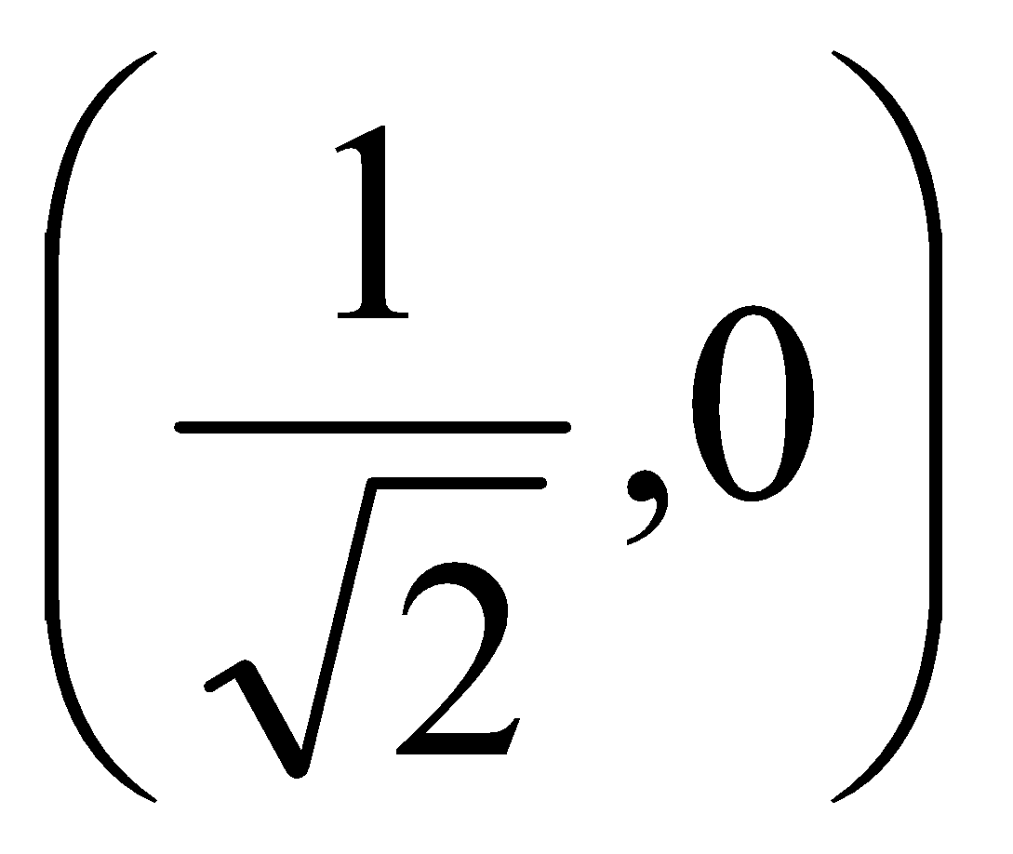

ANSWERS
1 c) [-1,1] 1
2 b) –$π$/2 1
3 a)x=1,y = 2 1
4 b)2$π/5$ 1
5 c)5$π$²/4, $π$²/8 1
6 d)-2 1
7 a)$π$/12 1
8 c)$π$/4 1
9 d)1 1
10 Solution:
Ans:(a)
Let y=tan⁻¹$√3$
tan y=$√3$
tan y=tan$\frac{π}{3}$
y=$\frac{π}{3}$
since the range of tan⁻¹x is ($\frac{-π}{2}$ , $\frac{π}{2})$
hence the principal value is $\frac{π}{3}$ 1
11 Solution:
Ans:(c)
Given cos⁻¹(cos1540$°$) =cos⁻¹{cos(360*4+100$°$)}
=cos⁻¹cos100$°$ [Cos (2$π+ϴ)$=cosϴ
=100$°$ [cos⁻¹cosϴ=ϴ,ϴϵ[0,π]
$∴$ cos⁻¹(cos1540$°$)=100$°$ 1
12 Solution:
Ans: (c)
The domain of sin⁻¹x is[-1.1]
Therefore f(x)=sin⁻¹(2x+3), for all x
Satisfying;-1$≤$2x-3$≤$1
-1+3 ≤ 2x-3+3 ≤ 1+3
2 ≤ 2x ≤4
1 ≤ x ≤2
x ϵ [1,2] 1
13 (a) 1
14 (c) [-1/2, 1/2] 1
15 (d) √(2/3) 1
16 (d) 1 1
17 (c) 3/√2 1
18 (c) π/6 1
19 c 1
20 c 1
21 a 1
22 c 1
23 (c) 1
24 (d) 1
25 (c) 1
ASSERTION & REASON QUESTIONS
Choose the correct option in the following questions of Assertion – Reason Questions.
(a) Both A and R are correct; R is the correct explanation of A.
(b) Both A and R are correct; R is not the correct explanation of A.
(c) A is true but R is false
(d) A is false but R is true
1 Assertion(A): All trigonometric functions have their inverses over their respective domains.
Reason(R): The inverse of tan⁻¹x exists for some x ϵ R 1
2 Assertion (A) Range of [sin⁻¹ x + 2 cos⁻¹ x] is [ 0 , π ].
Reason (R) Principal value branch of sin⁻¹ x has range [-$\frac{π}{2}$ , $\frac{π}{2}$ ] 1
3 Assertion (A) The domain of the function sec⁻¹ 2x is
(- $∞$ , - $\frac{1}{2}$ ]$∪$ [ $\frac{1}{2}$ , $∞$ )
Reason (R) sec⁻¹(-2) = - $\frac{π}{4}$ 1
4 Assertion (A) All trigonometric functions have their inverses over their respective domains.
Reason (R) The inverse of tan⁻¹ x exists for some x$∈$ R 1
5 Assertion (A): The value of $sinsin [(-\sqrt{3} )+(-\frac{\sqrt{3}}{2})]$ is 1
Reason (R):$\left(-x\right)=-x$ and $\left(-x\right)=x$. 1
6 Assertion (A) : the domain of the function $\left(2x\right)$ is $(-∞,\frac{-1}{2}]∪[\frac{1}{2},∞)$
Reason (R) : $\left(-2\right)=-\frac{π}{4}$ 1
7 Assertion (A): $x ≥x for all xϵ\left[-1,1\right]$
Reason (R) : $x$ is decreasing function in $\left[-1,1\right]$ 1
8 Assertion (A) : Maximum value of ${\left(x \right)}^{2}$ is $π^{2}$.
Reason (R) : Range of the principal value branch of $x$ is $\left[-\frac{π}{2},\frac{π}{2}\right]$.
1
9 Assertion:$\frac{1}{2} )=\frac{2π}{3}$
Reason:$\left(-x\right)=π-x$. 1
10 Assertion (A): The domain of the function sec-1x is the set of all real numbers.
Reason(R): For the function sec-1x, x can take all real values except in the interval (-1, 1) 1
^{ANSWERS}
1 (d)
Assertion: we know that all trigonometric functions have inverse over their restricted domains
So, assertion is incorrect.
Reason(R) tan⁻¹:R $→$($\frac{-π}{2}$ , $\frac{π}{2})$
i.e. the inverse of tan x exists for some xϵ R
so, reason is correct. 1
2 (d) 1
3 (c) 1
4 D 1
5 c 1
6 c 1
7 d 1
8 c 1
9 a 1
10 d 1
2 MARKS TYPE QUESTIONS
1 Find the value of tan² (sec⁻¹ 2) + cot² (cosec⁻¹ 3). 2
2 If $α$ = tan⁻¹ (tan 5$π/4)$ and $β$ = tan⁻¹ ( -tan 2$π/3)$ , then establish a relation between $α$ and $β$. 2
3 Compute the value of tan⁻¹ 1 + tan⁻¹ 2 + tan⁻¹ 3. 2
4 If cos (tan⁻¹ x ) = sin ( cot⁻¹ $\frac{3}{4}$ ) then solve for x. 2
5 Let x, y, z ϵ[-1,1] be such that sin⁻¹x+sin⁻¹y+sin⁻¹z=$\frac{3π}{2}$ find the values of x²⁰²⁰+y²⁰²¹+z²⁰²² 2
6 Draw the graph of sec⁻¹x and write the domain of
sec⁻¹(2x+1) 2
7 Evaluate the following question :
tan⁻¹($\frac{cosx}{1+sinx}$),$\frac{-π}{2}<x<\frac{π}{2}$ 2
8 Prove that tan(cot⁻¹x)=cot(tan⁻¹x) state with the reason whether the equality is valid for all the values of x 2
9 What is the principal value of sin⁻¹ (- 2) 2
10 Find the value of tan⁻¹[2 cos (2 sin⁻¹$\frac{1}{2}$ )] + tan⁻¹ 1 2
ANSWERS
1 tan² (sec⁻¹ 2) + cot² (cosec⁻¹ 3)
= sec²(sec⁻¹ 2) -1 + cosec²(cosec⁻¹ 3) – 1
= {sec(sec⁻¹ 2)}² + {cosec(cosec⁻¹ 3)}² – 2
=(2)² + (3)² - 2 =11 2
2 $α$ = tan⁻¹ (tan 5$π/4)$ and $β$ = tan⁻¹ ( -tan 2$π/3)$
= tan⁻¹ [tan($π$ + $π/4$)] = tan⁻¹ ( -tan($π$ – $π$/3))
= tan⁻¹ [tan $π/4$] = tan⁻¹ (tan $π$/3)
= $π/4$ = $π/3$
$π=$4 $α$ $π=3 β$
Therefore, 4 $α$ =$3 β$ 2
3 tan⁻¹ 1 + tan⁻¹ 2 + tan⁻¹ 3
= tan⁻¹ 1 + tan⁻¹ ($\frac{2+3}{1-2.3}$ )
= tan⁻¹ 1 + tan⁻¹(-1)
= $π/4$ + 3$π/4$ =$π$ 2
4 cos (tan⁻¹ x ) = sin ( cot⁻¹ $\frac{3}{4}$ )
Let tan⁻¹ x = $α$
Or, x = tan $α$
Or, cos $α$ = $\frac{1}{\sqrt{{ 1+ x}^{2}}}$
Or, $α$ = cos⁻¹$\frac{1}{\sqrt{{ 1+ x}^{2}}}$
Similarly let cot⁻¹ $\frac{3}{4}$ = $β$
Cot $β$ =3/4
Sin $β$= 4/5
Equating both the sides we get $\frac{1}{\sqrt{{ 1+ x}^{2}}}$ = 4/5
Squaring both sides 16(${ 1+ x}^{2}$ ) = 25
X = $± ¾$ 2
5 Solution:
For any xϵ[-1,1],the maximum value of sin⁻¹x is, $\frac{π}{2}$ and it attains the value at x=1.
$∴$sin⁻¹x $≤$ $\frac{π}{2}, sin-1y≤$ $\frac{π}{2}$, $sin-1z≤$ $\frac{π}{2}$ for all x, y, zϵ [-1,1]
=sin⁻¹x+sin⁻¹y+sin⁻¹z$≤$ $\frac{π}{2}+$ $\frac{π}{2}$ $+$ $\frac{π}{2}$ for all x, y, zϵ [-1,1]
= sin⁻¹x+sin⁻¹y+sin⁻¹z$≤$ $\frac{3π}{2}$ for all x, y, zϵ [-1,1]
$∴$ sin⁻¹x+sin⁻¹y+sin⁻¹z$=$ $\frac{3π}{2}$
$∴$ sin⁻¹x=$\frac{π}{2}$ , sin⁻¹y = $\frac{π}{2}$ , sin⁻¹z =$\frac{π}{2}$
= x = 1, y = 1 ,z = 1
$∴$x²⁰²⁰+y²⁰²¹+z²⁰²²= (1)²⁰²¹+(1)²⁰²²+(1)²⁰²³=3 2
6 Solution:
The graph of sec-1x
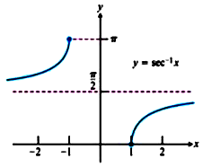
The domain of sec-1x is(-$∞$,-1]$∪$[1,$∞$)
Therefore, sec-1(2x+1) is meaningful,if
2x+1$≥$ 1 or , 2x+1$≤$ -1
2x$≥$ 0 or , 2x$≤$ -2
x$≥$ 0 or , x$≤$ -1
x ϵ(-∞,-1]$∪[0,∞)$
Hence, the domain of sac-¹(2x+1) is (-∞,-1] $∪[0,∞$) 2
7 Solution:
tan-1($\frac{cosx}{1+sinx}$) =tan-1{$\frac{cos2\frac{x}{2} - sin2\frac{x}{2}}{cos2\frac{x}{2}+sin2\frac{x}{2}+2sin\frac{x}{2}cos\frac{x}{2}}$}
={$\frac{(cos\frac{x}{2} - sin\frac{x}{2})(cos\frac{x}{2} + sin\frac{x}{2})}{(cos\frac{x}{2}+sin\frac{x}{2})2}$}
= tan-1{$\frac{cos\frac{x}{2} - sin\frac{x}{2}}{cos\frac{x}{2}+sin\frac{x}{2}}$}
=tan-1{$\frac{1-tan\frac{x}{2}}{1+tan\frac{x}{2}}$}
=tan-1{tan($\frac{π}{4} - \frac{x}{2})$}
$= \frac{π}{4} - \frac{x}{2}$ [$\frac{-π}{2}<x<\frac{π}{2}$ =$\frac{-π}{4}<-\frac{x}{2}<\frac{π}{4} =0<\frac{π}{4}-\frac{x}{2}<\frac{π}{2}$ ] 2
8 Solution:
We know that tan-1x+cot-1=$\frac{π}{2}$
Or, cot-1x=$\frac{π}{2}$ - tan-1x for all xϵR
tan(cot-1x)=tan($\frac{π}{2}$ -tan-1x ) for all xϵR
=cot(tan-1x) for all xϵR
Clearly, the equality holds for all xϵR as tan-1x+cot-1x=$\frac{π}{2}$ 2
9 sec-1 (-2) = π – sec-1 (2)
[∵ sec-1 (- x) = π – sec-1 (x); |x| ≥ 1
= π – sec-1(sec π3) = π – π3
[∵ sec π3 = 2 and sec-1 (sec θ) = θ; ∀ θ ∈ [0, π] – {π2}]
= 2π3
which is the required principal value. 2
10 $\frac{π}{2}$
– MARKS TYPE QUESTIONS
- 1 Find the number of real solutions of the equation $\sqrt{1+coscos 2x }$ = $\sqrt{2}$ cos⁻¹(cos x ) in [$π/2,π$ ]
- 2 Express tan(cos⁻¹ x) in terms of x only and hence evaluate tan (cos⁻¹$\frac{8}{17}$ ).
- 3 Is tan ( cot⁻¹ x) = cot (tan⁻¹ x)? Justify your answer.
4 write the value of cos-1(−1/2) + 2 sin-1(1/2). 3
5 Write the value of tan (2 tan-11/5) 3
6 Evaluate $3\left(\frac{1}{\sqrt{2}}\right)+2\left(\frac{\sqrt{3}}{2}\right)+0$ 3
7 Express $\left(\frac{coscos x }{1-sinsin x }\right) ,\frac{-3π}{2}<x<\frac{π}{2}$, in the simplest form. 3
8 Write in simplest form
$\left(\frac{\sqrt{1-coscos x }}{\sqrt{1+coscos x }}\right),0<x<π$. 3
9 Simplify
$\frac{x}{\sqrt{a^{2}-x^{2}}} , |x|<a$ . 3
10 Simplify
$\left(\frac{\sqrt{1+sinsin x }+\sqrt{1-sinsin x }}{\sqrt{1+sinsin x }-\sqrt{1-sinsin x }}\right)$, where, $x∈\left(0,\frac{π}{4}\right)$ 3
ANSWERS
1 $\sqrt{1+coscos 2x }$ = $\sqrt{2}$ cos⁻¹(cos x) , [$π/2,π$ ]
⇒$\sqrt{1+2 \cos^{2}x-1}$ = $\sqrt{2}$ cos⁻¹(cos x)
⇒ $\sqrt{2}$ cos x = $\sqrt{2}$ cos⁻¹(cos x)
⇒ cos x = x which is not true for any x $∈$ [$π$/2, $π$ ]
Hence, no real solution exists in the given interval. 3
2 Let cos⁻¹ x = $θ$ ⇒ x = cos $θ$
Now sin $θ$ = $\sqrt{1- x^{2}}$
So, tan $θ$ = $\frac{sin θ}{cos θ }$= $\frac{\sqrt{1- x^{2}}}{x}$
Hence, tan (cos⁻¹$\frac{8}{17}$ ) = $\frac{\sqrt{1- {(\frac{8}{17})}^{2}}}{\frac{8}{17}}$ = $\frac{\frac{15}{17}}{\frac{8}{17}}$ = 15/8 3
3 Let cot⁻¹ x = $θ$,
X = cot $θ$
=tan ($π$ /2 – $θ$ )
Tan⁻¹x = ($π$ /2 – $θ$ )
So, tan(cot⁻¹ x) = tan $θ$= cot($π$ /2 – $θ$ )= cot($π$ /2- cot⁻¹ x)= cot (Tan⁻¹x)
This equality is valid for all values of x since tan⁻¹x and cot⁻¹ x are true for all x $ϵ$R. 3
4 Solution:
The sum of three angles of triangle is π
A+B+C=π
⇒cot⁻¹3​+cot⁻¹2​+C=π
⇒cot⁻¹$\frac{6-1}{3+2} +C$= π { cot-1x+cot-1y=cot-1$\frac{xy-1}{x+y}$ }
⇒cot⁻¹$\frac{5}{5}$+C = π
⇒cot⁻¹1 +C = π
⇒$\frac{π}{4}$ +C =π
⇒C=π - $\frac{π}{4}$ =$\frac{3π}{4}$ 3
5 Solution:
The given equation is;
Cos(tan⁻¹x)=sin(cot⁻¹$\frac{3}{4}$)
⇒Cos(tan⁻¹x)=cos($\frac{π}{2}$ – cot⁻¹$\frac{3}{4}$) [sinϴ=cos($\frac{π}{2}$ -ϴ)]
⇒cos(tan⁻¹x)=cos(tan⁻¹$\frac{3}{4}$) [tan⁻¹x+cot⁻¹=$\frac{π}{2}$]
⇒tan⁻¹x=tan⁻¹$\frac{3}{4}$
⇒x=$\frac{3}{4}$ 3
6 $3\left(\frac{1}{\sqrt{2}}\right)+2\left(\frac{\sqrt{3}}{2}\right)+0$
=$3\left(sinsin \frac{π}{4} \right)+2\left(coscos \frac{π}{6} \right)+\left(coscos \frac{π}{2} \right)$
$$=3\frac{π}{4}+2*\frac{π}{6}+\frac{π}{2}$$
$=\frac{19π}{12}$ 3
7 We have $\left(\frac{coscos x }{1-sinsin x }\right) =\left[\frac{sinsin \left(\frac{π}{2}-x\right) }{1-coscos \left(\frac{π}{2}-x\right) }\right]$
$$=\left[\frac{2sinsin \left(\frac{π}{4}-\frac{x}{2}\right)coscos \left(\frac{π}{4}-\frac{x}{2}\right) }{2\sin^{2}\left(\frac{π}{4}-\frac{x}{2}\right)}\right]$$
=$cotcot \left(\frac{π}{4}-\frac{x}{2}\right)$
=$\left[tantan \left(\frac{π}{2}-\left(\frac{π}{4}-\frac{x}{2}\right)\right) \right]$
=$\frac{π}{4}+\frac{x}{2}$ as $\frac{-3π}{2}<x<\frac{π}{2}$ 3
8 $Let \left(\frac{\sqrt{1-coscos x }}{\sqrt{1+coscos x }}\right)=y$
Y=$\left[\sqrt{\frac{2\sin^{2}\left(\frac{x}{2}\right)}{2\cos^{2}\left(\frac{x}{2}\right)}}\right]$
Y=$\left[\sqrt{\tan^{2}\left(\frac{x}{2}\right)}\right]$
Y=$\left[tan\left(\frac{x}{2}\right)\right]$
Y=$\frac{x}{2}$, x<$π$ 3
9 $y=\frac{x}{\sqrt{a^{2}-x^{2}}} ,$
Let $x=asinsin θ$
So, $y=\left(\frac{asinsin θ }{\sqrt{a^{2}-a^{2}\cos^{2}θ}}\right)$
$=\left(\frac{asinsin θ }{acoscos θ }\right)$ $=θ$ = $\frac{x}{a}$ 3
10 $\left(\frac{\sqrt{1+sinsin x }+\sqrt{1-sinsin x }}{\sqrt{1+sinsin x }-\sqrt{1-sinsin x }}\right)$
$$=\left(\frac{\sqrt{{\left(coscos \frac{x}{2} +sinsin \frac{x}{2} \right)}^{2}}+\sqrt{{\left(coscos \frac{x}{2} -sinsin \frac{x}{2} \right)}^{2}}}{\sqrt{{\left(coscos \frac{x}{2} +sinsin \frac{x}{2} \right)}^{2}}-\sqrt{{\left(coscos \frac{x}{2} -sinsin \frac{x}{2} \right)}^{2}}}\right)$$
$=\left(cotcot \frac{x}{2} \right)$ $=\frac{x}{2}$ 3
4 – MARKS TYPE QUESTIONS (CASE BASED QUESTIONS)
1 Two men on either side of a flag staff of 30 metres high from the level of eye observe its top at the angles of elevation $α and β$ respectively (as shown in the figure above). The distance between the two men is 40$√3$ metres and the distance between the first person A and the flag staff is 30$√3$ metres. Based on the above information answer the following questions.
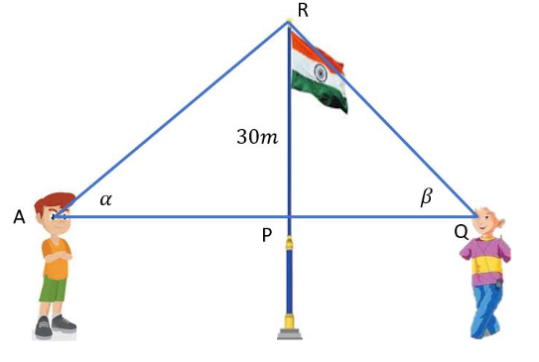
- Find ∠QAR and ∠AQR.
- Find ∠ARQ.
- Find the principal value of sin⁻¹{ sin($α$ +$\frac{2π}{3}$ ) }
Find the principal value of cos⁻¹ { cos ($β$ + $\frac{π}{3}$ )} 4
2 Architect Rahut was asked to design an office building for a multinational company. the fine storied building has five pillars in the lawn, which are congruent and in the shape of triangular prisms .Two of the base angles are given to be tan⁻¹2 and tan⁻¹3

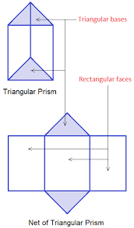
(i)tan⁻¹2+tan⁻¹3-----------------
(a)$\frac{π}{4}$ (b) $\frac{π}{2}$ (c) $\frac{3π}{4}$ (d)π
(ii)the third angle is
(a)$\frac{π}{4}$ (b) $\frac{π}{2}$ (c) $\frac{3π}{4}$ (d)π
(iii)If tan⁻¹x + tan⁻¹y =$\frac{π}{4}$ then x+y+xy=----------------------
(a)1 (b)0 (c)-1 (d)none of these
(iv)tan⁻¹x+tan⁻¹y+tan⁻¹z= $\frac{π}{2}$, then xy+yz+zx=------
(a)1 (b)0 (c)xyz (d)xy+yz+zx 4
3 In a school project Anu was asked to construct a triangle and name it as ABC . Two angles A and B were given to be equal to tan⁻¹$\frac{1}{2}$ and tan⁻¹$\frac{1}{3}$ respectively;

(i)The value of sinA is -------------
(a)$\frac{1}{2}$ (b) $\frac{1}{3}$ (c) $\frac{1}{√5}$ (d) $\frac{2}{√5}$
(ii)Cos(A+B+C)=----------
(a)1 (b)0 (c)-1 (d)$\frac{1}{2}$
(iii)if B=cos⁻¹x then x=-----
(a)$\frac{1}{√5}$ (b) $\frac{3}{√10}$ (c) $\frac{1}{√10}$ (d) $\frac{2}{√5}$
(iv)the value of A+B=--------
(a)$\frac{π}{6}$ (b) $\frac{π}{4}$ (c) $\frac{π}{3}$ (d) $\frac{π}{2}$ 4
4 Today in class of Mathematics, Mr. Gupta was explaining the inverse trigonometry functions. He draws the graph of the $x$ and explained that for $x$, the branch with range $\left[-\frac{π}{2},\frac{π}{2}\right]$ is called principal value branch. Thus, $\sin^{-1} : \left[-1,1\right]→\left[-\frac{π}{2},\frac{π}{2}\right]$ .
Based on the above information answer the following questions,

(1)Find the domain of $\sqrt{x-1}$. [1]
(2)Find the domain of $\left[x\right]$. [1]
(3)Find the value of $sinsin \left[\frac{π}{3}-\left(-\frac{1}{2}\right) \right]$. [2] 4
5 Read the following passage and answer the following questions.
In a school project Ravi was asked to construct a triangle ABC in which
B and C are given by $\left(\frac{1}{2}\right)$ and $\left(\frac{1}{3}\right)$ respectively.
- Find the value of sinB
- Find the value of cosC
- Find the value of B+C
OR
Find the value of cos (B+C) 4
6 Ram and Mohan are students of class XII. One day their Mathematics teacher told them about Inverse trigonometric functions. Teacher sketch the graph of y = tan⁻¹ x on the board as follows.
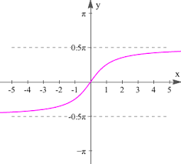
Based on the above information answer the following questions
- The domain of tan⁻¹ (3x + 2) is
- R b) R⁺ c) (-π/2, π/2) d) (0, π)
- Principal value of tan⁻¹(-1) is
- π/4 b) –π/4 c) -1 d) 3π/4
iii)The principal value of tan⁻¹(tan(-6)) is
- -6 b) 2π -6 c) 6 - 2π d) None
4
ANSWERS
1 a)In $∆$RPA, tan $α$ = RP/AP= 30/ 30$√3$ = 1/$√3$ = tan $π$/6
So, $α$ = ∠QAR= $π$/6
PQ = 40$\sqrt{3}- 30\sqrt{3}$= 10$\sqrt{3}$
b)In $∆$RPQ, tan $β$ =RP/PQ= 30/10$\sqrt{3}$ = $\sqrt{3}$ = tan $π$/3
So, $β$ = ∠AQR= $π$/3
c) sin⁻¹{ sin($α$ +$\frac{2π}{3}$ ) } = sin⁻¹{ sin($π/6$+$\frac{2π}{3}$ ) } = sin⁻¹{ sin($5π/6$ ) }=
sin⁻¹{ sin($π-π/6$ ) } = $π/6 ϵ$ [ -$π$/2, $π$/2]
d)cos⁻¹ { cos ($β$ + $\frac{π}{3}$ )}= cos⁻¹ { cos ($π/3$ + $\frac{π}{3}$ )} = cos⁻¹ { cos ($2π/3$ )}
= $2π/3 ϵ$ [ $0$, $π$] 4
2 Solution:
(i)tan⁻¹2+tan⁻¹3=tan⁻¹($\frac{2+3}{1-2*3}$)
=tan⁻¹($\frac{5}{1-6}$)
=tan⁻¹(($\frac{5}{-5}$)
=tan⁻¹(-1)
=$π$ - $\frac{π}{4}$
= $\frac{3π}{4}$
(ii)let the third angle be x
Since all three angles are in a triangle
Sum of angles=180$°$
Sum of angles=π
tan-12+tan-13+x=π
$\frac{3π}{4}$ +x= π
x= π- $\frac{3π}{4}$
x =$\frac{π}{4}$
(iii)given that
tan⁻¹x +tan⁻¹y =$\frac{π}{4}$
tan⁻¹($\frac{x+y}{1-xy}$) =$\frac{π}{4}$
$\frac{x+y}{1-xy}$ =$tan\frac{π}{4}$
$\frac{x+y}{1-xy}$ =1
x+y=1-xy
x+y+xy=1
(iii)given that
tan⁻¹x+tan⁻¹y+tan⁻¹z=π
tan⁻¹x+tan⁻¹y=π-tan⁻¹z
tan⁻¹x+tan⁻¹y = tan⁻¹0- tan⁻¹z
tan⁻¹($\frac{x+y}{1-xy}$)=tan⁻¹(-z)
$$\frac{x+y}{1-xy} =-z$$
⇒x+y=- z + xyz
x+y+z=xyz
(iv)given that
tan⁻¹x+tan⁻¹y+tan⁻¹z=$\frac{π}{2}$
tan⁻¹x+tan⁻¹y=$\frac{π}{2} -$ tan⁻¹z
tan⁻¹x+tan⁻¹y=cot⁻¹z
tan⁻¹x+tan⁻¹y=tan⁻¹$\frac{1}{z}$
tan⁻¹($\frac{x+y}{1-xy}$) = tan⁻¹$\frac{1}{z}$
$\frac{x+y}{1-xy}$ = $\frac{1}{z}$
xz+yz=1-xy
xy+xz+yz=1 4
3 Solution:
(i)given A=tan-1$\frac{1}{2}$
tanA=$\frac{1}{2}$
now we know that 1+tan2A=sec2A
1+tan2A=$\frac{1}{cos2A}$
1+tan2A=$\frac{1}{1-sin2A}$
Putting tanA=$\frac{1}{2}$
1+($\frac{1}{2}$)²=$\frac{1}{1-sin2A}$
1+$\frac{1}{4}$=$\frac{1}{1-sin2A}$
⇒$\frac{5}{4}$=$\frac{1}{1-sin2A}$
1-sin2A=$\frac{4}{5}$
⇒1-$\frac{4}{5}$=sin2A
⇒$\frac{1}{5}$ =sin2A
Sin²A=$\frac{1}{5}$
SinA=$\frac{1}{√5}$
(ii)
since ABC is a triangle
By angle sum property of triangle
A+B+C=180⁰
Thus ,
Cos(A+B+C)=cos180$°$=-1
(iii)
Given B = tan-1(⅓)
⇒ tan B = ⅓
∴ cos B = 3/√10
B = cos-1(3/√10)
⇒ x = 3/√10
(iv)
Given A=tan-1$\frac{1}{2}$
B=tan-1$\frac{1}{3}$
Now,
A+B= tan-1$\frac{1}{2}$+ tan-1$\frac{1}{3}$
Using tan-1x+tan-1y=tan-1($\frac{x+y}{1-xy}$)
= tan-1($\frac{\frac{1}{2}+\frac{1}{3}}{1-\frac{1×1}{2×3}}$ )
= tan⁻¹($\frac{\frac{3+2}{2×3}}{1-\frac{1}{6}}$ )
=tan⁻¹($\frac{\frac{5}{6}}{\frac{5}{6}}$)
= tan⁻¹(1)
=$\frac{π}{4}$ 4
4 (1)Since, $0≤x-1≤1$
$1≤x ≤2$, Domain = $\left[1,2\right]$
(2)Since, domain of $x =\left[-1,1\right]$
So, $\left[x\right]=\{-1, -1≤x<0 0, 0≤x<1 1, 1≤x<2$
So Domain of $\left[x\right] =[-1,2)$
(3)$sinsin \left[\frac{π}{3}-\left(-\frac{1}{2}\right) \right]$
$=sinsin \left[\frac{π}{3}+\frac{π}{6}\right] =sinsin \left(\frac{π}{2}\right) =1$ 4
- 5 $\frac{1}{\sqrt{5}}$
- $\frac{3}{\sqrt{10}}$
- $\frac{π}{4}$
OR
$\frac{1}{\sqrt{2}}$ 4
6 i) (a) x is real, implies 3x + 2 is real. So domain is R
(ii)(b) tan(-π/4) = -1 implies tan⁻¹(-1) = -π/4
(iii) (b)tan⁻¹(tan (-6)) = tan⁻¹(- tan6) = tan⁻¹(tan(2π – 6)) = 2π – 6 4

CHAPTER – 3
MATRICES

SYLLABUS:
Concept, notation, order, equality, types of matrices, zero and identity matrix, transpose of a matrix, symmetric and skew symmetric matrices. Operation on matrices: Addition and multiplication and multiplication with a scalar. Simple properties of addition, multiplication and scalar multiplication. Non - commutativity of multiplication of matrices and existence of non-zero matrices whose product is the zero matrix (restrict to square matrices of order 2). Invertible matrices and proof of the uniqueness of inverse, if it exists;

SL NO | QUESTION | MARK
 | MULTIPLE - CHOICE QUESTIONS
1 | $If A=\{a_{ij}\}$ is a square matrix of order 2 such that $a_{ij}=\{1, when i≠j 0, when i=j ,$  $A) \left(1 0 1 0 \right)$ B) $\left(1 1 0 0 \right)$ C) $\left(0 1 1 0 \right)$ D) $\left(1 0 0 1 \right)$ | 1
2 | Let A be a skew symmetric matrix of order 3. If |A|=x, then (2023)^{x} is  A) 2023 B) 1/2023 C) 2023² D) 1 | 1
3 | If a matrix A = [1 2 3], then the matrix A$A^{T}$ is :  A) 14 B) $\left[1 0 0 0 2 0 0 0 3 \right]$ C) $\left[1 2 3 2 3 1 3 1 2 \right]$ D)[14] | 1
4 | A and B are two matrices of order 3x2 and 3x2 then the order of the matrix AB^{t}.  A) 3x3 B) 2x2 C) 2x3 D) Not define | 1
5 | If for a square matrix A, $A^{2}-3A+I=O and A^{-1}=xA+yI$, then the value of x+y is :  A) -2 B) 2 C) 3 D) -3 | 1
6 | If $A=\left[0 1 0 0 \right], then A^{2023}$ is equal to  A) $\left[0 1 0 0 \right]$ B)$\left[0 2023 0 0 \right]$ C)$\left[0 0 0 0 \right]$ D)$\left[2023 0 0 2023 \right]$ | 1
7 | Number of symmetric matrices of order 3x3 with each entry 1or-1 is  A) 256 B) 64 C) 512 D) 4 | 1
8 | If $\left[1 2 1 2 3 1 3 a 1 \right]$ is a non singular matrix $a∈A,$ then the set A is  A) R B) {0} C) {4} D) R-{4} | 1
9 | If $\left[2 0 5 4 \right]=P+Q$, where P is a symmetric and Q is a skew symmetric matrix, then Q is equal to  A) $\left[2 5/2 5/2 4 \right]$ B) $\left[0 -5/2 5/2 0 \right]$ C) $\left[0 5/2 -5/2 0 \right]$  D) $\left[2 -5/2 5/2 4 \right]$ | 1
10 | If O(A)=2×3, O(B)=3×2, O(C)= 3×3 then which of the following is not defined?  i)CB+A’ ii)C(A+B’)’ iii)BAC iv)C(A+B’) | 1
11 | If A= $\left[1 2 3 1 4 9 1 8 27 \right]$ what is the value of |adjA|?  i)36 ii)72 iii)144 iv) none | 1
12 | The matrix A has x rows and (x+5) columns and matrix B has y rows and (11-y) column. Both AB and BA exist then the value of x and y are-  i) 8,3 ii)3,4 iii)3,8 iv)8,8 | 1
13 | If the matrix $\left[1 3 a+2 2 4 8 3 5 10 \right]$ is singular then what is  the value of a?  i)-2 ii) 4 iii) 2 iv) -4 | 1
14 | If I is a unit matrix of order 10 then the determinant of I is equal to _____$∙$  i)10 ii)1 iii)1/10 iv)9 | 1
15 | What is the total number of possible matrices of order 3x3 with each entry 2 and 0 ?  i)9 ii)27 iii)81 iv)512 | 1
16 | If A=$\left[0 2 3 -4 \right]$ and kA = $\left[0 3a 2b 24 \right]$ , then the value of k ,a, b are respectively  i)-6, -12, -18 ii)-6,4,9  iii)-6, -4, -9 iv)-6,12,18 | 1
17 | If A=$\left[4 x+2 2x-3 x+2 \right]$ is a symmetric matrix , then x=  i)3 ii)2 iii)4 iv)5 | 1
18 | if A is a square matrix of order 4 and I is unit matrix then which of the following is true?  i)det(2A) = 2detA ii) det(-A) = -det A  iii)det(A+I) = det A+I iv)det(2A)= 16det(A) | 1
19 | If A is a non-singular matrix satisfying A²-A+2I=0, then A⁻¹=  i)I-A ii) $\frac{1}{2}(I-A)$ iii)I+A iv)$\frac{1}{2}$(I+A) | 1
20 | If the order of matrix A is m × p. And the order of B is  p × n. Then the order of matrix AB is?  (a) n × p  (b) m × n  (c) n × p  (d) n × m | 1
21 | If a matrix has 6 elements, then number of possible orders of the matrix can be  (a) 2  (b) 4  (c) 3  (d) 6 | 1
22 | If A = diag (3, -1), then matrix A is  (a)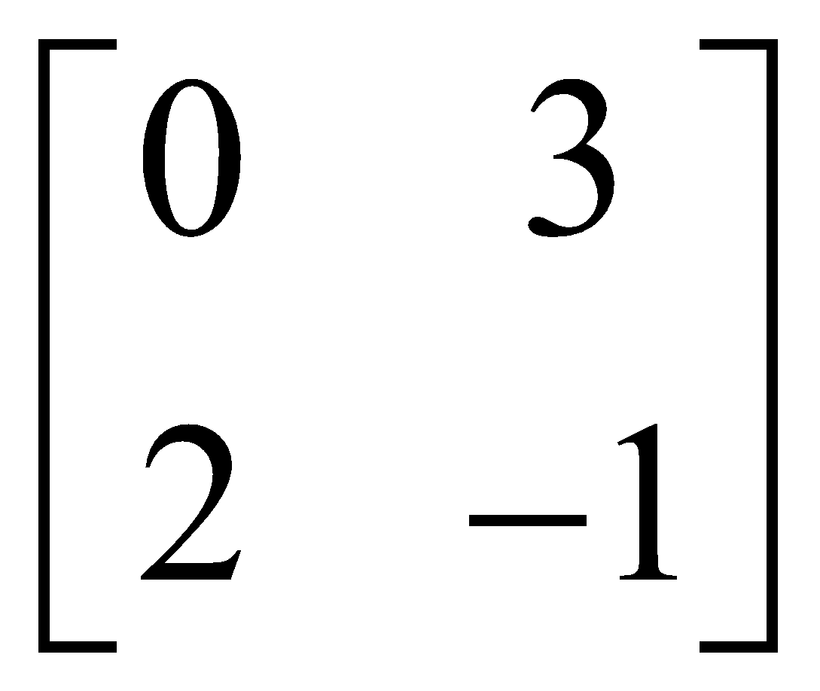 (b) 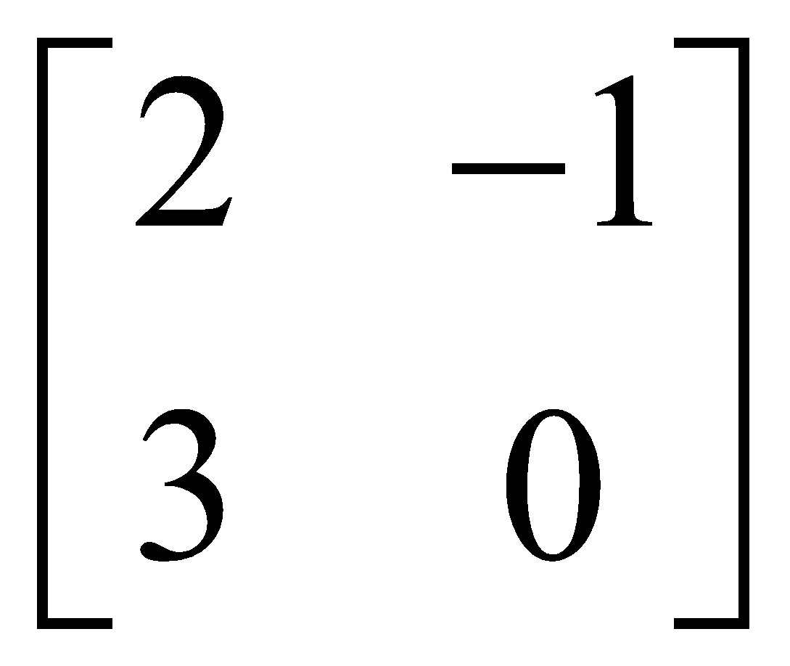  (c)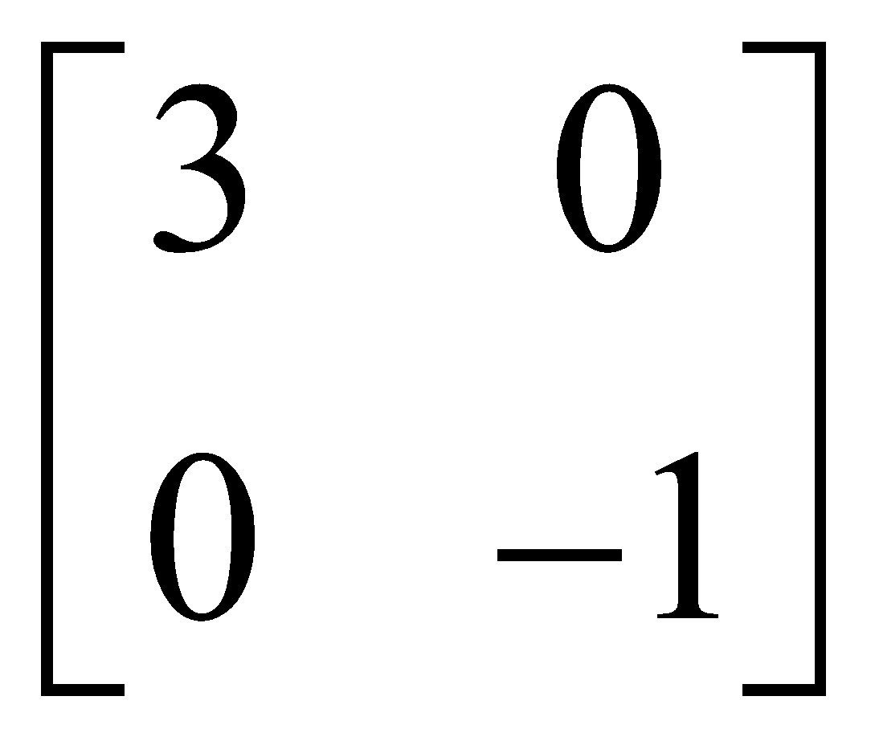 (d)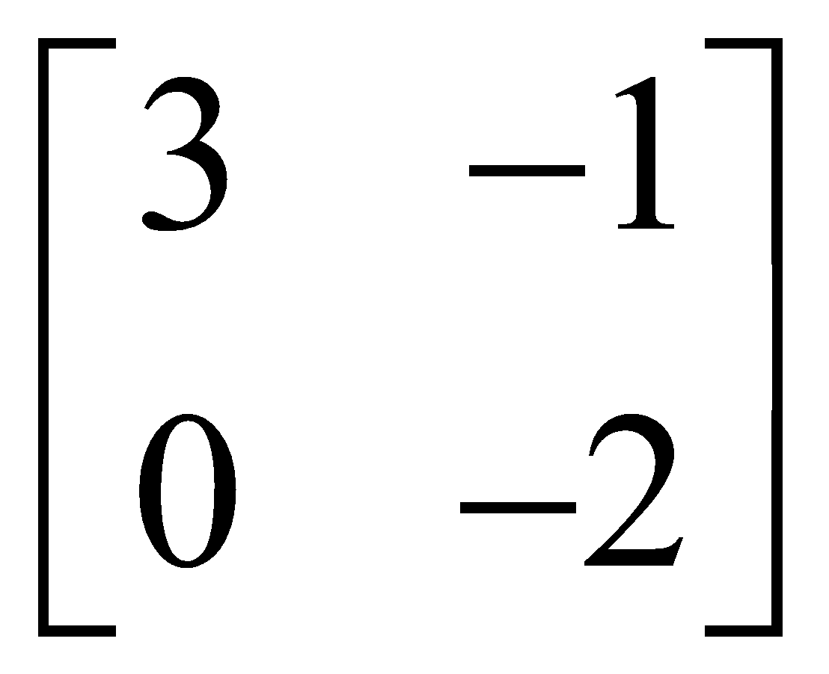 | 1
23 | If A = [a_{ij}] is a 2 × 3 matrix, such that a_{ij} $=\frac{ {\left(-i+2j\right)}^{2}}{5}$  then a₂₃ is  (a)  (b)  (c) 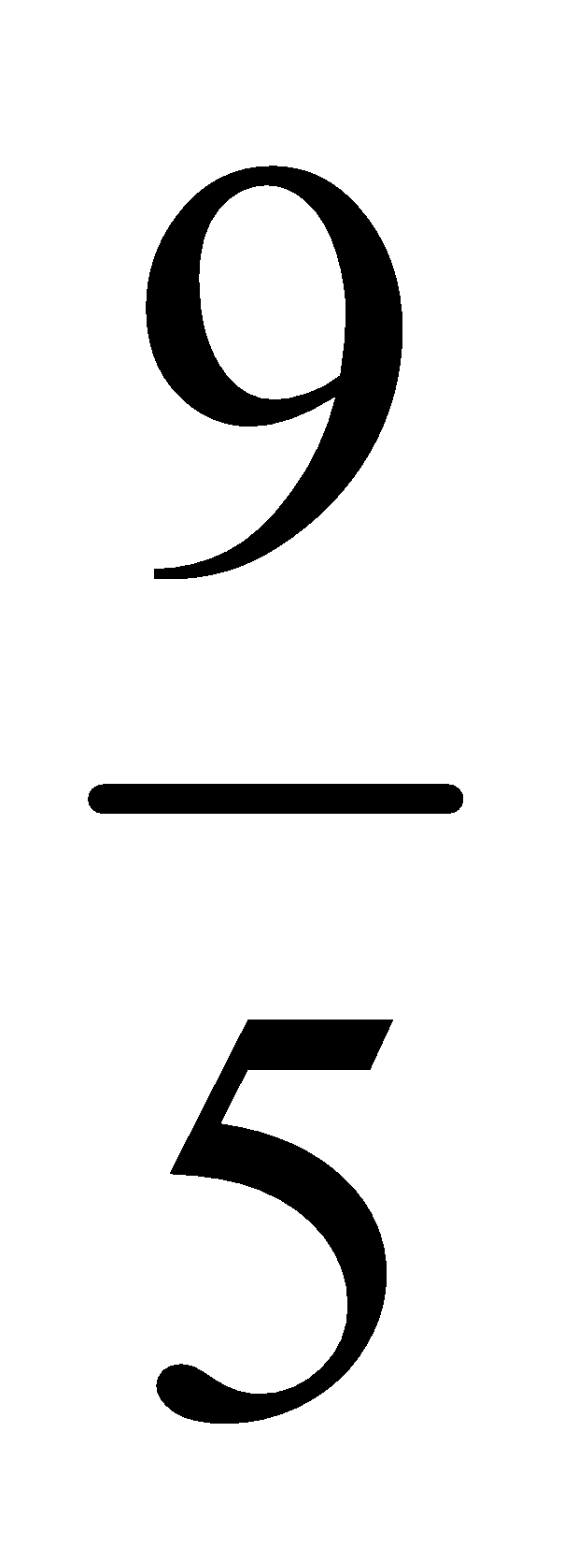 (d) 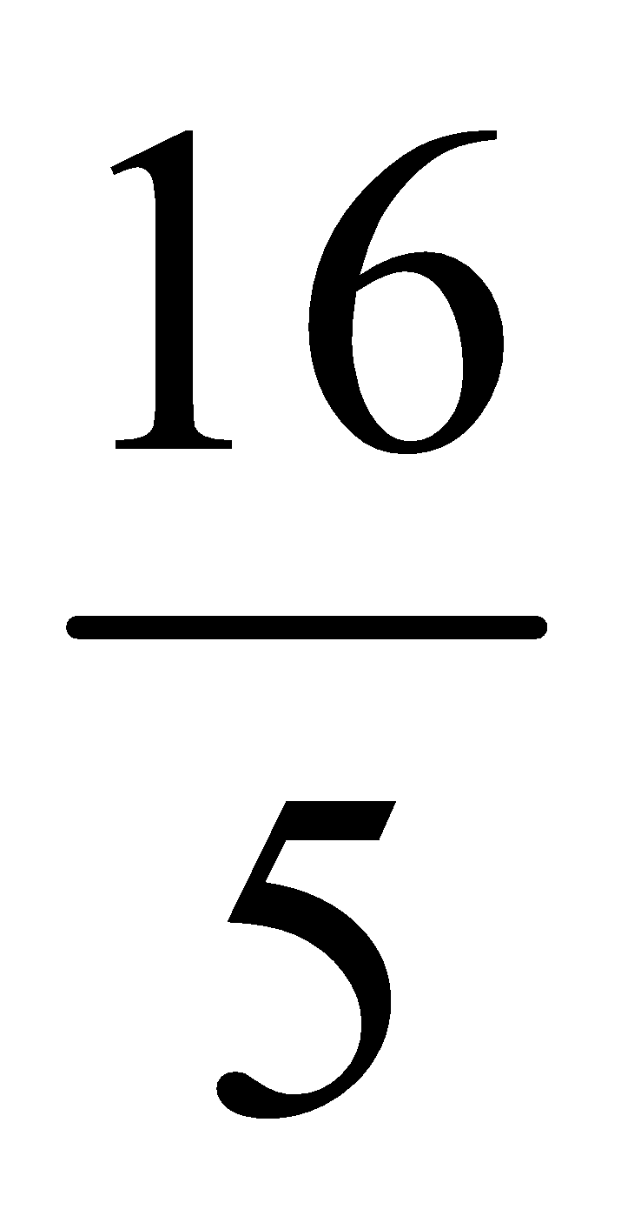 | 1
24 | If A = diag. [ 5, -2, 7] ; B = diag. [7, 8, 5], then $3A - 2B=$  (a) diag. [ 1, -22, -11] (c) diag. [-1, 22, -11]  (b) diag. [-1, -22, 11] (d) diag. [1, -22, 11] | 1
25 | If A is a symmetric matrix of integers with zeroes on the main diagonal, the sum of the entries of A must be an ____.  a. integer b. odd integer  c. even integer d. irrational number | 1
 | ANSWERS | 1
1 | C | 1
2 | D | 1
3 | D | 1
4 | A | 1
5 | B | 1
6 | C | 1
7 | C | 1
8 | D | 1
9 | B | 1
10 | (iv)C(A+B’)  Ans- O(B’) =2X3  O(A+B’)=2X3  C(A+B’) is not defined as number of column of C $≠$number of rows in A+B’ | 1
11 | (iii)144  Ans- det(A)=12  Det(adjA) =det(A)³⁻¹ =12² =144 properties:- det(adjA)=det(A)^{n-1} | 1
12 | iii)3,8  ans:- AB exist if x+5=y  BA exist if 11-y=x  Solving these two equation : x=3 and y=8 | 1
13 | ii)4  ans:-if the determinant of a matrix is zero then the matrix is called singular.  Thus, det(A)=0  i.e 2a-8=0  i.e a=4 | 1
14 | ii)1  ans:- determinant of a unit matrix of any order is 1. | 1
15 | iv)512  ans:-in a 3x3 order matrix total number of entry is 9. Each entry is done by either 2 or 0 i.e by 2ways.so, by fundamental principle of counting the total number of ways in which 9elements can be chosen to form matrices is 2⁹=512 . | 1
16 | iii)-6, -4, -9  ans:- kA=$k\left[0 2 3 -4 \right]=\left[k 2k 3k -4k \right]=\left[0 3a 2b 24 \right]$  by equality of matrices  -4k=24 i.e k=-6  3a=2k i.e a=-4  2b=3k i.e b=-9 | 1
17 | iv)5  ans:- for a symmetric matrix A=A^{T}  x+2= 2x-3  x=5 | 1
18 | iv)det(2A) = 16(detA)  ans:- $\left|kA\right|=k^{n}\left|A\right|$ where A is matrix of order n | 1
19 | ii)$\frac{1}{2}(I-A)$  ans:-A is non-singular matrix so A⁻¹ exist  multiply A⁻¹ in both side of matrix equation and use A⁻¹A=I and A⁻¹I=A⁻¹ | 1
20 | b | 1
21 | b | 1
22 | c | 1
23 | d | 1
24 | d | 1
25 | c | 1
 | ASSERTION & REASON QUESTIONS
Choose the correct option in the following questions of Assertion – Reason Questions.
(a) Both A and R are correct; R is the correct explanation of A.
(b) Both A and R are correct; R is not the correct explanation of A.
(c) A is true but R is false
(d) A is false but R is true
1 | Assertion (A) : If $A=\left(0 -2 3 2 0 6 -3 -6 0 \right), then A^{-1} does not exit$  Reason (R) : If A is a skew symmetric matrix of odd order, then A is singular. | 1
2 | Assertion (A) : If $A is a square matrix such that A^{2}=I, then {(I+A)}^{3}-3A=I$  Reason (R) : AI=IA=A, where I is the identity matrix. | 1
3 | Assertion (A): Let $A and B are 2×2 matrices, AB=I_{2}⟹A=B^{-1}$  Reason (R): AB=O $⟹A=O or B=O$ | 1
4 | Assertion: The matrix A = $\left[2 0 0 0 2 0 0 0 2 \right]$is a scalar matrix  Reason: Any matrix is scalar if its principal diagonal elements are same | 1
5 | Assertion: The matrix $\left[0 1 -2 -1 0 3 2 -3 0 \right]$is a skew symmetric matrix  Reason: All the diagonal elements of a skew symmetric matrix are zero. | 1
6 | Assertion: For two matrices A and B, $\left(A+B\right)\left(A-B\right)≠A^{2}-B^{2}$  Reason: AB≠BA, for matrix multiplication. | 1
7 | Assertion: If A and B are skew symmetric matrices then AB -BA is a symmetric matrix.  Reason: For a matrix to be symmetric A^{T} = - A | 1
8 | Assertion: If the order of matrices A, B and C are 2×3,3×4,4×2 then order of matrix ABC is 2×2.  Reason: We can multiply two matrices if number of columns of first matrix is equal to number of rows of second matrix. | 1
9 | ASSERTION (A): Matrix $\left[0 3 2 -3 0 -7 -2 7 0 \right]$ is a skew-symmetric matrix.  REASON(R): A matrix A is skew-symmetric if A^{T} = A. | 1
10 | Let A, B, C are three matrices of same order.  Now, consider the following statements  Assertion (A): If A = B, then AC = BC  Reason (R): If AC = BC, then A = B | 1
 | ANSWERS
1 | a | 1
2 | d | 1
3 | c | 1
4 | d | 1
5 | b | 1
6 | a | 1
7 | c | 1
8 | b | 1
9 | c | 1
10 | d | 1
 | 2 MARKS TYPE QUESTIONS
1 | Two farmers Shyam and Balwan singh cultivated only three varieties of pulses namely Urad, Masoor and Mung. The sales of these varieties of pulses by both the farmers in the month of September and October are given by the following matrices A and B.  September sales in Rupees:  $A=\left[10000 20000 30000 50000 30000 10000 \right]$  October sales in rupees  $B=\left[5000 10000 6000 20000 10000 10000 \right]$  1 What is the combined sales of Masoor in September and October for Balwar Singh. | 2
2 | A bolt manufacturing company produces three types of bolts x, y and z which he sell in two markets. Annual sales are indicated in the following table:  If unit sales price x, y and z are Rs.2.50, Rs.1.50 and Rs.1 respectively, then answer the following.  Total revenue collected from market I and II. | 2
  Market | Products (in numbers)
  Market | X | Y | z
  I | 5000 | 1000 | 9000
  II | 3000 | 10000 | 4000
3 | If A = $\left[ab b^{2} -a^{2} -ab \right]$ and A^{n}= 0 then find minimum value of n?  i)2 ii) 3 iii) 4 iv)5 | 2
4 | If A =$\left[4 2 -1 1 \right]$ and I is the identity matrix of order 2 then (A-2I) (A-3I) =  i)1 ii) zero matrix iii) Identity matrix iv) 0 | 2
5 | For what value of p, A² =0, where A= $\left[p 1 -1 -p \right]$  i)0 ii) $∓$1 iii) -1 iv) 1 | 2
6 | If A = $\left[1 tan\frac{θ}{2} -tan\frac{θ}{2} 1 \right]$ and AB = I then B=  i)cos²$\frac{θ}{2}$ A ii) cos²$\frac{ θ}{2}$ I iii) cos²$\frac{θ}{2}$ A^{T} iv) none | 2
7 | If α and β are the roots of the equation 1+x+x²=0, then  $\left[1 β α α \right]\left[α β 1 β \right]$=  i)$\left[1 1 1 2 \right]$ ii)$\left[-1 -1 -1 2 \right]$ iii)$\left[1 -1 -1 2 \right]$ iv)$\left[-1 -1 -1 -2 \right]$ | 2
8 | If A is a square matrix such that A² = I, then find the simplified value of (A – I)³ + (A + I)³ – 7A. | 2
9 | Write the number of all possible matrices of order 2 × 2 with each entry 1, 2 or 3. | 2
10 | 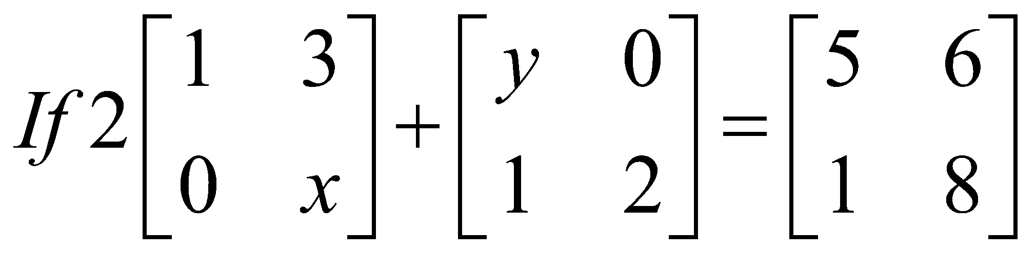then, find the value if x+ y. | 2
 | ANSWERS | 2
1 | $A=\left[10000 20000 30000 50000 30000 10000 \right]$ and $B=\left[5000 10000 6000 20000 10000 10000 \right]$  A+B = $\left[15000 30000 36000 70000 40000 20000 \right]$ | 2
2 | Rs.23000 and Rs.26500 | 2
3 | i)2  ANS:- we can find that A²=0 (0 here is zero matrix)  A³=A²A=0$∙$A =0  A^{n}=0 for all n≥2 | 2
4 | ii)zero matrix  ans- (A-2I)(A-3I) =$\left[2 2 -1 -1 \right]\left[1 2 -1 -2 \right]$ = 0 | 2
5 | ii)$∓$1  ANS:- A²=0  P²-1=0  P=$∓1$ | 2
6 | iii)cos²$\frac{θ}{2}$A^{T}  ans:-$\left|A\right|$=1+tan²$\frac{θ}{2}$  AB=I ie B=A⁻¹  B=(adjA)\$\left|A\right|$  B=$\left[1 -tan\frac{θ}{2} tan\frac{θ}{2} 1 \right]$/sec²$\frac{θ}{2}$  =cos²$\frac{θ}{2}$ $∙A$^{T} | 2
7 | ii)$\left[-1 -1 -1 2 \right]$  as $α and β$are roots of 1+x+x²=0  $α+ β=-1$ and $αβ$=1  Also $1+α+ α^{2}=0$ and 1+$β+β^{2}=0$ | 2
8 | A² = I ……. (i)  Now, (A – I)³ + (A + I)³ – 7A  = (A³ – 3A²I + 3AI² – I) + (A³ + 3A²I + 3AI² + I³) – 7A  = A³ – 3A² + 3AI – I + A³ + 3A² + 3AI + I – 7A  [∵ A²I = A² and I³ = I³ = I]  = 2A³ + 6AI – 7A = 2A² A + 6A – 7A [∵ AI = A]  = 2IA – A [from Eq. (1)]  = 2A – A = A [∵ IA = A] | 2
9 | A matrix of order 2 × 2 has 4 entries. Since, each entry has 3 choices, 1, 2 or 3, therefore number of required matrices  3⁴ = 3 × 3 × 3 × 3 = 81. | 2
10 | X=3 , Y = 3 hence X+Y = 6 | 2
 | 3 – MARKS TYPE QUESTIONS
1 | A trust fund has Rs.35000 is to be invested in two different types of bonds. The first bond pays 8% interest per annum which will be given to orphanage and second bond pays 10% interest per annum which will be given to an NGO. Use matrix multiplication, determine how to divide Rs.35,000 among two types of bonds if the trust fund obtain an annual total interest of Rs.3200. | 3
2 | In a city there are two factories A and B. Each factory produces sports clothes for boys and girls. There are three types of clothes produced in both the factories type I, type II and type III. For boys the number of units of types I, II and III respectively are 80, 70 and 65 in factory A and 85, 64 and 72 are in factory B. For girls the number of units of types I, II and II respectively are 80, 75, 90 in factory A and 50, 55, 80 are in factory B.  1. Write the matrix P, if P represents the matrix of number of units of each type produced by factory A for both boys and girls.  2. Write the matrix Q, if Q represents the matrix of number of units of each type produced by factory B for both boys and girls.  3. Find the total production of sports clothes of each type for boys. | 3
3 | The sum of three number is 6. If we multiply third number by 3 and add second number to it, we get 11. By adding first and third number we get double of the second number. The three numbers are respectively -  - 2,3,1 iii)3 ,3,2  - 2,1,3 iv)1,2,3 | 3
4 | If 3x+2Y = I and 2X -Y = 0 where I and 0 are the null matrices of order 3 respectively then :-  i) X=1/7 , Y=2/7 ii) X=2/7 ,Y= 1/7  iii) X= (1/7)I , Y = (2/7)I iv) X= (2/7)I , Y = (1/7)I | 3
5 | To control a crop disease it is necessary to use 8 units of chemical A ,14 units of chemical B, and 13 units of chemical C. One barrel of spray P contains 1 unit of A, 2units of B and 3 units of C. One unit of spray Q contains 2units of A, 3 units of B and 2 units of C. One barrel of spray R contains 1 unit of A, 2 units of B and 2 units of C .  Based on the above information answer the following questions :-  (a)if x barrels of spray P, y barrels of spray Q and z barrels of spray R are be used to just meet the requirement, then the above information can be represented in the form of :  i)x+2y+z=8 2x+3y+2z=14 3x+2y+2z=13  ii) x+2y+3z=8 x+3y+2z=14 x+2y+2z=13  iii) x+2y+z=14 2x+3y+2z=8 3x+2y+2z=13  iv) x+2y+z=13 2x+3y+2z=8 3x+2y+2z=14  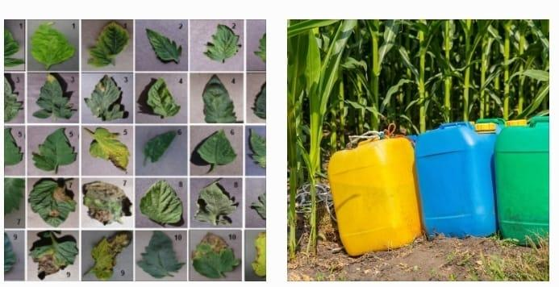  (b)if spray P, Q and R cost RS.500, RS.250 and RS.200 per barrel, the total cost incurred is  i)1200 ii)1500 iii)950 iv)1600 | 3
6 | If A =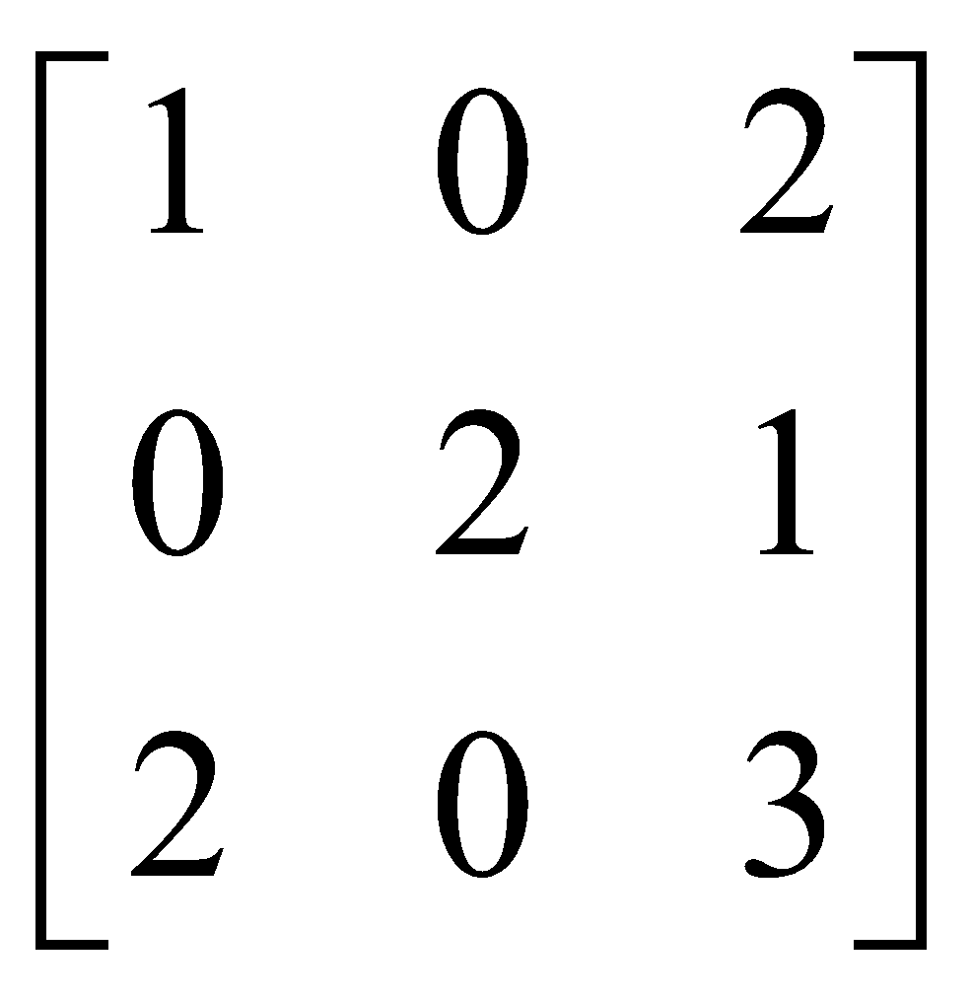satisfies A³ – 6A² + 7A + kI₃ = 0,  find the value of k | 3
7 | If A = 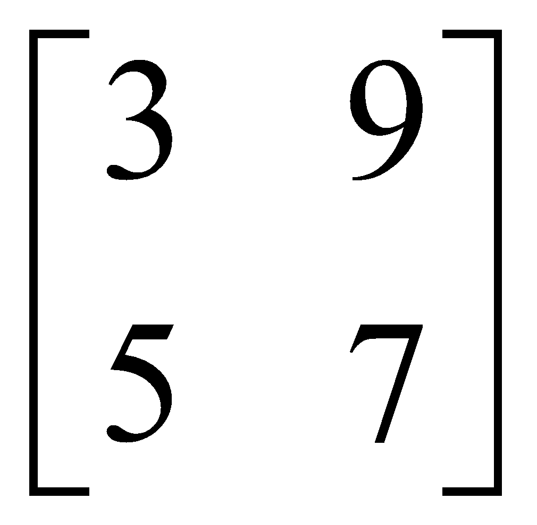 is written as A = P + Q, where P is a symmetric matrix and Q is skew-symmetric matrix, then write the matrix P | 3
8 | For what value of x, is the matrix A =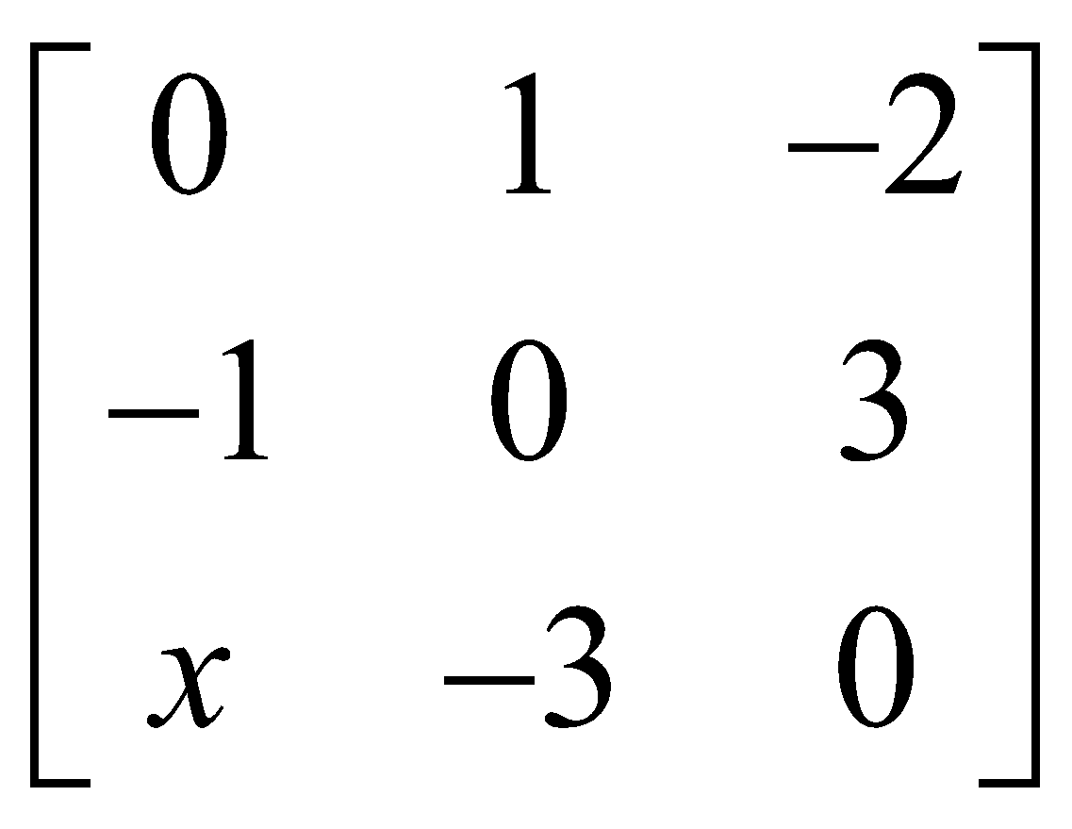a skew-symmetric matrix? | 3
9 | Find the values of x, y, z if the matrix A=.$\left[0 2y z x y-z x -y z \right]$ Satisfy the equation find $A^{T}$A = I3 | 3
10 | If $F\left(x\right)=\left[coscos x -sinsin x 0 sinsin x coscos x 0 0 0 1 \right]$,  Show that $F\left(x\right).F\left(y\right)=F\left(x+y\right)$. | 3
 | ANSWERS
1 | Let investment in first type of bond be Rs.x  The investment in second type of bond = Rs.35000-x  $\left[x, 35000-x\right].\left[\frac{8}{100} \frac{10}{100} \right]=[3200]$  After that will get investment in first bond = Rs.15000  And investment in second bond = Rs.20000 | 3
2 | 1. $P=\left[80 80 70 75 65 90 \right]$  2. $Q=\left[85 50 65 55 72 80 \right]$  3. X+Y=[165 135 137] | 3
3 | iv) 1,2,3  Ans:-  The given problem can be represented as  a+b+c = 6  b+3c =11  a-2b+c=0  corresponding matrix equation is  $\left[1 1 1 0 1 3 1 -2 1 \right]\left[a b c \right]=\left[6 11 0 \right]$ (AX=B)  $\left[a b c \right]$ = $\frac{1}{9}$ $\left[7 -3 2 3 0 -3 -1 3 1 \right]\left[6 11 0 \right] =\left[1 2 3 \right]$ (X=A⁻¹B=$\frac{Adj A}{\left|A\right|}$B )  So the three numbers are a= 1, b=2, c=3. | 3
4 | iii)X=(1/7)I ,Y=(2/7)I  ans:- 3X+2Y=I …….(1)  2X-Y=0  4X-2Y=0 ……(2)  Solving (1) and (2) 7X=I  i.e X=$\frac{1}{7}I$ and Y=$\frac{2}{7}I$ | 3
5 | (a)(i) x+2y+z=8 2x+3y+2z=14 3x+2y+2z=13  (b)(iv)1600  Ans:- (a)as x,y,z be the number of barrel of spray P, Q, R respectively  spray P contains 1 unit of A, 2units of B and 3 units of C  spray Q contains 2units of A, 3 units of B and 2 units of C  spray R contains 1 unit of A, 2 units of B and 2 units of C .  thus option (i) is correct representation  (b)solving the liner equation by matrix method AX=B ie X=BA⁻¹  $$\left[x y z \right]=\left[8 14 13 \right]\left[2 -2 1 2 -1 0 -5 4 -1 \right]=\left[1 2 3 \right]$$  Prices of spray P,Q,R are RS.500 ,RS.250, RS.200 respectively  So, the total cost incurred is 1x500+2x250+3x200=1600 | 3
6 | A³ – 6A² + 7A + kI₃ = 0  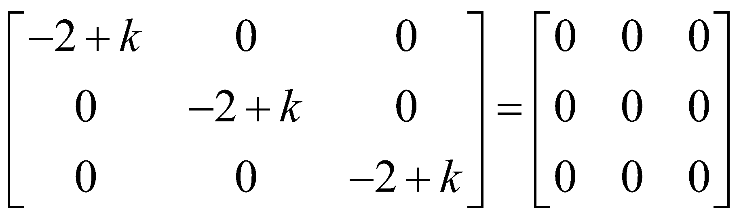  K=2 | 3
7 | 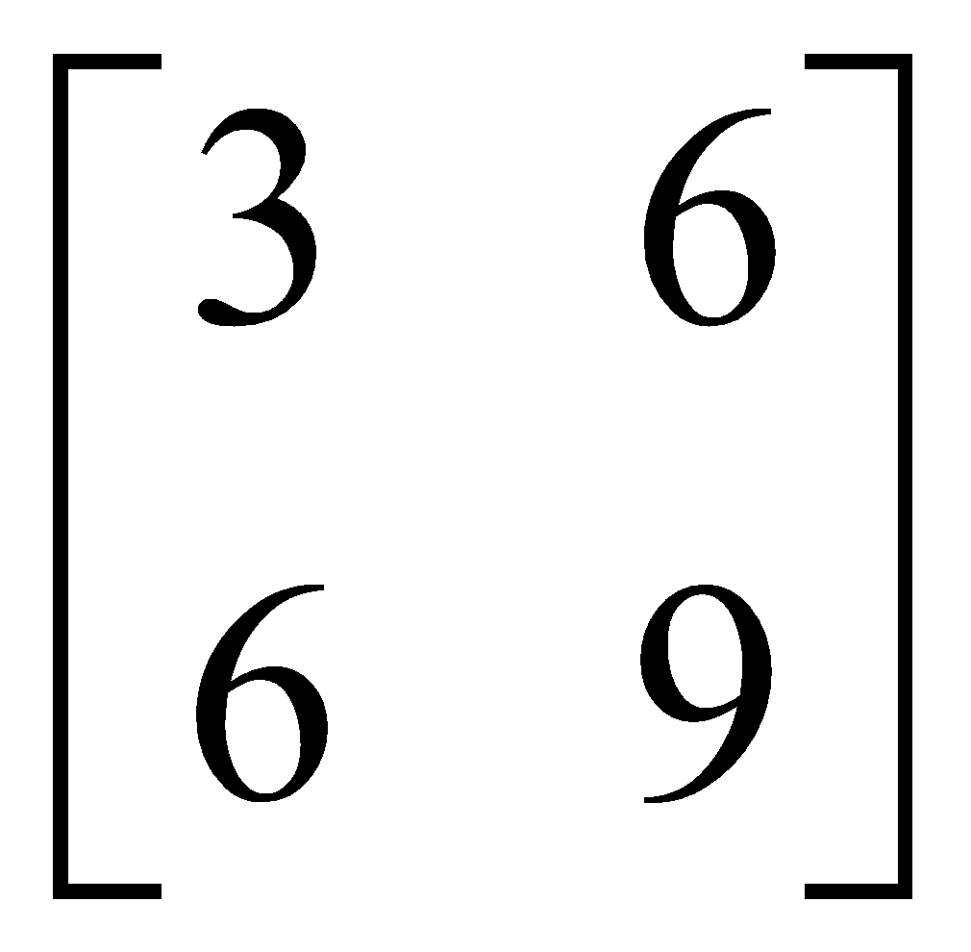 | 3
8 | A= - A^{T}  X=2 | 3
9 | A=$\left[0 2y z x y -z x -y z \right]$  A^{T}=$\left[0 x x 2y y -y z -z z \right]$  A^{T}A=13  - 2x²=1  - x= ±$\frac{1}{\sqrt{2}}$  - 4y²=1  - y=±$\frac{1}{2}$  - 3z²=1  - z= ±$\frac{1}{\sqrt{3}}$ | 3
10 | $F\left(x\right)=\left[coscos x -sinsin x 0 sinsin x coscos x 0 0 0 1 \right]$.  $F\left(y\right)=\left[coscos y -sinsin y 0 sinsin y coscos y 0 0 0 1 \right]$.  $F\left(x\right)×F\left(y\right)$=$\left[coscos x -sinsin x 0 sinsin x coscos x 0 0 0 1 \right]×\left[coscos y -sinsin y 0 sinsin y coscos y 0 0 0 1 \right]$  = $\left[coscos (x+y) -sinsin (x+y) 0 sinsin (x+y) coscos (x+y) 0 0 0 1 \right]$  = $F\left(x+y\right)$ | 3
 | 4 – MARKS TYPE QUESTIONS (CASE BASED QUESTIONS)
1 | Ram purchases 3 pens, 2 bags, and 1 instrument box and pays ₹ 41. From the same shop, Dheeraj purchases 2 pens, 1 bag, and 2 instrument boxes and pays ₹ 29, while Ankur purchases 2 pens, 2 bags, and 2 instrument boxes and pays ₹ 44.    Read the above information and answer the following questions:  - Find the cost of one pen. (1 mark)  - What are the cost of one pen and one bag? (1 mark)  - What is the cost of one pen & one instrument box? (2 marks) | 4
2 | Three friends Ravi, Raju and Rohit were buying and selling stationery items in a market. The price of per dozen of Pen, notebooks and toys are Rupees x, y and z respectively. Ravi purchases 4 dozen of notebooks and sells 2 dozen pens and 5 dozen toys. Raju purchases 2 dozen toys and sells 3 dozen pens and 1 dozen of notebooks. Rohit purchases one dozen of pens and sells 3 dozen notebooks and one dozen toys. In the process, Ravi, Raju and Rohit earn ₹ 1500, ₹ 100 and ₹400 respectively.    What is the price of one dozen pens? (1 mark)  What is the total price of one dozen pens and one dozen of notebooks?(1 mark)  What is the sale amount of Ravi? (2 marks) | 4
3 | Three schools DPS, CVC and KVS decided to organize a fair for collecting money for helping the flood victims. They sold handmade fans, mats and plates from recycled material at a cost of Rs. 25, Rs.100 and Rs. 50 each respectively. The numbers of articles sold are given as  School /Article DPS CVC KVS  Handmade fans 40 25 35  Mats 50 40 50  Plates 20 30 40  Based on the information given above, answer the following questions:  (i). What is the total money (in Rupees) collected by the school DPS?  (ii). If the number of handmade fans and plates are interchanged for all the schools, then what is the total money collected by all schools?  (iii). How many articles (in total) are sold by three schools? | 4
4 | There are two families A and B. There are 4 men, 6 women and 2 children in family A and 2 men, 2 women and 4 children in family B. The recommended daily amount of calories is 2400 for men, 1900 for women and 1800 for children 45 grams of protein for men, 55 grams for women and 33 grams for children.  (i) Represent the above information using matrices  (ii) Calculate the total requirement of calories and proteins for each of the two families. | 4
5 | A trust caring for handicapped children gets Rs.30000 every month from its donors. The trust spends half of the funds received for medical & educational care of the children & for that it charges 2% of the spent amount from them, & deposited the balance amount in a private bank to get the money multiplied so that the trust goes on functioning regularly.  What percent of interest should the trust get from the bank so as to get a total of Rs. 1800 every month? Use the matrix method to find the rate of interest.   | 4
6 | There are 2 families A and B. There are 4 men, 6 women and 2 children in family A, and 2 men, 2 women 4 children in family B. The recommend daily number of calories is 2200 for men, 2500 for women, 2000 for children and 75 grams of proteins for men, 70 grams for women and 35 grams for children. Represent the above information using matrix.  Using matrix multiplication, calculate the total requirement of calories and proteins for each of the two families. What awareness can you create among people about the planned diet from this question?   | 4
 | ANSWERS
1 | (i) ₹ 2 (ii) ₹17 (iii) ₹7 | 4
2 | (i) ₹ 100 (ii) ₹ 300 (iii)₹ 1200 | 4
3 | (i) Total money collected by the school DPS is Rs. 7000  (ii) Total money collected by all the schools is Rs. 18500  (iii) The total articles sold by the schools is 330 | 4
4 | (i) The matrices are P = $\left[4 6 2 2 2 4 \right]$ Q = $\left[2400 1900 1800 \right]$ and R = $\left[45 55 33 \right]$  (ii) Here PQ =$\left[4 6 2 2 2 4 \right]$ $\left[2400 1900 1800 \right]$  = $\left[24600 15800 \right]$  And PR = $\left[4 6 2 2 2 4 \right]\left[45 55 33 \right]$  = $\left[576 332 \right]$  Hence total requirement of calories and protein for family A are 24600 and 576 grams respectively and total requirement of calories and protein for family B are 15800 and 332 grams respectively. | 4
5 | Let us assume that the earning of trust from all the charges is x and earning of trust from the interest obtained from the bank is y.  Total fund received is RS.30000  X= 2% of RS.15000 = 300  As matrix it can be represented as  $$\left[1 1 1 0 \right]\left[x y \right]=\left[1800 300 \right]$$  $$\left[x y \right]=\left[300 1500 \right]$$  Let R be the rate of interest by the bank  As y=1500 =$\frac{R}{100}X15000=150 i.e$. R =10%  So, the rate of interest the trust get by the bank is 10%. | 4
6 | The given data can be represented as-  Family member:-  Diet to in-take:-  This can be solved in matrix multiplication as  $$\left[4 6 2 2 2 4 \right]\left[2200 75 2500 70 2000 35 \right]=\left[27800 790 17400 430 \right]$$  Thus family A required 27800calories and 790gms of protein ; family B required 17400calories and 430gms of protein. | 4
   | Men | women | Children
  A | 4 | 6 | 2
  B | 2 | 2 | 4
   | Calories | protien
  Men | 2200 | 75
  Women | 2500 | 70
  children | 2000 | 35
 | 5 – MARKS TYPE QUESTIONS
1 | A manufacture produces three stationery products Pencil, Eraser and Sharpener which he sells in two markets. Annual sales are indicated below.  Market Products (in numbers)  Pencil Eraser Sharpener  A 10,000 2,000 18,000  B 6,000 20,000 8,000  If the unit sale price of Pencil, Eraser and Sharpener are Rs.2.50, Rs.1.50and Rs.1.00 respectively, and unit cost of the above three commodities are Rs.2.00, Rs.1.00 and Rs.0.50 respectively, then  1) Total revenue of market A  A) Rs.64,000 B) Rs.60,400 C) Rs.46,000 D) Rs.40,600  2) Total revenue of market B is  A) Rs.35,000 B) Rs.53,000 C) Rs.50,300 D) Rs.30,500  3) Cost incurred in market A :  A) Rs.13,000 B) Rs.30,100 C) Rs.10,300 D) Rs.31,000  4) Cost incurred in market B :  A) Rs.13,000 B) Rs.30,100 C) Rs.10,300 D) Rs.31,000  5) Profits in market A and B respectively are  A) (Rs,15,000, Rs.17,000) B) ( Rs.17,000, Rs.15,000)  C) (Rs.51,000, Rs.71,000) C) (Rs.10,000, Rs.20,000) | 5
2 | Three school DPS, CVC and KVS decided to organize a fair for collecting money for helping the flood victims. They sold handmade fans, mats and plates from recycled material at a cost of Rs.25, Rs.100 and Rs.50 each respectively. The number of articles sold are given as  1. What is the total money collected by the school DPS?  A) Rs.700 B) Rs.7000 C) Rs.6125 D) Rs.7875  2. What is the total amount of money collected by schools CVC and KVS?  A) Rs.14000 B) Rs.15,725 C) Rs.21000 D) 13,125  3. What is the total amount of money collected by all three school DPS, CVC and KVS?  A) Rs.15775 B) Rs.14,000 C) Rs.21,000 D) Rs.17125  4. How many articles are sold by three schools?  A) 230 B) 130 C) 430 D) 330  5. What is the total amount of money collected by all three school DPS, CVC?  A) Rs.14875 B) Rs.13000 C) Rs.14975 D) Rs.13875 | 5
  School/Article | DPS | CVC | KVS
  Handmade fans | 40 | 25 | 35
  Mats | 50 | 40 | 50
  Plates | 20 | 30 | 40
3 | PROMOTING AWARENESS FOR WOMEN  To promote the making of toilet for women, an organization tried to generate awareness through  - House call  - Letters  - Announcement    The cost for each attempt is given bellow  - Rs.50  - Rs.20  - Rs.40  The number of attempts made in three villages X, Y and Z are given bellow  Find the total cost incurred by the organization for three villages using matrices` | 5
   | House call | Letters | Announcements
  X | 400 | 300 | 100
  Y | 300 | 250 | 75
  Z | 500 | 400 | 150
4 | Matrices allow arbitrary linear transformations to be displayed in a consistent format, suitable for computation. This also allows transformations to be composed easily (by multiplying their matrices).  Linear transformations like stretching, squeezing, rotation, shearing, reflection, orthogonal projection are not the only ones that can be represented by matrices.  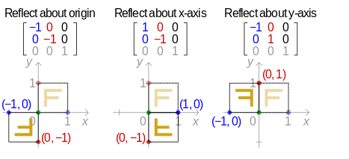  - REFLECTION IN X-AXIS  If P(X,Y) is a point then its reflection in X-axis is P’(X’,Y’) where X’=X and Y’=-Y  Which can also be given by $\left(X' Y' \right)=\left(1 0 0 -1 \right)\left(X Y \right)$  - REFLECTION IN Y-AXIS  If P(X,Y) is a point then its reflection in Y-axis is P’(X’,Y’) where X’=-X and Y’=Y  Which can also be given by$\left(X' Y' \right)=\left(-1 0 0 1 \right)\left(X Y \right)$  - REFLECTION IN ORIGIN  If P(X,Y) is a point then its reflection in origin is P’(X’,Y’) where X’=-X and Y’=-Y  Which can also be given by$\left(X' Y' \right)=\left(-1 0 0 -1 \right)\left(X Y \right)$  Using this concept of transformation find the reflection of the following points  - (2,-3) in X-axis  - (-5,7) in Y-axis  - (11,23) in origin | 5
5 | 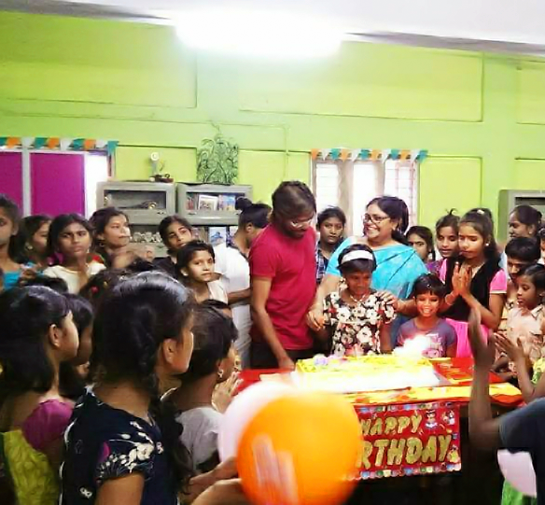  On her birthday, Seema decided to donate some money to children of an orphanage home. If there were 8 children less, everyone would have got Rs. 10 more. However, if there were 16 Children more, everyone would have got Rs. 10 less. Let the no. Of children be x and the amount of money distributed be y (in Rs.)  - Find the equation in term of x and y and represent it in the form of Matrix.  - Find the number of children who were given some money by seema.  - How much money is given to each child by Seema. OR  How much money Seema spends in distributing the money to all the students of orphanage? | 5
 | ANSWERS
1 | 1-C, 2-B 3-D 4-C 5-A | 5
2 | 1-B 2-A 3-C 4-D 5-A | 5
3 | Ans:-  The above problem can be represented by matrices as-  Cost matrix A =$\left[house call letters announcement \right]$  $$= \left[50 20 40 \right]$$  X Y Z  No. of attempts in villages B =$\left[400 300 500 300 250 400 100 75 150 \right]$  The total cost in making the awareness is given by AB  i.e AB=$\left[50 20 40 \right]\left[400 300 500 300 250 400 100 75 150 \right]$  =$\left[30000 23000 39000 \right]$  Thus the cost incurred to the promote making toilets for women in villages X, Y and Z are RS.30000, RS.23000 and RS.39000 respectively. | 5
4 | Ans:-  - The reflection of P(2,-3) is  $\left(x y \right)=\left(1 0 0 -1 \right)\left(2 -3 \right)=\left(2 3 \right)$ ;P’(2,3)  - the reflection of Q(-5,7) is  $\left(x y \right)=\left(-1 0 0 1 \right)\left(-5 7 \right)=\left(5 7 \right)$ ;Q’(5,7)  (c ) the reflection of R(11,23) is  $\left(x y \right)=\left(-1 0 0 -1 \right)\left(11 23 \right)=\left(-11 -23 \right)$ ;R’(-11,-23) | 5
5 | (i)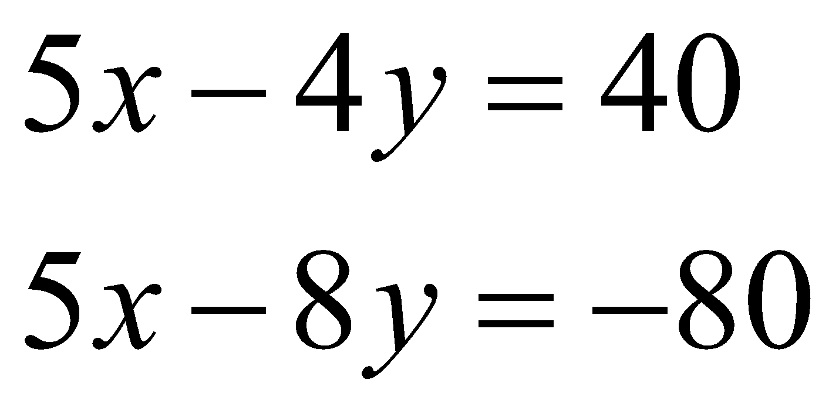  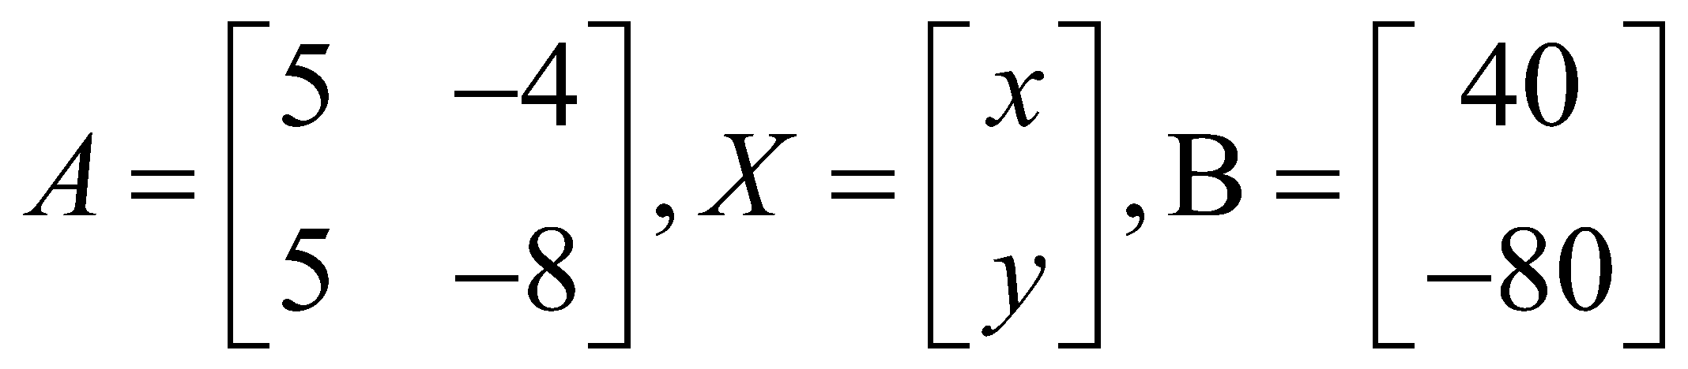  (ii) 33  (iii)30 or 960 | 5

CHAPTER – 4
DETERMINANTS

SYLLABUS:
Determinant of a square matrix (up to 3 x 3 matrices), minors, co-factors and applications of determinants in finding the area of a triangle. Adjoint and inverse of a square matrix. Consistency, inconsistency and number of solutions of system of linear equations by examples, solving system of linear equations in two or three variables (having unique solution) using inverse of a matrix.

SL NO | QUESTION | MARK
 | MULTIPLE - CHOICE QUESTIONS
1 | Let A be a square matrix of order 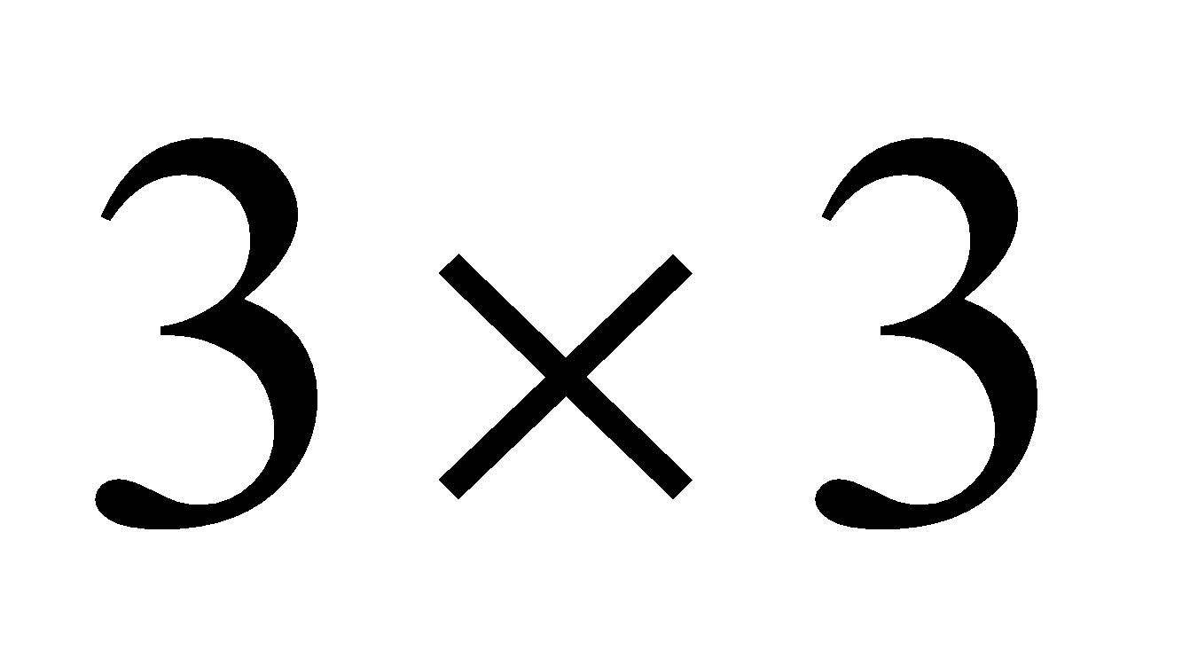such that  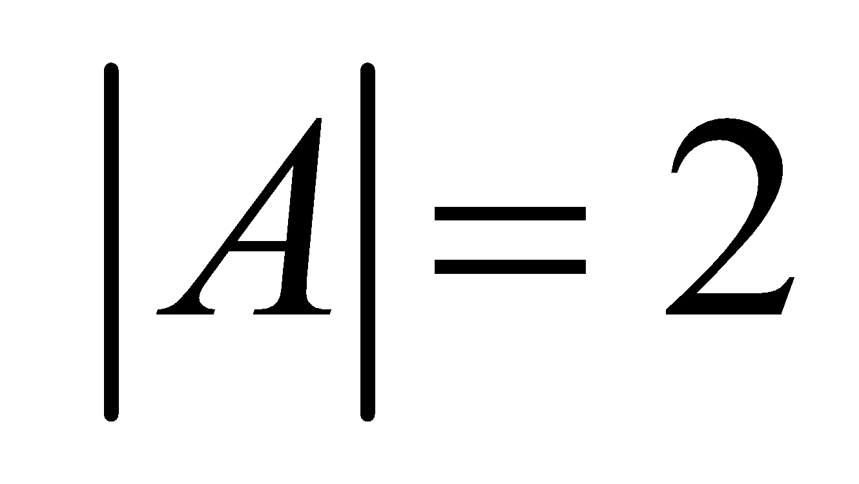, then the value of 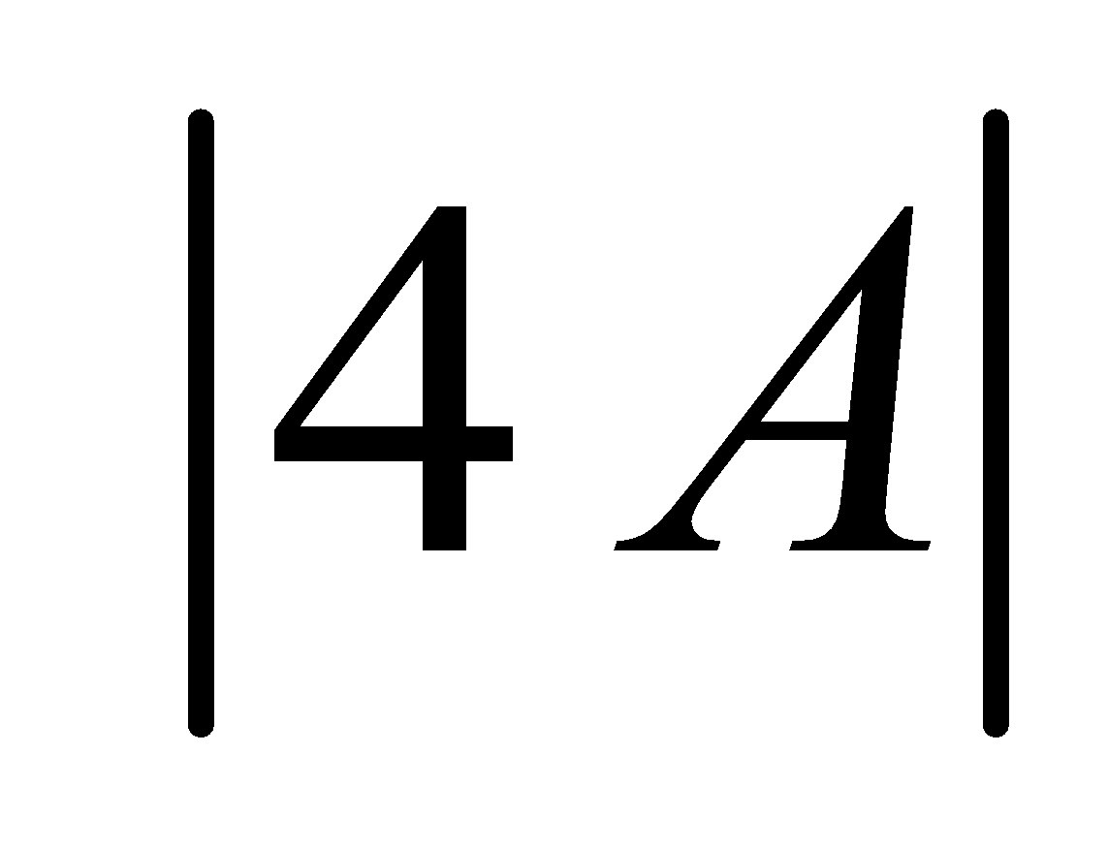 ?  (a) 128 (b) 64 (c) 8 (d) 16 | 1
2 | The co-factor of 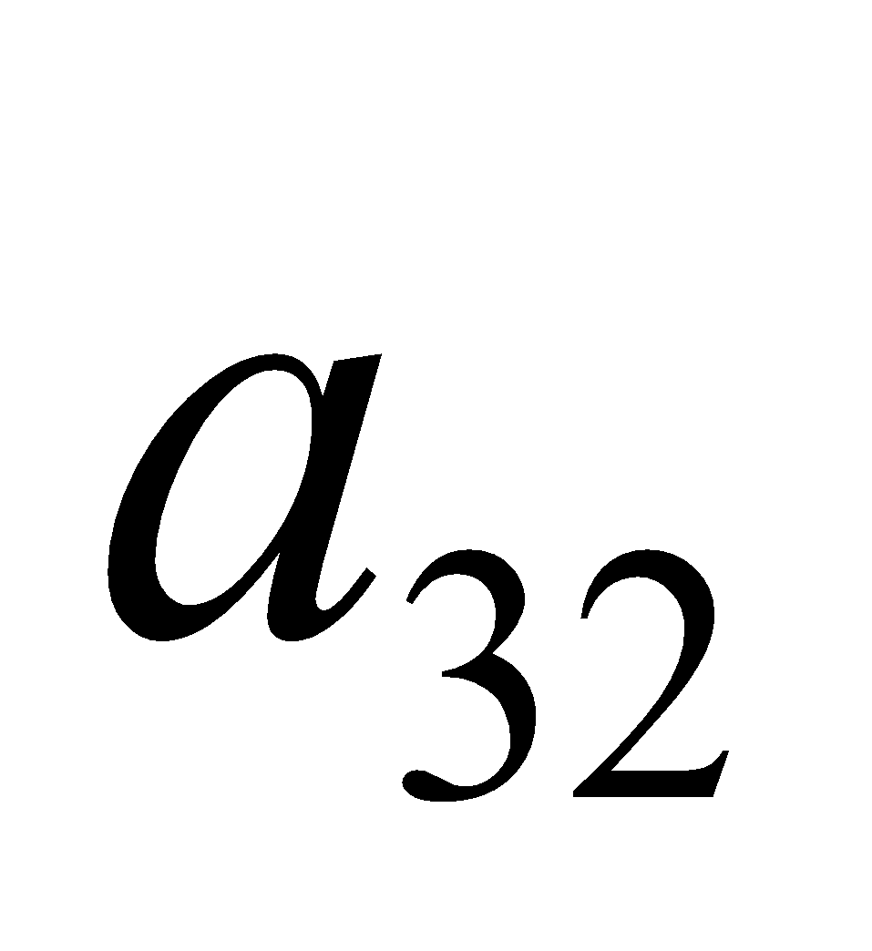in the determinant 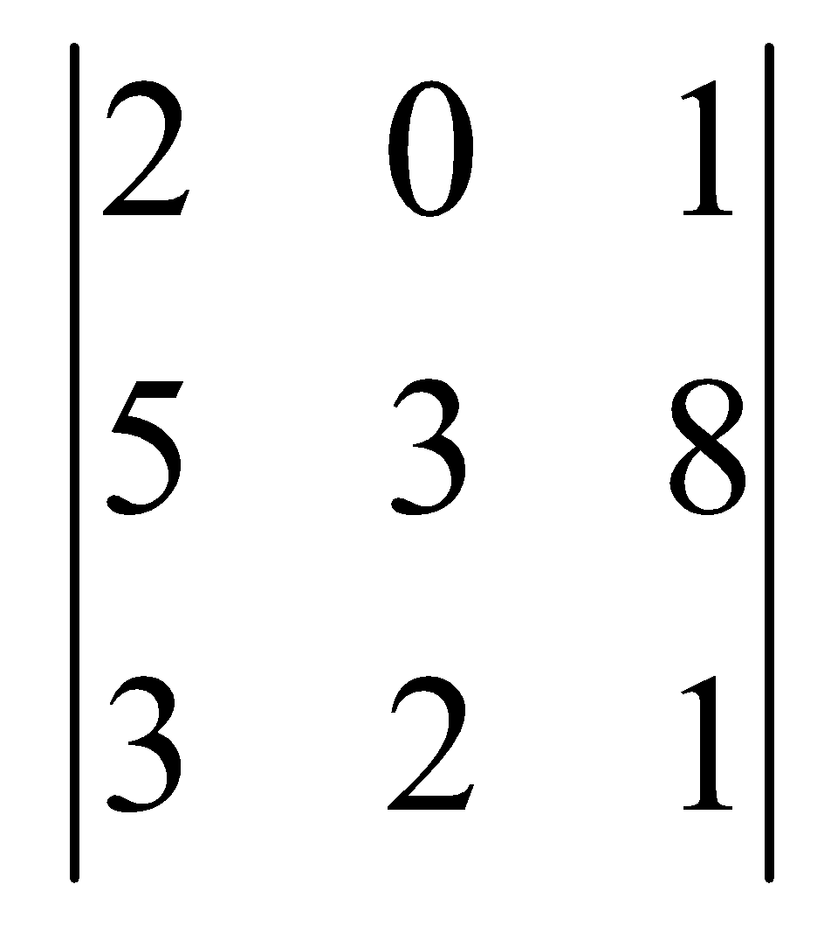 is ?  (a) 11 (b) 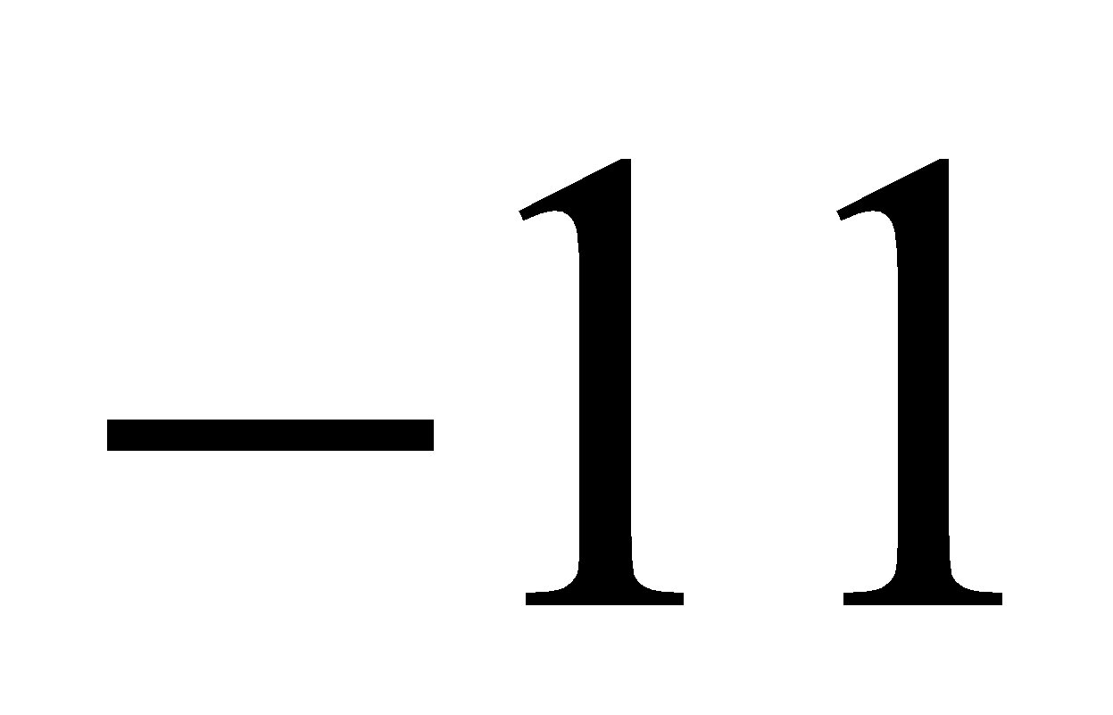 (c) 12 (d) 10 | 1
3 | If 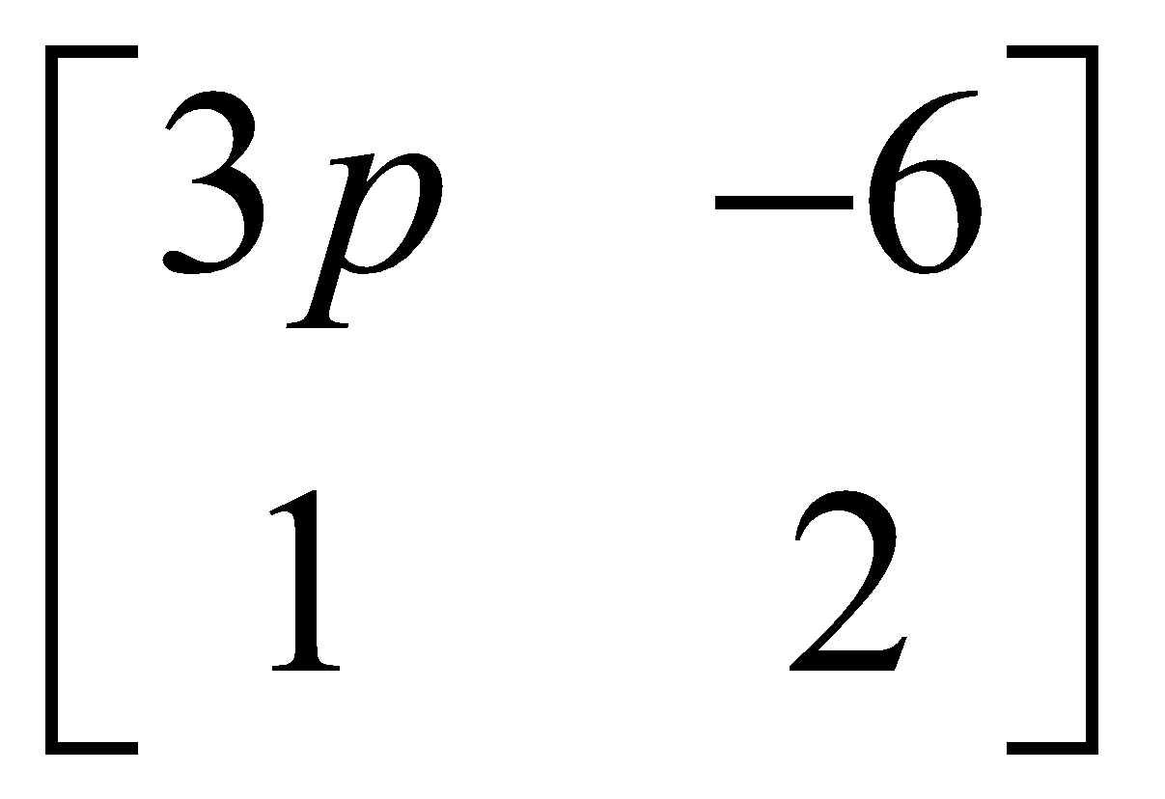 is a singular matrix, then the value of ‘p’ is  (a) 2 (b) 3 (c) 0 (d) 1 | 1
4 | If 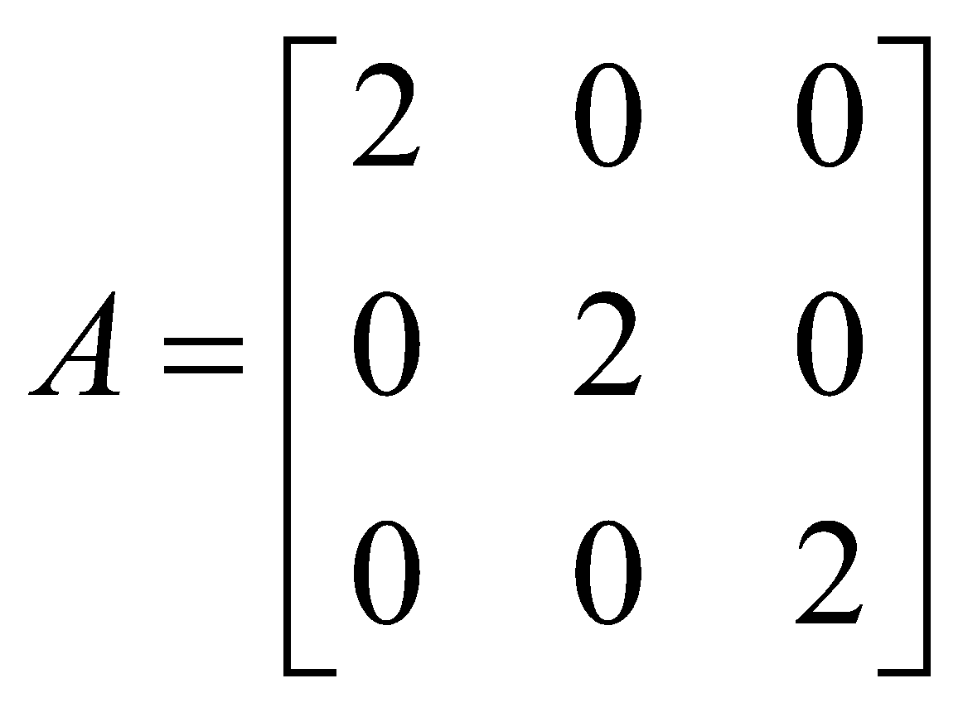, then the value of  is ?  (a) 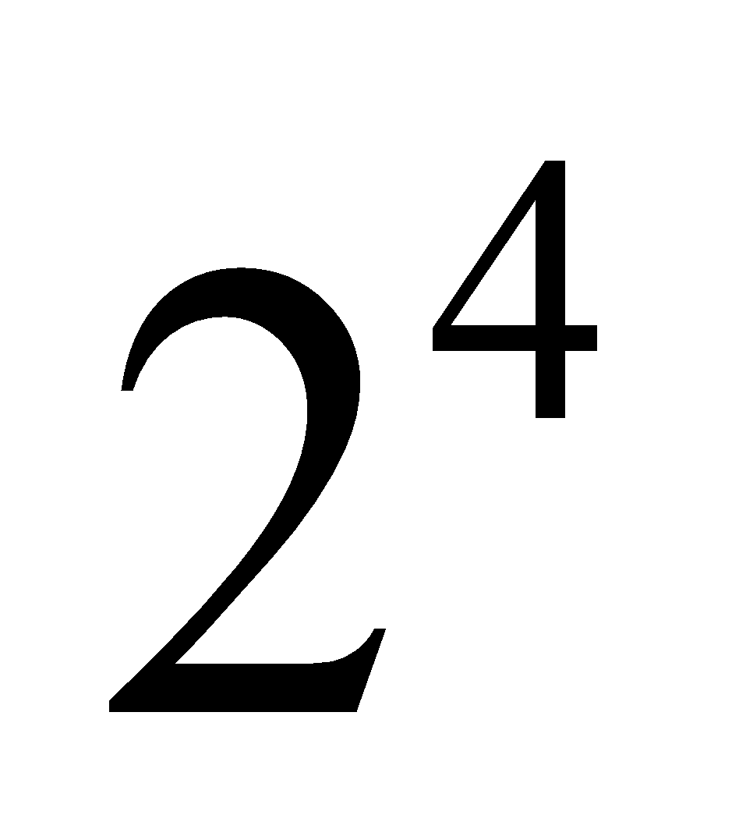 (b) 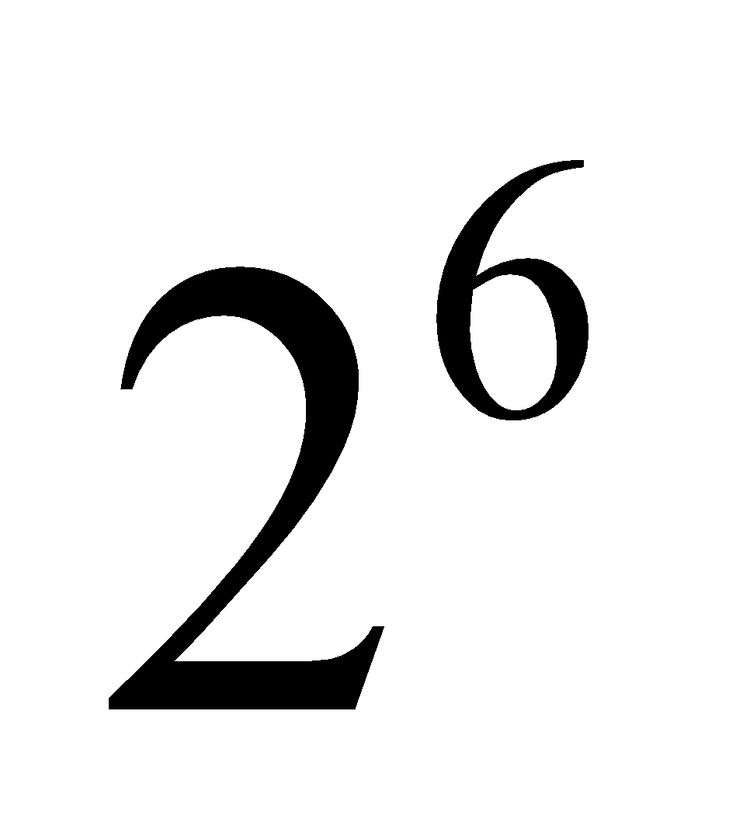 (c) 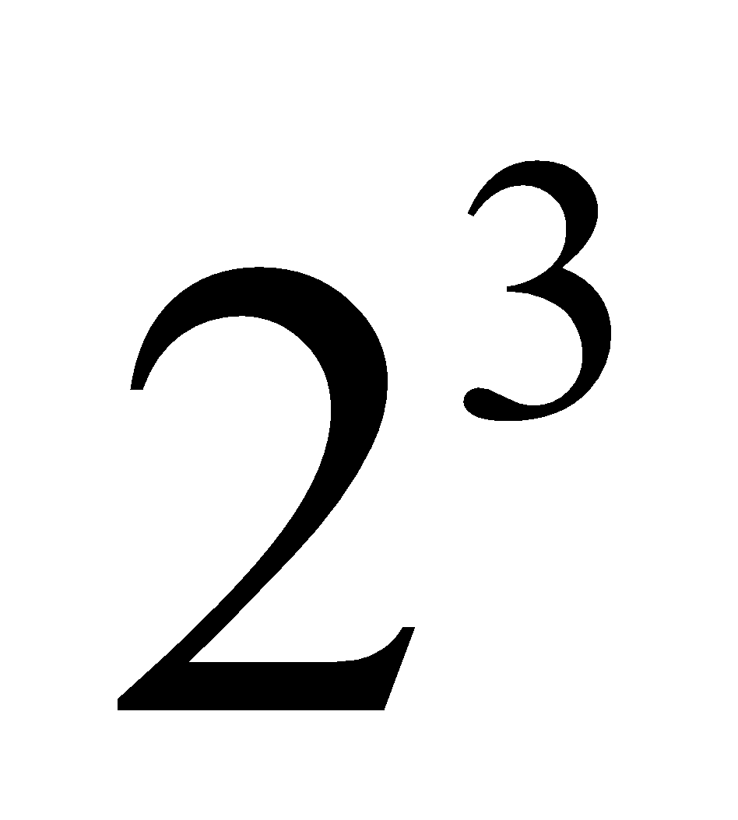 (d) 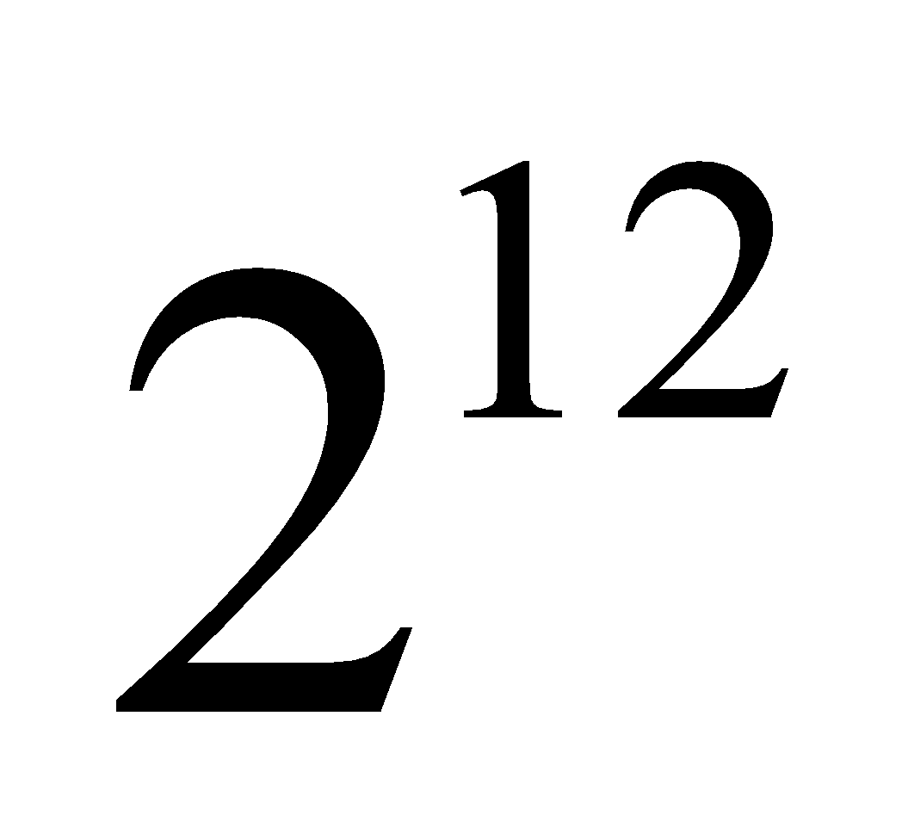. | 1
5 | If 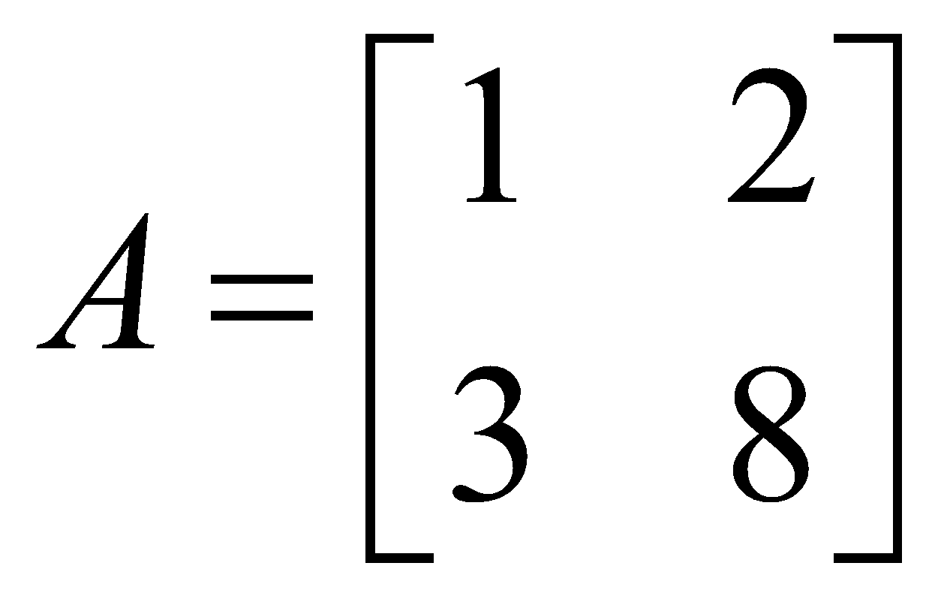, then 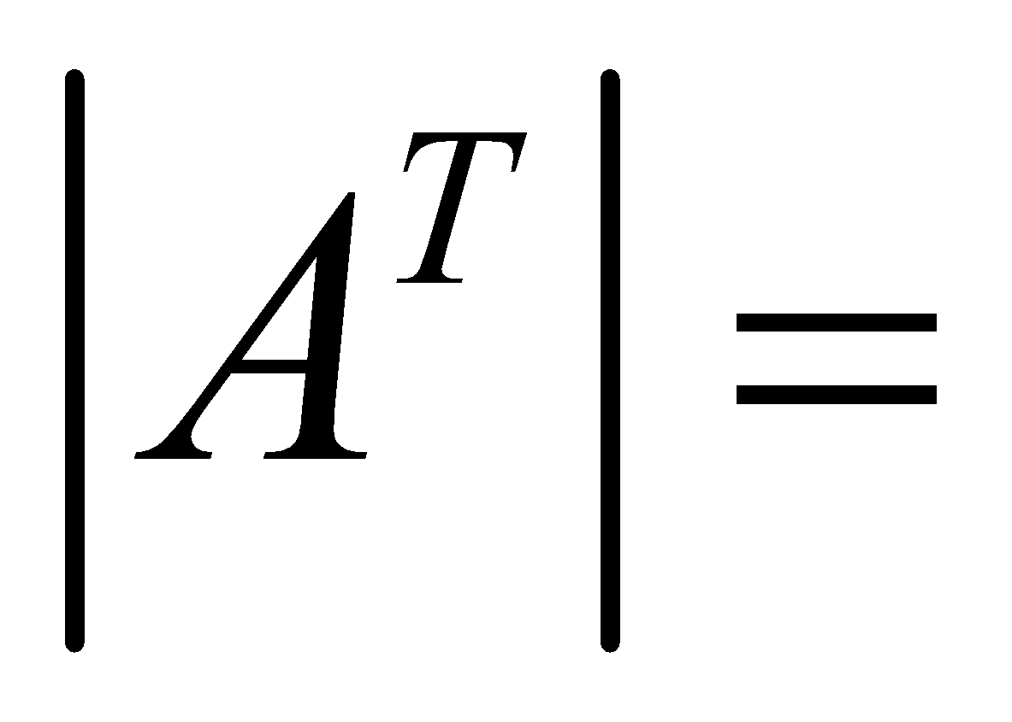?  (a) 2 (b) 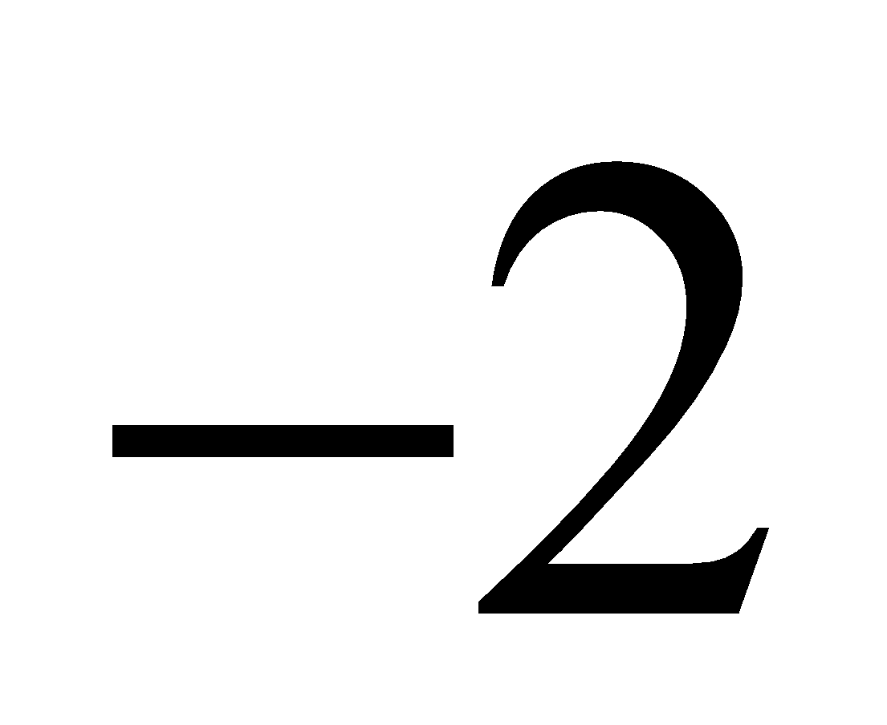 (c)  (d) 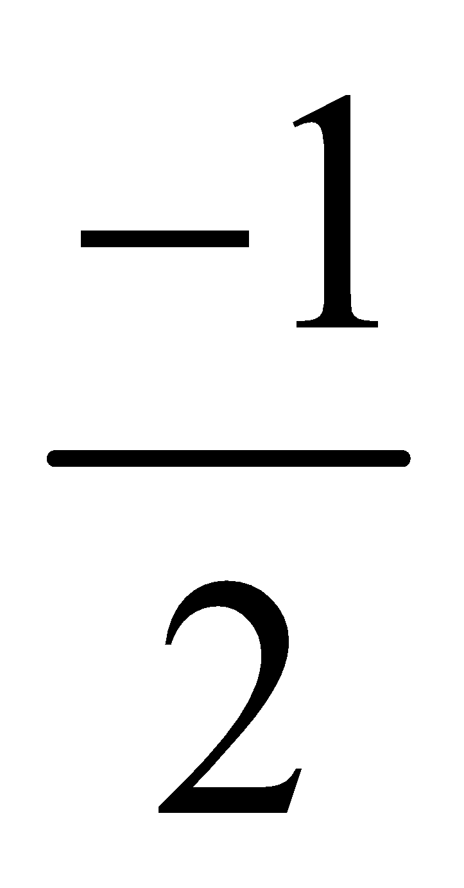 | 1
6 | If A is a skew symmetric matrix of order 3, then the value of 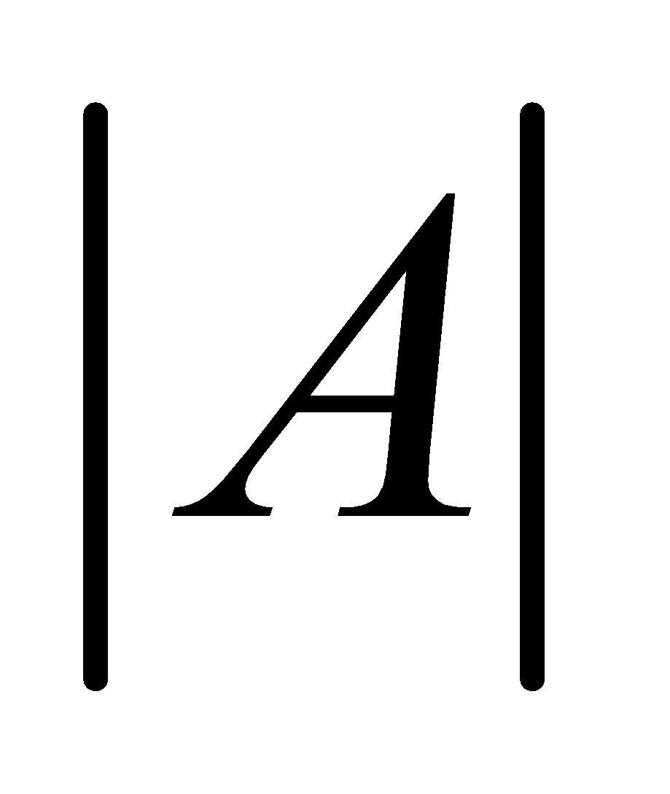 is ?  (a) 1 (b) 3 (c) 2 (d) 0 | 1
7 | The system of equations is ?  (a) consistent  (b) consistent with a unique solution  (c) consistent with infinitely many solutions  (d) has its solution lying along x-axis in 3D space | 1
8 | Let matrix B be the adjoint of a square matrix A, I be the identity matrix of same order as A. If k 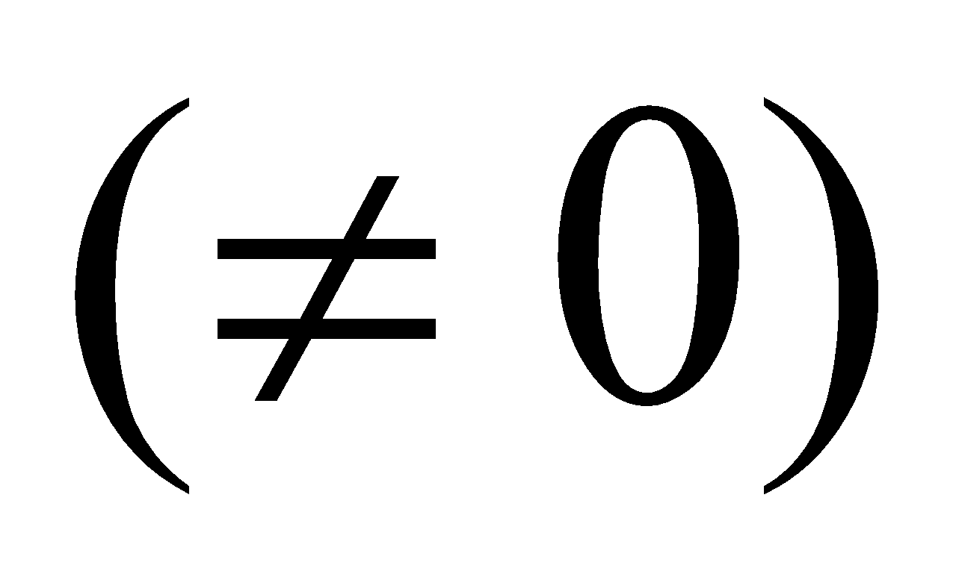is the determinant of the matrix A, then what is AB equal to?  (a) I (b) kI (c) 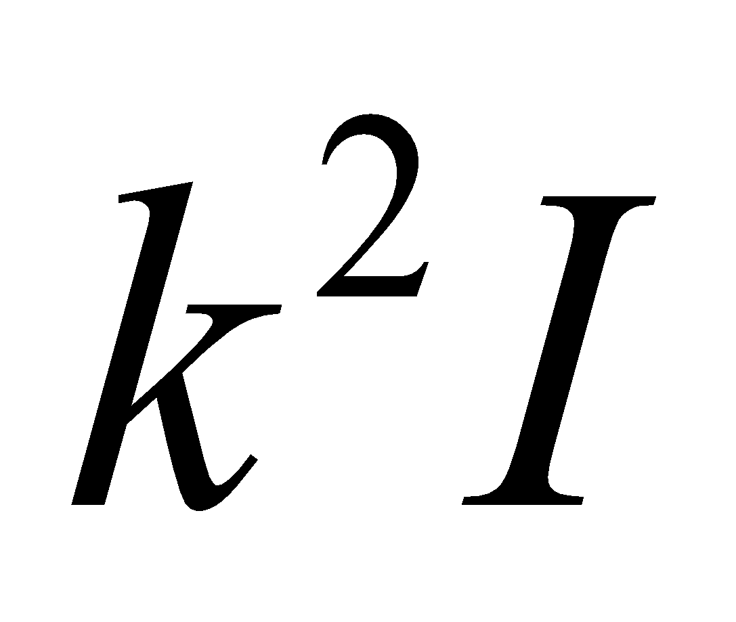 (d) 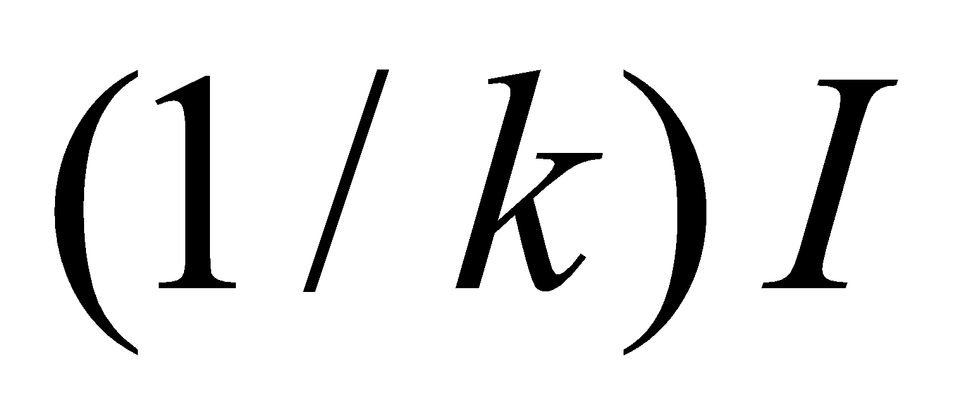 | 1
9 | If 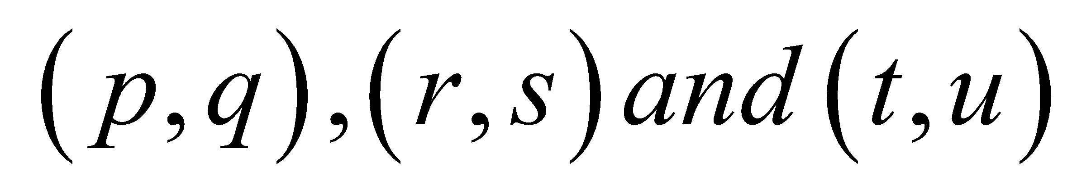 are the vertices of 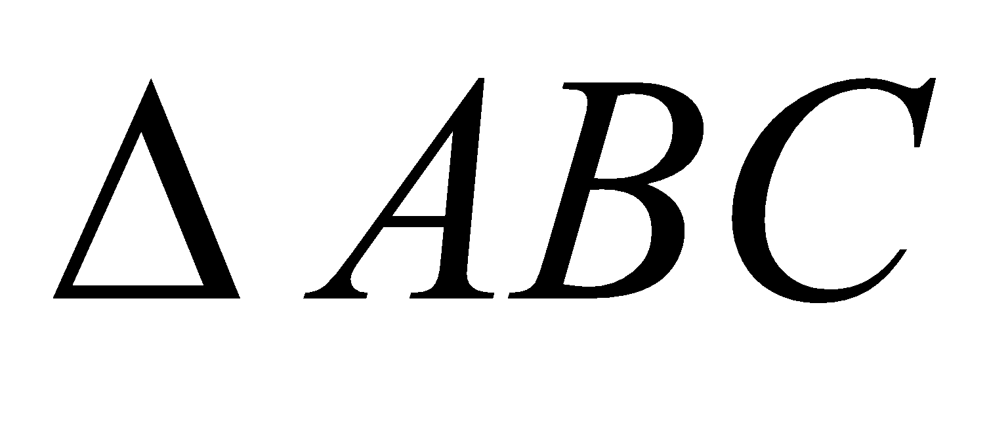 and 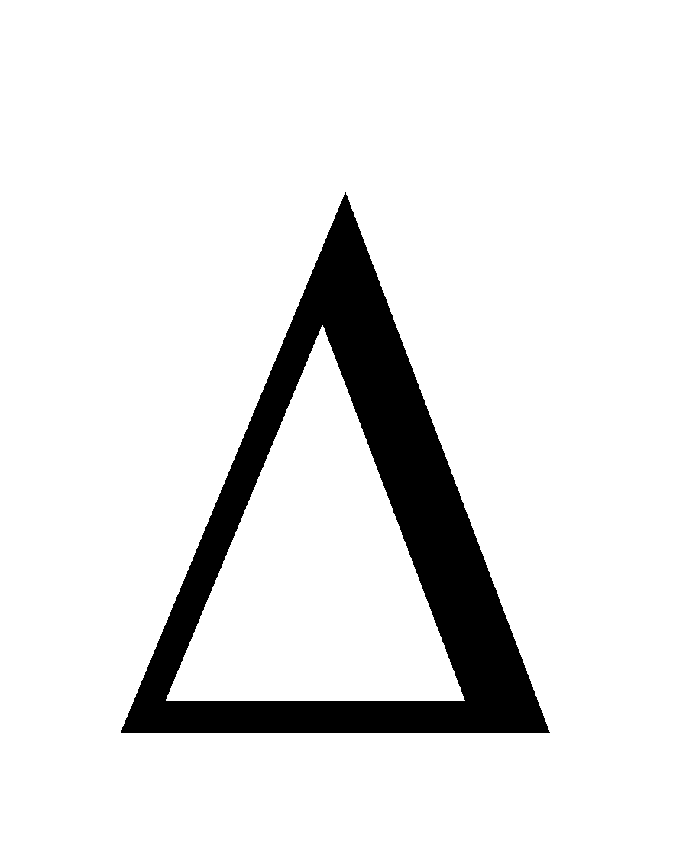denotes the area of then 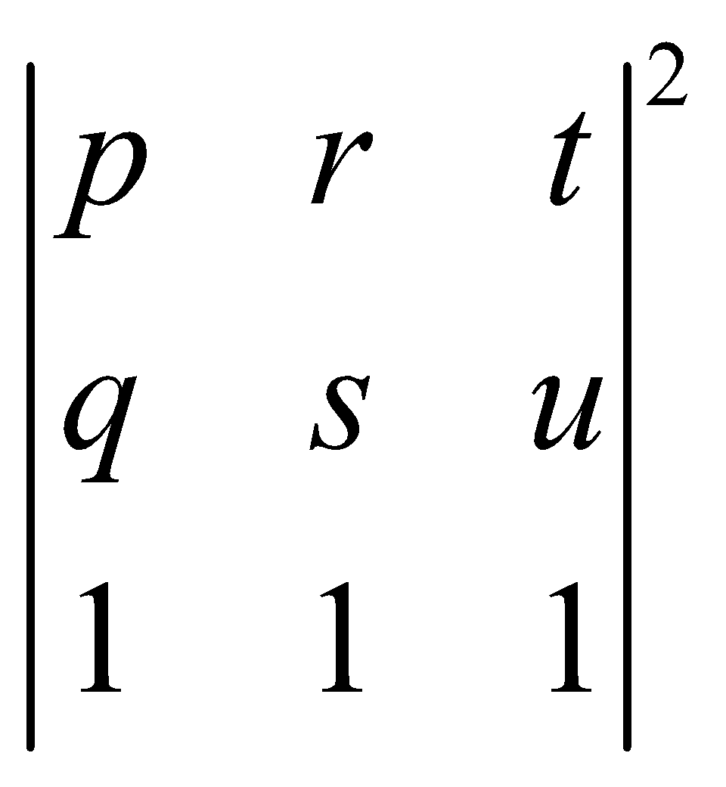 is equal to ?  (a) 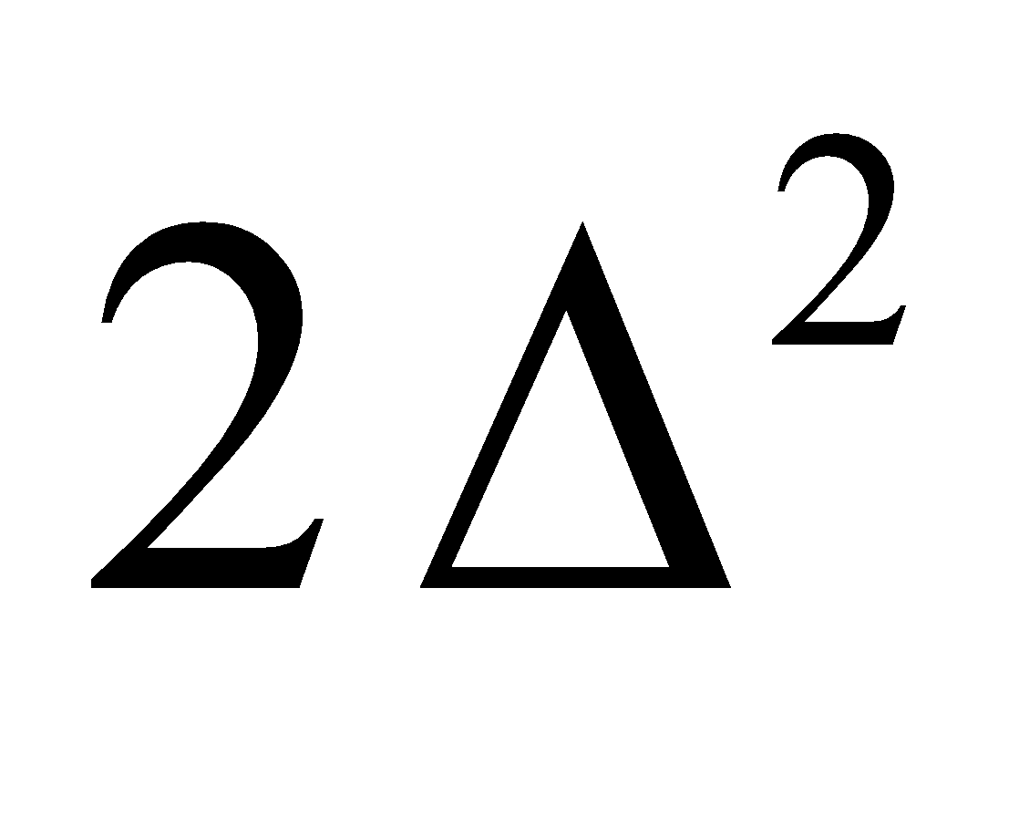 (b) 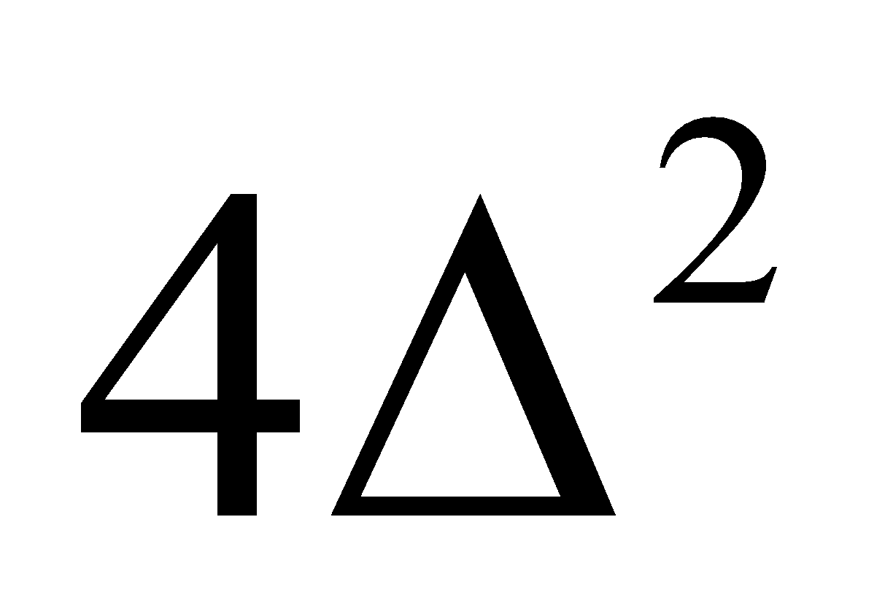 (c) 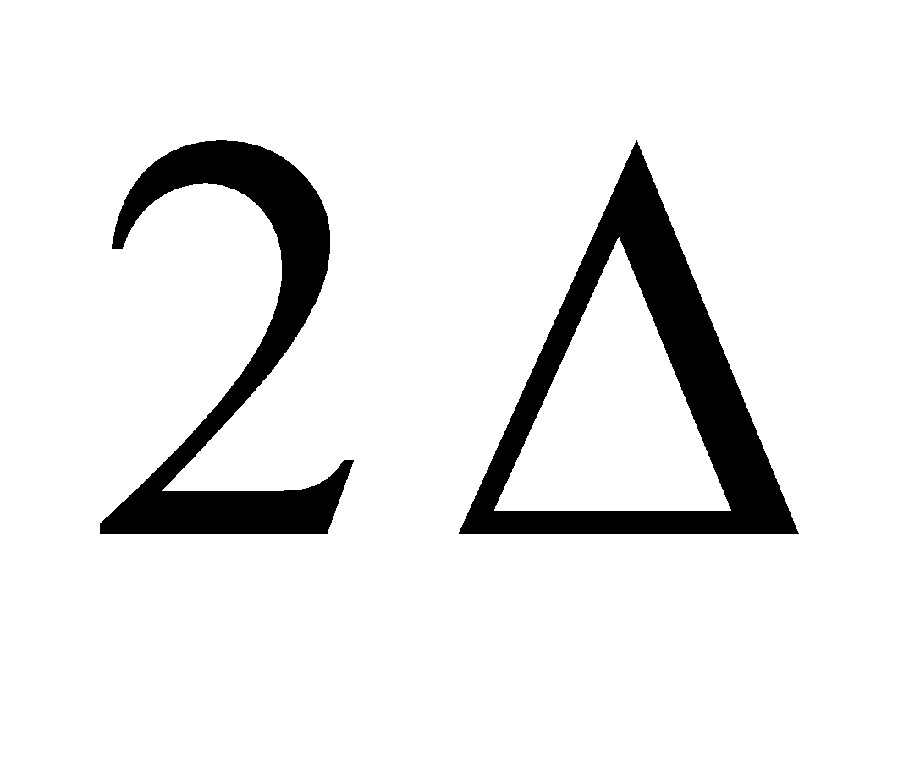 (d) 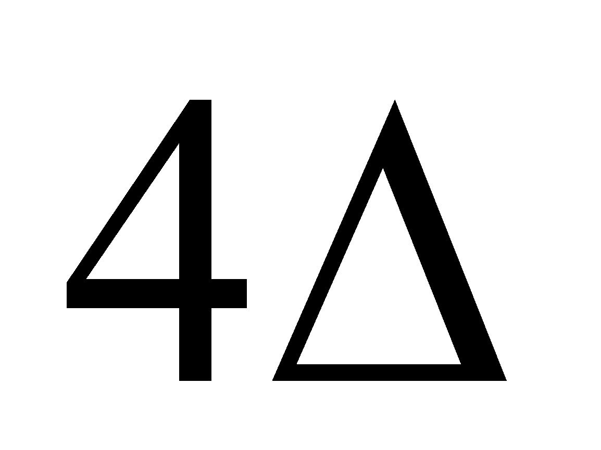 | 1
10 | If A is a square matrix of order 3 and det A =5 then what is the determinant of 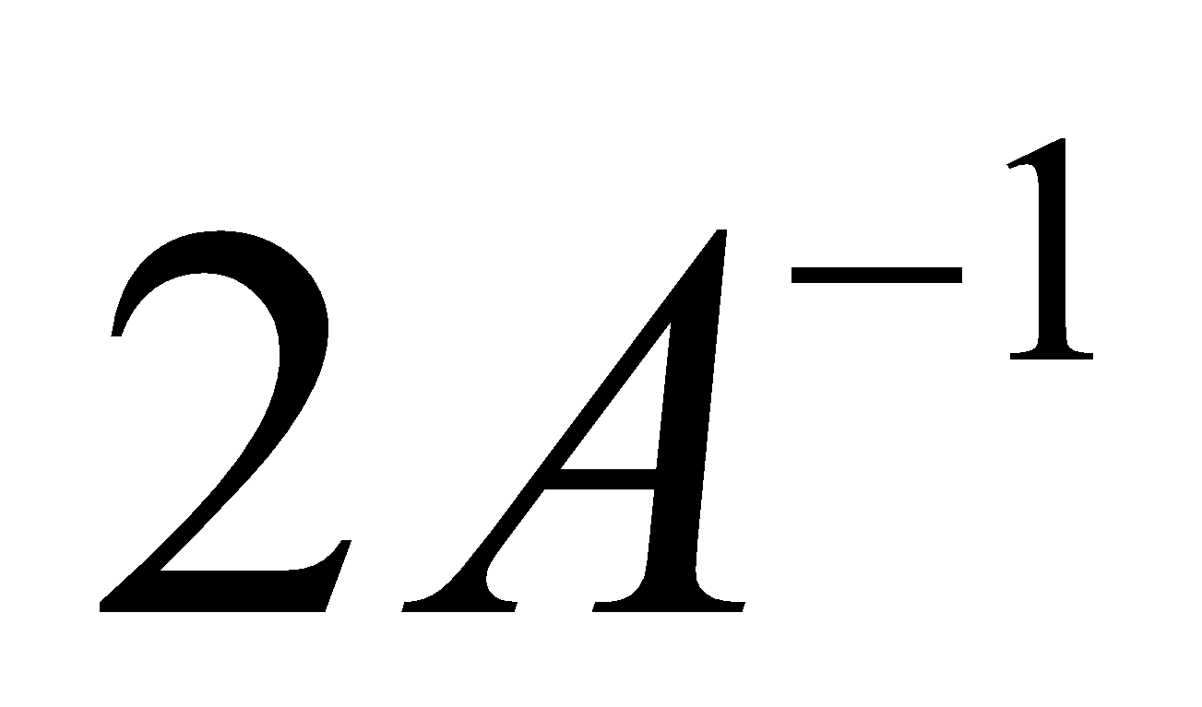 ?  (a) 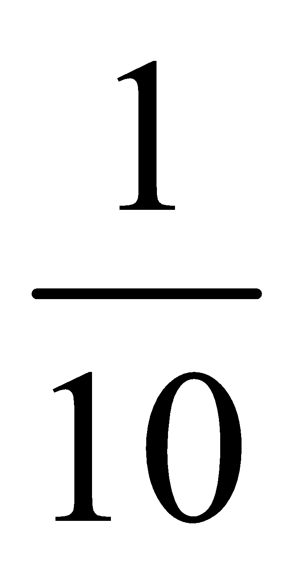 (b)  (c) 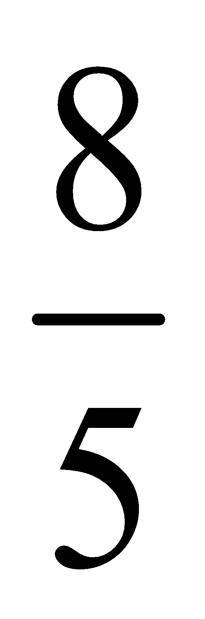 (d) 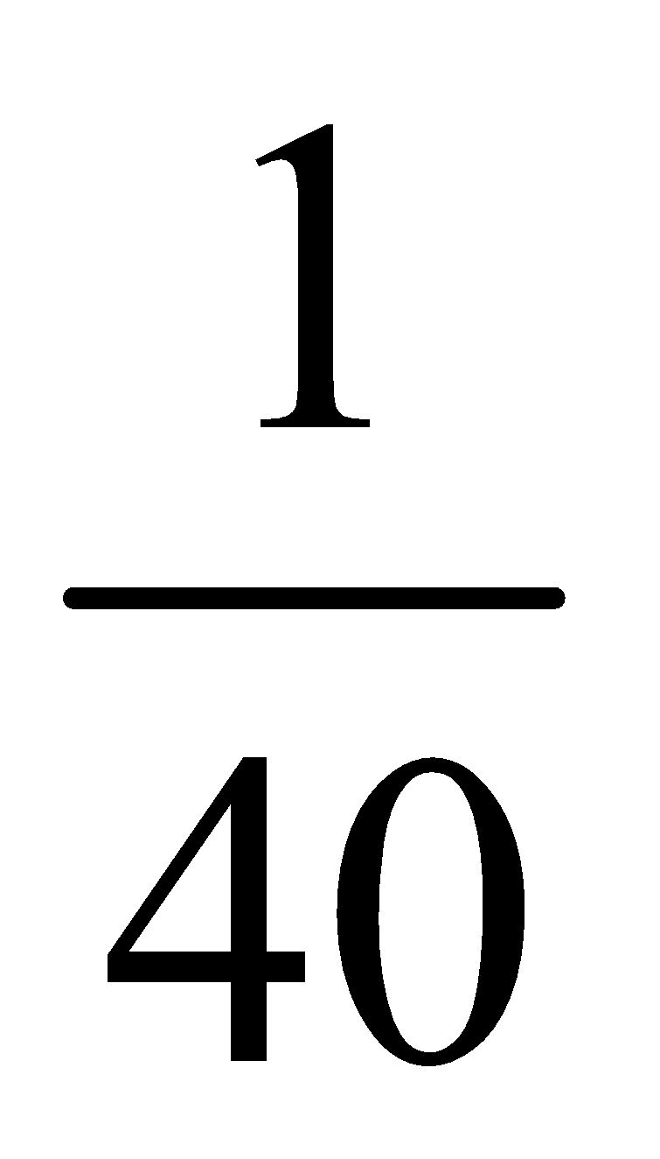 | 1
11 | A is a square matrix of order 3 and $\left|A\right|$ = 6 ,what be the value of $\left|3 adj A\right|$ .  (a) 972 (b) 216 (c) 36 (d) 27 | 1
12 | If $\left|2 4 5 1 \right|$ = $\left|2x 4 6 x \right|$,then the possible value(s) of x is /are  (a) 3 (b) $\sqrt{3}$  (c) - $\sqrt{3}$ (d) $\sqrt{3}$ &-$\sqrt{3}$ | 1
13 | If A and B are two non - singular matrices of same order, then  (a) AB is non-singular  (b) AB is singular  (c) (AB)⁻¹ = A⁻¹ B⁻¹  (d) AB is not invertible | 1
14 | If A is a square matrix of order 3 such that A (adj A) = $\left[-2 0 0 0 -2 0 0 0 -2 \right]$ ,then $\left| adj A\right|$ is equal to  (a) -2 (b) -4 (c) 4 (d) -8 | 1
15 | The matrix $\left[-2 -1 3 k 0 7 -1 1 4 \right]$ is not invertible for  (a) k= -1 (b) k = 1 (c) k = 0 (d) k $∈$ R –{1} | 1
16 | Three points P(2x,x+3) ,Q(0,x) and R(x+3,x+6) are collinear ,then x is  (a) 0 (b) 2 (c) 3 (d) 1 | 1
17 | If x = -4 is a root of $\left[x 2 3 1 x 1 3 2 x \right]$ = 0 then the sum of other two root is  (a) 4 (b) -3 (c) 2 (d) 5 | 1
18 | If A is a non-singular square matrix of order 3 such that $\left|adjA \right|$ = 64 then the value of $\left|A\right|$ is  (a) 8 (b) –8 (c) 8, -8 (d) 4 | 1
19 | If A and B are square matrices of the order 3, such that $\left|A\right|$ = 2 and AB = 2I , Then the value of $\left|B\right|$ .  (a) 2 (b) 1 (c) 4 (d) 8 | 1
20 | If $A=\left(a_{ij}\right)$ is a square matrix of order 3 and $A_{ij}$ is the cofactor of $a_{ij}$ , then $\left|A\right|$is given by  (A) a₁₁ A₃₁ + a₁₂A₃₂ + a₁₃A₃₃  (B) a₁₁ A₁₁ + a₁₂A₂₁ + a₁₃A₃₁  (C) a₂₁ A₁₁ + a₂₂A₁₂ + a₂₃A₁₃  (D) a₁₁ A₁₁ + a₂₁A₂₁ + a₃₁A₃₁ | 1
21 | If the points (2, -3), (k, -1) and (0, 4) are collinear, then find the value of 4k.  (a) 4 (b) 7/140 (c) 47 (d) 40/7 | 1
22 | If A is a singular matrix, then A(adjA) is  (a) null matrix (b) scalar matrix (c). identity matrix (d) none of these | 1
23 | If A and B are invertible matrices, then which of the following is not correct?  (a) adj A = |A|.A⁻¹ (b) det (A) ⁻¹ = [det (A)]⁻¹  (c) (AB)⁻¹ = B⁻¹A⁻¹ (d) (A + B)⁻¹ = B⁻¹ + A⁻¹ | 1
24 | If A is a skew- symmetric matrix of order 3 and $\left|A\right|=x, then {\left(2023\right)}^{x}$ is equal to  (a) 2023 (b) $\frac{1}{2023}$ (c) ${\left(2023\right)}^{x}$ (d) 1 | 1
25 | Which of the following is not true  (A). If A= [a_{ij}] is a diagonal matrix of order n≥2,then |A| = a₁₁. a₂₂ ... . a_{nn}  (B).If A and B are square matrix of same order, then |AB| = |A||B|  (C).If A is a square matrix of order n then |kA| = k^{n} |A|  (D). If A and B are square matrix of same order, then |A + B| = |A| + |B| | 1
 | ANSWERS
1 | (a) | 1
2 | (b) | 1
3 | (d) | 1
4 | (b) | 1
5 | (a) | 1
6 | (d) | 1
7 | (b) | 1
8 | (b) | 1
9 | (b) | 1
10 | (c) | 1
11 | (a) | 1
12 | (a) | 1
13 | (a) | 1
14 | (c) | 1
15 | (b) | 1
16 | (d) | 1
17 | (a) | 1
18 | (c) | 1
19 | ( c) | 1
20 | d | 1
21 | d | 1
22 | a | 1
23 | d | 1
24 | d | 1
25 | D | 1
 | ASSERTION & REASON QUESTIONS
Choose the correct option in the following questions of Assertion – Reason Questions.
(a) Both A and R are correct; R is the correct explanation of A.
(b) Both A and R are correct; R is not the correct explanation of A.
(c) A is true but R is false
(d) A is false but R is true
1 | Assertion: The determinant of a skew symmetric matrix of even order is perfect square.  Reason: The determinant of skew symmetric matrix of odd order is equal to zero | 1
2 | Assertion: matrix A=|$4 0 4 0 3 2 4 2 1$| and matrix B⁻¹=|$1 3 3 1 4 3 1 3 4$|, Then (AB)⁻¹ does not exist.  Reason: Since |A|=0, (AB)⁻¹=B⁻¹A⁻¹ is meaningless. | 1
3 | Assertion: if every element of a third order determinant of value D is multiplied by 5, then the value of new determinant is 125D.  Reason: if k is a scalar and A is an n×n matrix, then |kA|=k^{n}|A| | 1
4 | Assertion: If  is the cube root of unity, then 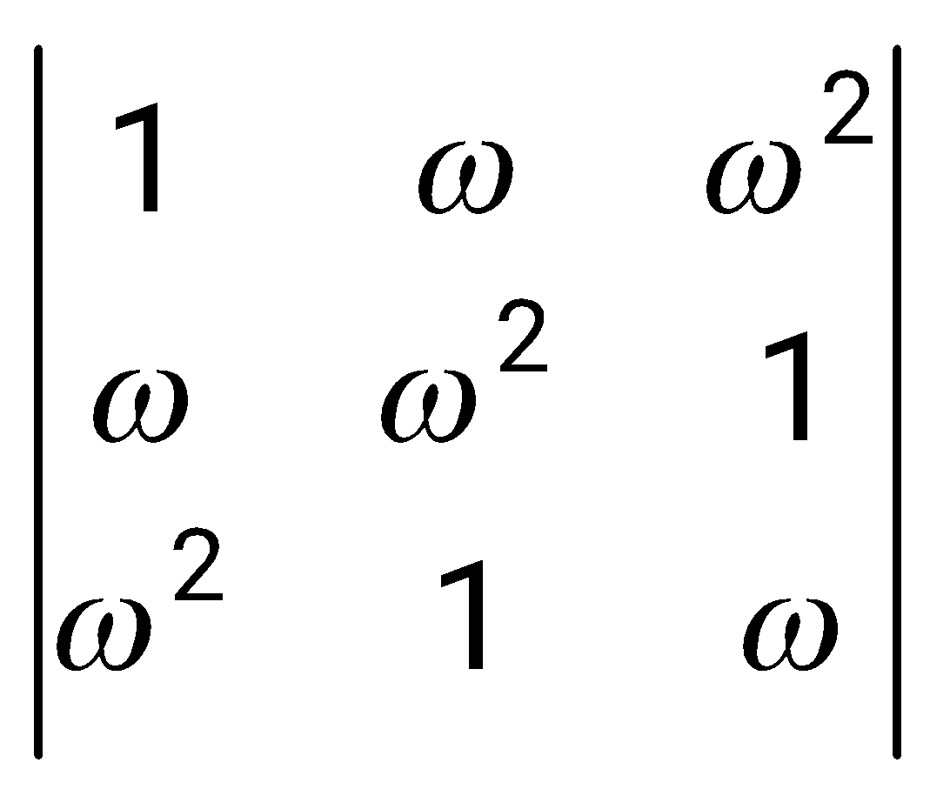= 5  Reason: 1+ + $ω^{2}$ =0 if is the cube root of unity. | 1
5 | Assertion: If 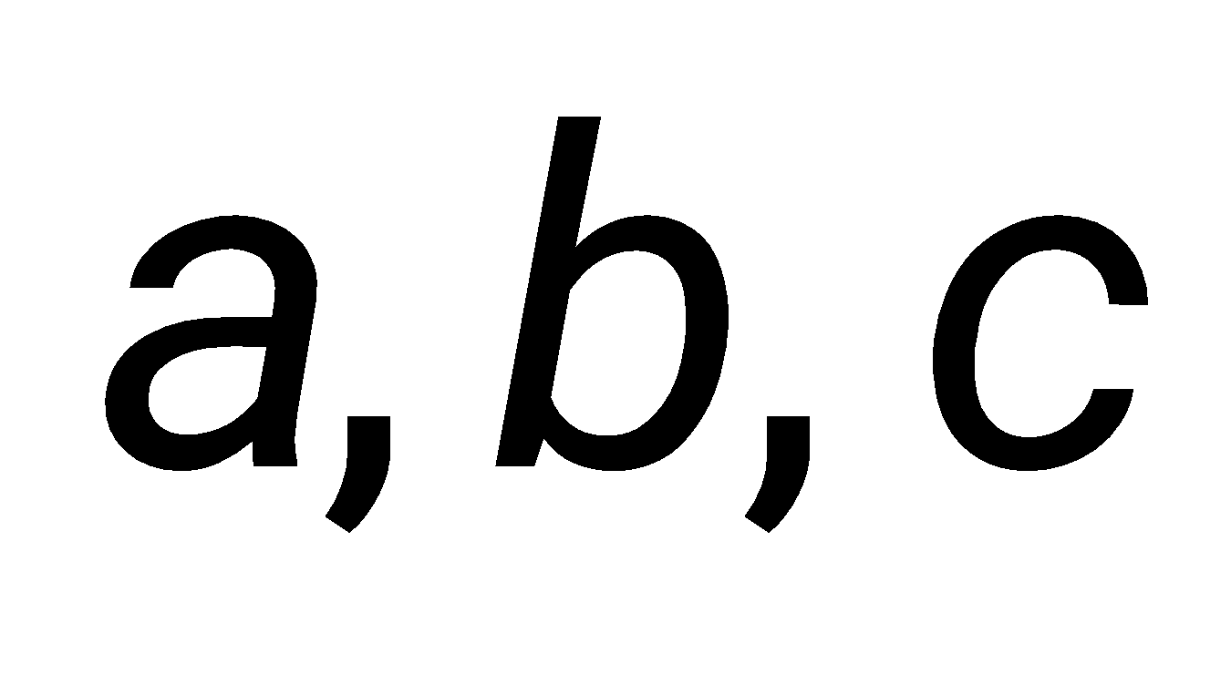 are in A.P., then the value of 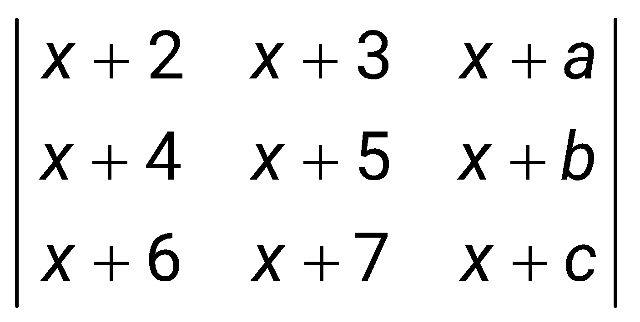 is zero.  Reason: a, b, c are in G.P. then $b^{2}$=ac | 1
6 | Assertion: The value of the determinant 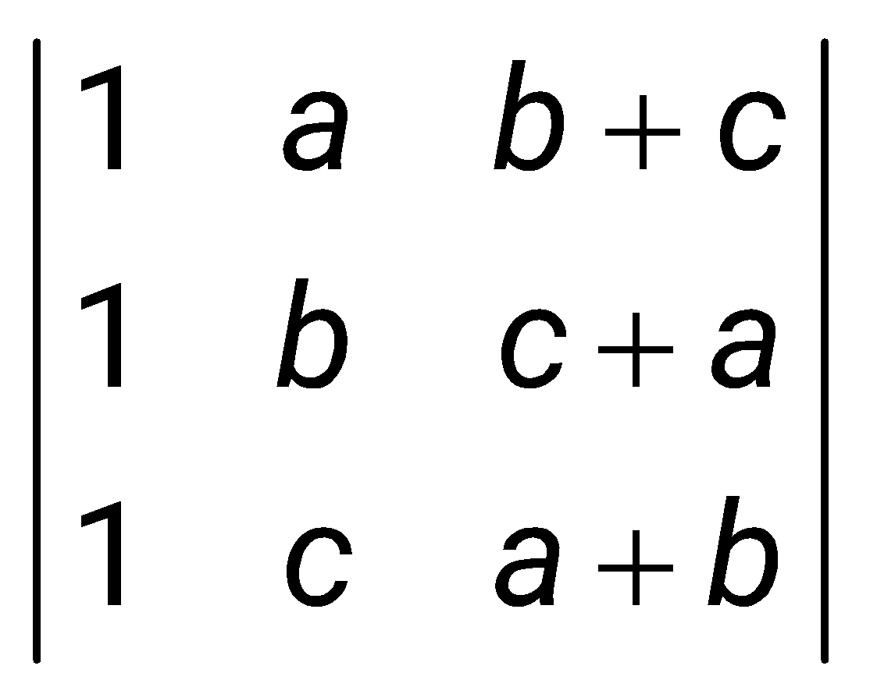is zero  Reason: If two rows (or columns) of a determinant are identical the value of the determinant is zero. | 1
7 | Assertion: If A = $\left[2 3 5 -2 \right]$ and A⁻¹ =KA, then K = $\frac{1}{19}$.  Reason: |A⁻¹| = $\frac{1}{|A|}$ | 1
8 | Assertion (A): Minor of an element of a determinant of order n (n $≥2)$  is a determinant of order n.  Reason (R): If A is an invertible matrix of order 2, then det(A⁻¹) is equal to $\frac{1}{\left|A\right|}$. | 1
9 | Assertion (A): Determinant of a skew- symmetric matrix of order 3 is zero.  Reason (R): For any matrix A, $\left|A´\right|$ = $\left|A\right|$ and $\left|-A\right|$ = -$\left|A\right|$. | 1
10 | Assertion (A) The system of equations 2x – y = -2; 3x + 4y = 3 has unique solution and x = -$\frac{5}{11}$ and y = $\frac{12}{11}$.  Reason (R) The system of equations AX = B has a unique solution, if $\left|A\right|$ = 0. | 1
 | ANSWERS
1 | b | 1
2 | d | 1
3 | a | 1
4 | c | 1
5 | b | 1
6 | a | 1
7 | a | 1
8 | d | 1
9 | c | 1
10 | c | 1
 | 2 MARKS TYPE QUESTIONS
1 | If W is an imaginary cube root of unity, find the value of  $$\left|W^{2} W 1 1 W^{2} W W 1 W^{2} \right|$$ | 2
2 | Suppose A is any 3$×3$ non-singular matrix and $\left(A-3I\right)\left(A-5I\right)=O$, where $I=I_{3 }and O= O_{3}$. If $αA+βA^{-1}$=4I, then what will be value of $α+β$. | 2
3 | If $If A= \left[-4 -1 3 1 \right]$, then what will be the determinant of the matrix $(A^{2016}-2A^{2015}-A^{2014})$. | 2
4 | Given that $A=[a_{ij}]$ is a square matrix of order 3 and $\left|A\right|=-7$, then find the value of $\sum_{i=1}^{3}{}a_{i2}A_{i2}$. | 2
5 | Let A be a square matrix of order 3 such that A (adj A) = 2I, where I is the identity matrix. Write the value of $\left|adjA\right|$. | 2
6 | Let $θ=\frac{π}{5}$ and $A=\left[coscos θ sinsin θ sinsin θ coscos θ \right].$If $B=A+A^{4},$then find the value of Det(B). | 2
7 | Find the value of y if $\left|2 4 5 1 \right|$ =$\left|2y 4 6 y \right|$ | 2
8 | Find the equation of the line joining (1, 2) and (3,6) using determinants. | 2
9 | Verify A(adj. A) =(adj. A)A = (det A). I for  A= $\left[2 3 -4 -6 \right]$ | 2
10 | What is the inverse of the matrix$\left[2 5 1 3 \right]$? | 2
 | ANSWERS | 2
1 | $$\left|w^{2} w 1 1 w^{2} w w 1 w^{2} \right|$$  R₁$⟶$ R₁ + R₂ + R₃  $$\left|w^{2}+w+1 w 1 1+w^{2}+w w^{2} w w+1+w^{2} 1 w^{2} \right|$$  So we know that $w^{2}+w+1$=0  $\left|0 w 1 0 w^{2} w 0 1 w^{2} \right|$ =0 | 2
2 | Given, ($A-3I)$ ($A-5I)=O$  Or, $A^{2}-8A+15I=O$  Post multiplying by $A^{-1}$ on both sides , we have,  $\frac{1}{2}A+\frac{15}{2}A^{-1}=4I …….(i)$  Comparing (i) with $αA+βA^{-1}=4I$,  $α=\frac{1}{2} and β=\frac{15}{2}$  $α+β=8.$ | 2
3 | We have,  $A^{2}=\left[13 3 -9 -2 \right]$  $\left|A\right|=-1$  $\left|A^{2016}-2A^{2015}-A^{2014}\right|$ = $\left|A^{2014}\right|\left|A^{2}-2A-I\right|$  = $-25$. | 2
4 | $\left|A\right|=-7$  $\sum_{i=1}^{3}{}a_{i2}A_{i2}=Determinant of the matrix A expanded along C_{2}$  $=\left|A\right|$  $=-7$ | 2
5 | Since,  $A.\left(adj A\right)=\left|A\right|I$  So, $A.(adj A) = 2I$  Or, $\left|A\right|=2$  Now, $\left|adj A\right|={\left|A\right|}^{n-1}$  Or, $\left|adj A\right|=2^{3-1}$  = 4 | 2
6 | $A^{2}=\left[coscos 2θ sinsin 2θ -sinsin 2θ coscos 2θ \right]$  $A^{4}=\left[coscos 4θ sinsin 4θ -sinsin 4θ coscos 4θ \right]$  $B=A+A^{4}$  $\left|B\right|=2+2coscos 3θ$  $=\frac{5-\sqrt{5}}{2}∈(1, 2)$ | 2
7 | .$+√3$, -$√3$ | 2
8 | 2x-y=0 | 2
9 | Verification | 2
10 | $\left[3 -5 -1 2 \right]$ | 2
 | 3 – MARKS TYPE QUESTIONS
1 | A Boy Monty brought 2 Bags, 1 Pen and 3 pencils and Paid 25 rupees, in same shop Nihar bought 3 bags, 2 pens & 1 Pencil and Paid 40 rupees and Pabitra brought 1 Bag, 3 pens & 2 Pencil and paid 30 rupees. Multiply by matrix method | 3
2 | Using the property of determinants and without expanding, prove that:  $$\left|x a x+a y b y+b z c z+c \right|=0$$ | 3
3 | If 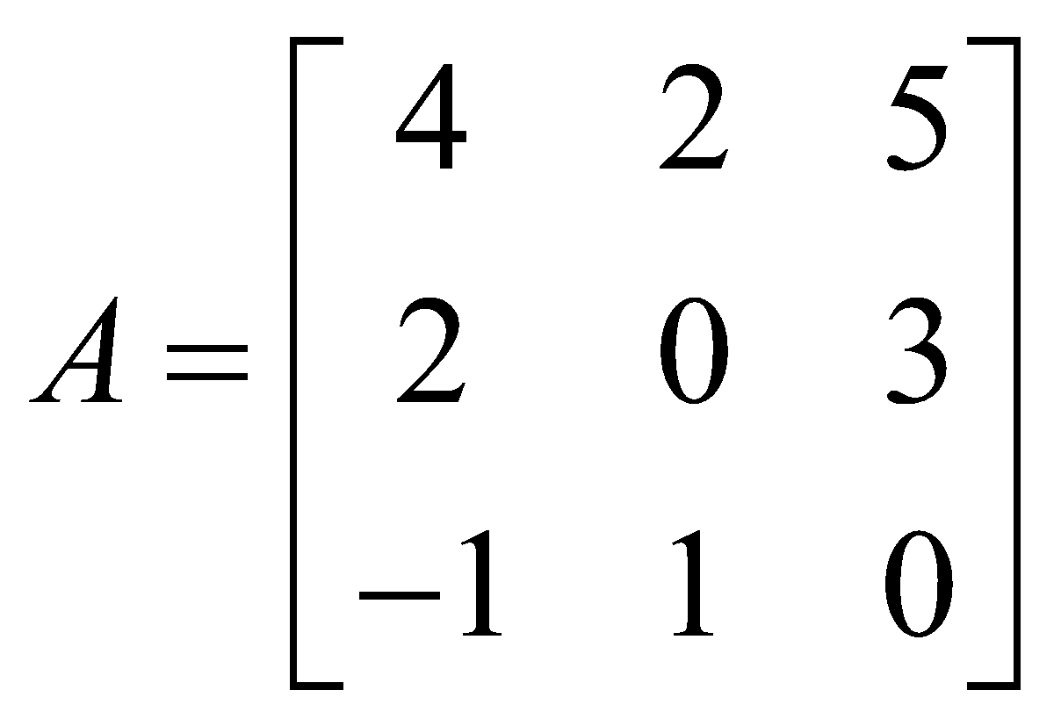, then find the determinant of 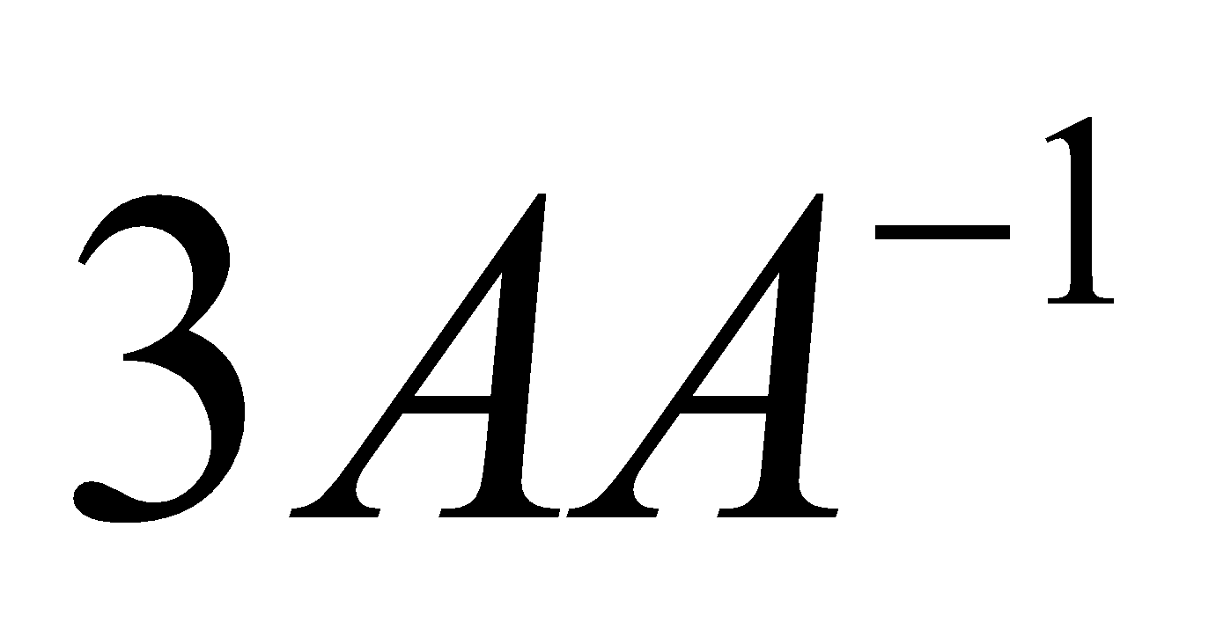. | 3
4 | Find the matrix X such that 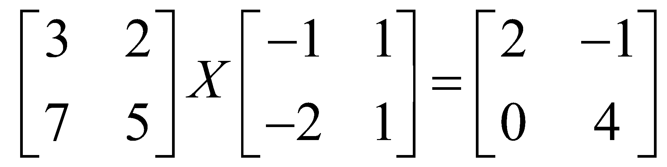 | 3
5 | Find the inverse of the matrix $\left[1 0 0 0 coscos ∝ sin∝ 0 sin∝ -cos∝ \right]$. | 3
6 | Find the adjoint of the matrix A = $\left[-1 -2 -2 2 1 -2 2 -2 1 \right]$ and hence show that A( adj A) = $\left|A\right|$ I₃ . | 3
7 | Let $A= \left[2 3 1 ,2 \right],B=\left[4 -6 -2 4 \right]$. Then compute AB. Hence solve the equation 2x + y = 4, 3x +2y = 1 | 3
8 | The monthly incomes of two brothers Sirish and Srijan are in the ratio 3:4 and the monthly expenditures are in the ratio 5:7. Each brother saves Rs. 15000 per month..    Using matrix find their monthly income | 3
9 | On his birthday Rahul decided to donate some money to the children of an orphanage home. If there were 8 children less, everyone would have got Rs. 10 more. However if there were16 children more, everyone would have got Rs. 10 less.    Using matrix method the number of children and amount distributed by Rahul. | 3
10 | Show that the points (a + 5, a – 4), (a – 2, a + 3) and (a, a) do not lie on a straight line for any value of a. | 3
 | ANSWERS
1 | Let the cost of 1 bag =x  And the cost of 1 pen =y  ⇒3x+4y=257  ⇒4x+3y=324  Equation (1) × 4: 12x+16y=257×4  Equation (2) × 3: 12x+9y=324×3  Subtract two equations;  ⇒7y=56  ⇒y=8  ⇒x=75  ⇒total cost of 1 bag and 10 pens=x+10y=75+80=155 | 3
2 | $$\left|x a x+a y b y+b z c z+c \right|$$  Applying the Sum Property of determinants, we have  $\left|x a x+a y b y+b z c z+c \right|$ =  $$\left|x a x y b y z c z \right|+\left|x a a y b b z c c \right|$$  We know, if two rows or columns of a determinant are identical, then the value of the determinant is zero.  Since, the two columns in both the determinants are identical, thus its determinant would be zero.  ⇒$\left|x a x+a y b y+b z c z+c \right|$ =0+0  ⇒$\left|x a x+a y b y+b z c z+c \right|$ =0 | 3
3 | As 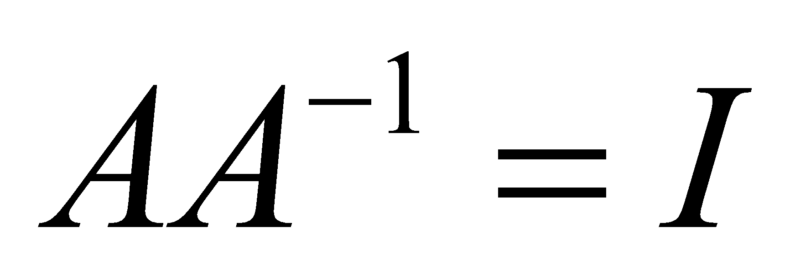 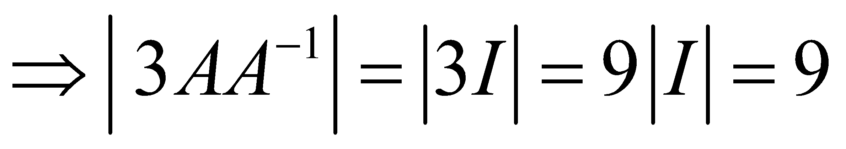 | 3
4 | 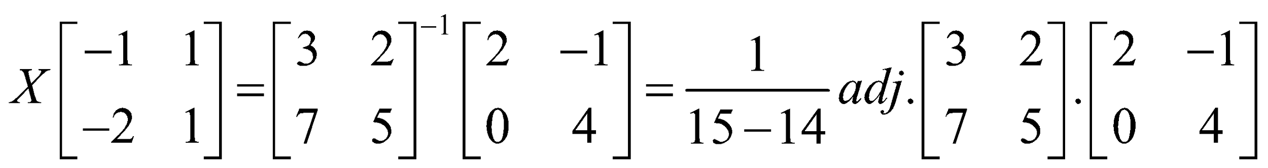  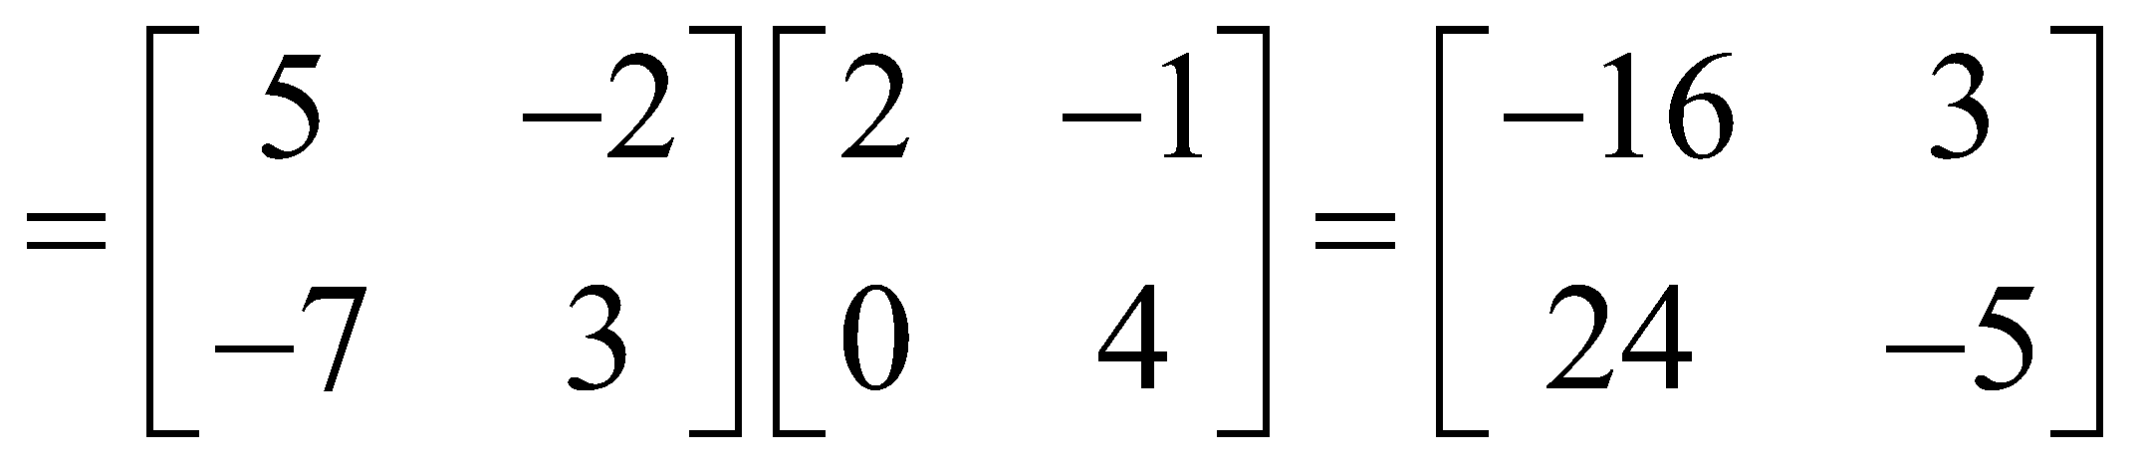 | 3
5 | $Let \left|A\right|$ = $\left[1 0 0 0 coscos ∝ sin∝ 0 sin∝ -cos∝ \right]$  = 1(-cos²$∝$ - sin²$∝)$ = -(cos²$∝$ + sin²$∝)$ = -1  $⇨$ A⁻¹ exist.  A⁻¹ = $\left[1 0 0 0 coscos ∝ sin∝ 0 sin∝ -cos∝ \right]$ | 3
6 | Adj A= $\left[-3 6 6 -6 3 -6 -6 -6 3 \right]$  Determinant A = 27  For correct proof | 3
7 | $AB=\left[2 0 0 2 \right]=2I,$ $⇒A\left(\frac{1}{2}B\right)=I$ $⇒A^{-1}=\frac{1}{2}B=\frac{1}{2}\left[4 -6 -2 4 \right]=\left[2 -3 -1 2 \right]$  Given system of equations is PX=Q, where $P=\left[2 1 3 2 \right]=A^{T };X= \left[x y \right]$ ; $Q= \left[4 1 \right]$  $$∴X=P^{-1}Q={(A^{T })}^{-1}Q={(A^{-1})}^{T}Q=\left[7 -10 \right]$$  $$∴x=7,y=-10$$ | 3
8 | Let monthly income of Sirish and Srijan be 3x and 4x and their expenditure are 5y and 7y respectively  $∴$ 3x - 5y = 15000, 4x - 7y = 15000  AX=B, where A = $\left[3 -5 4 -7 \right]$, 𝑋 $= \left[x y \right]$ , 𝐵 = $\left[15000 15000 \right]$  $A^{-1}=\left[7 -5 4 -3 \right]$, $∴ X=A^{-1}B=\left[7 -5 4 -3 \right]\left[15000 15000 \right]=\left[30000 15000 \right]$  , $∴$ income of Sirish = Rs. 90000, income of Srijan = Rs.120000 | 3
9 | Let number of children be x and amount for each student be Rs. Y  So, $\left(x-8\right)\left(y+10\right)=xy ⇒5x-4y=40$  $\left(x+16\right)\left(y-10\right)=xy⇒5x-8y=-80$  AX=B, where A = $\left[5 -4 5 -8 \right]$, 𝑋 $= \left[x y \right]$ , 𝐵 = $\left[40 -80 \right]$  $A^{-1}=\frac{-1}{20}\left[-8 4 -5 5 \right]$, $∴ X=A^{-1}B=\left[32 30 \right]$  No. of students = 32, Amount given to each students = Rs 30 | 3
10 | Area of the triangle with the points (a + 5, a – 4), (a – 2, a + 3) and (a, a) as vertices is  ½ $\left|a + 5 a - 4 1 a - 2 a + 3 1 a a 1 \right|$  $=$ ½ [3a+15+2a-8-5a]=7/2 , non-zero value independent of a  So points (a + 5, a – 4), (a – 2, a + 3) and (a, a) are not collinear. | 3
 | 4 – MARKS TYPE QUESTIONS (CASE BASED QUESTIONS)
1 | Two schools X and Y want to award their selected students on the values of Hard work, Honesty and Punctuality. The school X wants to award Rupees P each, Rupees q each and Rupees r each for the three respective values to its 3,2 and 1 students respectively with a total award money of Rupees 3000/- School wants to spend rupees 3500/- to award in 2,4 & 3 students on the respective values. The total amount of awards for one prize on each value is Rupees 1500/-. Using the concept of Determinants & matrices, Answer the following questions  I) what is the award money for punctuality?  a. 500 b. 300 c. 900 d. 1000  II) What is the award money for hard work?  a. 200 b. 900 c.800 d. 500 | 4
2 | Three friends Rahul, Ravi and Rakesh went to a vegetable market to purchase vegetables. Rahul Purchased 1kg of each Potato, Onion and Brinjal for a total of Rs. 21. Ravi purchased 4kg Potato,3kgOnion and 2kgBrinjal for a total of Rs. 60. Rakesh purchased 6kg Potato,2kg Onion and 3kg Brinjal for a total of Rs. 70.  - If cost of potato, onion and brinjal are Rs. X, Y and Z respectively then convert above situation into system of linear equation.  - Convert the system of equations in (i) in the form of AX=B.  - Find the cost of potato, onion and brinjal. | 4
3 | Three shopkeepers Ram Lal, Shyam Lal, and Ghansham are using polythene bags, handmade bags (prepared by prisoners), and newspaper envelopes as carrying bags. It is found that the shopkeepers Ram Lal, Shyam Lal, and Ghansham are using (20,30,40), (30,40,20), and (40,20,30) polythene bags, handmade bags, and newspaper envelopes respectively. The shopkeeper’s Ram Lal, Shyam Lal, and Ghansham spent ₹250, ₹270, and ₹200 on these carry bags respectively.  - What is the cost of one polythene bag?  - What is the cost of one handmade bag?  - What is the cost of one newspaper bag?  Keeping in mind the environmental conditions, which shopkeeper is better? | 4
4 | A factory produces three products every day. Their production on a particular day is 45 tones. It is found that production of third product exceeds the production of first product by 8 tons while production of first and third products is twice the production of second product.  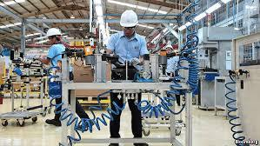  - If x, y and z respectively denotes the quantity (in tons) of first, second and third products produced, then construct the system of equation and write it in matrix form.  - If ${\left[1 1 1 1 0 -2 1 -1 1 \right]}^{-1}=\frac{1}{6}\left[2 2 2 3 0 -3 1 -2 1 \right]$, then find the inverse of $\left[1 1 1 1 0 -1 1 -2 1 \right]$  - Find x : y : z | 4
5 | A trust invested some money in two type of bonds. The first bond pays 10% interest and second bond pays 12% interest. The trust received Rs 2400 as interest. However, if trust had interchanged money in bonds they would have got Rs 100 less.  Let the amount invested in first type and second type of bond be Rs x and Rs y.  Based on the above information, answer the following questions;  - Write the equations in terms of x and y representing the given information.  - Write the matrix equation representing the given information.  Find the amount invested by trust in first and second bond respectively. | 4
6 | Manjit wants to donate a rectangular plot of land for a school in his village. When he was asked to give dimensions of the plot, he told that if its length is decreased by 50 m and breadth is increased by 50 m, then its area will remain same, but if length is decreased by10 m and breadth is decreasedby 20m, then its area will decreasey5300 m²  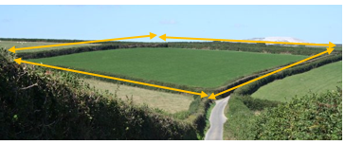  Based on the information given above, answer the following questions :  i) The value of x(length of rectangular field )is  (a) 150 m b) 400 m c) 200 m d) 320 m  ii) The value of y (breadth of rectangular field) is  (a) 150 m b)200 m c) 430 m d) 350 m  iii) How much is the area of rectangular field?  a) 60000 sq m b)30000 sq m c) 3000 sq m d) 30000 m  iv) The equations in terms of x and y are  a. x+y =50, 3x-y = 550  b.x-y=50, 2x+y=550  c. x+y= 50, 2x+ y=550  d.x+y= 50, 2x+y=550 | 4
7 | A missile launched to hit its target follows a parabolic path. Its velocity at any instant ‘t’ is given by 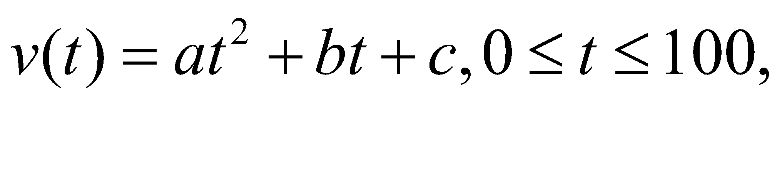where a,b and c are constants. It has been found that the velocity at time t=3, t=6 and t=9 seconds are respectively 64,133 and 208 miles per second.  If 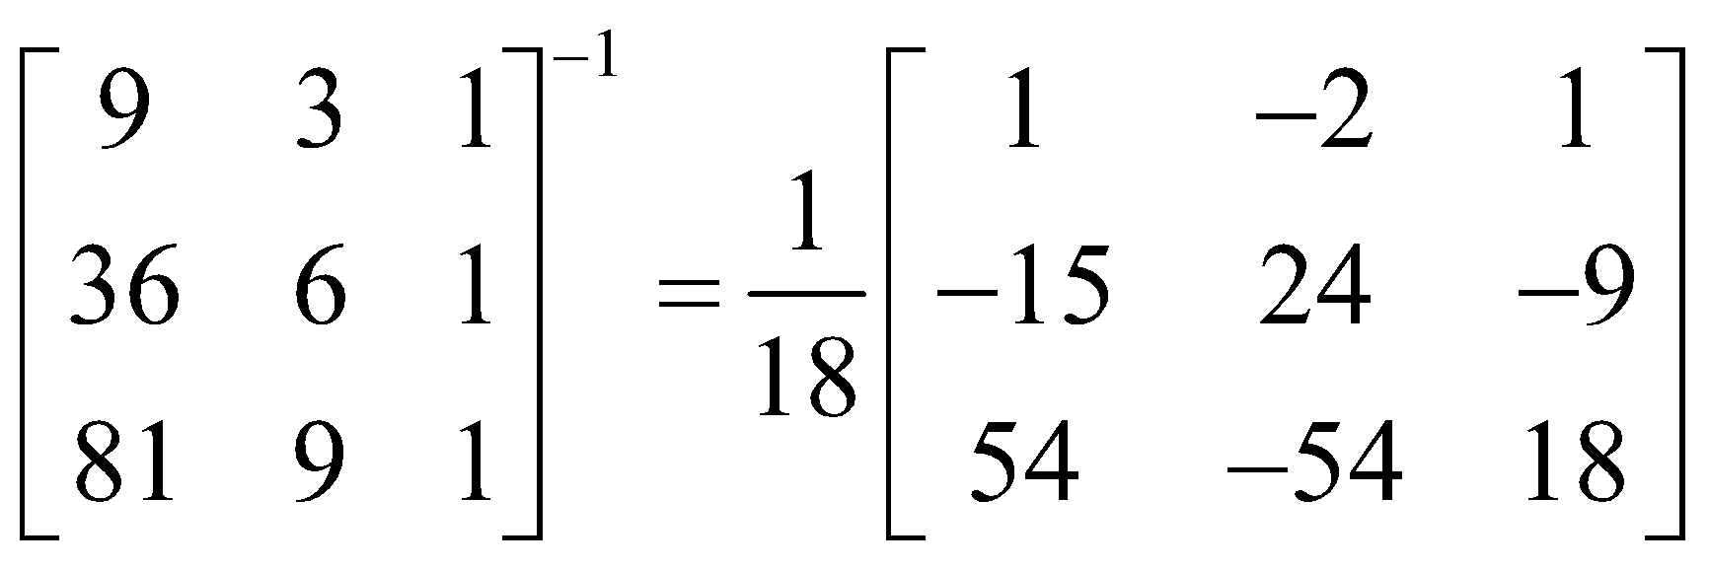, then answer the following questions.  - Find the value of b+c.  - Find 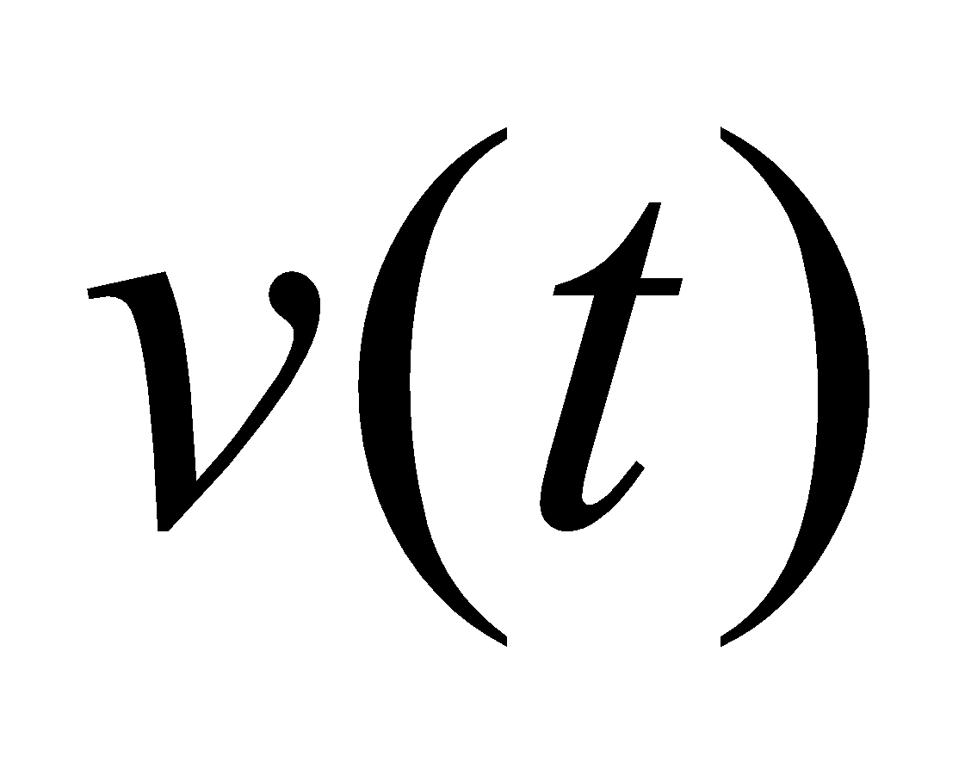.  - Calculate the speed at time t=15 seconds.  At what time the missile acquires a speed of 784 miles/sec? | 4
 | ANSWERS
1 | According to statement  3p+2q+r=3000  2p+4q+3r=3500  p+q+r=1500  Converting the system of equations in matrix form, we get  $\left[3 2 1 2 4 3 1 1 1 \right]$ $\left[X Y Z \right]$=$\left[3000 3500 1500 \right]$  i.e AX=B  Where A=$\left[3 2 1 2 4 3 1 1 1 \right]$ X=$\left[X Y Z \right]$  B=$\left[3000 3500 1500 \right]$  |A|= $\left[3 2 1 2 4 3 1 1 1 \right]$  =3(4-3)-2(2-1)+1(6-4)  =3×1-2×1+1×2=3-2+2=3≠0  X =$A^{-1}$B $A^{-1}$= $\frac{adjA}{\left|A\right|}$  adjA= ${\left[cofactors of A\right]}^{T}$  cofactors of A =$\left[1 1 -2 -1 2 -1 2 -7 8 \right]$  adjA=$\left[1 -1 2 1 2 -7 -2 -1 8 \right]$  $A^{-1}$= $\frac{adjA}{\left|A\right|}$ =$\frac{\left[1 -1 2 1 2 -7 -2 -1 8 \right]}{3}$ =$\frac{1}{3}$ $\left[1 -1 2 1 2 -7 -2 -1 8 \right]$  X=$A^{-1}$B  =$\left[\frac{1}{3} \frac{-1}{3} \frac{2}{3} \frac{1}{3} \frac{2}{3} \frac{-7}{3} \frac{-2}{3} \frac{-1}{3} \frac{8}{3} \right]$ $\left[3000 2300 1500 \right]$  =$\left[1000-1100+1000 1000+2200-3500 2000-1100+4000 \right]$=$\left[900 -300 900 \right]$  p=900, q=-300, z=900 | 4
2 | (i) x +y+z= 21 , 4x+3y+2z=60 ,6x+2y+3z=70  $(ii)\left[1 1 1 4 3 2 6 2 3 \right]\left[x y z \right]$=$\left[21 60 70 \right]$  x= Rs 5 , y= Rs 8 ,z= Rs. 8 | 4
3 | Let the cost of one polythene bag, one handmade bag, one newspaper bag be R x,y, z respectively.  Then  20x+30y+40z=250 i e 2x+3y+4z=25  30x+40y+20z=270 i e 3x+4y+2z=27  40x+20y+30z=200 i e 4x+2y+3z=20  These can be written as  AX=B where  A= $\left(2 3 4 3 4 2 4 2 3 \right)$,X =$\left(x y z \right)$,B=$\left(25 27 20 \right)$  Det A=16-3-40=-27,  Adj A=$\left(8 -1 -10 -1 -16 8 -10 8 -1 \right)$, A-1 =Adj A / det A  X=A-1 B=1/(-27) $\left(8 -1 -10 -1 -16 8 -10 8 -1 \right)\left(25 27 20 \right)$=$\left(1 11 2 \right)$  X=1,y=11,z=2  cost of one polythene bag=Rs 1  cost of one handmade bag=Rs 11  cost of one newspaper bag=Rs 2  newspaper bag is better for environment. | 4
4 | - By given information $x+y+z=45, -x+z=8, x-2y+z=0$  In matrix form $\left[1 1 1 1 0 -2 1 -1 1 \right]\left[x y z \right]=\left[45 8 0 \right]$  - We know that ${\left(A^{'}\right)}^{-1}={\left(A^{-1}\right)}^{'}$  $∴ {\left[1 1 1 1 0 -1 1 -2 1 \right]}^{-1}= \frac{1}{6}\left[2 3 1 2 0 -2 2 -3 1 \right]$  - $\left[x y z \right]=\frac{1}{6}\left[2 3 1 2 0 -2 2 -3 1 \right]\left[45 8 0 \right]=\frac{1}{6}\left[66 90 114 \right]=\left[11 15 19 \right]$  $∴x :y :z=11 :15 :19$ | 4
5 | - As per given information :  10x/100 + 12y/100 = 2800  12x/100 + 10y/100 = 2700  After simplifying the equations are 5x +6y = 140000, 6x +5y = 135000  - Let A = $\left[5 6 6 5 \right]$ ,X = $x y$ and B $\left(\frac{140000}{135000}\right)$  - Given system cn be written as AX = B  Where $\left[A \right]$ = $\left[5 6 6 5 \right]$ = 25-36=-11  ⇨ A⁻¹ exist.  Now, X = A⁻¹ B  After solving we get , x = 10000 and y = 15000 | 4
6 |  | 4
  i | b | ii | a | iii | b | iv | b
7 | 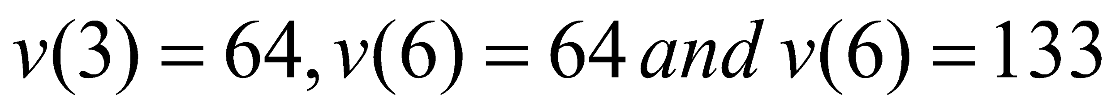  In matrix form 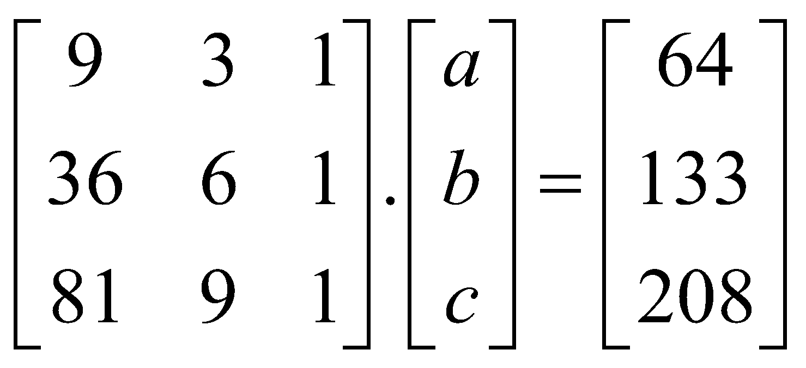 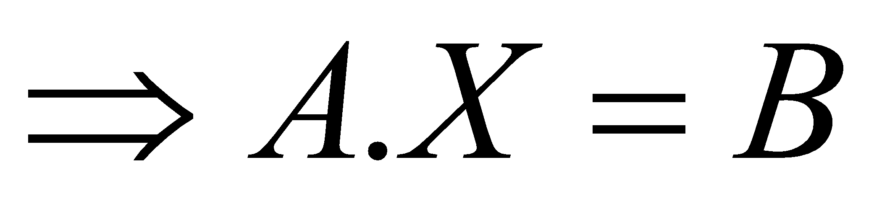 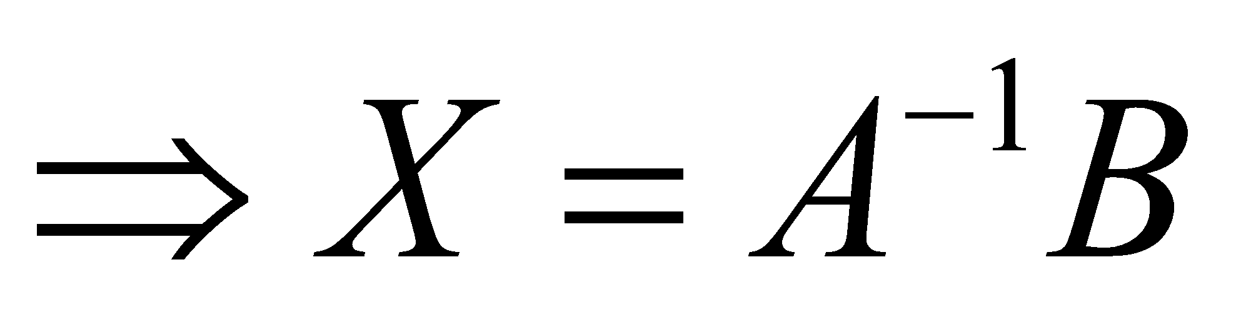 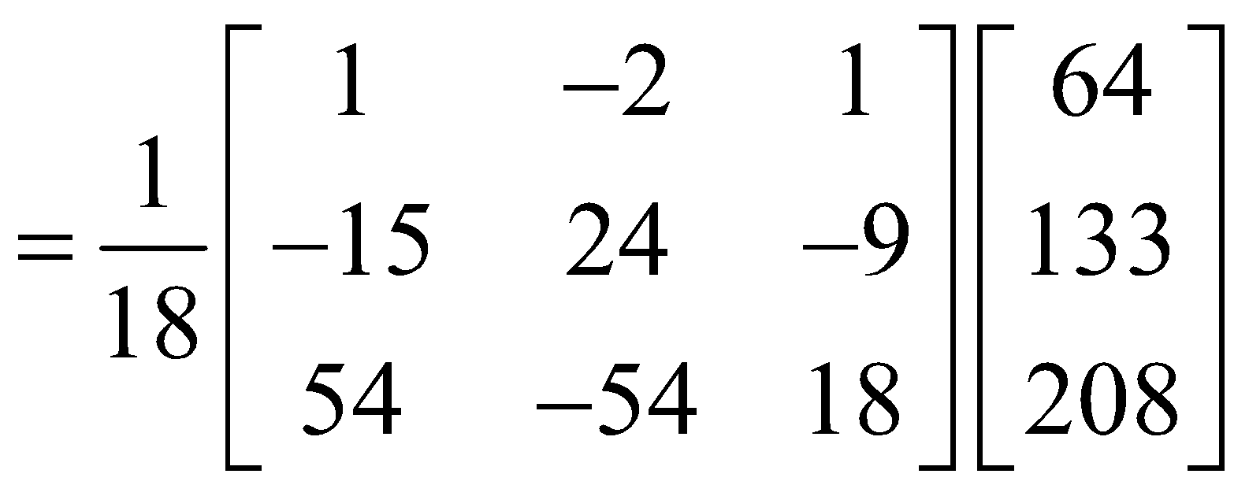= 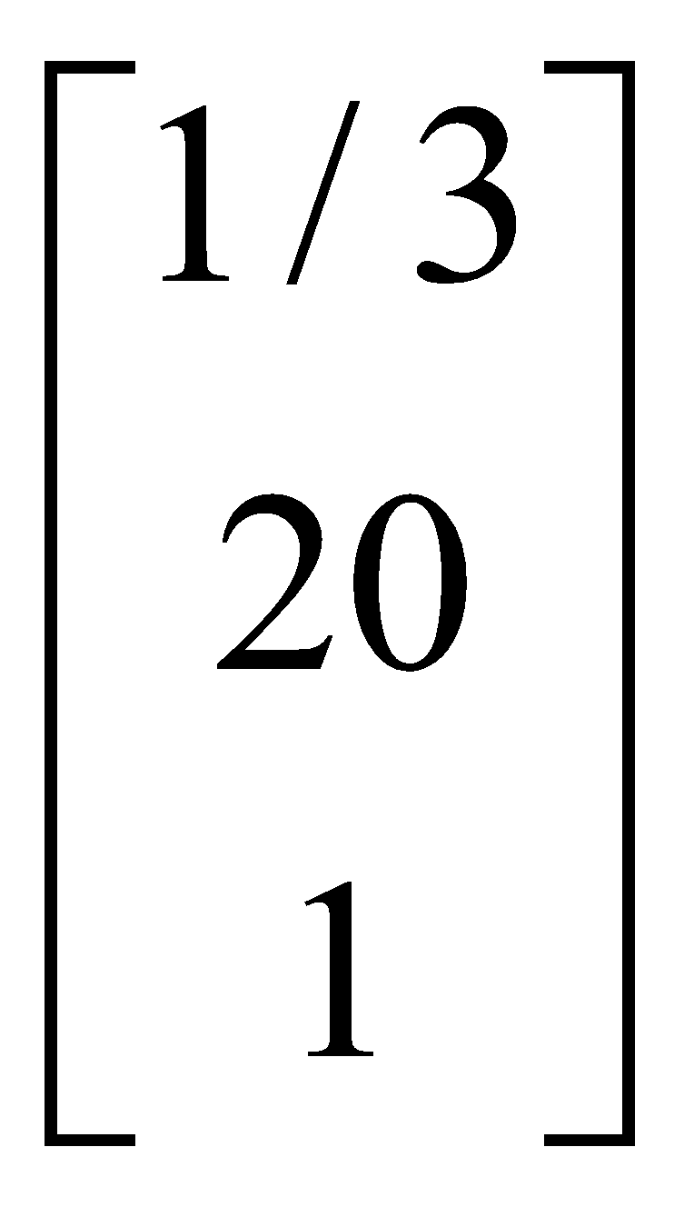 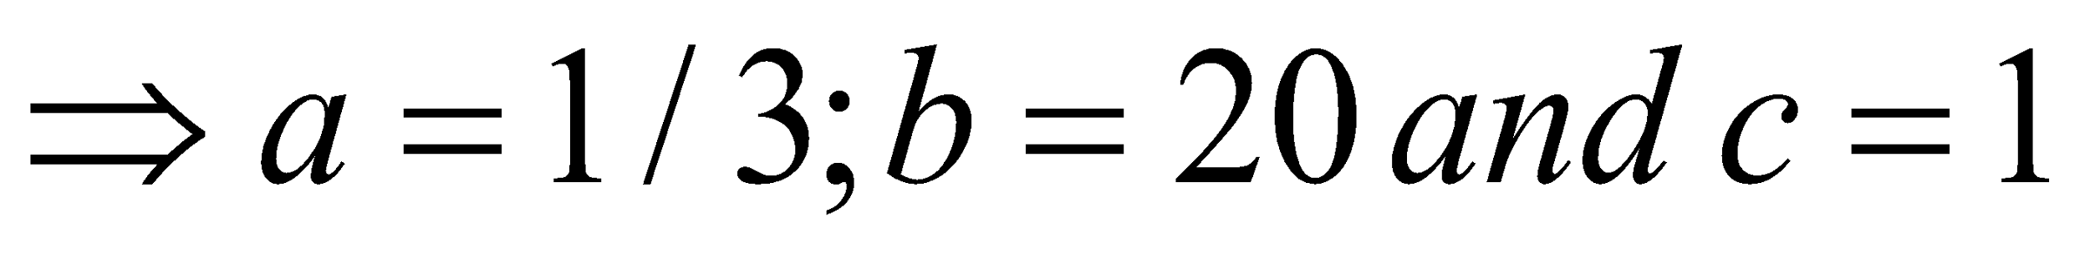  - 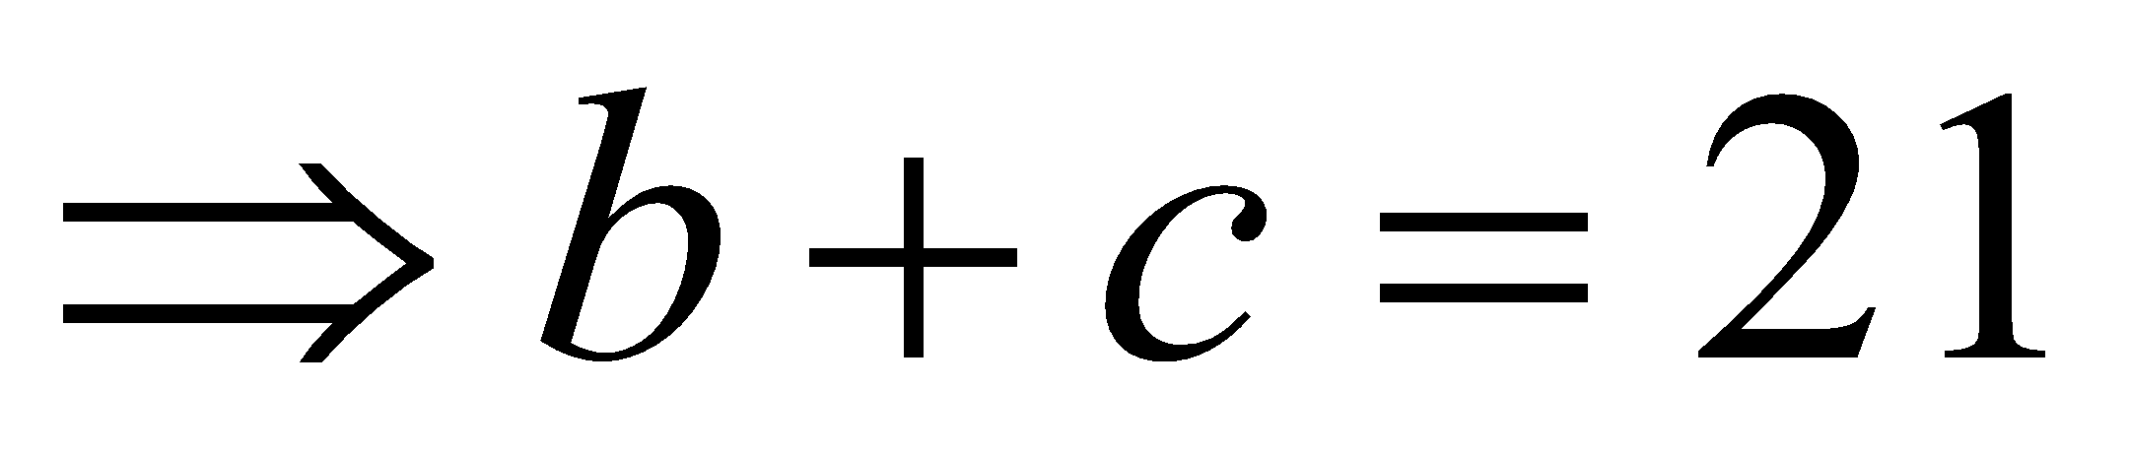  - 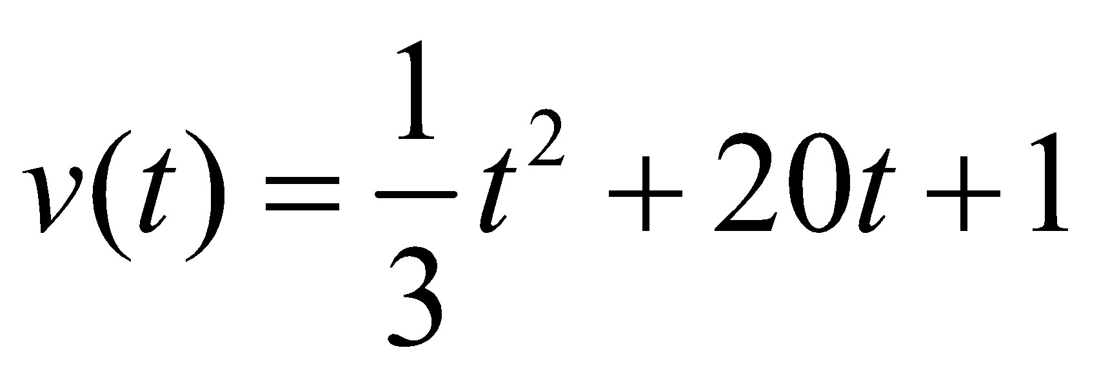  - 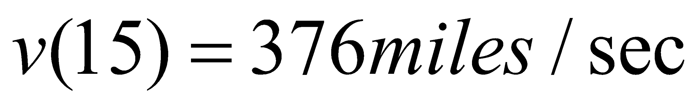  27 seconds. | 4
 | 5 – MARKS TYPE QUESTIONS
1 | If A=$\left[2 -3 5 3 2 -4 1 1 -2 \right]$ find${ A}^{-1}$. Hence solve the given equations $2x-3y+5z=11;$  $$3x+2y-4z=-5;$$  $$x+y-2z=-3.$$ | 5
2 | Given that A = $\left[-4 4 4 -7 1 3 5 -3 -1 \right]$ and B = $\left[1 -1 1 1 -2 -2 2 1 3 \right]$ , find AB and use it to solve the system of equations:  x – y + z = 4; x – 2y – 2z = 9; 2x + y +3z = 1 | 5
3 | Two factories decided to award their employees for three values of (a) adaptable to new techniques, (b) careful and alert in difficult situations and (c) keeping calm in tense situations, at the rate of Rs. x, y and z per person respectively. The first factory decided to honour respectively 2, 4 and 3 employees with a total prize money of Rs.29000. The second factory decided to honour respectively 5, 2 and 3 employees with the prize money of Rs.30500. If the three prizes per person together cost Rs. 9500, then  (i) Represent the above situation by a matrix equation and form linear equations using matrix multiplication.  (ii) Solve these equations using matrices.  (iii) Which values are reflected in the questions? | 5
4 | Radhika buys 5 pencils, 3 rulers and 1bottle and pays a sum of ₹160. Amit buys 2 pencils, 1 ruler and 3 bottles for ₹190. Also Ankit buys 1 pencil, 2 rulers and 4 bottles for ₹ 250.    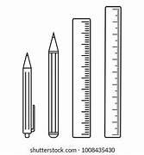  Express the above in matrix form and find the cost of each article. | 5
5 | Solve the following system of equations , using matrix method;  $$\frac{2}{x}+\frac{3}{y}+\frac{10}{z}=4 ; \frac{4}{x}-\frac{6}{y}+\frac{5}{z}=1 ; \frac{6}{x}+\frac{9}{y}-\frac{20}{z}=2$$ | 5
 | ANSWERS
1 | .$\left|A\right|$= 2(-4+4) - (-3)(-6+4)+5(3-2) = 2.0+3(-2)+5.1 = 0-6+5 = $-$1$≠0∴A^{-1}$exists.  Then,adj A = ${\left[0 2 1 -1 -9 -5 2 23 13 \right]}^{T}$= $\left[0 -1 2 2 -9 23 1 -5 13 \right]$  $${∴A}^{-1}=\frac{1}{\left|A\right|} adj A =\frac{1}{-1}\left[0 -1 2 2 -9 23 1 -5 13 \right]= \left[0 1 -2 -2 9 -23 -1 5 -13 \right]$$  The given system of equations can be written as a single matrix equation  $$\left[2 -3 5 3 2 -4 1 1 -2 \right]\left[x y z \right]=\left[11 -5 -3 \right]$$  i.e. $AX=B$  $⟹X=A^{-1}B$= $\left[0 1 -2 -2 9 -23 -1 5 -13 \right]\left[11 -5 -3 \right]$= $\left[0.11+1.\left(-5\right)+\left(-2\right).(-3) -2.11+9.\left(-5\right)+\left(-23\right).(-3) -1.11+5.\left(-5\right)+\left(-13\right).(-3) \right]$  = $\left[0-5+6 -22-45+69 -11-25+39 \right]$  $⟹\left[x y z \right]=\left[1 2 3 \right]$ $∴ x=1, y=2, z=3.$ | 5
2 | AB = $\left[-4 4 4 -7 1 3 5 -3 -1 \right]\left[1 -1 1 1 -2 -2 2 1 3 \right]$  = $\left[-4+4+8 4-8+4 -4-8+12 -7+1+6 7-2+3 -7-2+9 5-3-2 -5+6-1 5+6-3 \right]$  =$\left[8 0 0 0 8 0 0 0 8 \right]$ = 8 $\left[1 0 0 0 1 0 0 0 1 \right]$ = 8 I₃  => ($\frac{A}{8}$ ) B = I => B⁻¹ = $\frac{A}{8}$  => B⁻¹ = $\frac{1}{8}\left[-4 4 4 -7 1 3 5 -3 -1 \right]$  The given system of equations can be written as a single matrix equation  $\left[1 -1 1 1 -2 -2 2 1 3 \right]\left[x y z \right]=\left[4 9 1 \right]$i.e. B X = C=> X = B⁻¹ C = $\frac{1}{8}\left[-4 4 4 -7 1 3 5 -3 -1 \right]\left[4 9 1 \right]$ = $\frac{1}{8}\left[24 -16 -8 \right]$  =>$\left[x y z \right]= \left[3 -2 -1 \right]$=> x =2, y = -2, z= -1 | 5
3 | According to the question,  $2x+3y+4z=29000$  $5x+2y+3z=30500$  $x+y+z=9500$  The above equations can be written as,  $AX=B$  Where $A=\left[2 3 4 5 2 3 1 1 1 \right]$, $X=\left[x y z \right]$, $B=\left[29000 30500 9500 \right]$  Therefore,  $X=A^{-1}B$  Solving We get,  $$x=2750, y=3500, z=3250.$$ | 5
4 | Let the cost of the three articles be ₹ , ₹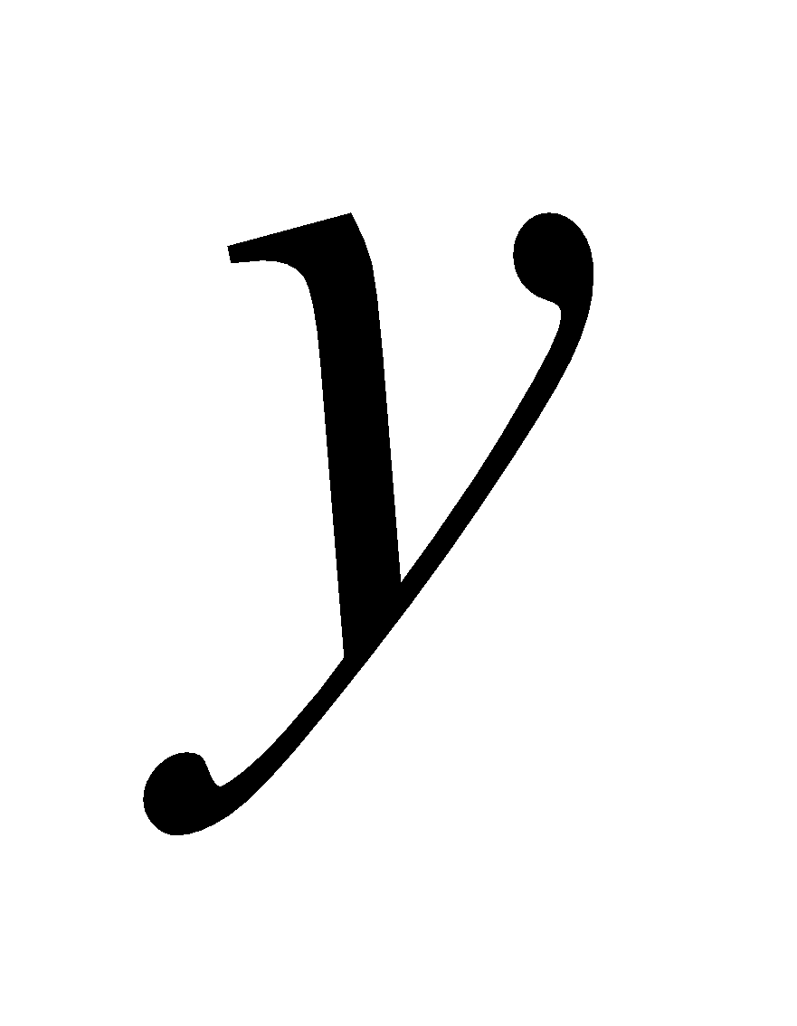 and ₹z respectively.  In matrix form the equations can be represented as  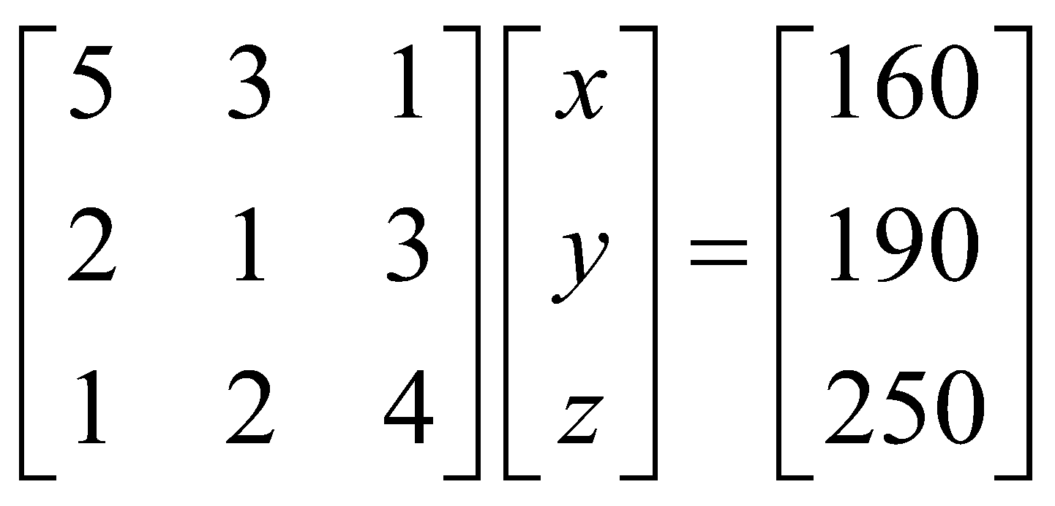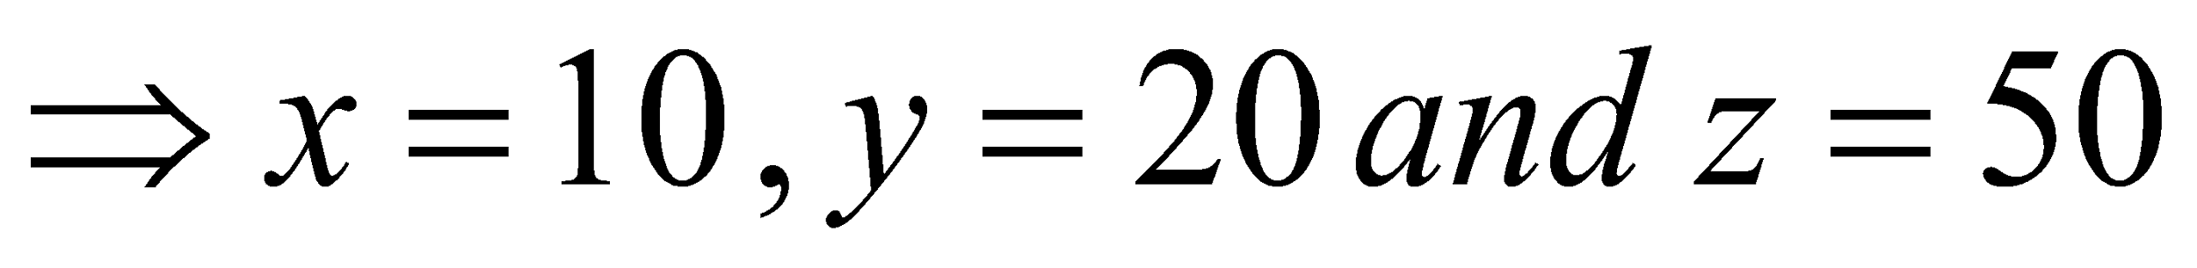 | 5
5 | Let $\frac{1}{x}=a ,\frac{1}{y}=b , \frac{1}{z}= c$ ,then the given system of equation become  2a+3b+10c = 4  4a–6b +5c = 1  6a + 9b – 20c= 2  This system of equation can be written as Ax = B  Here, A = $\left[2 3 10 4 -6 5 6 9 -20 \right]$ X = $\left[x y z \right]$ and B = $\left[4 1 2 \right]$  Now, $\left|A\right|$ = 2(120-45) -3(-80-30) +10(36+36)  = 150+30+720 =1200  ⇨ A⁻¹ exist.  adj(A) = $\left[75 150 75 110 -100 30 72 0 -24 \right]$  A ⁻¹ = 1/1200 $\left[75 150 75 110 -100 30 72 0 -24 \right]$  Now, X = A^{–1}B  Putting the values, we get, x= 2 ,y = 3 , z = 5 | 5

CHAPTER – 5
CONTINUITY & DIFFERENTIABILITY

SYLLABUS:
Continuity and differentiability, chain rule, derivative of inverse trigonometric functions, 𝑙𝑖𝑘𝑒 sin⁻¹ 𝑥 , cos⁻¹ 𝑥 and tan⁻¹ 𝑥, derivative of implicit functions. Concept of exponential and logarithmic functions. Derivatives of logarithmic and exponential functions. Logarithmic differentiation, derivative of functions expressed in parametric forms. Second order derivatives.

SL NO | QUESTION | MARK
 | MULTIPLE - CHOICE QUESTIONS
1 | The function $f\left(x\right)=\{\frac{x^{2}-9}{x-3}, x≠3 5 , x=3$  (a) is continuous at $x=3$ (b) has removable discontinuity at $x=3$  (c) has discontinuity of first kind at $x=3$(d) has discontinuity of second kind at $x=3$ | 1
2 | The function $f\left(x\right)=\{x+3, if x≤2$  $$x+4, if x>2$$  (a) is continuous at $x=2$ (b) has removable discontinuity at $x=2$  (c) has discontinuity of first kind at $x=2$  d) has discontinuity of second kind at $x=2$ | 1
3 | The greatest integer function $f\left(x\right)=\left[x\right],$at integer points,  (a) is continuous (b) has removable of first kind  (c) has removable discontinuity (d) has discontinuity of second kind. | 1
4 | The function $f\left(x\right)=\{{\left(x-1\right)}^{n} sinsin \left(\frac{1}{x-1}\right) , x≠1 0 , x=1$ is continuous at $x=1$  (a) for all value of $n$ (b) for $n>0$ (c) $n=0 only$ (d) for $n<0$ | 1
5 | The function $f\left(x\right)=\{coscos \frac{1}{x} , x≠0 0 , x=0$  (a) is continuous at $x=0$(b) has discontinuity of second kind at $x=0$  (c) has removable discontinuity at $x=0$  (d) has discontinuity of first kind at $x=0$ | 1
6 | The number of points of discontinuity of $f\left(x\right)=\left[x\right] in [3, 7]$ is  (a) 4 (b) 5 (c) 6 (d) 8 | 1
7 | Let $f$ and $g$ be two real functions continuous at $x=a,$ then $f+g$  (a) is continuous at $x=a$ (b) may or may not be continuous at $x=a$  (c) is discontinuous at $x=a$ (d) is continuous at $f\left(a\right)+g(a)$. | 1
8 | If and $g$ are two real functions continuous at a and $f(a)$ respectively, then  (a) $g$of is continuous at $f(a)$ (b) $g$of is continuous at a  (c) $fog$is continuous at a (d) $fog$ is continuous at $f\left(a\right)$ | 1
9 | $If f\left(x\right)=\{\frac{e^{x}-1}{1n(1+2x)}, x≠0 k , x=0$ is continuous at $x=o,$ then $k=$  (a) $\frac{2}{3}$ (b) 3 (c) 2 (d) $\frac{3}{2}$ | 1
10 | The function $f\left(x\right)=\{\frac{sin {ax}^{°}}{x}, x≠0 k , x=0$is continuous at $x=0, if k=$  (a) $\frac{π}{180}$ (b) $\frac{a π}{180}$ (c) $\frac{π}{180 a}$ (d) $\frac{180 a}{π}$ | 1
11 | What value of k, the function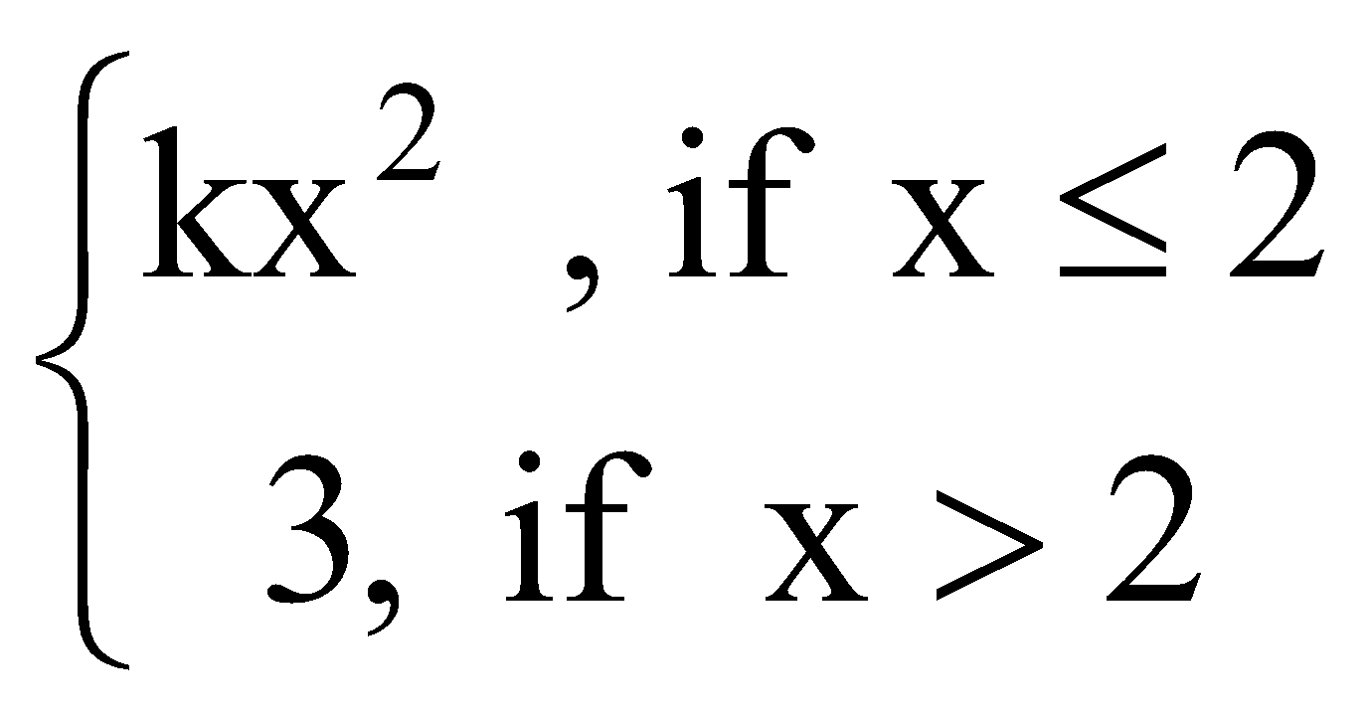 is continuous at x=2.  (a)0 (b)1 (c) 3/4 (d) 3/2 | 1
12 | The relationship between “a” and “b” so that the function ‘f’ defined by:  f(x)=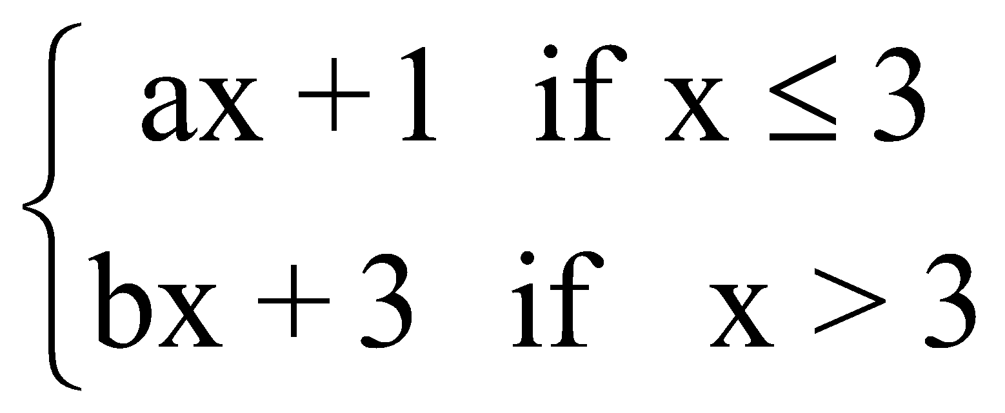is continuous at x=3.  (a) $a-b=2/3$ (b) $a=-b$  (c) $a-b=3$ (d) none of these | 1
13 | 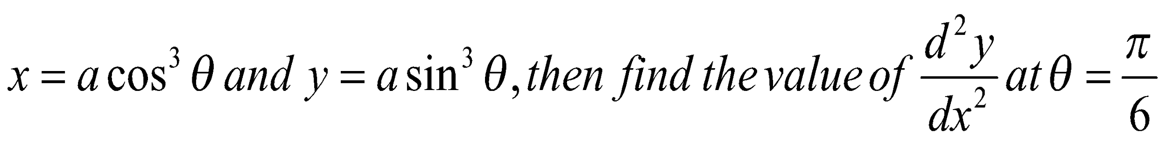  (a)1 (b) 0 (c) 7 (d) none of these | 1
14 | If $y={\left(1+\frac{1}{x}\right)}^{x}$, then $\frac{dy}{dx}=$  (a)${(1+\frac{1}{x})}^{x}$[log(1+$\frac{1}{x})$ – $\frac{1}{ x+1}$] (b)${(1+\frac{1}{x})}^{x}$[log(1+$\frac{1}{x})$]  (c) 0 (d) 1 | 1
15 | The differential coefficient of $f(logx)$ with respect to $x$, where $f\left(x\right)=logx$ is  - $\frac{x}{logx}$ (c) $\frac{logx}{x}$  ${\left(b\right)(xlogx)}^{-1}$ (d) none of these | 1
16 | Choose correct option  If $f\left(x\right)=t^{5}$ then $\frac{dy}{dx}$ is  - 5t⁴ (c) 5t⁵  $(b)\frac{t^{6}}{6}$ (d) none of these | 1
17 | Choose correct option  If $y=x^{6}$ find $\frac{dy}{dt}$  - $6x^{5}$ (c) 0  - 1 (d) none of these | 1
18 | which of the statements(s) is/are incorrect?  - if f+ g is continuous at x+ a, then f and g are continuous at x=a  - if $\left(fg\right)$exists, then $f$ and $g$ both exists  - Discontinuity at x = a implies that non-existences of limit  All functions defined on a closed interval attain maximum or a minimum value in its interval | 1
19 | If $sinsin y =xcoscos \left(a+y\right) ,$then $\frac{dx}{dy}$is:  (A) $\frac{coscos a }{\cos^{2}(a+y)}$ (B) $\frac{-coscos a }{\cos^{2}(a+y)}$  (C) $\frac{coscos a }{\sin^{2}y}$ (D) $\frac{a }{\sin^{2}y}$
20 | If y² = ax² + bx + c, then $\frac{d}{dx}$(y³y₂) =  1 (b)-1 (c)$\frac{4ac-b^{2}}{a^{2}}$ (d)0 | 1
21 | If u = x² + y² and x = s+3t, y = 2s – t, then $\frac{d^{2}u}{{dx}^{2}}$ is equal to  (a)12 (b)32 (c)36 (d)10 | 1
22 | The function f(x) = [x], where [x] is greatest integer function, is continuous at  (a)4 (b)-2 (c)1 (d)1.5 | 1
23 | The number of points at which the function f(x) = $\frac{1}{x-[x]}$ is not continous is  (a)1 (b)2 (c)3 (d) none of these | 1
24 | If u = sin⁻¹$\left(\frac{2x}{1+x^{2}}\right)$ and v = tan⁻¹$\left(\frac{2x}{1-x^{2}}\right)$, then $\frac{du}{dv}$ is  - 2 (b)x (c) -1 (d)1 | 1
25 | If y = log$\left(\frac{1-x^{2}}{1+x^{2}}\right)$, then $\frac{dy}{dx}$ is equal to  $\frac{4x^{3}}{1-x^{4}}$ (b) $\frac{-4x}{1-x^{4}}$ (c)$\frac{1}{4-x^{4}}$ (d) $\frac{-4x^{3}}{1-x^{4}}$ | 1
 | ANSWERS | 1
1 | (b) We find the find that $\frac{x^{2}-9}{x-3} = \left(x+3\right)=6 ≠f(3)$  So, $f(x)$ has removable discontinuity at $x=3$ | 1
2 | (c): We find that $= and f\left(x\right) f\left(x\right)= x+4=6.$  $∴$ $f\left(x\right)≠ f\left(x\right)$  Hence, $f(x)$ has discontinuity of first kind at $x=2.$ | 1
3 | (b): At any integer k, we find that  $f\left(x\right)= f\left(k-h\right) = \left[k-h\right]=k-1$  and $f\left(x\right) =f\left(k+h\right)= \left[k+h\right]=k$  $∴$ $f\left(x\right)≠ f\left(x\right) .$ So, $f\left(x\right)$ has discontinuity of first kind at $x=k$ | 1
4 | (b) : We find that  $f\left(x\right) ={\left(x-1\right)}^{n} sinsin \left(\frac{1}{x-1}\right)$  $=0×\left(An oscillating number between-1and 1\right)=0, if n>0$  $=f\left(0\right), if n=0.$  Hence, $f(x)$ is continuous at $x=1$ for all $n>0.$ | 1
5 | (b) : We find that $f\left(x\right) =coscos \frac{1}{x} =$ An oscillating number between $-1 and 1.$  So, $f\left(x\right)$ does not exist. Hence, $f(x)$ has discontinuity of first kind at $x=0.$ | 1
6 | (Ans. (a): The function $f\left(x\right)=[x]$ is discontinuous at $x=4, 5, 6$ in $[3, 7]$. It is right continuous at $x=3$ and left discontinuous $x=7$. Hence, there are four points of discontinuity. | 1
7 | (a): The sum of continuous functions is continuous function. Therefore, $f+g$ if continuous at $x=a.$ | 1
8 | (b): The composition of continuous functions is a continuous function. Therefore, $gof$ is continuous at $x=a.$ | 1
9 | (d): If $f\left(x\right)$ is continuous at $x=0,$ then  $f\left(x\right)=f(0) \frac{e^{3x}-1}{1n(1+2x)}=k ⟹\frac{3^{3x}-1}{3x} ×\frac{2x}{1n(1+2x)}×\frac{3}{2}=k⟹\frac{3}{2}=k$ | 1
10 | (b): If $f(x)$ is continuous at $x=0,$ then  $$\frac{sinsin {ax}^{°} }{x}=k ⟹\frac{sin\frac{π ax}{180}}{\frac{π ax}{180}} ×\frac{πa}{180}=\frac{πa}{180}$$ | 1
11 | C | 1
12 | A | 1
13 | A | 1
14 | D | 1
15 | A | 1
16 | B | 1
17 | D | 1
18 | b | 1
19 | d | 1
20 | b | 1
21 | d | 1
22 | d | 1
23 | d | 1
24 | d | 1
25 | d | 1
 | ASSERTION & REASON QUESTIONS
Choose the correct option in the following questions of Assertion – Reason Questions.
(a) Both A and R are correct; R is the correct explanation of A.
(b) Both A and R are correct; R is not the correct explanation of A.
(c) A is true but R is false
(d) A is false but R is true
1 | Assertion(A): If f(x)=$x^{n}, n≠0$ is differentiable for all x, then x can be any element of the interval [1, ∞).  Reason(R): If f(x)=$x^{n}, n≠0$ is differentiable for all x, then x can be any element of the interval (1, ∞). | 1
2 | Assertion (A): Modulus function is continuous function.  Reason (R): Modulus function is differentiable function. | 1
3 | Assertion (A): $f\left(x\right)$ is continuous at $x=a$ if $f(x)$ exist and equal to $f(a)$  Reason (R): $f\left(x\right)$ is continuous at a point, then $\frac{1}{f(x)}$ is also continuous at the point | 1
4 | Assertion: If x= a($θ$+ sin$θ$) , y =a(1-cos$θ$ ) then $\frac{dy}{dx}$ =$tan\frac{θ}{2}$  Reason: x=f($θ$),y=g($θ$) then dy /dx =$\frac{\frac{dy}{dθ}}{\frac{dx}{dθ}}$ | 1
5 | Assertion: If $x^{\frac{2}{3}}+y^{\frac{2}{3}}$ = $a^{\frac{2}{3}}$ then $\frac{dy}{dx}=$ -$\sqrt[3]{\frac{y}{x}}$  Reason: x= a$\cos^{3}θ ,y=a\sin^{3}θ$dy /dx =$\frac{\frac{dy}{dθ}}{\frac{dx}{dθ}}$ | 1
6 | Assertion (A): if y=sin x, then $\frac{d³y}{dx³}$=-1 at x=0.  Reason (R): if y=f(x). g(x), then $\frac{dy}{dx}$ = f(x).$\frac{d}{dx}$g(x)+g(x)$\frac{d}{dx}$f(x). | 1
7 | Assertion (A): |sin x| is a continuous function.  Reason (R): if f(x) and g(x) both are continuous functions, then gof(x) is also a continuous function. | 1
8 | Assertion: - $If y=(2x\sqrt{1-x^{2}}) , then \frac{dy}{dx}=\frac{2}{\sqrt{1-x^{2}}}$  Reason: - $(2x\sqrt{1-x^{2}}) =2x$ | 1
9 | Assertion: - $If y=loglog sinsin x , then \frac{dy}{dx}=cotcot x$  Reason: - $y=f\left(x\right) and x=g\left(t\right), then \frac{dy}{dx}=\frac{dy}{dt}.\frac{dt}{dx}$ | 1
10 | Assertion (A): $\left|sinsin x \right|$ is continuous for all x $∈$ R.  Reason (R) : sin x and $\left|x\right|$ are continuous in R. | 1
 | ANSWERS
1 | a | 1
2 | c | 1
3 | d | 1
4 | a | 1
5 | a | 1
6 | b | 1
7 | a | 1
8 | b | 1
9 | a | 1
10 | a | 1
 | 2 MARKS TYPE QUESTIONS
1 | Find the value of $k$for which $f\left(x\right)=\{\frac{1 - coscos 4x }{8x^{2}}, if x≠0 k , if x=0$ is continuous at $x=0 .$ | 2
2 | Find the value of $k$ for which $f\left(x\right)=\{\frac{x^{2} + 3x-10}{x-2}, if x≠2 k , if x=2$ is continuous at $x=2 .$ | 2
3 | Discuss the differentiability of $f\left(x\right)=x\left|x\right|$at $x=0 .$ | 2
4 | Differentiate $\left(\frac{1+ cos x}{sin x}\right)$ with respect to $x .$ | 2
5 | If $x=a(2θ-sinsin 2θ)$ and $=a(1-coscos 2θ)$ , find $\frac{dy}{dx}$ when $θ=\frac{π}{3}$ . | 2
6 | If log 𝑦 =tan⁻¹ 𝑥, 𝑡h𝑒𝑛 𝑝𝑟𝑜𝑣𝑒 𝑡h𝑎𝑡  (1 + 𝑥²)y₂ + (2𝑥 − 1)y₁ =0 | 2
7 | Find the value of k for which 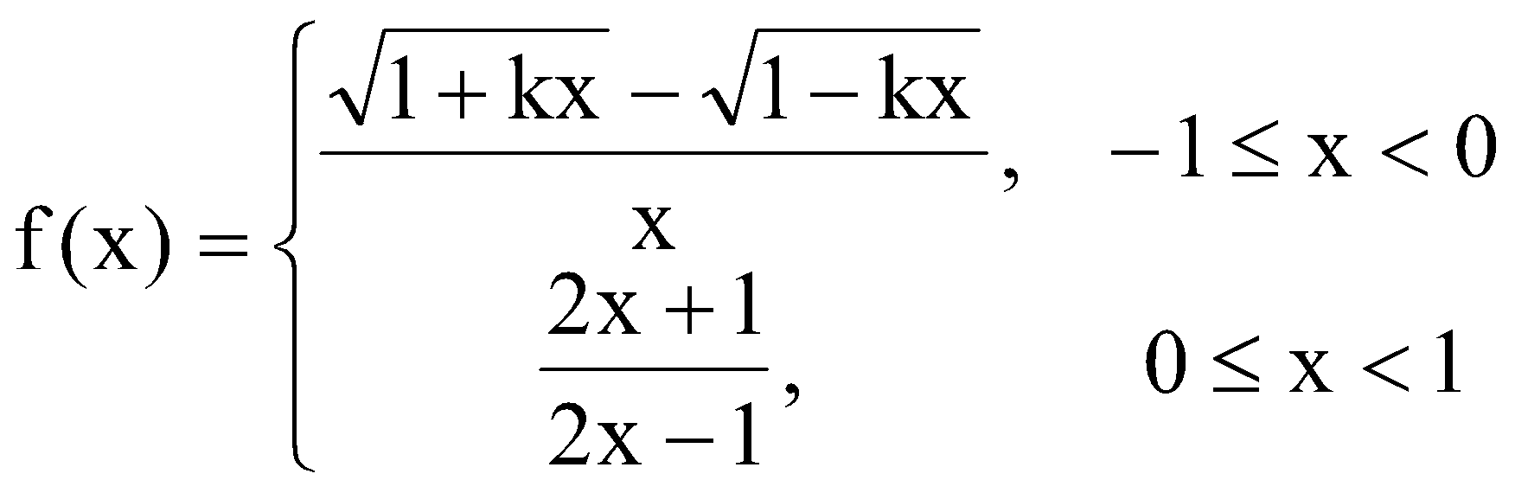 | 2
8 | If siny = x sin(a+y),prove that 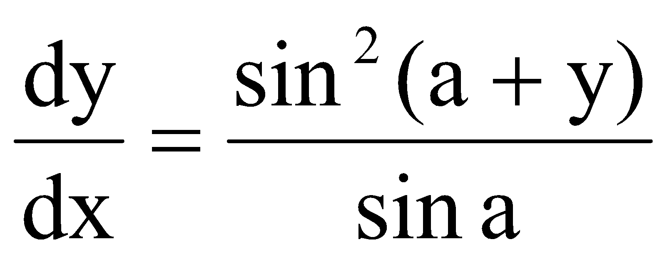 | 2
9 | $x^{2 }+2xy+y^{3}=42$ then find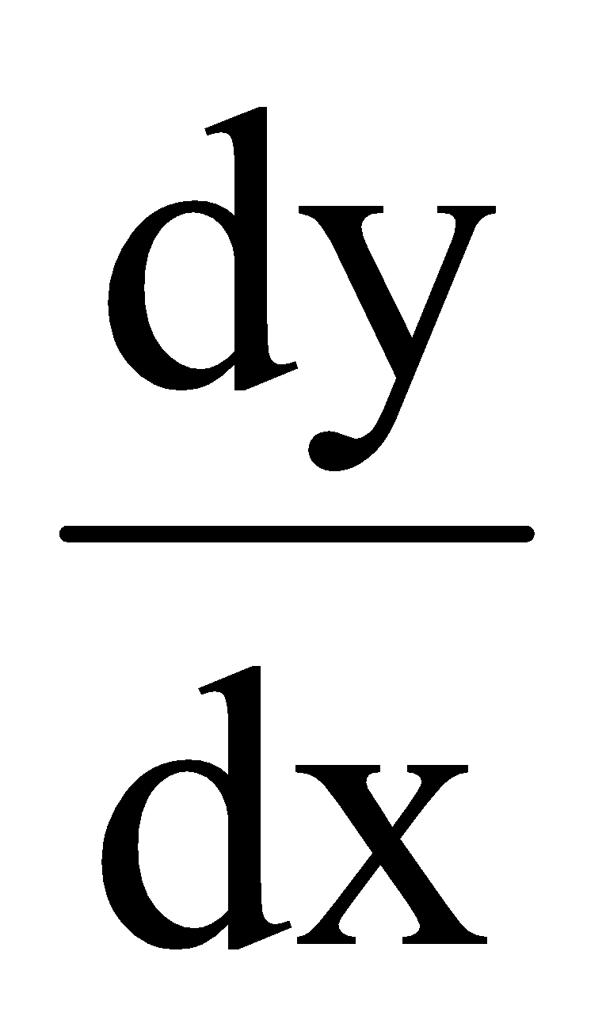 | 2
10 | If 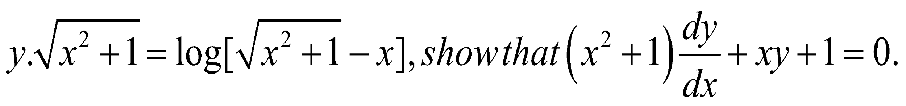 | 2
 | ANSWERS | 2
1 | $$\frac{1 - coscos 4x }{{8x}^{2}} =k⇒\lim_{x→0}\frac{2 \sin^{2} 2x}{8x^{2}}=k ⇒\lim_{x→0}{( \frac{sinsin 2x }{2x} )}^{2}=k ⇒k=1$$ | 2
2 | $$\frac{(x-2)(x+5)}{x-2} =k ⇒k=7$$ | 2
3 | $$f\left(x\right)=\{x^{2} , x≥0 {-x}^{2} , x<0$$  LHD =$\frac{f\left(x\right)-f(0)}{x-0} =\frac{-x^{2}-0}{x-0}= 0$  RHD = $\frac{f\left(x\right)-f(0)}{x-0} =\frac{x^{2}-0}{x-0}= 0$ | 2
4 | $$\left(\frac{2 \cos^{2}\frac{x}{2}}{2 sin \frac{x}{2 }\frac{x}{2} }\right)=\left(cot\frac{x}{2}\right)=\left[tan\left(\frac{π}{2}-\frac{x}{2}\right)\right]= \frac{π}{2}-\frac{x}{2}$$  $$f^{'}(x)= -\frac{1}{2}$$ | 2
5 | $\frac{dx}{dθ}=a\left(2-2cos 2θ\right)=4a\sin^{2}θ$&$\frac{dy}{dθ}=2asin 2θ=4a sinθ cosθ ⇒{\frac{dy}{dx}]}_{\frac{π}{3}}=\frac{1}{\sqrt{3}}$ | 2
6 | Correct proof | 2
7 | $$K=\frac{-1}{\sqrt{2}}$$ | 2
8 | Correct proof should be there without step missing | 2
9 | $$2x+2y\left(1\right)+2x.\frac{dy}{dx}+3y^{2}.\frac{dy}{dx}=0$$  $$\frac{dy}{dx}=\frac{-2(x+y)}{2x+3y^{2}}$$ | 2
10 | Correct proof | 2
 | 3 – MARKS TYPE QUESTIONS
1 | If the $f\left(x\right)$ given by $f\left(x\right)=\{3ax+b , if x>1 11 , if x=1 5ax-2b , if x<1$ is continuous at $x=1$ ,  find the values of $a$ and $b$ . | 3
2 | Let $f\left(x\right)=\{\frac{1 - coscos 4x }{x^{2}} , if x<0 a , if x=0 \frac{\sqrt{x}}{\sqrt{16 + \sqrt{x}} - 4} , if x>0 ,$Determine the value of $a$ so that $f\left(x\right)$ is continuous at $x=0$ | 3
3 | If $y=\sqrt{\frac{1-x}{1+x}}$, prove that $\left(1-x^{2}\right)\frac{dy}{dx}+y=0$ . | 3
4 | If${ (x-a)}^{2}$+${ (x-b)}^{2}$= c²for some c>0.Prove that 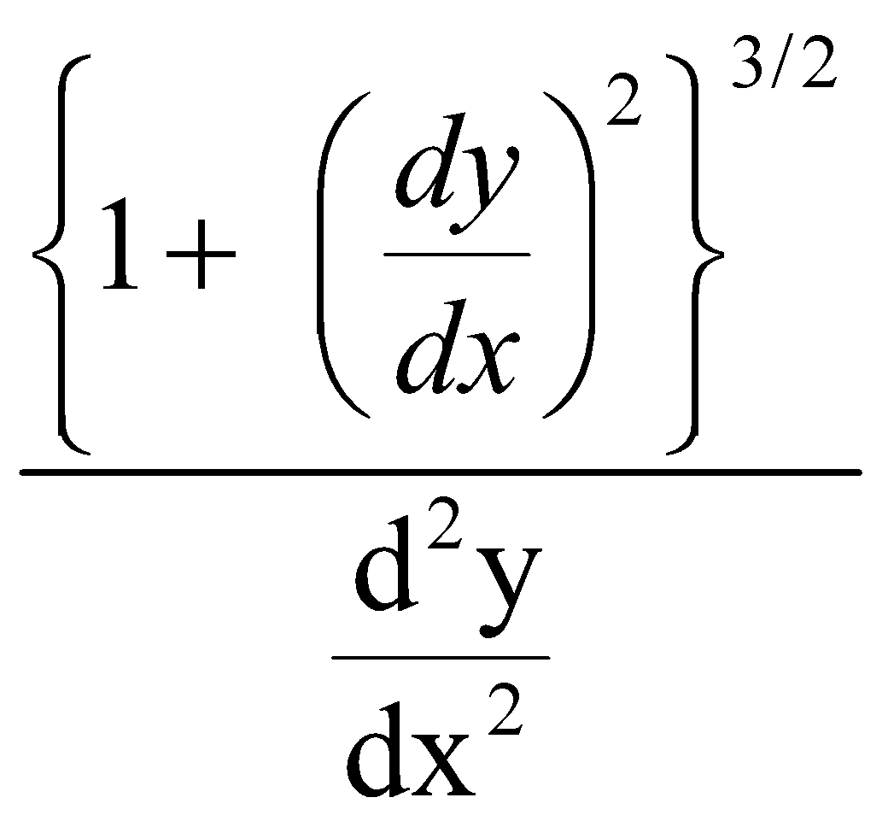 is a constant, | 3
5 | Find 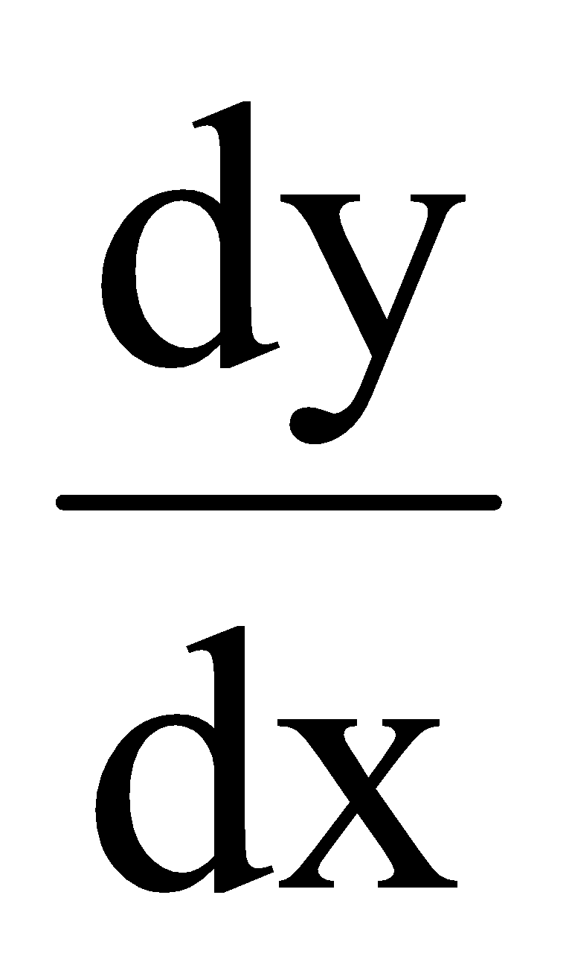if (cos x)^{y} = (cos y)^{x} | 3
6 | y = 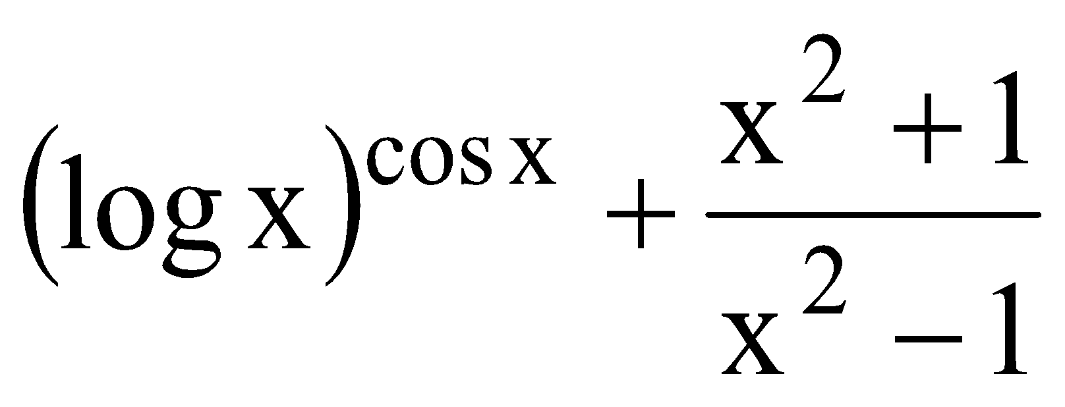, find 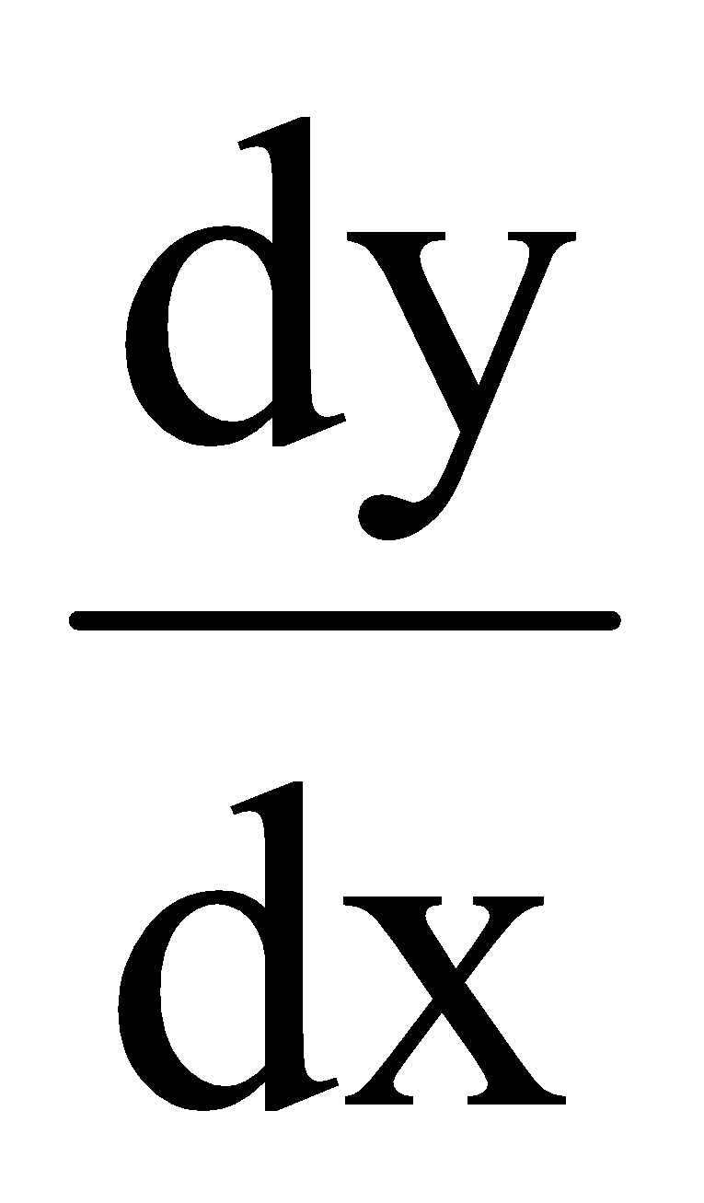 | 3
7 | Find the points of discontinuity , if any, of the function,  f(x) = |x| + 3 , x$≤$ -3  -2x , -3 < x< 3  6x +2 , x> 3 | 3
8 | If siny = x sin (a + y) , prove that $\frac{dy}{dx}$ = $\frac{\sin^{2}(a+y)}{sin a}$ | 3
9 | Discuss the differentiability of f(x) = x|x| at x = 0 | 3
10 | Let $f\left(x\right)=\{\frac{1 - coscos 4x }{x^{2}} , if x<0 a , if x=0 \frac{\sqrt{x}}{\sqrt{16 + \sqrt{x}} - 4} , if x>0 ,$Determine the value of $a$ so that $f\left(x\right)$ is continuous at $x=0$ | 3
 | ANSWERS
1 | $$\lim_{x→1^{-}} f\left(x\right)=\lim_{x→1^{+}}f\left(x\right)=f(1)$$  $$5a-2b=3a+b=11 ⇒ a=3 and b=2$$ | 3
2 | $\lim_{x→0^{-}} f\left(x\right)$ = $\lim_{x→0^{-}}\frac{1 - coscos 4x }{x^{2}} =\lim_{x→0^{-}}\frac{2 \sin^{2} 2x}{x^{2}}=2×4×\lim_{x→0^{-}}{( \frac{sinsin 2x }{2x} )}^{2}=8$  $\lim_{x→0^{+}} f\left(x\right)=\lim_{x→0^{+}}\frac{\sqrt{x}}{\sqrt{16 + \sqrt{x}} - 4}×\frac{\sqrt{16 + \sqrt{x}}+ 4}{\sqrt{16 + \sqrt{x}}+ 4}$ =$\lim_{x→0^{+}}\sqrt{16 + \sqrt{x}}+ 4=4+4=8$  $⇒$ a = 8 | 3
3 | $$\frac{dy}{dx}=\frac{1}{2}\sqrt{\frac{1+x}{1-x}}×\frac{d}{dx}\left(\frac{1-x}{1+x}\right)⇒\frac{dy}{dx}=-\sqrt{\frac{1+x}{1-x}} ×\frac{1}{{\left(1+x\right)}^{2}}\left[Multiplying by \left(1-x^{2}\right)\right]$$ | 3
4 | Correct proof should be there without step missing | 3
5 | $$\frac{dy}{dx}=\frac{logtany+ytanx}{logcosx-xsecycosecy}$$ | 3
6 | ${(logx)}^{cosx }\left\{-sinxlog\left(logx\right)+\frac{cosx}{xlogx}\right\}$ +$\frac{4x}{{(1+x^{2)}}^{2}}$ | 3
7 | Discontinuous at x = 3 | 3
8 | x = $\frac{siny}{sin(a + y)}$  $\frac{dx}{dy}$ = $\frac{sin(a+y -y)}{\sin^{2}(a + y)}$  $\frac{dy}{dx}$ = $\frac{\sin^{2}(a+y)}{sin a}$ | 3
9 | LHD = RHD = 0 , f(x) is differentiable at x = 0 | 3
10 | $\lim_{x→0^{-}} f\left(x\right)$ = $\lim_{x→0^{-}}\frac{1 - coscos 4x }{x^{2}} =\lim_{x→0^{-}}\frac{2 \sin^{2} 2x}{x^{2}}=2×4×\lim_{x→0^{-}}{( \frac{sinsin 2x }{2x} )}^{2}=8$  $\lim_{x→0^{+}} f\left(x\right)=\lim_{x→0^{+}}\frac{\sqrt{x}}{\sqrt{16 + \sqrt{x}} - 4}×\frac{\sqrt{16 + \sqrt{x}}+ 4}{\sqrt{16 + \sqrt{x}}+ 4}$ =$\lim_{x→0^{+}}\sqrt{16 + \sqrt{x}}+ 4=4+4=8$  $⇒$ a = 8 | 3
 | 5 – MARKS TYPE QUESTIONS
1 | For what value of $k$ is the following function continuous at $=-\frac{π}{6}$ ?  $$f\left(x\right)=\{\frac{x+coscos x }{x + \frac{π}{6}} , if x≠-\frac{π}{6} k , if x=-\frac{π}{6}$$ | 5
2 | Find $\frac{dy}{dx}$ , if $y={\left(tantan x \right)}^{cot x}+{\left(cotcot x \right)}^{tantan x }$ | 5
3 | If x = cost(3-2cos²t) and y = sint(3-2sin²t), then find the value of $\frac{dy}{dx}$ at t = $\frac{π}{4}$ | 5
4 | If y= log(x + $\sqrt{x^{2}+a^{2}}$), then show that ${(x}^{2}+a^{2})\frac{d^{2}y}{{dx}^{2}}$ + x$\frac{dy}{dx}$ = 0 | 5
 | ANSWERS
1 | $$\frac{2\left(\frac{\sqrt{3}}{2}sinsin x+coscos x .\frac{ 1}{ 2} \right)}{\left(x + \frac{π}{6}\right)} =\frac{2\left(coscos \frac{π}{6} sinsin x+coscos x sin\frac{π}{6} \right)}{\left(x + \frac{π}{6}\right)} =\frac{2sin\left(x+\frac{π}{6}\right)}{\left(x + \frac{π}{6}\right)} =2 ⇒ k=2$$ | 5
2 | $$\frac{dy}{dx}={\left(tantan x \right)}^{cot x}{cosec}^{2}x\left(1-loglog tantan x \right)+{\left(cotcot x \right)}^{tantan x }\sec^{2}x\left(loglog cotcot x -1 \right)$$ | 5
3 | Given that:  x = cost(3-2cos²t)  on differentiating w.r.t ‘t’ we get  dx/dt = d/dt(cost(3-2cos²t))  = cost(4costsint) –sint(3-2cos²t)  = 4cos²tsint-3sint + 2cos²tsint  = 6cos²tsint – 3sint……………….(i)  Now,  y = sint(3-2sin²t)  on differentiating w.r.t ‘t’ we get  dy/dt = d/dt(sint(3-2sin²t)  = sint(-4sintcost) + cost(3 – 2sin²t)  = -4sin²tcost + 3cost – 2sin²tcost  = 3cost – 6sin²tcost……………..(ii)  eq. (ii) / (i)  dy/dx = $\frac{3cost-6\sin^{2}tcost}{6\cos^{2}tsint-3sint}$  = $\frac{3cost(1-2\sin^{2}t) }{3sint({2cos}^{2}t-1)}$  = $\frac{3costcos2t }{3sintcos2t}$  = cott  at t = $\frac{π}{4}$  dy/dx = cot$\frac{π}{4}$  = 1 | 5
4 | Given,  $y=log[x+√\left(x^{2}+a^{2}\right)]$  Differentiating both side w.r.t x, we get,  $$⇒\frac{dy}{dx}=\frac{1}{x+\sqrt{x^{2}+a^{2}}}\frac{d}{dx}\left(x+\sqrt{x^{2}+a^{2}}\right)\left[∵\frac{d}{dx}\left(logx\right)=\frac{1}{x}d\left(x\right)\right]$$  $$⇒\frac{dy}{dx}=\frac{1}{x+\sqrt{x^{2}+a^{2}}}\left(1+\frac{2x}{2 \sqrt{x^{2}+a^{2}}}\right)\left[∵\frac{d}{dx}\left(\sqrt{x^{2}=a^{2}}\right)=\frac{2x}{2 \sqrt{x^{2}+a^{2}}}\right]$$  $$⇒\frac{dy}{dx}=\frac{1}{x+\sqrt{x^{2}+a^{2}}}\left(\frac{x+\sqrt{x^{2}+a^{2}}}{\sqrt{x^{2}+a^{2}}}\right)$$  $$⇒ \frac{dy}{dx}=\frac{1}{\sqrt{x^{2}+a^{2}}}$$  $$⇒ \frac{dy}{dx}(\sqrt{x^{2}+a^{2}})=1$$  Again differentiating both side w.r.t x, we get  $$⇒ \left(\sqrt{x^{2}+a^{2}}\right)\frac{d}{dx}\left(\frac{dy}{dx}\right)+\frac{dy}{dx}\frac{d}{dx}\left(\sqrt{x^{2}+a^{2}}\right)=\frac{d\left(1\right)}{dx}$$  $$⇒\left(\sqrt{x^{2}+a^{2}}\right)\frac{d^{2}y}{dx^{2}}+\frac{2x\frac{dy}{dx}}{2 \sqrt{x^{2}+a^{2}}}=0\left[∵\frac{d}{dx}\left(\sqrt{x^{2}+a^{2}}\right)=\frac{2x}{2 \sqrt{x^{2}+a^{2}}}\right]$$  $$⇒ \left(\sqrt{x^{2}+a^{2}}\right)\frac{d^{2}y}{dx^{2}}+\frac{dy}{dx}\frac{x}{\sqrt{x^{2}+a^{2}}}=0 \left[multiplying \sqrt{x^{2}+a^{2}} both side\right]$$ | 5

CHAPTER – 6
APPLICATION OF DERIVATIVES

SYLLABUS:
Applications of derivatives: rate of change of bodies, increasing/decreasing functions, maxima and minima (first derivative test motivated geometrically and second derivative test given as a provable tool). Simple problems (that illustrate basic principles and understanding of the subject as well as real - life situations).

SL NO | QUESTION | MARK
 | MULTIPLE - CHOICE QUESTIONS
1 | The interval in which the function f given by f(x) = x²e^{-x} is strictly increasing  (a) (-$∞,∞)$ (b) (-$∞,$ 0) (c) (2 $,∞)$ (d) (2$,0)$ | 1
2 | The maximum value of (${\frac{1}{x} )}^{x}$  (a) e (b) $e^{e}$ (c) $e^{\frac{1}{e}}$(d) $( {\frac{1 }{e })}^{\frac{1}{e}}$ | 1
3 | The maximum value of [ x(x-1) + 1]^{1/3},0$≤x≤1$ is  (a) ($\frac{1}{3}$ )^{1/3} (b) $\frac{1}{2}$ (c) 1 (d) 0 | 1
4 | The maximum volume of slope of the curve y= -x³+3x²+12x-5 is  (a) 0 (b) 9 (c) 12 (d) 15 | 1
5 | The total revenue in rupees received from the sale of x units of a product is given by R(x) = 3x² +36x +5.The marginal revenue, when x = 15 is  (a) 126 (b) 96 (c) 90 (d) 116 | 1
6 | The rate of change of the area of a circle with respect to its radius r at r = 6 cm is  (a) 10$π$ (b) 12$π$ (c) 8$π$ (d) 11$π$ | 1
7 | The rate of change in area of square w.r.t side when side is $\frac{1}{√3}$ unit is  (a) $\frac{2}{√3}$ unit²/sec (b) $\frac{1}{√53}$ unit²/sec (c) 2 unit²/sec (d) none of these | 1
8 | For which value of ‘a’ is the function f(x) = ax²+2 decreasing in [1.2] ?  (a) (1$,2)$ (b) (-$∞,0)$ (c) [1$,$ 2] (d) none of these | 1
9 | If the function f(x) = 2x² – kx +5 is increasing on [1,2] ,then k lies in the interval  (a) (-$∞,4)$ (b) (4,$∞$) (c) (-$∞,8)$ (d) (8,$∞$) | 1
10 | If x is real,the minimum value of x²-8x+17 is  (a) -1 (b) 0 (c) 1 (d) 2 | 1
11 | The rate of change of the area of a wheel of a cycle with respect to the distance between the outer surface and the hub of the wheel, which is 6 cm is  (a)36π (c)12 π  (b)24 π (d)17 π | 1
12 | The area of a trapezium is defined by function 𝑓 and given by  $f(x) = (10 + x)\sqrt{100-x^{2}}$, then the area when it is maximized is:  (A) 75 sq. unit (B) 7$\sqrt{3}$ sq. unit (C) $75\sqrt{3}$ sq. unit (D) 5 sq. unit | 1
13 | The maximum value of ${[x(x - 1) + 1]}^{\frac{1}{3}}, 0≤ x ≤ 1$is:  (A) $0$ (B) $\frac{1}{2}$ (C) 1 (D) $\sqrt[3]{\frac{1}{3}}$ | 1
14 | The value of $x$ for which $\left(x-x^{2}\right)$ is maximum is  (a)3/4 (c)1/3  (b)1/2 (d)1/4 | 1
15 | If x is real, then the minimum value of $x^{2}-8x+17$ is  (a)-1 (c)0  (b)1 (d)2 | 1
16 | The value of b for which the function $f\left(x\right)=x+coscos x +b$ is strictly decreasing over R is  (a)b≥1 (c)for no values of b  (b)b≤1 (d)b=1 | 1
17 | The interval on which the function  $f\left(x\right)=x^{2}-4x+6$ is strictly increasing is  (a) $\left(-∞,2\right)∪\left(2,∞\right)$  (b)$\left(2,∞\right)$  (c)$\left(-∞,2\right)$  (d)$(-∞,2]∪\left(2,∞\right)$ | 1
18 | The area of a trapezium is defined by a function which is given by  $f\left(x\right)=\left(10+x\right)\sqrt{100-x^{2}}$ then the area when it is maximized is  (a)75 cm² (c)7$\sqrt{3}$ cm²  (b)75$\sqrt{3}$ cm² (d)5 cm² | 1
19 | Function $f\left(x\right)=2x^{3}-6x+5$, is an increasing function in the interval  (A) $\left(-∞,-\frac{1}{2}\right)∪(\frac{1}{2},∞)$ (B) $\left(-1,1\right)$(C) $\left(-1,-\frac{1}{2}\right)$ (D) $\left(-∞,-1\right)∪(1,∞)$ | 1
20 | A company makes closed water storage tank. The water tank is cylindrical in shape. Let  S be the given surface area, r be the radius of base and h be height of the tank. Based on the information provided answer the following:  Relation between S, r and h is:  - $S=2πrh+2πr^{2}$  - $S=2πrh+πr^{2}$  - $S=πr^{2}h+πr^{2}$  - $S=πr^{2}h+2πr^{2}$ | 1
21 | A function $y = f(x)$ is said to have a local maximum value if  A) $\frac{dy}{dx} =0$&$\frac{d^{2}y}{dx^{2}} =0$ B) $\frac{dy}{dx} =0$&$\frac{d^{2}y}{dx^{2}}>0$  C) $\frac{dy}{dx} =0$&$\frac{d^{2}y}{dx^{2}}<0$ D) $\frac{dy}{dx} =0$&$\frac{d^{2}y}{dx^{2}} ≤0$ | 1
22 | The sign of $f^{'}(x)$ changes from positive to negative as x increases through x = a then  A) $x = a$is a point of local minimum B) $x = a$ is a point of local maximum  C) $x = a$is a point of inflection D) None of these | 1
23 | The sign of $f^{'}(x)$ changes from negative to positive as x increases through x = a then  A) $x = a$is a point of local minimum B) $x = a$ is a point of local maximum  C) $x = a$is a point of inflection D) None of these | 1
24 | Maximum value of sin x. cos x is  A) $\frac{1}{2}$ B) $\frac{1}{4}$ C) $\sqrt{2}$ D) $2\sqrt{2}$ | 1
25 | Maximum slope of the curve y = $-x^{3}{+3x}^{2}+9x-27$ is  A) $0$ B) $12$ C) $16$ D) $32$ | 1
 | ANSWERS | 1
1 | (d) (2$,0)$ | 1
2 | (c) $e^{\frac{1}{e}}$ | 1
3 | (c) 1 | 1
4 | (d) 15 | 1
5 | (a) 126 | 1
6 | (b) 12$π$ | 1
7 | (a) $\frac{2}{√3}$ unit²/sec | 1
8 | (b) (-$∞,0)$ | 1
9 | (a) (-$∞,4)$ | 1
10 | (c) 1 | 1
11 | c | 1
12 | c | 1
13 | c | 1
14 | b | 1
15 | b | 1
16 | c | 1
17 | b | 1
18 | b | 1
19 | d | 1
20 | a | 1
21 | c | 1
22 | b | 1
23 | a | 1
24 | a | 1
25 | b | 1
 | ASSERTION & REASON QUESTIONS
Choose the correct option in the following questions of Assertion – Reason Questions.
(a) Both A and R are correct; R is the correct explanation of A.
(b) Both A and R are correct; R is not the correct explanation of A.
(c) A is true but R is false
(d) A is false but R is true
1 | Assertion (A : The function $f\left(x\right)=x^{3}+3x^{2}+3x+7$ is increasing for all real values of $x$  Reason (R) : For any function $y=f(x)$ to be increasing, $\frac{dy}{dx}>0$ | 1
2 | Assertion: The minimum value of $f(x) =x^{2}-8x+17$ is 1  Reason: If $f^{' }(c) = 0$ and $f " (c) > 0$ then $f$has a local minimum. | 1
3 | Assertion: If two positive numbers are such that sum is 16 and sum of their cubes is minimum, then the numbers are 8 and 8.  Reason: Let $f$ be twice differentiable at x = c such that $f^{' }(c) = 0$ and $f " (c) > 0$ then $f$has a local minima and f ( c ) is the local minimum value of $f$. | 1
4 | Assertion (A) : The function f(x) = x³ – 3x² + 6x – 100 is strictly increasing on R  Reason (R) : A strictly increasing functions is an injective function | 1
5 | Assertion (A) : The function f(x) = log x is defined for all x $∈(0, ∞)$  Reason (R) : If $f^{'}\left(x\right)>0$ then f(x) is strictly decreasing function. | 1
6 | Assertion (A) : f(x) = a(x + sin x) is an increasing function if a $∈$( 0, ∞)  Reason (R) : The given function f(x) is increasing only if a $∈$( 0, ∞) | 1
7 | Assertion (A):- the curve x=y² and xy=k cut at right angle if 8k²=1  Reason(R):-Two curves intersect at right angles if the tangents to the curve at the point of intersection are perpendicular to each other i.e. product of their slope is -1. | 1
8 | Assertion: The function $f\left(x\right)=loglog cosx$ is increasing function for $\left[0 , \frac{π}{2}\right]$.  Reason: Function is strictly increasing when slope of tangent is positive and function is strictly decreasing when the slope of tangent is negative. | 1
9 | Assertion (A): The function $f\left(x\right)=\frac{logx}{x}$ is increasing in the interval (0, e)  Reason (R):A function is increasing if f’(x)>0 | 1
10 | Assertion (A): ${f=e}^{x}$ do not have maxima or minima in R.  Reason(R): Monotonic functions have maxima or minima at endpoints of Domain. | 1
 | ANSWERS
1 | a | 1
2 | a | 1
3 | a | 1
4 | b | 1
5 | c | 1
6 | d | 1
7 | a | 1
8 | d | 1
9 | a | 1
10 | a | 1
 | 2 MARKS TYPE QUESTIONS
1 | A stone is dropped into a quiet lake and waves move in circles at the speed of 5 cm/s. At the instant when the radius of the circular wave is 8 cm, how fast is the enclosed area increasing? 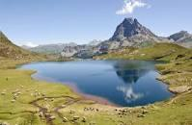 | 2
2 | The volume of a cube is increasing at the rate of 9 cm³/s.  How fast is its surface area increasing when the length of an edge is 10 cm? | 2
3 | Find the values of x for which y = [x(x-2)]² is an increasing function. | 2
4 | The money to be spent for the welfare of the employees of a firm is proportional to the rate of change of its total revenue(marginal revenue).If the total revenue(in rupees) received from the sale of x units of a product is given by R(x)=3x²+36x+5,find the marginal revenue  when x=5.  | 2
5 | Prove that the function f given by f(x) = log sinx is strictly increasing on (0,$\frac{π}{2}$ ) and strictly decreasing on ($\frac{π}{2}$, ). | 2
6 | A car is moving along a straight road. Its position at a time t is given by  $s\left(t\right)=2t^{3}-3t^{2}-12t+1$ meters. At what time when the car changes direction?  (a)30 seconds (c)1 seconds  (b)2 seconds (d) 22 seconds  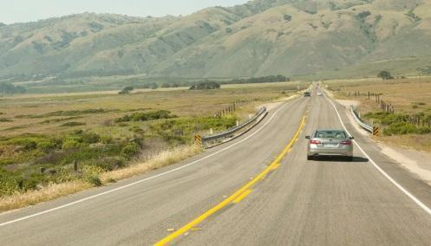 | 2
7 | A spherical snowball is melting in such a way that its radius decreasing at a rate of 0.1 cm/min. At what rate is the volume of the snowball is decreasing when the radius is 5 cm? | 2
8 | A cylindrical tank is being filled with water at a constant rate. The tank has a height of 6m and radius of 4m. If the water level rises at a rate of 2m per hour, how fast is the volume of water increasing when the water level is 3m high?  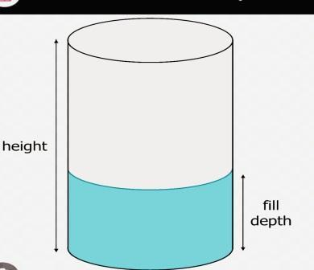 | 2
9 | A stone is dropped into a calm lake, creating a circular ripple that expands at a rate of 1.5m/s. Find the rate at which the area of the ripple is increasing when the radius is 4m. | 2
10 | The side length of a square is increasing at a rate of 2cm/s. At what rate is the area of the square increasing when the side length is 5cm? | 2
 | ANSWERS | 2
1 | Let x be the radius and A be the area of circle  $\frac{dx}{dt}$ = 5 cm/s  A = $π$r²  $\frac{dA}{dt}$ =2$πr\frac{dx}{dt}$ = 2$π$ x 8 x 5 = 80$π$cm²/s | 2
2 | Let V be the volume and S be the surface area of cube of side x cm.  $\frac{dV}{dt}$ = 9 cm³/s  V = x³  $\frac{dV}{dt}$ = 3x².$\frac{dx}{dt}$  $\frac{dx}{dt}$ = $\frac{3}{x^{2}}$  Again S = 6x²  $\frac{dS}{dt}$ =12x . $\frac{3}{x^{2}}$ = 36/x = 36/10 = 3.6 cm²/s | 2
3 | Y=[x(x-2)]²  $\frac{dy}{dx}$ = 2[x(x-2)] x (2x-2) = 4x(x-1)(x-2) , critical points x=0/1/2  For increasing function $\frac{dy}{dx}$ $>$ 0  From sign rule  y increasing for x$ϵ$ (0,1) $∪$ (2,$∞)$ | 2
4 | R(x)=3x²+36x+5  $\frac{dR}{dx}$ = 6x +36  $\frac{dR}{dx}$at x= 5 is 66 | 2
5 | f’(x) =$\frac{1}{sinx}$ . cosx = cotx  When x $ϵ$ (0,$\frac{π}{2}$ ) then f’(x) $>$ 0 and when x $ϵ$ ($\frac{π}{2}$, $π$ ) then f’(x) $<$ 0  So, f(x) is strictly increasing on (0,$\frac{π}{2}$ ) and strictly decreasing on ($\frac{π}{2}$, ). | 2
6 | Given, position of a car at time t is given as $s\left(t\right)=2t^{3}-3t^{2}-12t+1$  A car changes direction when its velocity changes its sign. So the velocity is the derivative of the position at time t.  i.e. $v\left(t\right)$=$s^{'}\left(t\right)$  So in order to know when the velocity changes we have to set $v\left(t\right)=0$.  $6t^{2}-6t-12$=0  Or $t^{2}-t-2$=0  Or $\left(t-2\right)\left(t+1\right)=0$  So, $t=2 or t=-1$  As time can’t be negative so the car changes its direction at 2 seconds. | 2
7 | There is a snowball of spherical shape. Let its radius be $r$.  Then the volume of the snowball is same as the volume of the sphere with radius $r.$  The volume of the sphere is $v=\frac{4}{3}πr^{3}$  Now $\frac{ⅆv}{ⅆt}=4πr^{2}\frac{ⅆr}{ⅆt}$  Since the radius is decreasing so $\frac{ⅆr}{ⅆt}=-0.1$cm/min and radius is 5cm so  $\frac{ⅆv}{ⅆt}=4π{\left(5\right)}^{2}\left(-0.1\right)= -10π$ cm³ /min.  So the volume of the snowball is decreasing at a rate of $10π$ cm³/min. | 2
8 | If $r$ is the radius of the cylindrical tank and its height is $h$ then volume of the cylindrical tank will be  $v=πr^{2}h$  Given that $\frac{ⅆh}{ⅆt}$= 2 m/hr , $h$ = 3m and $r$ = 4m  Now  $\frac{ⅆv}{ⅆt}=2πrh\frac{ⅆv}{ⅆt}+πr^{2}\frac{ⅆh}{ⅆt}$  $$\frac{ⅆv}{ⅆt}=2π\left(4\right)\left(3\right)\left(0\right)+π{\left(4\right)}^{2}\left(2\right)$$  =$32π$ m3/hr  The volume of water is increasing at a rate of 32$π$cubic meters per hour. | 2
9 | Let r be the radius of the circular ripple and A be the area of the ripple.  The area A of a circle is A=πr²  Differentiate A with respect to time t:  $\frac{ⅆA}{ⅆt}$=2πr$\frac{ⅆr}{ⅆt}$  Given $\frac{ⅆr}{ⅆt}$=1.5m/s and r=4m, substitute and solve for $\frac{ⅆA}{ⅆt}$:  $\frac{ⅆA}{ⅆt}$=2π(4)⋅1.5=12πm²/s  So, when the radius of the ripple is 4 m4m, the area of the ripple is increasing at a rate of12πm²/s. | 2
10 | Let s be the side length of the square and A be the area of the square.  The area A of a square is A=s²  Differentiate A with respect to time t:  $\frac{ⅆA}{ⅆt}$​=2s$\frac{ⅆs}{ⅆt}$​  Given $\frac{ⅆs}{ⅆt}$=2cm/s and s=5cm, substitute and solve for $\frac{ⅆA}{ⅆt}$:  $\frac{ⅆA}{ⅆt}$=2(5)⋅2=20cm²/s  So, when the side length of the square is 5cm, the area of the square is increasing at a rate of 20cm2/s. | 2
 | 3 – MARKS TYPE QUESTIONS
1 | Sand is pouring from a pipe at the rate of 12 cm³/s.The falling sand forms a cone on the ground in such a way that the height of the cone is always one-sixth of the radius of the base.How fast is the height of the sand cone increasing when the height is 4 cm ? 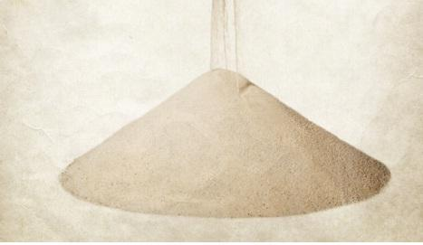 | 3
2 | Prove that y = $\frac{4sinθ}{(2+cosθ)}$ – $θ$ is increasing function of $θ$ in [ 0,$\frac{π}{2}$ ]. | 3
3 | A rectangular sheet of tin 45 cm by 24 cm is to be made into a box without top,by cutting off square from each corner and folding up the flaps.What should be the side of the square to be cut off so that the  volume of the box is maximum? 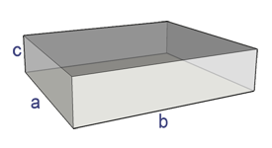 | 3
4 | A wire is 12 meters long. If the wire is cut into two pieces and each piece is bent to form a square, find the lengths of the sides of the squares to maximize the total area. | 3
5 | A kite is flying at a height of 50m above the ground. The kite string is attached to a point on the ground 100m away from the person flying the kite. The string is being let out at a rate of 2m/s. How fast is the kite rising when it is 150m away from the person?  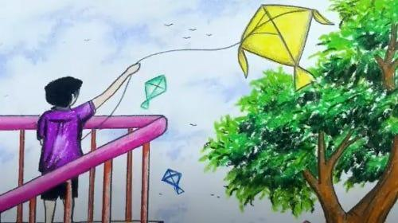 | 3
6 | A rocket is fired vertically upwards. It ascends with a velocity given by v=50t−5t², where t is the time in seconds and v is the velocity in m/s. Find the maximum height reached by the rocket and the time at which it occurs.   | 3
7 | Read the following passage and answer the questions given below.  In a street two lamp posts are 300 feet apart. The light intensity at a distance d from the first (stronger) lamp post is 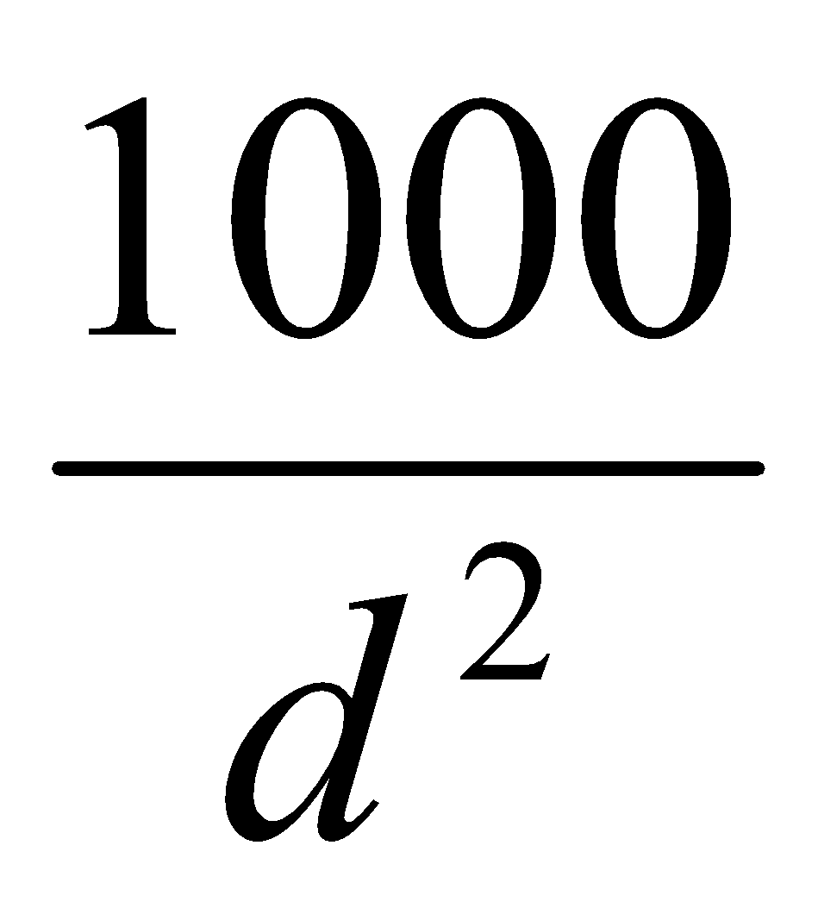, the light intensity at distance d from the second (weaker) lamp post is 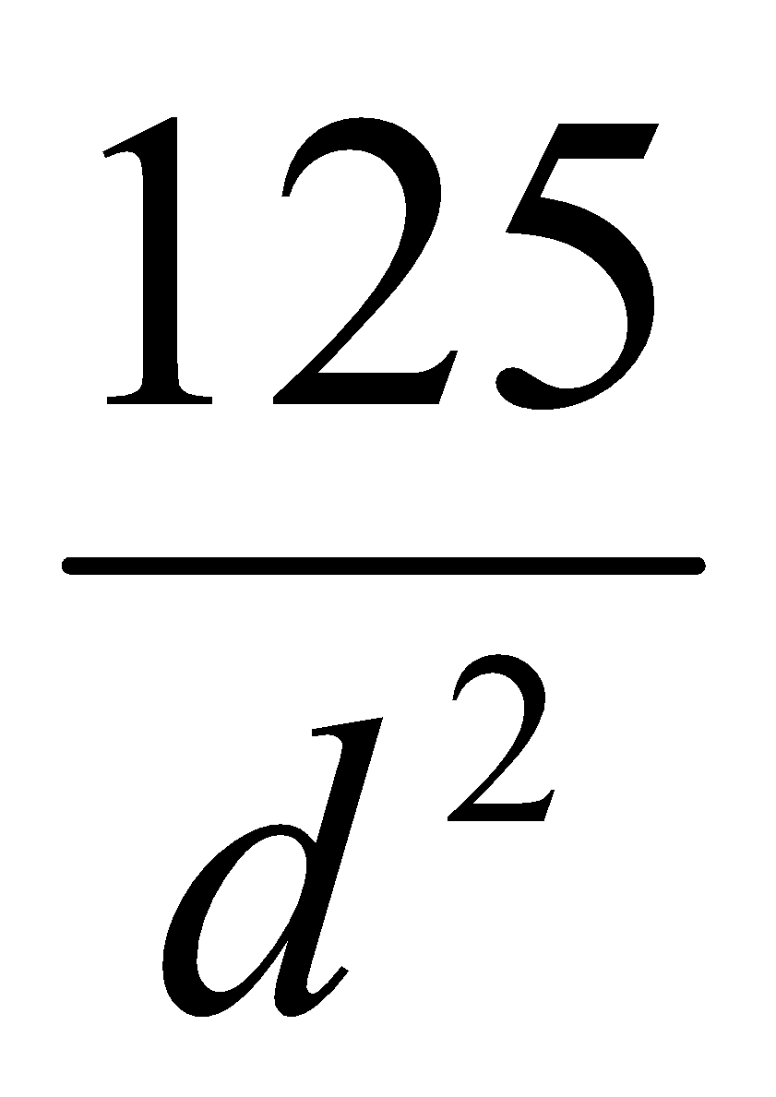 (in both cases the light intensity is inversely proportional to the square of the distance to the light source).  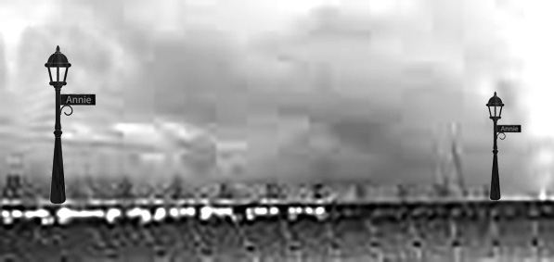  The combined light intensity is the sum of the two light intensities coming from both lamp posts.  Find the distance of the darkest spot between the two lights? | 3
8 | Read the following passage and answer the questions given below:  Some young entrepreneurs started an industry “Young achievers” for casting metal into various shapes. They put up an advertisement online stating the same and expecting order to cast method for toys, sculptures, decorative pieces and more.  A group of friends wanted to make innovative toys and hence contacted the “Young achievers” to order them to cast metal into solid half cylinders with a rectangular base and semicircular ends.  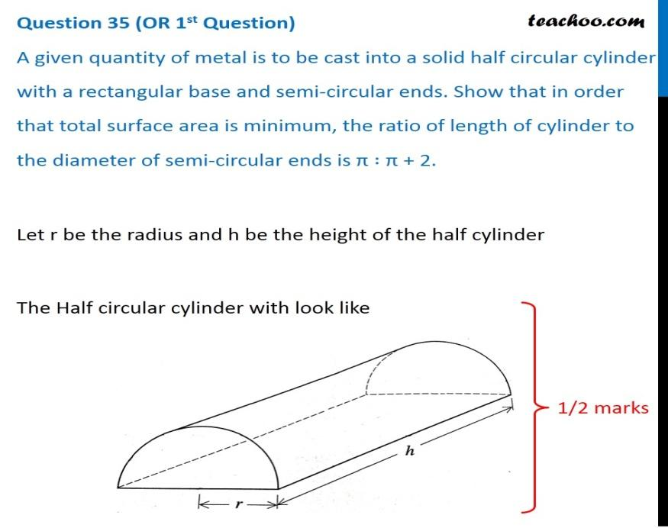  (i)For the given volume V, Find the condition for the total surface area S to be minimum.  (ii) Use second derivative test to prove that Surface area is minimum for given volume.  OR  (ii) Find the ratio h: 2r for S to be minimum. | 3
9 | Find the intervals in which the function f given by$f\left(x\right)=sinx+cosx,$Where $0≤x≤2π,$is strictly increasing or strictly decreasing. | 3
 | ANSWERS
1 | V =$\frac{1}{3}π$r²h,  Given $\frac{dV}{dt}$ = 12 cm³/s  Or,$\frac{d}{dt}$($\frac{1}{3}π$r²h) = 12  Or,r = 6h  Now $\frac{d}{dt}$($\frac{1}{3}π$(6h)²h) = 12  Or,$\frac{dh}{dt}$ = 1/3$π$h²  When h= 4 cm,$\frac{dh}{dt}$ = 1/48$π$. | 3
2 | y = $\frac{4sinθ}{(2+cosθ)}$ – $θ$  $\frac{dy}{dx}$ =$\frac{\left(2+cosθ\right).4cosθ-4 sinθ.(θ-sinθ)}{{(2+cosθ)}^{2}}$ – 1 = $\frac{ cosθ.(4-cosθ)}{{(2+cosθ)}^{2}}$  $\frac{dy}{dx}$ $>$ 0 for$θ$ $∈$ [ 0,$\frac{π}{2}$ ] i.e increasing function in [ 0,$\frac{π}{2}$ ]. | 3
3 | Let x be the length of square  V = (45-2x)(24-2x).x  $\frac{dV}{dx}$= 12x²- 276x +1080 = 12(x-18)(x-5)  For maximum $\frac{dV}{dx}$ = 0, x = 5,18  X = 18 is not possible as breadth is 24 cm.  $\frac{d^{2}V}{dx^{2}}$ at x = 5 is - 156 $<$ 0( x = 5 is the point of maximum). | 3
4 | Let x be the length of one piece of wire, so the length of the other piece is 12−x.  Each piece is bent into a square, so the sides of each square are s=$\frac{x}{4}$​.  The total area A of the two squares is A=2s².  Substitute s=4x​ into the area equation:  A=2($\frac{x}{4}$)²=$\frac{x^{2}}{8}$  Differentiate A with respect to x, set the derivative to 0, and solve for x:  $\frac{ⅆA}{ⅆx}$=$\frac{2x}{8}$=$\frac{x}{4}$  Setting $\frac{ⅆA}{ⅆx}$=0: $\frac{x}{4}$=0, which has no solution.  So, there are no critical points for A and no maximum or minimum.  Since the wire is 12 meters long, we must have x+(12−x)=12, which means x=6.  The lengths of the sides of the squares are s=$\frac{x}{4}$​=$\frac{6}{4}$​=$\frac{3}{2}$​ meters. | 3
5 | Let x be the horizontal distance from the person to the point directly below the kite, and let h be the height of the kite above the ground.  Given h=50m, $\frac{ⅆx}{ⅆt}$​=2m/s, and x=100m, we want to find $\frac{ⅆh}{ⅆt}$ when x=150m.  By the Pythagorean theorem, x²+h²=d², where d is the length of the kite string. Since the string is being let out at a constant rate, $\frac{ⅆx}{ⅆt}$=2m/s.  Differentiate both sides of the equation with respect to time t:  2x$\frac{ⅆx}{ⅆt}$+2h$\frac{ⅆh}{ⅆt}$​=2$\frac{ⅆd}{ⅆt}$​  Substitute the given values:  2(100)(2)+2(50)$\frac{ⅆh}{ⅆt}$=2(2)  400+100$\frac{ⅆh}{ⅆt}$=4  Solve for $\frac{ⅆh}{ⅆt}$​:  100$\frac{ⅆh}{ⅆt}$=4−400  100$\frac{ⅆh}{ⅆt}$​=−396  $\frac{ⅆh}{ⅆt}$=−396/100​  $\frac{ⅆh}{ⅆt}$=−3.96m/s  So, when the kite is 150m away from the person, the kite is rising at a rate of 3.96m/s downwards . | 3
6 | Given the velocity function v=50t−5t2, we want to find the maximum height reached by the rocket and the time at which it occurs.  The height h of the rocket can be determined by integrating the velocity function:  h=∫v dt=∫ (50t−5t²) dt  h=25t²−$\frac{5}{3}$t³+C  To find the constant C, we can use the initial condition that at t=0, ℎ=0  0=25(0)²−$\frac{5}{3}$ (0)³+C  C=0  So, the height function is h=25t²−$\frac{5}{3}$​t³  To find the maximum height, we need to find the critical points of h by differentiating with respect to t and setting the derivative equal to 0:  $\frac{ⅆh}{ⅆt}$​=50t−5t²  Setting $\frac{ⅆh}{ⅆt}$=0:  0=50t−5t2  0=t(50−5t)  This gives t=0 and t=10 as critical points.  Evaluate the height at these critical points:  h(0)=25(0)²−$\frac{5}{3}$ (0)³=0  h(10)=25(10)²−$\frac{5}{3}$ (10)³=2500−$\frac{5000}{3}$=$\frac{500}{3}$​m  So, the rocket reaches a maximum height of$\frac{500}{3}$ ​ m at t=10 seconds. | 3
7 | We have l(x) = 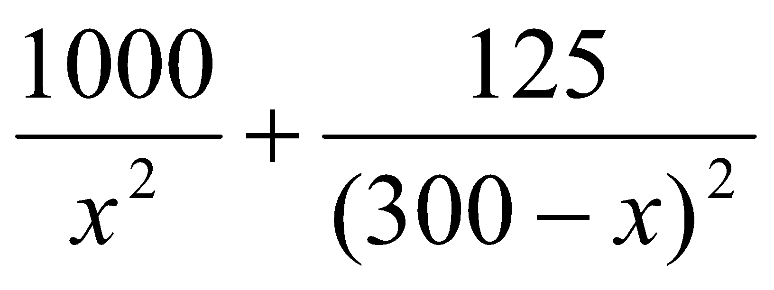  l’(x) = 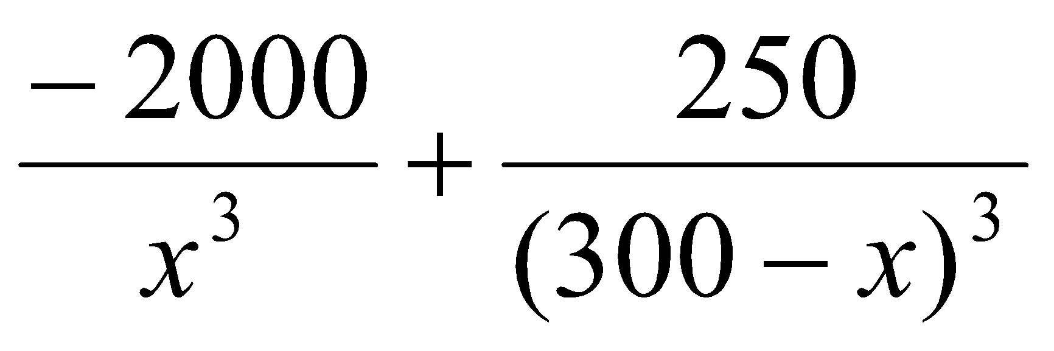  l’(x) = 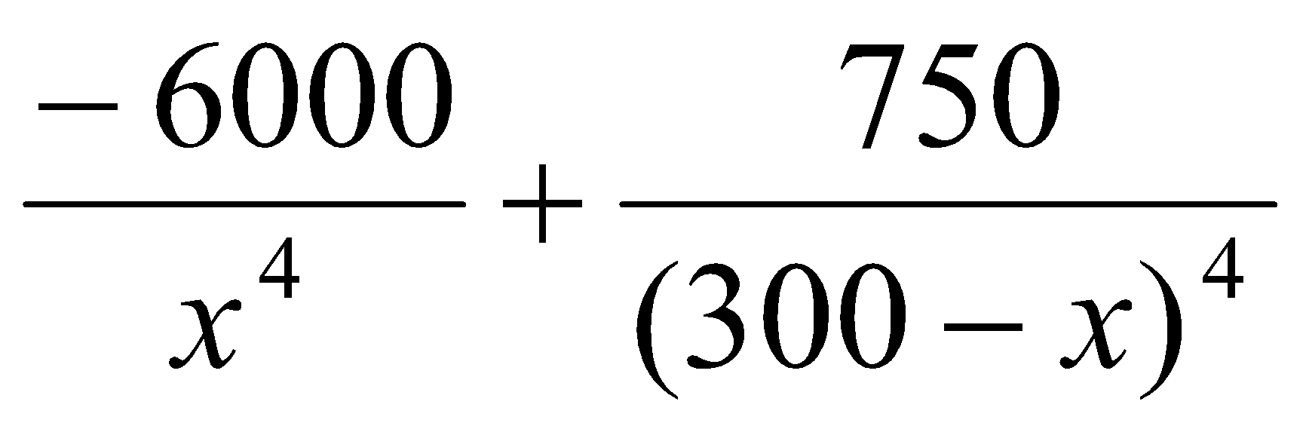  _{For maxima / minima, l’(x) =0}  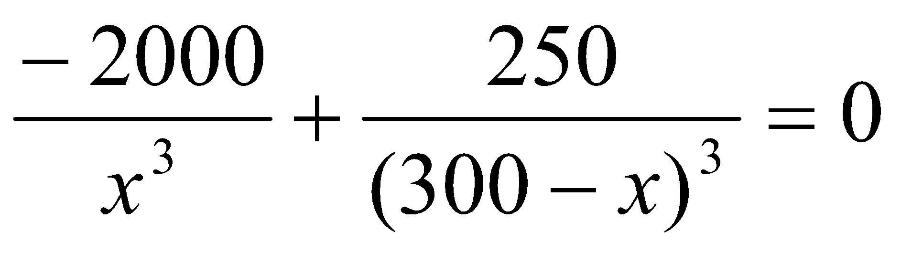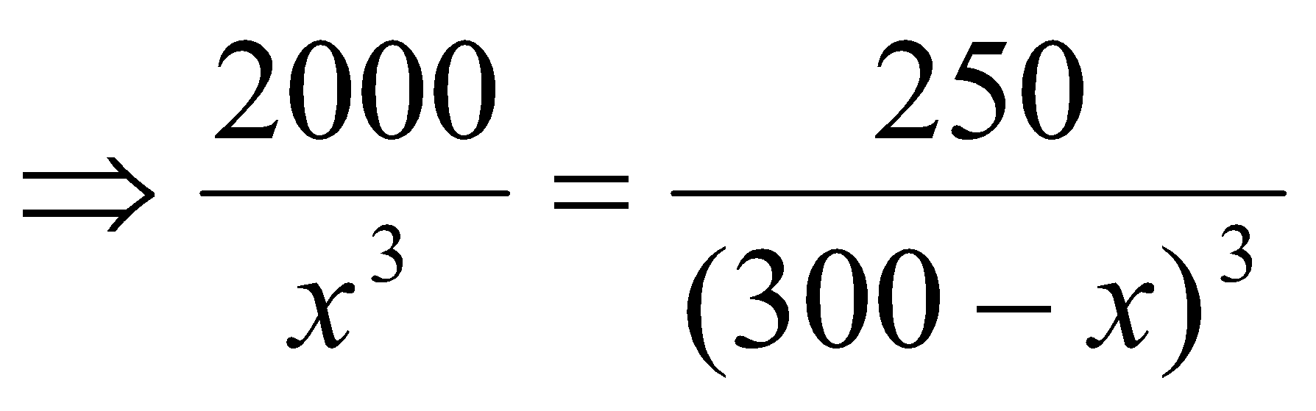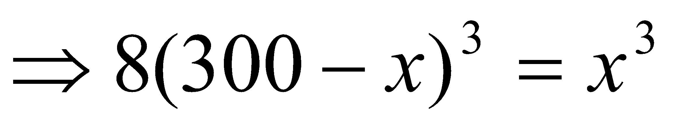  Taking cube root on both sides, we get  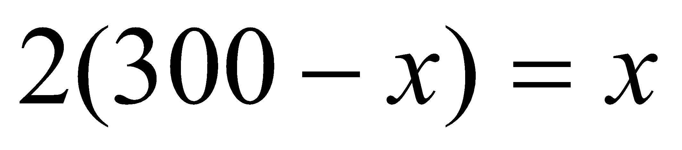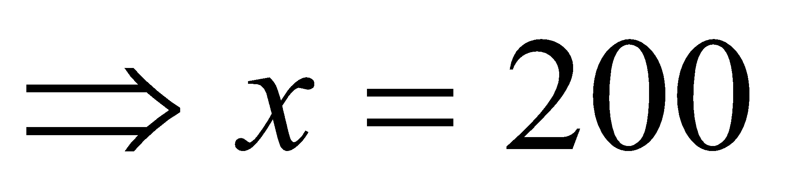  Thus l(x) is minimum when you are at 200 feet from the strong intensity lamp post.  Since, l(x) is minimum when x = 200 feet,  therefore the darkest spot between the two light is at a distance of 200 feet from stronger lamp post, i.e., at a distance of 300 – 200 = 100 feet from the weaker lamp post. | 3
8 | (i) 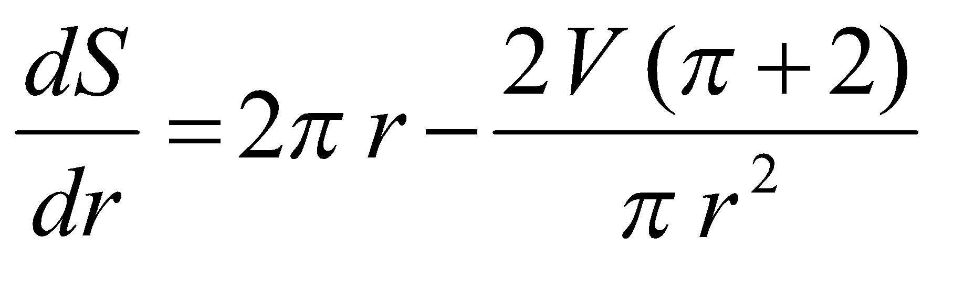  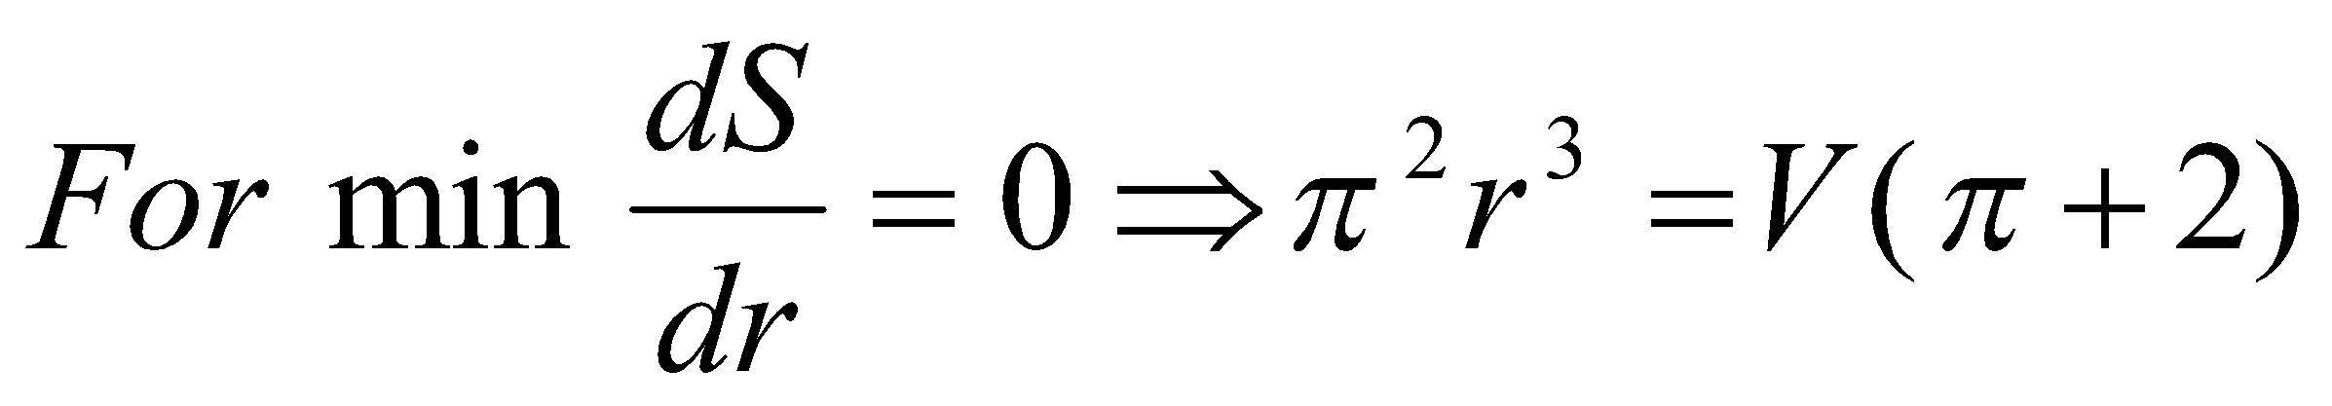  (ii)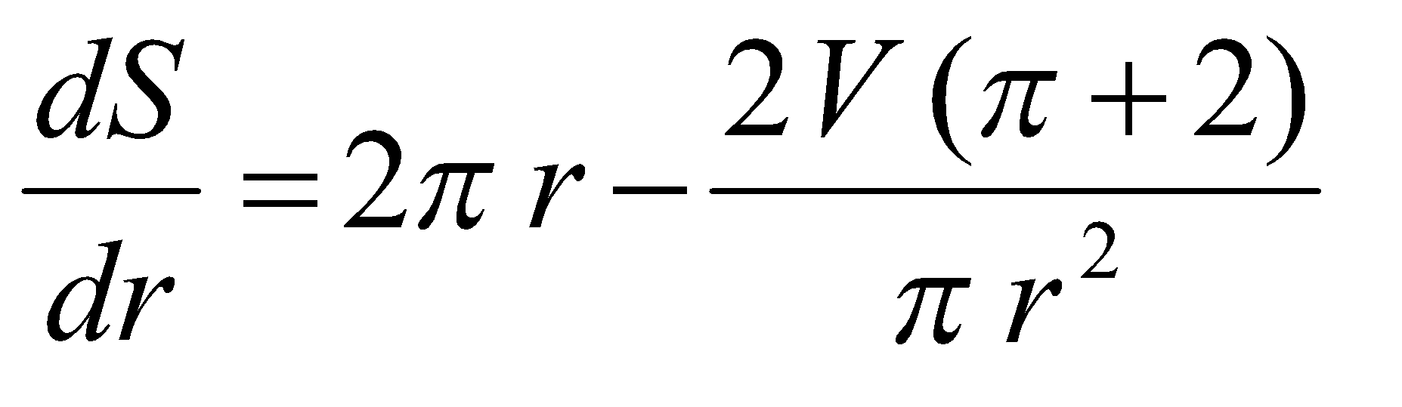  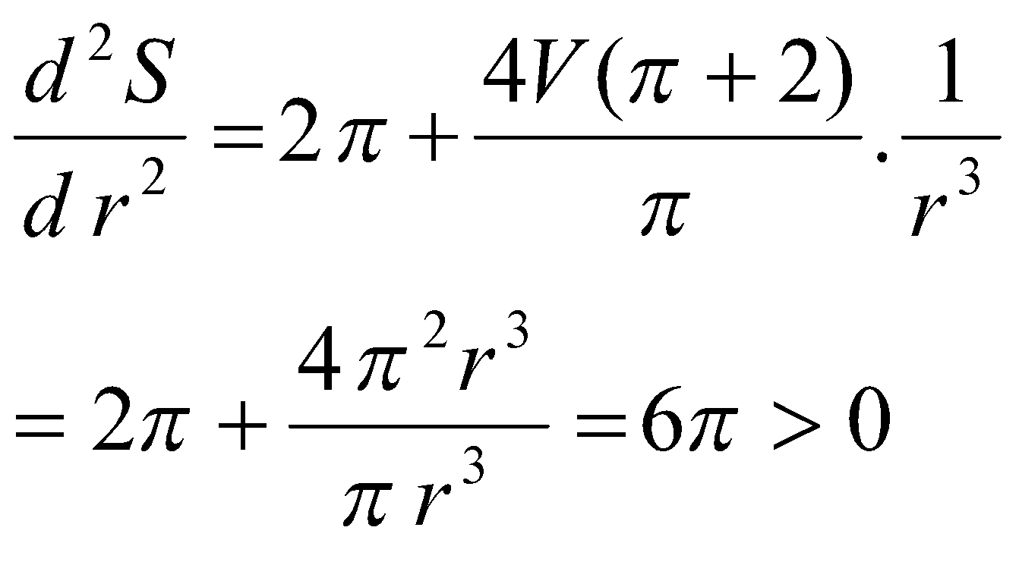  OR  Since 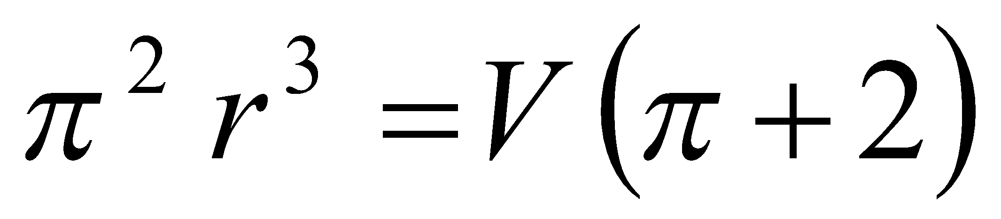  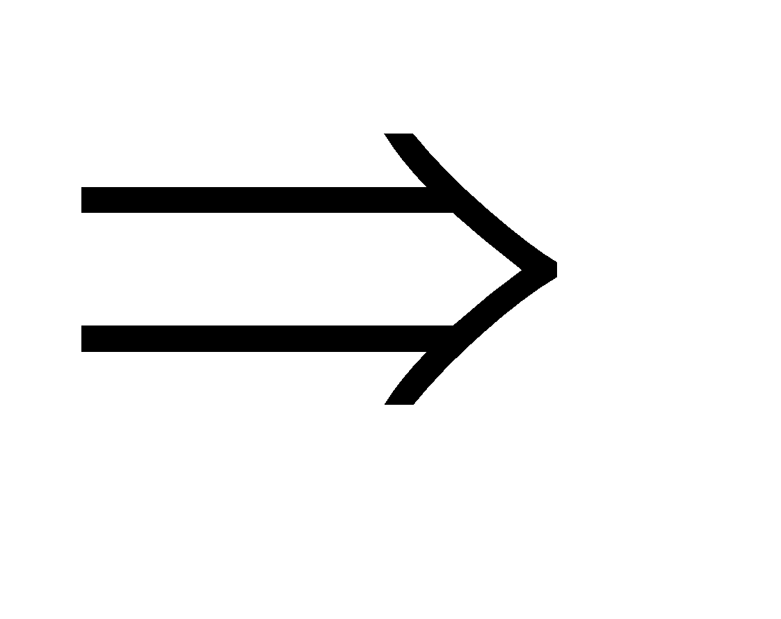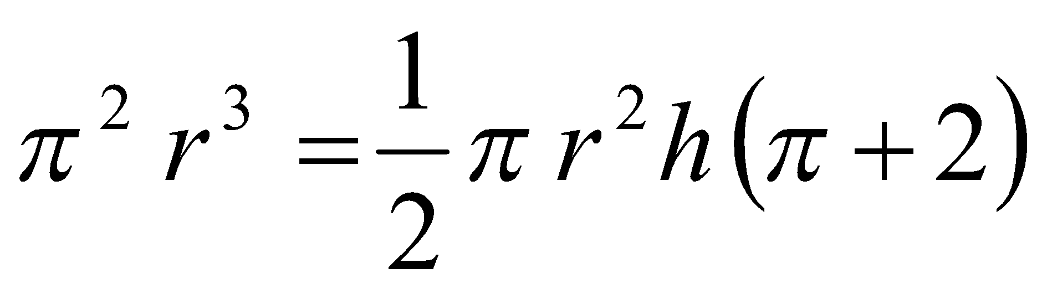  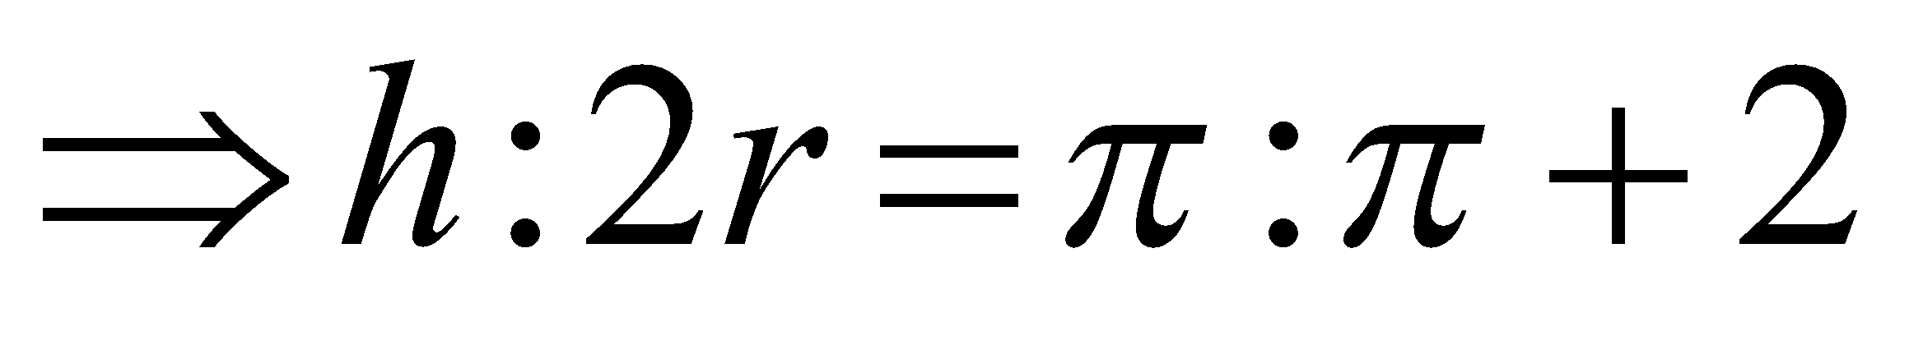 | 3
9 | [0, π/4),( π/4, 5π/4) and(5 π/4, 2π]  checking in each interval, for Strictly increasing & Strictly decreasing | 3
 | 4 – MARKS TYPE QUESTIONS (CASE BASED QUESTIONS)
1 | A real estate company is going to build a new apartment complex. The land they have purchased can hold at most 5000 apartments. Also, if they make x apartments, then the maintenance costs for the building, landscaping etc., would  be as follows:  Fixed cost = Rs 40,00,000  Variable cost =Rs (140x – 0.04x²)  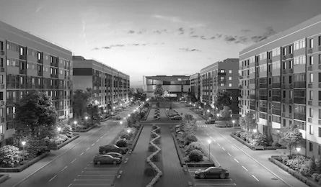  If C(x) denote the maintenance cost function, then C(x) = 40,00,000 + 140x – 0.04x²  (i) Find the intervals in which the function C(x) is strictly increasing/strictly decreasing.  (ii) Find the points of local maximum/local minimum, if any, in the interval (0, 5000) as well as the points of absolute maximum/absolute minimum in the interval [0, 5000]. Also, find the corresponding local maximum/local minimum and the absolute  maximum/absolute minimum values of the function. | 4
2 | 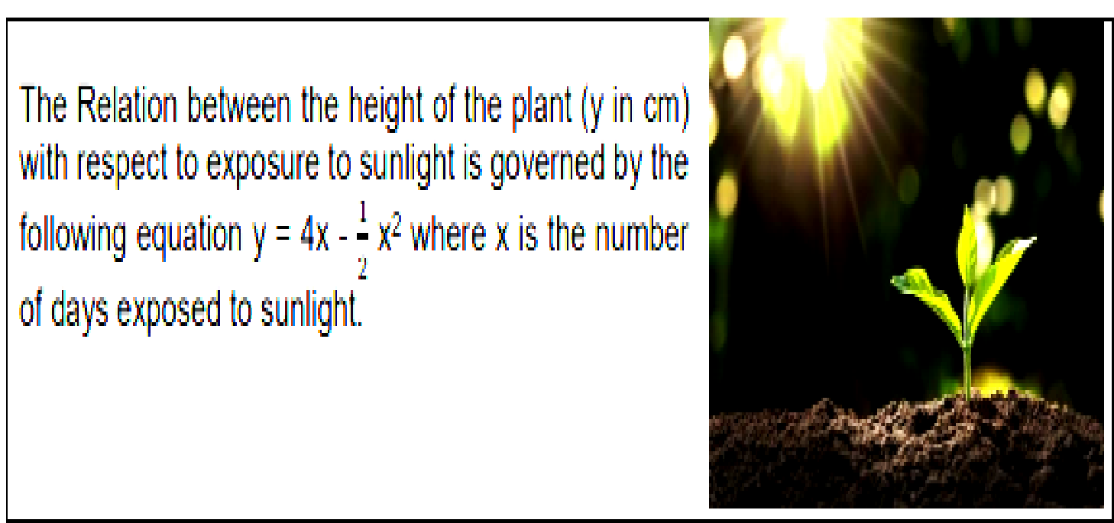  The relation between the height of the plant (y in cm) with respect to exposure to sunlight is governed by the equation $y=4x- \frac{x^{2}}{2}$ , where x is the number of days exposed to sunlight.  - What is the rate of growth of plant?  - On which day the plant attains the maximum height.  - What is the maximum height of the plant?  OR  What is the height of the plant after two days? | 4
3 | Read the passage given below and answer the following questions. To become fit and fine every person does some physical work or exercises. One morning two friends Mohan and Ahmed went for a morning walk in a park. They have decided to choose two different parabolic paths whose equations are y² = 4x(Mohan) and x² = 4y(Ahmed) respectively for their walk.  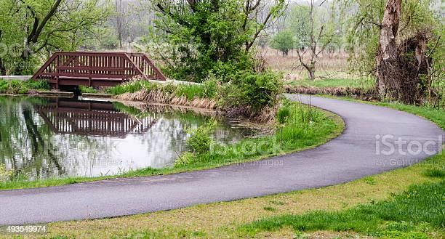  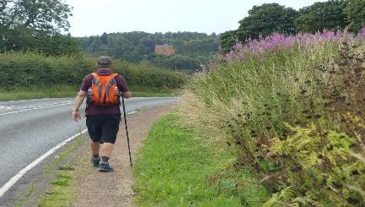  (i) The point at which both the paths meet is  (A) (0, 4) (B) (4, 0) (C) (0. 0) and (4, 4) (D) they never meet.  (ii) At the point (0, 0) the tangent to the curve y² = 4x is  (A) parallel to the x-axis. (B) parallel to the y-axis.  (C) parallel to the line y = 0. (D) perpendicular to the line x = 0.  (iii) At the point (0, 0) the tangent to the curve x² = 4y is  (A) parallel to the x-axis (B) parallel to the y-axis  (C) perpendicular to the line y = 0. (D) Parallel to the line x = 0.  (iv) At the point (0, 0) the angle between the tangents to the curve x² = 4y and y² = 4x is  (A) 0 (B) $\frac{π}{4}$(C) $\frac{π}{2}$ (D) $\frac{π}{3}$ | 4
4 | Read the passage given below and answer the following questions.  Let P(x) = 4x³ – 6x² – 72x + 30 is the total profit function of a company, where x is the production of the company.    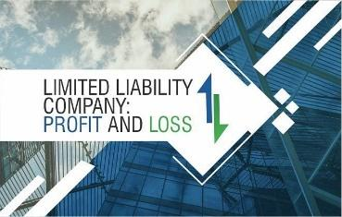  (i) What is the value of P’(x)?  (A) 12 x² - 12 x + 72 (B)12 x² + 12 x – 72 (C) x² - x – 6 (D) 12 x² -12x - 72  (ii) Determine the critical points of the profit function?  (A) -2, -3 (B) -2, 3 (C) 2, -3 (D) 2, 3  (iii) Check in which interval the profit is strictly increasing.  (A) (– ∞, – 2] $∪$ (3, ∞) (B) (– ∞, – 2] $∩$ [3, ∞)  (C) (– ∞, – 2) $∪$ (3, ∞) (D) (– ∞, – 2) $∪$ (3, ∞)  (iv) Check in which interval the profit is strictly decreasing.  (A) [ -2, 3} (B) [ -2, 3) (C) (– 2, 3). (D) (-2, 3] | 4
5 | An open box is to be made out of a piece of cardboard measuring 24 cm x 24 cm by cutting of equal squares from the corners and turning up the sides.  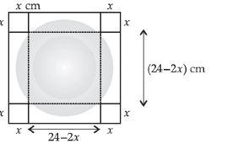  Based on this information answer all the following Questions.  (i)The volume V(x) of the open box is  $a) 4x^{3}-96x^{2}+576x$ b) $4x^{3}+96x^{2}+576x$  c) $2x^{3}-48x^{2}+288x$ d) $2x^{3}+48x^{2}+288x$  ( ii)The value of $\frac{dV}{dx}$ is  a) $12(x^{2}+16x-48)$ b) $12(x^{2}-16x+48)$  c) $6(x^{2}+8x-24)$ d) $6(x^{2}-8x+24)$  (iii)The value of $\frac{d^{2}V}{dx^{2}}$ is  a) $24(x+8)$ b) $12(x-4)$ c) $24(x-8)$ d) $12(x+4)$  (iv)For what value of the height, the volume of the open box is maximum  a) 3 cm b) 9 cm c) 1 cm d) 4cm | 4
6 | A man has an expensive square shape piece of golden board of size 24 cm is to be made into a box without top by cutting from each corner and folding the flaps to form a box.  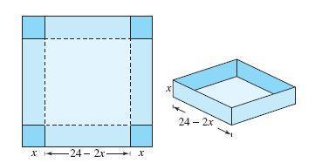  (i) Volume of open box formed by folding up the flap:  (a) 4(x3 – 24x2 + 144x) (b) 4(x3– 34x2 + 244x)  (c) x3 – 24x2 + 144x (d )4x3 – 24x2 + 144x  (ii) What should be the maximum volume of open box?  (a) 1034 cm3 (b) 1024 cm3 (c )1204 cm3 (d )4021 cm3  (iii) What should be the side of the square piece to be cut from each corner of the board to behold the maximum volume?  (a) 14 cm (b)12 cm (c )4 cm (d )5 cm  (iv) What are the dimensions cuboid i.e. l,b,h  (a ) 16,12,4 (b) 16,16,4 (c )18,16,4 (d )4,4,4 | 4
7 | Sai Chandan wants to construct a rectangular boundary for some area in his land for growing a vegetable garden. The boundary should be constructed in such a way that one side must be of bricks and the other three sides must be of wires. He has 200 m of fencing wire.  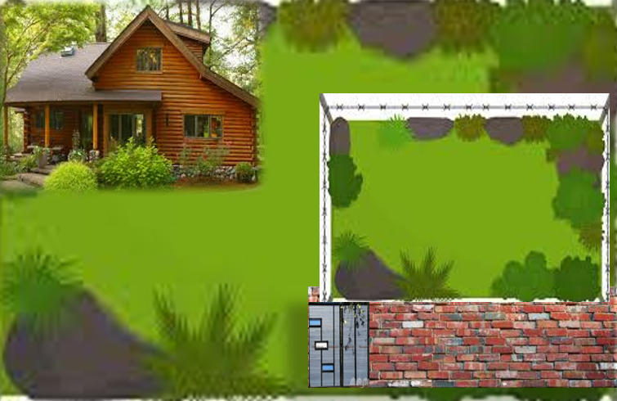  Based on the above information, answer the following questions:  (i) What needs to be maximized to construct the garden using 200 m of fencing wire?  (ii) If x denotes the length of side of boundary perpendicular to brick wall and y denotes the length of side parallel to brick wall, then find the relation representing total amount of fencing wire.  (iii) Find area of the boundary say A(x) in terms of x and also find the value of x at which the area will be maximum.  Find the dimension of the garden for which area is maximum. | 4
 | ANSWERS
1 | (i) We have C(x) = 40,00,000 + 140x – 0.04x²  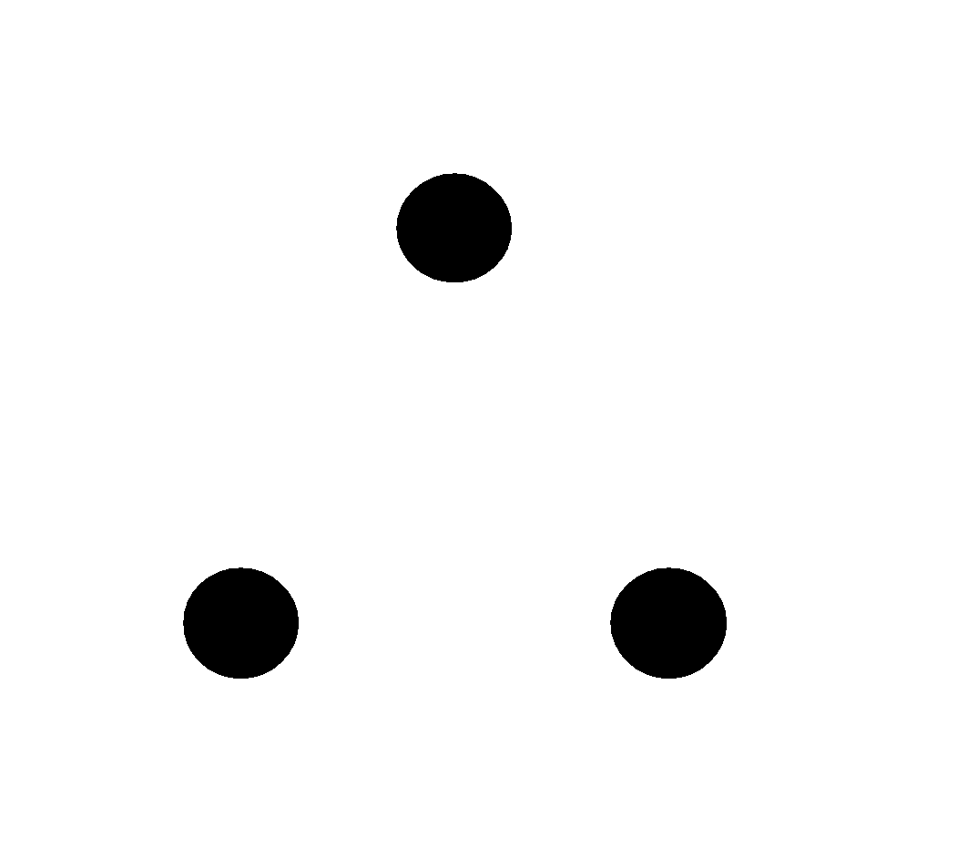C’(x) = 140 – 0.08x  For finding critical points,put C’(x) = 0  Then 140 – 0.08x = 0 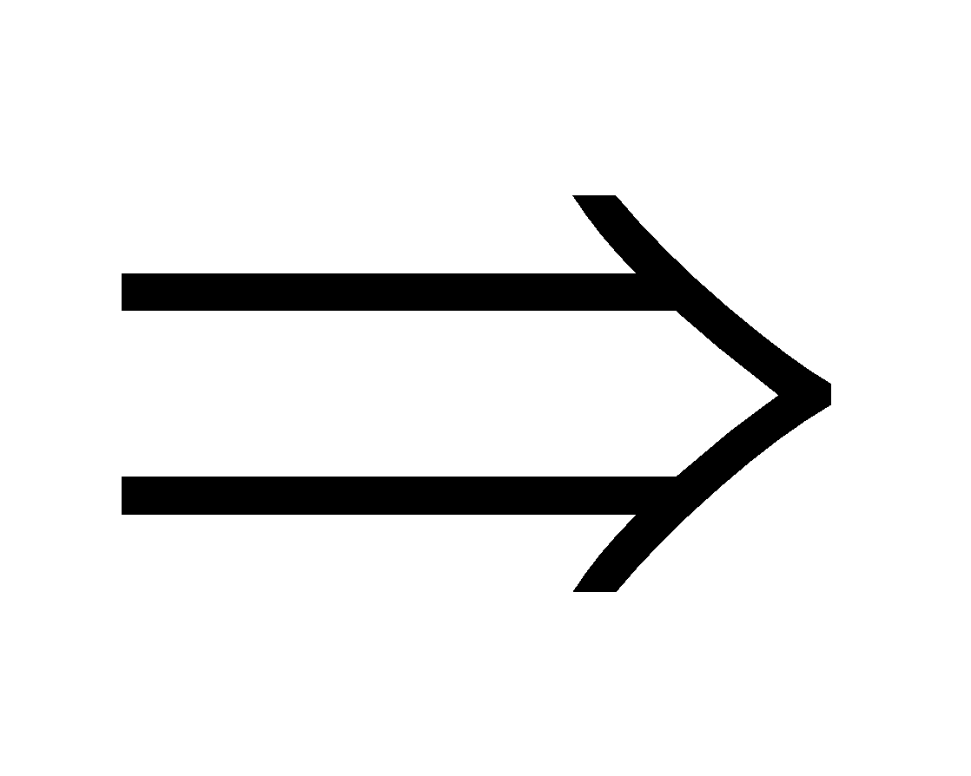x = 1750  Clearly, from the problem statement we can see that we only want critical points that are in the interval [0, 5000]  Intervals are (0, 1750), (1750,5000)  In Interval (0, 1750), C’(x) = Positive  C(x) is strictly increasing in [0, 1750]  In Interval (1750,5000), C’(x) = Negative  C(x) is strictly decreasing in [1750, 5000].  (ii)We have C(x) = 40,00,000 + 140x – 0.04x²  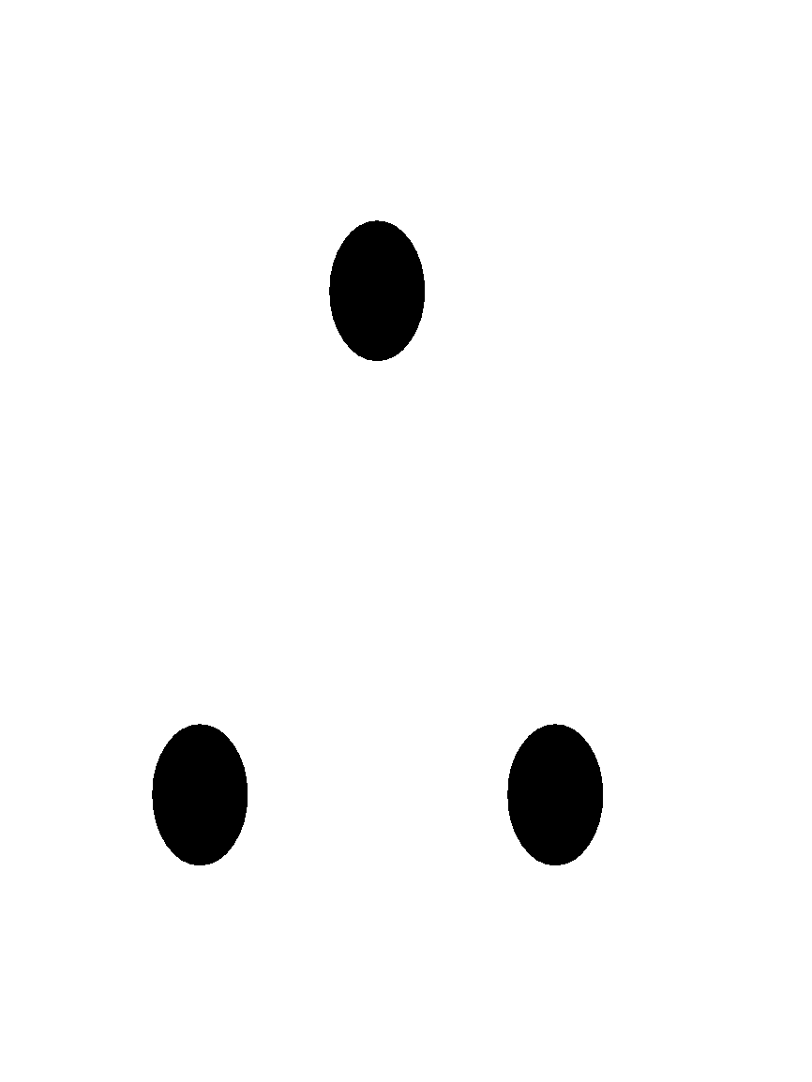C’(x) = 140 – 0.08x  C’’(x) = - 0.08  C’’(x)|_{x=1750}= -0.08 < 0  C(x) is Maximum at x = 1750 and Local Maximum Value = C (1750) = 4122500  Clearly, from the problem statement we can see that we only want critical points that are in the interval [0, 5000]  Now we have C (0) = 40, 00000  C (1750) = 4122500  C (5000) = 3700000  Absolute Maximum value of C(x)=4122500 | 4
2 | (i) As the height of the plant is given by  $$y=4x-\frac{1}{2}x^{2}$$  The rate of growth of plant is given by differentiating the above equation w.r.t x  $$y^{'}\left(x\right)=4-x$$  (ii) Maximum value of the given equation is  $$y^{'}\left(x\right)=0⟹x=4$$  So, the maximum height of the plant is on day x=4,  $$\left(iii\right) y\left(4\right)=4×4-\frac{1}{2}4^{2}=8$$  So, maximum height of plant is 8 cm.  OR  The height of the plant after x=2 days is  $$y\left(2\right)=4×2-\frac{1}{2}2^{2}=6$$  So, after two days height of the plant is 6 cm. | 4
3 | (i) C (ii) B (iii) A (iv) C | 4
4 | (i) D (ii) B (iii) D (iv) C | 4
5 | (i) A (ii) B (iii) C (iv) A | 4
6 | (i) A (ii) B (iii) C (iv) B | 4
7 | - To construct the garden using 200m of fencing wire, area to be maximized.  - 2x + y = 200  - A(x) = xy = x(200 - 2x) = 200x – 2x²  A^{I}(x) = 200 – 4x  A^{I}(x) = 0  - 200 – 4x = 0  - x = 50m  A^{II}(x) = - 4 < 0  - Area is maximum at x = 50m  - Area is maximum at x = 50m  2x + y = 200  y = 200 – 2x = 100  hence the dimension of the garden for which area is maximum is:  x = 50m & y = 100m | 4
 | 5 – MARKS TYPE QUESTIONS
1 | On the request of villagers,a construction agency designs a tank with the help of an architect.Tank consists of rectangular base with rectangular sides, open at the top so that its depth is 2m and volume is 8m³ as shown below:- 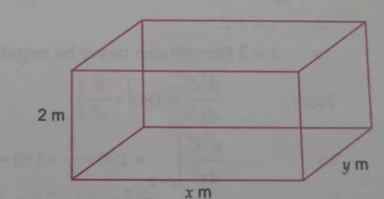  (i)If x and y represent the length and breadth of its rectangular base,then the relation between the variables is  (a) x+y = 8 (b) x.y = 4 (c) x+y = 4 (d) $\frac{x}{y}$ = 4  (ii) If construction of tank cost Rs.70 per sq.metre for the base and Rs.45 per sq.metre for sides,then making cost ‘C’ expressed as a function of x is  (a) C= 80+80(x+$\frac{4}{x}$) (b) C= 280x+280(x+$\frac{4}{x}$) (c) C= 280+180(x+$\frac{4}{x}$) (d) C= 70+70(x+$\frac{4}{x}$)  (iii)The owner of a construction agency is interested in minimizing the cost ‘C’ of whole tank,for this to happen the value of x should be  (a) 4m (b) 3m (c) 1m (d) 2m  (iv)For minimum cost ‘C’ the value of y should be  (a) 1m (b) 3m (c) 2m (d) 4m  (v)The Pradhan of village wants to know minimum coat.The minimum cost is Rs.  (a)2000 (b) 4000 (c) 11000 (d) 1000 | 5
2 | A helicopter is flying along the curve represented by y = x²+7.A soldier placed at (3,7) wants to shoot down the helicopter when it is nearest to him.  (i)If(x₁,y₁) represents the position of helicopter on the curve y = x²+7,when the distance D from soldier placed at S(3,7) is minimum, then the relation between x₁,y₁ is  (a)x₁ = y₁²+7 (b) y₁ = x₁²+7 (c) y₁ + x₁² =7 (d) y₁² + x₁ = 7.  (ii)The distance ‘D’ expressed as a function of x₁ is  (a) D = x₁²-6x₁ +x₁⁴(b) D = x₁²-6x₁ +9+x₁⁴(c) D² = x₁²-6x₁ +9+x₁⁴(d) D² = x₁²+6x₁ -9+x₁⁴  (iii)The soldier at S wants to know the enemy helicopter is nearest to soldier, then the value y₁ should be  (a) 4 (b) 3 (c) 8 (d) 5  (iv)When the enemy helicopter is nearest to soldier, then the value of D should be  (a) 4 units (b) 5 units (c) $\sqrt{5}$ units (d) $\sqrt{7}$ units  (v) The nearest position of helicopter from soldier is  (a) (1,$√5$ ) (b) (1,8) (c) (1,7) (d) (1,$√7$ ) | 5
3 | A rectangular garden with an area of 60$m^{2}$ is bounded by a straight fence along three sides. The fourth side is a wall of a building. Let x be the length of the garden parallel to the wall, and y be the width of the garden perpendicular to the wall. If the rate of change of x with respect to time is 2 m/s, at what rate is the width y changing when the width is 5 m?  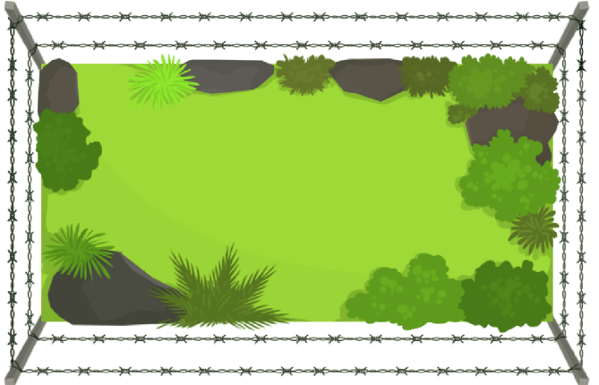 | 5
4 | A cylindrical tank with a radius of 6 meters is being filled with water at a rate of 10 cubic meters per minute. How fast is the water level rising when the water is 4 meters deep? | 5
5 | Rama wants to prepare a handmade gift box for her friend’s birthday at home. For making lower part of box, she takes a square 7piece of cardboard of side 40 cm.    Based on the above information, answer the following question:  (i) If x cm be the length of each side of the square cardboard which is to be cut off from corners of the square piece of side 40 cm , then possible value of x will be given by the interval  (A) $\left[0,20\right]$ (B) $\left(0,10\right)$(C) $\left(0,20\right)$ (D) $\left(0,40\right)$  (ii) Volume of the open box formed by folding up the cutting corner can be expressed as  (A) $V = x(20 - 2x)(20 - 2x)$(B) $V = x(40 - 2x)(40 - 2x)$  (C) $V = x(40 - 4x)(40 - 4x$) (D) $V = 2x(20 - 2x)(20 - 2x)$  (iii) The values of $x$ for which $\frac{dV}{dx}=0$ ,are  (A) 20, $\frac{20}{3}$ (B) 0, $\frac{20}{3}$ (C) 0, $\frac{10}{3}$ (D) 10, $\frac{10}{3}$  (iv) Rama is interested in maximising the volume of the box. So, what should be the side of the square to be cut off so that the volume of the box is maximum?  (A)20 cm (B) $\frac{20}{3}$ cm (C) $\frac{10}{3}$ cm (D) 10 cm  (v) The maximum value of the volume is  (A)$\frac{64000}{27}{cm}^{3}$(B) $\frac{128000}{27}{cm}^{3}$  (C) $\frac{8000}{27}{cm}^{3}$ (D) $\frac{16000}{27}{cm}^{3}$ | 5
 | ANSWERS
1 | (i)option (b) x.y = 4  (ii) option (c) C= 280+180(x+$\frac{4}{x}$)  (iii) option (d) 2 m  (iv) option (c) 2 m  (v) option (d) Rs 1000 | 5
2 | (i)option (b) y₁ = x₁²+7  (ii) option (c) D² = x₁²-6x₁ +9+x₁⁴  (iii) option (c) 8  (iv) option (c) $√5$ units  (v) option (b) (1,8) | 5
3 | Given: Area of the rectangular garden (A) = 60$m^{2}$  Rate of change of x with respect to time ($\frac{ⅆx}{ⅆt}$) = 2 m/s  Width of the garden (y) = 5m  We want to find the rate of change of y with respect to time ($\frac{ⅆy}{ⅆt}$).  The area of the rectangle is given by A=$xy$. Since A=60$m^{2}$, we have the equation $xy$=60.  Differentiate both sides of the equation with respect to time t:  $\frac{\dot{d}}{ⅆτ}\left(xy\right)=\frac{ⅆ}{ⅆt}\left(60\right)$.  Using the product rule for differentiation:  $\frac{ⅆx}{ⅆt}y+x\frac{ⅆy}{ⅆt}$=0.  Given $\frac{ⅆx}{ⅆt}$=2, y=5, and $xy$=60, we can solve for $\frac{ⅆy}{ⅆt}$ ​:  2⋅5 + x$\frac{ⅆy}{ⅆt}$=0.  10 + 5​$\frac{ⅆy}{ⅆt}$=0.  $\frac{ⅆy}{ⅆt}$=−2m/s.  So, when the width y is 5 m, the width is changing at a rate of −2 m/s. | 5
4 | Let r be the radius of the cylindrical tank and h be the height of the water.  Given r=6 meters and $\frac{ⅆv}{at}$=10 cubic meters per minute, we want to find $\frac{ⅆh}{ⅆt}$when h=4 meters.  The volume V of a cylinder is V=πr²h.  Differentiate V with respect to t:  $\frac{ⅆv}{at}$=2πrh $\frac{ⅆr}{ⅆt}$+πr²$\frac{ⅆh}{ⅆt}$  Solve for $\frac{ⅆh}{ⅆt}$  $$\frac{ⅆh}{ⅆt}=\frac{\frac{ⅆv}{dt}-2πrh\frac{ⅆr}{at}}{πr^{2}}$$  Substitute r=6, $\frac{ⅆv}{at}$=10, h=4, and $\frac{ⅆr}{ⅆt}$=0 (since the radius is constant):  $$\frac{ⅆh}{ⅆt}=\frac{10-2π(6)(4)(0)}{π{(6)}^{2}}$$  $\frac{ⅆh}{ⅆt}$​=​$\frac{10}{36π}$  So, the water level is rising at a rate of$\frac{10}{36π}$ meters per minute when the water is 4 meters deep. | 5
5 | (i) c (ii) b (iii) a (iv) b (v)b | 5

CHAPTER – 7
INTEGRALS

SYLLABUS:
Integration as inverse process of differentiation. Integration of a variety of functions by substitution, by partial fractions and by parts, Evaluation of simple integrals of the following types and problems based on them.

Fundamental Theorem of Calculus (without proof). Basic properties of definite integrals and evaluation of definite integrals.

SL NO QUESTION MARK
MULTIPLE - CHOICE QUESTIONS
1 If $\frac{d}{dx}$ [ f(x)] = ax + b and f(0) = 0 , then f(x) is equal to
a)a+b (b) $\frac{ax^{2}}{2}$ + bx (c) $\frac{ax^{2}}{2}$ + bx +C (d) b 1
2 $If I=\int{}\frac{{Sin}^{2}x -{Cos}^{2}x}{{Sin}^{2}x {Cos}^{2}x}dx, then value of I will be$.
$$\left(a\right)tantan x +coscos x +c \left(b\right) tantan x +cosec x+c$$
$\left(c\right)tantan x +cotcot x +c \left(d\right) tantan x +secsec x +c$ 1
3 $\int{}\frac{dx}{1+coscos 2x } is equal to,$
$$\left(a\right)tantan x +c \left(b\right) \frac{1}{2}tantan x +c$$
$\left(c\right)2tantan x +c \left(d\right) none of these$ 1
4 $\int_{-2}^{2}{}\left|x\right|dx is equals to,$
$\left(a\right) 0 \left(b\right)2 \left(c\right) 4 \left(d\right) 1$ 1
5 $\frac{d}{dx}\int{}f\left(x\right)dx is equals to,$
$\left(a\right) f^{'}\left(x\right) \left(b\right) f\left(x\right) \left(c\right) f\left(x^{'}\right) \left(d\right) f^{'}(x^{'})$ 1
6 $What is the value of \int_{0}^{\frac{π}{2}}{}\frac{\sqrt{tantan x }}{\sqrt{tantan x }+\sqrt{cotcot x }}dx$
$\left(a\right) \frac{π}{2} \left(b\right)\frac{π}{4} \left(c\right) \frac{π}{8} \left(d\right)\frac{π}{12}$ 1
7 $What is the value of \int_{1}^{e}{}\left(\frac{1+loglog x }{x}\right)dx$
$\left(a\right) \frac{3}{2} \left(b\right)\frac{1}{2} \left(c\right) e \left(d\right)\frac{1}{e}$ 1
8 $What is the value of \int_{-\frac{π}{2}}^{\frac{π}{2}}{}\sin^{9}xdx$

$\left(a\right) 0 \left(b\right)1 \left(c\right)-1 \left(d\right) 2$ 1
9 $Value of \int_{0}^{1}{}\left(\frac{x}{1+x}\right)dx$ is
$$\left(a\right)1-loglog 2 \left(b\right) loglog 2 -1$$
$$\left(c\right)1+loglog 2 \left(d\right) loglog 2$$
1
10 $\int_{0}^{3}{}\left[x\right]dx=$, where $\left[x\right]$ means the greatest integer less than or equal to $x.$
(a) 0 (b) 3 (c) 2 (d) 1 1
11 $\int{}xd(x^{2}+2)$
(a) $\frac{x^{2}}{2}+c$ (b) $x+c$ (c) $\frac{2x^{3}}{3}+c$ (d) $\frac{x^{4}}{4}+c$ 1
12 $\int{}2^{x}3^{x}dx$ is equal to
(a)$\frac{2^{x}}{ln2}+C$ (b) $\frac{3^{x}}{ln3}+C$ (c) $\frac{2^{x}3^{x}}{ln2 ln3}+C$ (d) $\frac{6^{x}}{ln6}+C$ 1
13 If $\int{}\frac{\sqrt{cotx}}{sinx cosx}dx=A\sqrt{cotx}+K$, then the value of A is __
(a)2 (b) 1 (c) -2 (d) -1 1
14 The anti – derivative of $\int{}\frac{\sin^{2}x}{\cos^{4}x}dx$is
(a) a polynomial of degree 5 in $sinx$
(b) a polynomial of degree 4 in $tanx$
(c) a polynomial of degree 5 in $tanx$
(d) a polynomial of degree x in $cosx$ 1
15 $\int{}\frac{x^{9}}{{\left(4x^{2}+1\right)}^{6}}dx$ is equal to
(a)$\frac{1}{5x}{\left(4+\frac{1}{x^{2}}\right)}^{-5}+C$ (c)$\frac{1}{5}{\left(4+\frac{1}{x^{2}}\right)}^{-5}+C$
(b)$\frac{1}{10}{\left(4+\frac{1}{x}\right)}^{-5}+C$ (d)$\frac{1}{10}{\left(4+\frac{1}{x^{2}}\right)}^{-5}+C$ 1
16 $\int{}\frac{dx}{x\left(x^{n}-1\right)}$ is equal to
(a) $\frac{1}{n}log\left|1-\frac{1}{x^{n}}\right|+C$ (c) $\frac{1}{n}log\left|\frac{x^{n}}{x^{n}-1}\right|+C$
(b) $\frac{1}{x^{n}}log\left|\frac{x^{n}}{x^{n}-1}\right|+C$ (d)$\frac{1}{x^{n}}log\left|\frac{x^{n}-1}{x^{n}}\right|+C$ 1
17 $\int{}\frac{3e^{x}-5e^{x}}{4e^{x}+5e^{x}}dx=Px+Qlog\left|4e^{x}+5e^{x}\right|+Constant$, then
(a)P$=\frac{-1}{8}, Q=\frac{-7}{8}$ (c) P$=\frac{1}{8}, Q=\frac{7}{8}$
(b) P$=\frac{-1}{8}, Q=\frac{7}{8}$(d) P$=\frac{1}{8}, Q=\frac{-7}{8}$ 1
18 The value of $\int_{-2}^{3}{}\left|1-x^{2}\right|dx$is
(a)$\frac{1}{3}$ (b)$\frac{14}{3}$ (c) $\frac{7}{3}$ (d) $\frac{28}{3}$ 1
19 If $\int_{0}^{π}{}xf\left(sinx\right)dx=A\int_{0}^{\frac{π}{2}}{}f\left(sinx\right)dx,$ then A is
(a)$2π$ (b)$π$(c)$\frac{π}{2}$ (d)0 1
20 $\int_{0}^{π}{}\left|sinx\right|dx$ is
(a)2 (b)$2π$ (c) $π$ (d) 0 1
21 $\int_{0}^{2}{}\left[x^{2}\right]dx$ is
(a)2 – $\sqrt{2}$ (b) 2 – $\sqrt{2}$ (c) $\sqrt{2}-1$ (d) $-\sqrt{2}-\sqrt{3}+5$ 1
22 $\int{}x^{2}e^{x^{3}}dx is equal to$
- $\frac{1}{3}e^{x^{3}}+C$
- $\frac{1}{3}e^{x^{2}}+C$
- $\frac{1}{2}e^{x^{3}}+C$
$\frac{1}{2}e^{x^{2}}+C$ 1
23 $\int{}e^{x}secx\left(1+tanx\right)dx is equal to$
- $e^{x}cosx+C$
- $e^{x}secx+C$
- $e^{x}sinx+C$
$e^{x}tanx+C$ 1
24 $\int{}\frac{xdx}{\left(x-1\right)(x-2)} is equal to$
- $log\left|\frac{{(x-1)}^{2}}{x-2}\right|$ + C
- $log\left|\frac{{(x-2)}^{2}}{x-1}\right|$ + C
- $log\left|({\frac{x-1}{x-2})}^{2}\right|$ + C
$log\left|\left(x-1\right)(x-2)\right|$ + C 1
25 $\int{}\frac{dx}{x\left(x^{2}+1\right)} equals$
- $log\left|x\right|-\frac{1}{2}loglog \left(x^{2}+1\right) +C$
- $log\left|x\right|+\frac{1}{2}loglog \left(x^{2}+1\right) +C$
- $-log\left|x\right|+\frac{1}{2}loglog \left(x^{2}+1\right) +C$
$\frac{1}{2}log\left|x\right|+loglog \left(x^{2}+1\right) +C$ 1
ANSWERS 1
1 b 1
2 c 1
3 b 1
4 c 1
5 b 1
6 b 1
7 a 1
8 a 1
9 a 1
10 (b) 1
11 (c) 1
12 (d) $\frac{6^{x}}{ln6}+C$ 1
13 (c) -2 1
14 (c) a polynomial of degree 3 in $tanx$ 1
15 (d)$\frac{1}{10}{\left(4+\frac{1}{x^{2}}\right)}^{-5}+C$ 1
16 (a) $\frac{1}{n}log\left|1-\frac{1}{x^{n}}\right|+C$ 1
17 (b) P$=\frac{-1}{8}, Q=\frac{7}{8}$ 1
18 (d) $\frac{28}{3}$ 1
19 (b)$π$ 1
20 (a)2 1
21 (d) $-\sqrt{2}-\sqrt{3}+5$ 1
22 a 1
23 b 1
24 b 1
25 a 1
ASSERTION & REASON QUESTIONS
Choose the correct option in the following questions of Assertion – Reason Questions.
(a) Both A and R are correct; R is the correct explanation of A.
(b) Both A and R are correct; R is not the correct explanation of A.
(c) A is true but R is false
(d) A is false but R is true
1 ) dx = 0
Reason(R) : If f(x) is an even function then 1
2 (sinx+cosx)dx = e^{x} sinx + c
R: (f(x)+f’(x))dx = e^{x} f(x) + c 1
3 Assertion:$\int_{0}^{1}{}\frac{2x}{5x^{2}+1}dx=\frac{1}{6}loglog 5$.
Reason: $\int_{a}^{b}{}f\left(g\left(x\right)\right)g^{'}\left(x\right)dx=\int_{g\left(a\right)}^{g\left(b\right)}{}f\left(t\right)dt$, where $t=g\left(x\right)$.. 1
4 Assertion:$\int_{0}^{π}{}\frac{x}{1-coscos α sinsin x }dx=\frac{π}{2}\int_{0}^{π}{}\frac{1}{1-sinsin α coscos x }dx$
Reason: Let $f\left(x\right)$ be a continuous function of x defined on $\left[0,a\right]$ such that $f\left(a-x\right)=f\left(x\right)$. Then, $\int_{0}^{a}{}xf\left(x\right)dx=\frac{a}{2}\int_{0}^{a}{}f\left(x\right)dx$. 1
5 Assertion:$\int_{0}^{2π}{}\cos^{5}x dx=2\int_{0}^{π}{}\cos^{5}x dx$
Reason: If $f\left(x\right)$ is a continuous function defined on $\left[-a,a\right]$, then $\int_{-a}^{a}{}f\left(x\right)dx=\{2\int_{0}^{a}{}f\left(x\right)dx, if f\left(x\right) is an even function 0, if f\left(x\right) is an odd function$ 1
6 Assertion: is equal to 5.
Reason: 1
7 Assertion: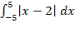 = 29.
Reason: 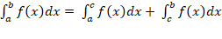, 1
8 Assertion: The value of $\int_{0}^{π}{}\frac{x}{1 + sinx}$ dx is 2$π$
Reason: $\int_{0}^{a}{}f(x)$ dx = $\int_{0}^{a}{}f(a-x)$ dx 1
9 Assertion:$\int_{-2}^{2}{}log⁡(\frac{1+x}{1-x}) dx=0$
Reason: If $f$ is an odd function, then $\int_{-a}^{a}{}f\left(x\right)dx=0$ 1
10 Assertion: $\int_{-\frac{π}{2}}^{\frac{π}{2}}{}loglog (\frac{a- sinsin θ }{a+sinsin θ })$ d$θ$ = 0
Reason: If f is an odd function, then $\int_{-a}^{a}{}f\left(x\right)dx$ =0 1
ANSWERS
1 c 1
2 a 1
3 d 1
4 d 1
5 b 1
6 c 1
7 a 1
8 d 1
9 a 1
10 a 1
2 MARKS TYPE QUESTIONS
1 Write the value of ∫ sec x(sec x + tan x) dx 2
2 Evaluate: $\int{}\frac{x^{3}-x^{2}+x-1}{x-1}dx$ 2
3 Evaluate: $\int{}\frac{dx}{5-8x-x^{2}}$ 2
4 Evaluate: $\int_{1}^{\sqrt{3}}{}\frac{dx}{1+x^{2}}$ 2
5 Evaluate: $\int_{-\frac{π}{2}}^{\frac{π}{2}}{}\sin^{5}x dx$ 2
6 Evaluate $\int{}\frac{dx}{cosx+\sqrt{3}sinx}$ 2
7 Evaluate $\int{}\frac{\left(x+3\right)e^{x}}{{\left(x+5\right)}^{3}}dx$ 2
8 Evaluate $\int{}{cosec}^{3}x dx$ 2
9 Evaluate $\int_{-π}^{π}{}\frac{\cos^{2}x}{1+a^{x}}dx, a>0$ 2
10 Evaluate:
$\int{}\tan^{-1}\left(\frac{cosx}{1-sinx}\right)dx, x∈\left(-\frac{π}{2}, \frac{3π}{2}\right)$ 2
ANSWERS 2
1 I = ∫sec x(sec x + tan x)dx
= ∫(sec2x + sec x tan x)dx
= ∫sec2 x dx + ∫sec x tan x dx
= tan x + sec x + C 2
2 $Let I=\int{}\frac{x^{3}-x^{2}+x-1}{x-1}dx$ $=\int{}\frac{x^{2}\left(x-1\right)+1\left(x-1\right)}{\left(x-1\right)}dx$
$=\int{}\frac{\left(x^{2}+1\right)\left(x-1\right)}{\left(x-1\right)}dx$ $=\int{}(x^{2}+1)dx=\frac{x^{3}}{3}+x+c$ 2
3 $\int{}\frac{dx}{5-8x-x^{2}}=\int{}\frac{dx}{5-2.4x-x^{2}+4^{2}-4^{2}}$
=$\int{}\frac{dx}{{\left(\sqrt{21}\right)}^{2}- {\left(x+4\right)}^{2}}$
=$\frac{1}{2\sqrt{21}}loglog \left(\frac{\sqrt{21}+x+4}{\sqrt{21}-x-4}\right) +c$ 2
4 $\int_{1}^{\sqrt{3}}{}\frac{dx}{1+x^{2}}={\left[x \right]}_{1}^{\sqrt{3}}$
$=\left(\sqrt{3}\right) -\left(1\right)$ = $\frac{π}{3}-\frac{π}{4}=\frac{π}{12}$ 2
5 $Use the property, \int_{-a}^{a}{}f\left(x\right)dx=0, if f\left(-x\right)=-f\left(x\right);f\left(x\right) is a odd function$
$$f\left(x\right)=\sin^{5}x ⟹ f\left(-x\right)=\sin^{5}\left(-x\right)=-\sin^{5}x=-f\left(x\right)$$
$so, f\left(x\right) is a odd function$
$\int_{-\frac{π}{2}}^{\frac{π}{2}}{}\sin^{5}x dx=0$ 2
6 $\int{}\frac{dx}{cosx+\sqrt{3}sinx}$= $\frac{1}{2}\int{}\frac{dx}{\frac{1}{2}cosx+\frac{\sqrt{3}}{2}sinx}$ = $\frac{1}{2}\int{}\frac{dx}{sin\frac{π}{6}cosx+cos\frac{π}{6}sinx}$ = $\frac{1}{2}\int{}\frac{dx}{sin\left(x+\frac{π}{6}\right)}$
= $\frac{1}{2}\int{}cosec\left(x+\frac{π}{6}\right)dx$ = $\frac{1}{2}logtan\left(\frac{x}{2}+\frac{π}{12}\right)+C$ 2
7 $\int{}\frac{\left(x+3\right)e^{x}}{{\left(x+5\right)}^{3}}dx$ =$\int{}\frac{\left(x+5-2\right)e^{x}}{{\left(x+5\right)}^{3}}dx$=$\int{}e^{x}\left\{\frac{1}{{\left(x+5\right)}^{2}}-\frac{2}{{\left(x+5\right)}^{3}}\right\}dx$ = $e^{x}\frac{1}{{\left(x+5\right)}^{2}}+C$ 2
8 $I=\int{}{cosec}^{3}x dx$=$\int{}cosecx {cosec}^{2}x dx$ =
= $cosecx\int{}{cosec}^{2}x dx-\int{}\frac{d}{dx}\left(cosecx\right)\int{}{cosec}^{2}x dx$
=$- cosecx cotx-\int{}cosecx \cot^{2}x dx$
=$- cosecx cotx-\int{}cosecx ({cosec}^{2}x-1) dx$
= $- cosecx cotx-\int{}{cosec}^{3}x dx+\int{}cosecx dx$
= $- cosecx cotx-I+\int{}cosecx dx$
$$2I=- cosecx cotx+log\left|tan\frac{x}{2}\right|$$
$∴I=- \frac{1}{2}cosecx cotx+\frac{1}{2}log\left|tan\frac{x}{2}\right|+C$ 2
9 $I=\int_{-π}^{π}{}\frac{\cos^{2}x}{1+a^{x}}dx$ ----- (i)
Also $I=\int_{-π}^{π}{}\frac{\cos^{2}\left(-x\right)}{1+a^{-x}}dx= \int_{-π}^{π}{}\frac{{a^{x}cos}^{2}x}{1+a^{x}}dx$ ---- (ii)
Adding $2I=\int_{-π}^{π}{}\cos^{2}xdx$ = $2\int_{0}^{π}{}\cos^{2}xdx$= $2.2\int_{0}^{\frac{π}{2}}{}\cos^{2}xdx$
$I=2\int_{0}^{\frac{π}{2}}{}\cos^{2}xdx$ =$2\int_{0}^{\frac{π}{2}}{}\sin^{2}xdx0$ = $2\int_{0}^{\frac{π}{2}}{}dx-2\int_{0}^{\frac{π}{2}}{}\cos^{2}xdx$
$I+I= 2\int_{0}^{\frac{π}{2}}{}dx=π∴ I=\frac{π}{2}$ 2
10 $\int{}\tan^{-1}\left(\frac{cosx}{1-sinx}\right)dx, x∈\left(-\frac{π}{4},\frac{π}{4}\right)$
= $\int{}\tan^{-1}\left(\frac{\cos^{2}\frac{x}{2}-\sin^{2}\frac{x}{2}}{{\left(cos\frac{x}{2}-sin\frac{x}{2}\right)}^{2}}\right)dx$
=$\int{}\tan^{-1}\left(\frac{cos\frac{x}{2}+sin\frac{x}{2}}{cos\frac{x}{2}-sin\frac{x}{2}}\right)dx$= $\int{}\tan^{-1}\left(\frac{1+tan\frac{x}{2}}{1-tan\frac{x}{2}}\right)dx$= $\int{}\tan^{-1}\left(tan\left(\frac{x}{2}+\frac{π}{4}\right)\right)dx$
= $\int{}\left(\frac{x}{2}+\frac{π}{4}\right)dx$ = $\frac{x^{2}}{4}+\frac{πx}{4}+C$ 2
3 – MARKS TYPE QUESTIONS
1 Evaluate: $\int{}\frac{x^{2}+x+1}{\left(x^{2}+1\right)\left(x+2\right)}dx$ 3
2 Evaluate: $\int{}\frac{\left(x-3\right)}{{\left(x-1\right)}^{3}}e^{x}dx$ 3
3 Evaluate $\int{}\frac{6e^{2x}+7e^{x}}{\sqrt{(e^{x}-5)(e^{x}-4)}}dx$ 3
4 Find the value of $\int_{-π}^{π}{}\frac{2x(1+sinx)}{1+\cos^{2}x}dx$ 3
5 Evaluate $\int_{0}^{1}{}\frac{log\left(1+x\right)}{1+x^{2}} dx$ 3
6 Evaluate : $\int_{0}^{π}{}\frac{xtanx}{secxcosecx}dx$ 3
7 Evaluate : $\int_{-1}^{2}{}f(x)dx, where f\left(x\right)= \left|x+1\right|+\left|x\right|+\left|x-1\right|$ 3
8 Evaluate : $\int_{0}^{\frac{π}{4}}{}\frac{sinx+cosx}{9+16 sin2x}dx$ 3
9 $Find the value of \int{}\frac{x^{7}}{x+1} dx$ 3
10 Find: $\int{}\frac{1}{\sqrt{x}\left(\sqrt{x}+ 1 \right)( \sqrt{x }+ 2 )}$dx 3
ANSWERS
1 $⇒\frac{x^{2}+x+1}{\left(x^{2}+1\right)\left(x+2\right)}=\frac{A}{x+2}+\frac{Bx+C}{x^{2}+1}$
$⇒$x2 + x + 1 = A(x2 + 1) + (Bx + C) (x + 2)
⇒ x2 + x + 1 = x2 (A + B) + x(2B + C) + (A + 2C)
On comparing the coefficients of x2, x and constant terms both sides, we get
A + B = 1 ……. (ii)
2B + C = 1 …….. (iii)
and A + 2C = 1 ……. (iv)
On substituting the value ofBfrom q. (ii) in Eq. (iii), we get
2(1 – A) + C = 1
⇒ 2 – 2A + C = 1
⇒ 2A – C = 1 ……. (v)
From above equations we get
$$⇒A=\frac{3}{5},B=\frac{2}{5} and C=\frac{1}{5}$$
$$⇒\frac{x^{2}+x+1}{\left(x^{2}+1\right)\left(x+2\right)}=\frac{A}{x+2}+\frac{Bx+C}{x^{2}+1}$$
$$⇒\frac{3}{5}\int{}\frac{dx}{x+2}+\frac{1}{5}\int{}\frac{2x+1}{x^{2}+1}dx$$
$$⇒\frac{3}{5}\int{}\frac{dx}{x+2}+\frac{1}{5}\int{}\frac{2x}{x^{2}+1}dx+\frac{1}{5}\int{}\frac{1}{x^{2}+1}dx$$
$$⇒\frac{3}{5}loglog \left(x+2\right) +\frac{1}{5}loglog \left(x^{2}+1\right) +\frac{1}{5}(x) +c$$
3
2 $\int{}\frac{\left(x-3\right)}{{\left(x-1\right)}^{3}}e^{x}dx=\int{}\frac{\left(x-1-2\right)}{{\left(x-1\right)}^{3}}e^{x}dx$
$$⇒\int{}\left[ \frac{x-1}{{\left(x-1\right)}^{3}}-\frac{2}{{\left(x-1\right)}^{3}}\right]e^{x}dx$$
$⇒\int{}\left[ \frac{1}{{\left(x-1\right)}^{2}}-\frac{2}{{\left(x-1\right)}^{3}}\right]e^{x}dx$
$we know that ⇒ \int{}e^{x}\left[f\left(x\right)+f^{'}\left(x\right)\right]dx= e^{x}.f\left(x\right)+c$
$where f\left(x\right)=\frac{1}{{\left(x-1\right)}^{2}}⇒f^{'}\left(x\right)=-\frac{2}{{\left(x-1\right)}^{3}}$
$hence \int{}\left[ \frac{1}{{\left(x-1\right)}^{2}}-\frac{2}{{\left(x-1\right)}^{3}}\right]e^{x}dx=\frac{e^{x}}{{\left(x-1\right)}^{2}}+c$
3
3 $\int{}\frac{(6e^{x}+7{)e}^{x}}{\sqrt{(e^{x}-5)(e^{x}-4)}}dx$ Let $e^{x}=t, then e^{x}dx=dt$
$$∴I=\int{}\frac{(6t+7)}{\sqrt{(t-5)(t-4)}}dt$$
Using the expression $6t+7=A\frac{d}{dt}\left(t^{2}-9t+20\right)+B$
Solving we get $A=3 and B=34$
$$∴I=\int{}\frac{\left(6t+7\right)}{\sqrt{\left(t-5\right)\left(t-4\right)}}dt=3\int{}\frac{\left(2t-9\right)}{\sqrt{t^{2}-9t+20}}dt+34\int{}\frac{1}{\sqrt{t^{2}-9t+20}}dt$$
=$6\sqrt{t^{2}-9t+20}$ +34$log\left|\left(x-\frac{9}{2}\right)+\sqrt{t^{2}-9t+20}\right|+C where t=e^{x}$ 3
4 $I=\int_{-π}^{π}{}\frac{2x(1+sinx)}{1+\cos^{2}x}dx$= $\int_{-π}^{π}{}\frac{2x}{1+\cos^{2}x}dx+2\int_{-π}^{π}{}\frac{xsinx}{1+\cos^{2}x}dx$
= 0 + $2\int_{-π}^{π}{}\frac{xsinx}{1+\cos^{2}x}dx$ ($f\left(x\right)=\frac{2x}{1+\cos^{2}x} is an odd fn.)$
= 4$\int_{0}^{π}{}\frac{xsinx}{1+\cos^{2}x}dx$ ($g\left(x\right)=\frac{xsinx}{1+\cos^{2}x} is an even fn.)$
Also $I=4\int_{0}^{π}{}\frac{(π-x)sin⁡(π-x)}{1+\cos^{2}(π-x)}dx$
Adding we get, $2I=4π\int_{0}^{π}{}\frac{sinx}{1+\cos^{2}x}dx$
$$I=2π\int_{0}^{π}{}\frac{sinx}{1+\cos^{2}x}dx$$
Putting $t=cosx¸ dt=-sinxdx$ , Also as $x=0, t=1 \& x=π, t=-1$
The integral reduces to $I=2π\int_{-1}^{1}{}\frac{dt}{1+t^{2}}=π^{2}$ 3
5 $\int_{0}^{1}{}\frac{log\left(1+x\right)}{1+x^{2}} dx$ Putting $x=tanθ$, then the integral reduces to
$$I=\int_{0}^{\frac{π}{2}}{}loglog \left(1+tanθ\right) dθ$$
Using the property $\int_{0}^{a}{}f\left(x\right)dx=\int_{0}^{a}{}f\left(a-x\right)dx$
$I=\frac{π}{8}log2$ 3
6 $Let I= \int_{0}^{π}{}\frac{xtanx}{secxcosecx}dx= \int_{0}^{π}{}x\sin^{2}xdx$
$$⇒I= \int_{0}^{π}{}(π-x)\sin^{2}(π-x)dx$$
$$⇒I= \int_{0}^{π}{}\left(π-x\right)\sin^{2}xdx ⇒2I= π\int_{0}^{π}{}\sin^{2}xdx$$
$$⇒2I= \frac{π}{2}\int_{0}^{π}{}{(1-cos2x}^{}) dx = \frac{π}{2}{\left[x- \frac{sin2x}{2}\right]}_{0}^{π}= \frac{π^{2}}{2}$$
$$⇒I= \frac{π^{2}}{4}$$
3
7 We can redefine f as
$$f\left(x\right)= \{2-x, if -1≤x<0 x+2, if 0≤x<1 3x, if 1≤x<2$$
$$⇒\int_{-1}^{2}{}f\left(x\right)dx= \int_{-1}^{0}{}\left(2-x\right)dx+ \int_{0}^{1}{}\left(x+2\right)dx+\int_{1}^{2}{}3xdx$$
$$= {\left[2x-\frac{x^{2}}{2}\right]}_{-1}^{0}+{\left[\frac{x^{2}}{2}+ 2x\right]}_{0}^{1}+{\left[\frac{3x^{2}}{2}\right]}_{1}^{2}$$
= $\frac{5}{2}+\frac{5}{2}+\frac{9}{2}= \frac{19}{2}$ 3
8 $Let I= \int_{0}^{\frac{π}{4}}{}\frac{sinx+cosx}{9+16 sin2x}dx= \int_{0}^{\frac{π}{4}}{}\frac{sinx+cosx}{9+16 \left[1- {\left(sinx-cosx\right)}^{2}\right]}dx$
Put $sinx-cosx=t ⇒ \left(sinx+cosx\right)dx=dt$
When x = 0 , t = -1, when x = $\frac{π}{4}$, t = 0
$$⇒ I\int_{-1}^{0}{}\frac{1}{9+16(1-t^{2})}dt=\int_{-1}^{0}{}\frac{1}{25+16t^{2}}dt=\frac{1}{16}\int_{-1}^{0}{}\frac{1}{{\left(\frac{5}{4}\right)}^{2}+t^{2}}dt$$
It is of the form $\int{}\frac{1}{a^{2}- x^{2}}dx= \frac{1}{2a}log\left|\frac{a+x}{a-x}\right|+C$
After evaluating, we get I = $\frac{1}{20}log3$ 3
9 We know that, $x^{7}+1=\left(x+1\right)(x^{6}-x^{5}+x^{4}-x^{3}+x^{2}-x+1)$
$$\int{}\frac{x^{7}}{x+1} dx$$
$$=\int{}\frac{x^{7}+1-1}{x+1} dx$$
$$=\int{}\frac{x^{7}+1}{x+1} dx-\int{}\frac{dx}{x+1}$$
$$=\int{}(x+1)\frac{x^{6}-x^{5}+x^{4}-x^{3}+x^{2}-x+1)}{(x+1)} dx-loglog |x+1|$$
$=\frac{x^{7}}{7}-\frac{x^{6}}{6}+\frac{x^{5}}{5}-\frac{x^{4}}{4}+\frac{x^{3}}{3}-\frac{x^{2}}{2}+x-loglog \left|x+1\right|+c$ (Answer) 3
10 $\int{}\frac{1}{\sqrt{x}\left(\sqrt{x}+ 1 \right)( \sqrt{x }+ 2 )}$dx
Let $\sqrt{x}$ = t $⇒$ $\frac{1}{2\sqrt{x}}$ dx = dt $⇒$ $\frac{1}{\sqrt{x}}$ dx = 2 dt
= 2 $\int{}\frac{1}{\left( t+1 \right)\left( t+2 \right)}$ dt = 2 $\int{}\frac{\left(t+2\right)- ( t+1)}{\left( t+1\right)\left( t+2 \right)}$ dt = 2 ( $\int{}\frac{1}{t+1}$dt $-$ $\int{}\frac{1}{t+2}$ dt )
= 2 [ log $\left|t+1\right|$ $-$log $\left|t+2\right|$ ] + C
= 2 log $\left|\frac{t+1}{t+2}\right|$ + c
= 2 log $\left|\frac{\sqrt{x} +1}{\sqrt{x} +2}\right|$ + C 3
5 – MARKS TYPE QUESTIONS
1 For a function f(x) , if f (-x ) = f(x) , then f is an even function and if f(-x ) = - f(x) , then f is an odd function .Again ,we have
$\int_{-a}^{a}{}f\left(x\right)dx$ = $\{2\int_{0}^{a}{}f\left(x\right)dx , if f\left(x\right)is even 0 , if f\left(x\right)is odd$ ,
On the above information answer the following questions ,
i)f(x) = x²sinx is an
a)even (ii) odd (iii) neither even nor odd (iv) none of these
ii)$\int_{-π}^{π}{}f\left(x\right)dx is$equal to
a)$\frac{π}{4}$ (b) 2$π$ (c)$\frac{π}{2}$ (d) 0
iii) f(x) xsinx , then $\int_{-π}^{π}{}f\left(x\right)dx is$
a) $π$ (b) 2$π$ (c) 3$π$ (d) 4$π$
(iv) $\int_{-\frac{π}{2}}^{\frac{π}{2}}{}\left|sinx\right|dx is$ equal to
a) 0 (b) 1 (c) 2 (d) 3 5
2 Prove that $\int_{0}^{a}{}\sin^{-1}\sqrt{\frac{x}{a+x}}dx=\frac{a}{2}(π-2)$ 5
3 Evaluate: $\int_{0}^{π}{}\frac{x.Sin x}{1+{Cos}^{2}x}dx$ 5
4 $Evaluate\int{}\frac{2x}{\left(x^{2}+1\right){\left(x^{2}+2\right)}^{2}}dx$ 5
5 Evaluate $\int_{0}^{π}{}\frac{xdx}{a^{2}\cos^{2}x+b^{2}\sin^{2}x}$ 5
ANSWERS
1 (i) (b)odd (ii) d) 0 (iii) even function , (b) 2$π$ (iv) (c) 2 5
2 $\int_{0}^{a}{}\sin^{-1}\sqrt{\frac{x}{a+x}}dx=\frac{a}{2}(π-2)$
(Put $x=a\tan^{2}θ and the apply Integration by parts)$ 5
3 $Let I=\int_{0}^{π}{}\frac{x.Sin x}{1+{Cos}^{2}x}dx …………..\left(1\right)$
$I=\int_{0}^{π}{}\frac{\left(π-x\right).Sin \left(π-x\right)}{1+{Cos}^{2}\left(π-x\right)}dx=\int_{0}^{π}{}\frac{\left(π-x\right).Sin x}{1+{Cos}^{2}x}dx…………………..\left(2\right)$

Add (1) and (2)
$2I=π\int_{0}^{π}{}\frac{Sin x}{1+{Cos}^{2}x}dx$
$Letx =t⇒-sinsin x dx=dt$
$When x=0⇒t=coscos 0 =1$
$and x=π⇒t=coscos π =-1$
$2I=-π\int_{1}^{-1}{}\frac{dt}{1+t^{2}}= \int_{-1}^{1}{}\frac{dt}{1+t^{2}}={\left[x \right]}_{-1}^{1}$
$2I=π\left[\left(1\right) -\left(-1\right) \right]=π\left[\frac{π}{2}+\frac{π}{2}\right]=\frac{π^{2}}{2}$
$I= \frac{π^{2}}{4}$ 5
4 $I=\int{}\frac{2x}{\left(x^{2}+1\right){\left(x^{2}+2\right)}^{2}}dx$

$$Let x^{2}=t⇒2xdx=dt$$
$$⇒I=\int{}\frac{dt}{\left(t+1\right){\left(t+2\right)}^{2}}$$
$$\frac{1}{\left(t+1\right){\left(t+2\right)}^{2}}=\frac{A}{t+1}+\frac{B}{t+2}+\frac{C}{{\left(t+2\right)}^{2}}$$

1 = A(t + 2)2 + B(t + 1) (t + 2) + C(t + 1)
⇒ 1 = A(t2 + 4 + 4t) + B(t2 + 2t + t + 2) + C(t + 1)
⇒ 1 = A(t2 + 4t + 4) + B(t2 + 3t + 2) + C(t + 1)
⇒ 1 = t2 (A + B) + t(4A + 3B + C) + 4A + 2B + C
On comparing the coefficients of 2, and the constant term from both sides, we get
A + B = 0
4A + 3B + C = 0 ……. (ii)
and 4A + 2B + C = 1 …….. (iii)
From Eq. (1), A = – B
Put the value of A in Eqs. (ii) and (iii), we get
– 4B + 3B + C = 0
⇒ – B + C = 0
⇒ B – C = 0 ……. (iv)
and – 4B + 2B + C = 1
⇒ – 2B + C = 1
⇒ 28 – C = – 1
Now, from Eqs. (iv) and (y), we get
– B = 1 ⇒ B = – 1
∴ A = 1 and C = – 1
$$⇒I= \int{}\frac{1}{t+1}dt-\int{}\frac{1}{t+2}dt-\int{}\frac{1}{{\left(t+2\right)}^{2}}dt$$
$$⇒I=loglog \left(t+1\right) -loglog \left(t+2\right) +\frac{1}{t+2}+c$$
$⇒I= loglog \left(x^{2}+1\right) -loglog \left(x^{2}+2\right) +\frac{1}{x^{2}+2}+c$ 5
5 $\int_{0}^{π}{}\frac{xdx}{a^{2}\cos^{2}x+b^{2}\sin^{2}x}$(= $\frac{π^{2}}{2ab}$)
Apply the following properties in series:
(i)$\int_{0}^{a}{}f\left(x\right)dx=\int_{0}^{a}{}f\left(a-x\right)dx$(ii)$\int_{0}^{2a}{}f\left(x\right)dx=2\int_{0}^{a}{}f\left(x\right)dx$ 5

CHAPTER – 8
APPLICATION OF INTEGRALS

SYLLABUS:
Applications in finding the area under simple curves, especially lines, circles/ parabolas/ellipses (in standard form only)

SL NO | QUESTION | MARK
 | MULTIPLE - CHOICE QUESTIONS
1 | The area of the region bounded by y = cos x between x=0 and x= π is  - 2sq unit  - 4sq unit  - 6sq unit  - 1sq unit | 1
2 | The area of the region bounded by the parabola y² = x and the straight-line y = x/2 is  - 1/3 sq unit  - 2/3 sq unit  - 3/3 sq unit  - 4/3 sq unit | 1
3 | The area bounded by the curve y² = 4ax and axis between y= -a and y=a is  - A²  - 6a²  - A²/6  - A²/2 | 1
4 | The area of the region bounded by the curve x=2y+3 and the line y= 1and y= -1is  - 2 sq unit  - 4 sq unit  - 6 sq unit  - 8 sq unit | 1
5 | The area bounded by the curve y= x² -1 and the straight-line x + y=3  - $\frac{√17}{7}$ sq unit  - $\frac{7\sqrt{1}7}{6}$sq unit  - $\frac{17√17}{6}$ sq unit  - 4 sq unit | 1
6 | The area of the region bounded by y = |x-2| , x=1 and x=3 and x-axis is  - 4sq unit  - 3sq unit  - 2sq unit  - 1 sq unit | 1
7 | Area of the triangle whose vertices formed from the x-axis and the line 3-|x| is  - $\frac{9}{2}$sq. unit  - $\frac{3}{2}$sq. unit  - $9sq. unit$  - 3 sq unit | 1
8 | Find the area of the region  - $\frac{1}{3}$sq. unit  - $\frac{1}{2}$sq. unit  - $\frac{1}{6}$sq. unit  - $\frac{1}{9}$sq. unit | 1
9 | If y= 2 sin x + sin 2x for 0$≤x≤2π$ then area enclosed by the curve and the x-axis is  - $\frac{9}{2}$sq. unit  - $8$sq. unit  - $12$sq. unit  - 4sq. unit | 1
10 | The area of the region bounded by the curves y=x, x=e and y=$\frac{1}{x}$ and all the positive x-axis is  - $\frac{1}{2}$sq. unit  - $\frac{3}{2}$sq. unit  - 1sq. unit  - $\frac{5}{2}$sq. unit | 1
11 | The area of the region bounded by the circle $x^{2}+y^{2}=1$ is  - 2$π$ sq. units (b) $π$ sq. units  (c) 3$π$ sq. units (d) 4$π$ sq. units | 1
12 | The area of the region bounded by the curve $y=x+1$ and the lines $x=2$ and $x=3$ is  - $\frac{7}{2}$ sq. units (b) $\frac{9}{2}$ sq. units  (c) $\frac{11}{2}$ sq. units (d) $\frac{13}{2}$ sq. units | 1
13 | The area of the region bounded by the curve $y^{2}=4x$, $y$-axis and the line $y=3$ is  - 2 (b) $\frac{9}{4}$  (c) $\frac{9}{3}$ (d) $\frac{9}{2}$ | 1
14 | The area bounded by $y=2-x^{2}$ and $x+y=0$ is  - $\frac{7}{2}$ (b) $\frac{9}{2}$  (c)9 (d) none of these | 1
15 | The area bounded by the parabola $x=4-y^{2}$ and y-axis, in square units, is  - $\frac{3}{32}$ (b) $\frac{32}{3}$  (c) $\frac{33}{2}$ (d) $\frac{16}{3}$ | 1
16 | Area lying between the curve $y^{2}=4x$ and $y=2x$ is  (a) $\frac{2}{3}$ (b) $\frac{1}{3}$ (c) $\frac{1}{4}$ (d) $\frac{3}{4}$ | 1
17 | The area bounded by the parabola $y^{2}=4ax$, latus rectum and $x$-axis is  - 0 (b) $\frac{4}{3}a^{2}$ (c) $\frac{2}{3}a^{2}$ (d) $\frac{a^{2}}{3}$ | 1
18 | The area of the region bounded by the ellipse $\frac{x^{2}}{a^{2}}+\frac{y^{2}}{b^{2}}=1$  - $πab$ (b) $πa^{2}b^{2}$ (c) $2πab$ (d) $ab$ | 1
19 | The area of the region bounded by the circle $x^{2}+y^{2}=a^{2}$  - $2πa$ (b) $πa^{2}$ (c) $2πa^{2}$ (d) None of these | 1
20 | The area of the region bounded by the curve $\frac{x^{2}}{4}+\frac{y^{2}}{9}=1$  - $6π$ (b) $36π$ (c) $18π$ (d) None of these | 1
21 | The area enclosed between the curve y=x² and y=√x is  - ⅙ sq. unit B) ½ sq. unit C) 4 sq. unit D) 1/3 sq. unit | 1
22 | The area enclosed among the curves 2x-3y=0, X axis, X=3 and X= 5 is  - 16 sq. units B ) 8 sq. units C) 4 sd. units D) 16/3 sq. units | 1
23 | Area bounded by the lines y=2+x, y= 2-x and x=2 is  - 3 sq. units B) 4 sq. units C) 8 sq. units D) 16sq. units | 1
24 | Area lying in the first quadrant and bounded by the circle x²+y²=4, and the lines x=0 and x=2 is  - π B) π/4 C) π/3 D) π/2 | 1
25 | The area of the region bounded by the curve y²=4x, Y axis and the line y=3 is  - 2 B)9/4 C)9/3 D) 9/2 | 1
 | ANSWERS | 1
1 | 2 sq unit | 1
2 | 4/3 sq unit | 1
3 | A ²/6 sq unit | 1
4 | 6 sq unit | 1
5 | $\frac{17√17}{6}$ sq unit | 1
6 | 1 sq unit | 1
7 | 9sq. unit | 1
8 | 9sq. unit | 1
9 | 12 sq. unit | 1
10 | b) $\frac{3}{2}$sq. unit | 1
11 | b | 1
12 | a | 1
13 | b | 1
14 | b | 1
15 | b | 1
16 | b | 1
17 | b | 1
18 | a | 1
19 | b | 1
20 | a | 1
21 | c | 1
22 | d | 1
23 | b | 1
24 | a | 1
25 | b | 1
 | ASSERTION & REASON QUESTIONS
Choose the correct option in the following questions of Assertion – Reason Questions.
(a) Both A and R are correct; R is the correct explanation of A.
(b) Both A and R are correct; R is not the correct explanation of A.
(c) A is true but R is false
(d) A is false but R is true
1 | ) dx = 0  Reason(R) : If f(x) is an even function then | 1
2 | (sinx+cosx)dx = e^{x} sinx + c  R: (f(x)+f’(x))dx = e^{x} f(x) + c | 1
3 | A: xsin(logx) + c  R: (xsin(logx)) = sin(logx) + cos(logx) | 1
4 | f’(x) + c  R: = f (x) | 1
5 | A: Derivative of a function at a point exists  R: Integration of a function at a point where it  Is defined , exists | 1
6 | Assertion : 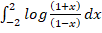=0  Reason : If f is an odd function, then | 1
7 | Assertion: Geometrically, derivative of a function is the slope of the tangent to the corresponding curve at a point.  Reason: Geometrically, indefinite integral of a function represents a family of curves parallel to  each other. | 1
8 | Assertion: Derivative of a function at a point exists.  Reason: Integral of a function at a point where it is defined, exists. | 1
9 | Assertion: If, then where C is an arbitrary constant.  Reason: Process of differentiation and integration are inverses of each other. | 1
10 | Assertion : The value of the integral  Reason: The value of the integral. | 1
 | ANSWERS
1 | c | 1
2 | a | 1
3 | a | 1
4 | d | 1
5 | c | 1
6 | a | 1
7 | b | 1
8 | c | 1
9 | d | 1
10 | a | 1
 | 2 MARKS TYPE QUESTIONS
1 | Sketch the region bounded by the lines 2x+y = 8, y = 2, y =4 and the y-axis. Hence, obtain its area, using integration. | 2
2 | Find the area bounded by y = x², the x-axis and the lines x = 1 and x = -1. | 2
3 | Find the area bounded by the curve y = x³ , x = -2 and x = 1. | 2
4 | Find the area of the region bounded by the parabola y² = 8x and the line x = 2. | 2
5 | Reshma draw a beautiful painting in which she draws mountains, trees, birds, river, houses etc. His little brother come across the painting and cut one of the mountains by drawing a straight line. Based on the above information find the area bounded by mountain and straight line. The equation of mountain is$y=-x^{2}$ and equation of straight line is    $x+y+2=0$  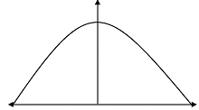 | 2
6 | Find the area bounded by the curve $y^{2}=9x and y=3x.$ | 2
7 | Location of the three houses of a society is represented by points A(0,5), B(3,2) and C (1,1). Find the area bounded by these three houses and the equation of line represented by house A, B, C are $y=4x+5, y=5-x, and 4y=x+5.$  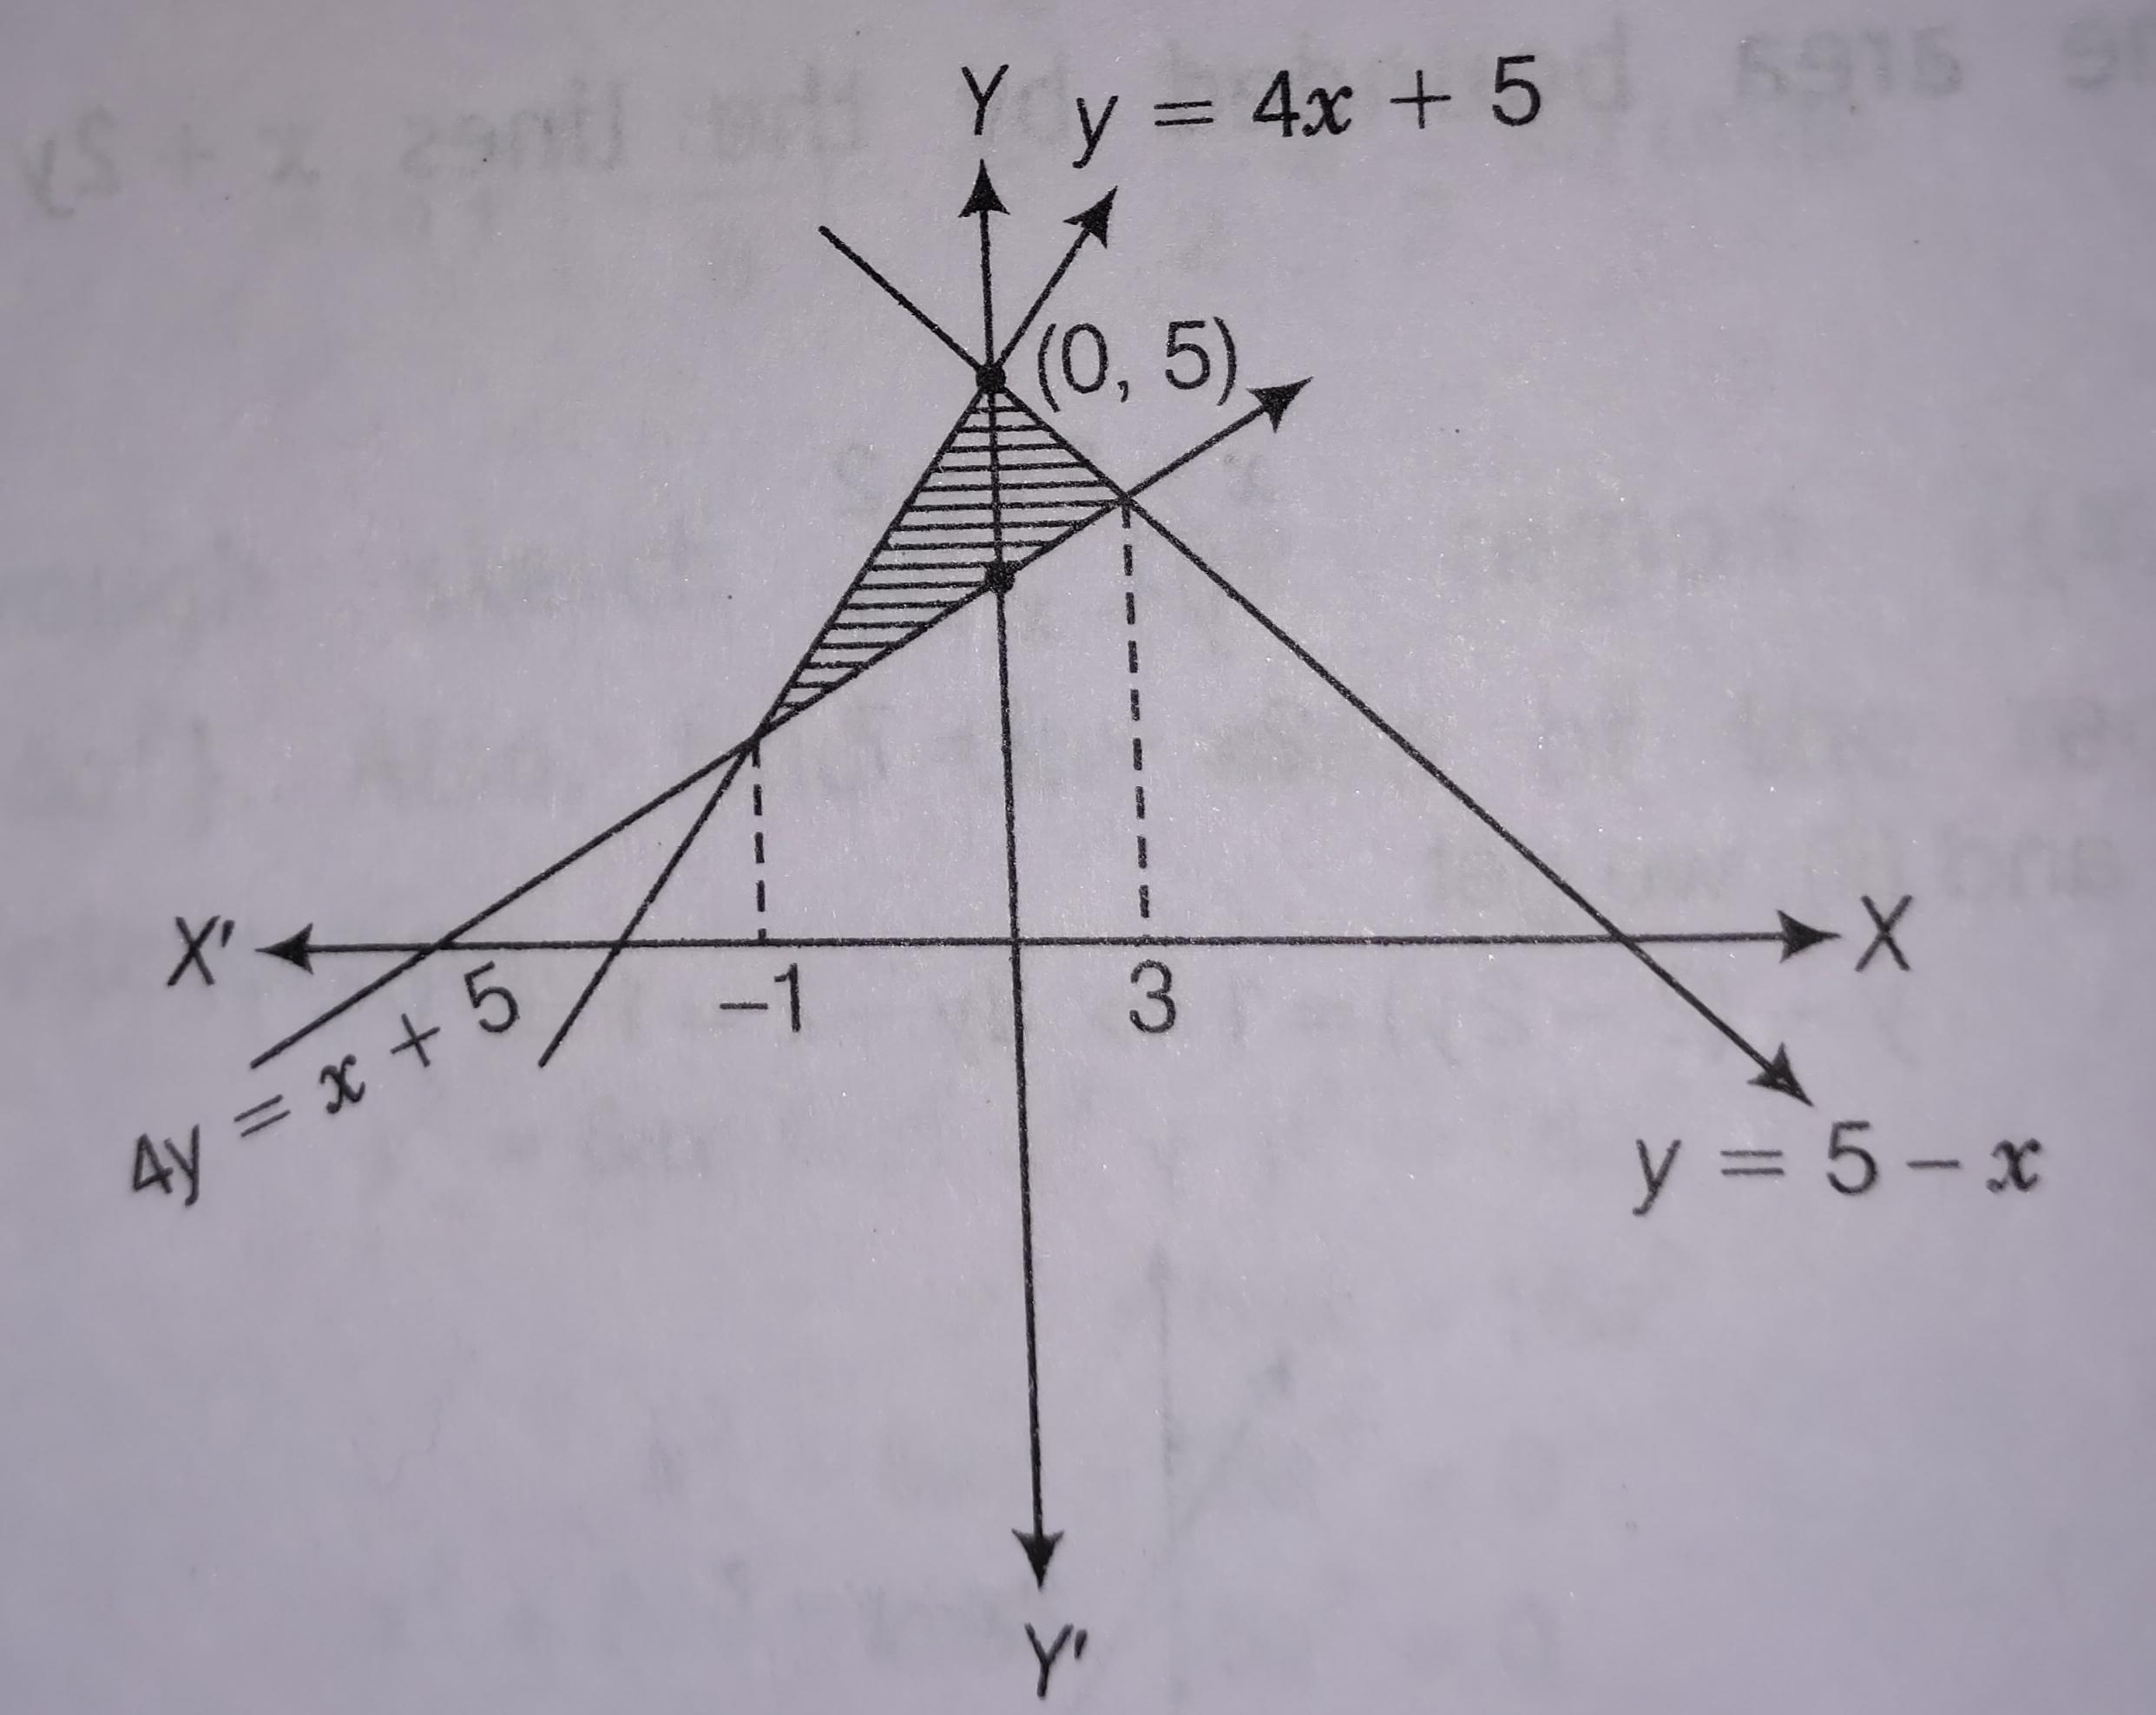       | 2
8 | If the area bounded by the curve y = 3x, x-axis and between the ordinates x = 1 and x = b is 12 sq..units, then find the value of b. | 2
9 | If the area bounded by the parabola y² = 16x and the line x=a is 128/3 sq. units, then find the value of a. | 2
10 | Using integration check whether given statement is true or false  Statement: The region under the curve y = √(1 – x²) on the interval [-1,1] has area A = π/2, | 2
 | ANSWERS | 2
1 | Region bounded by the lines 2x+y = 8, y = 2, y=4 is as shown in the below figure:  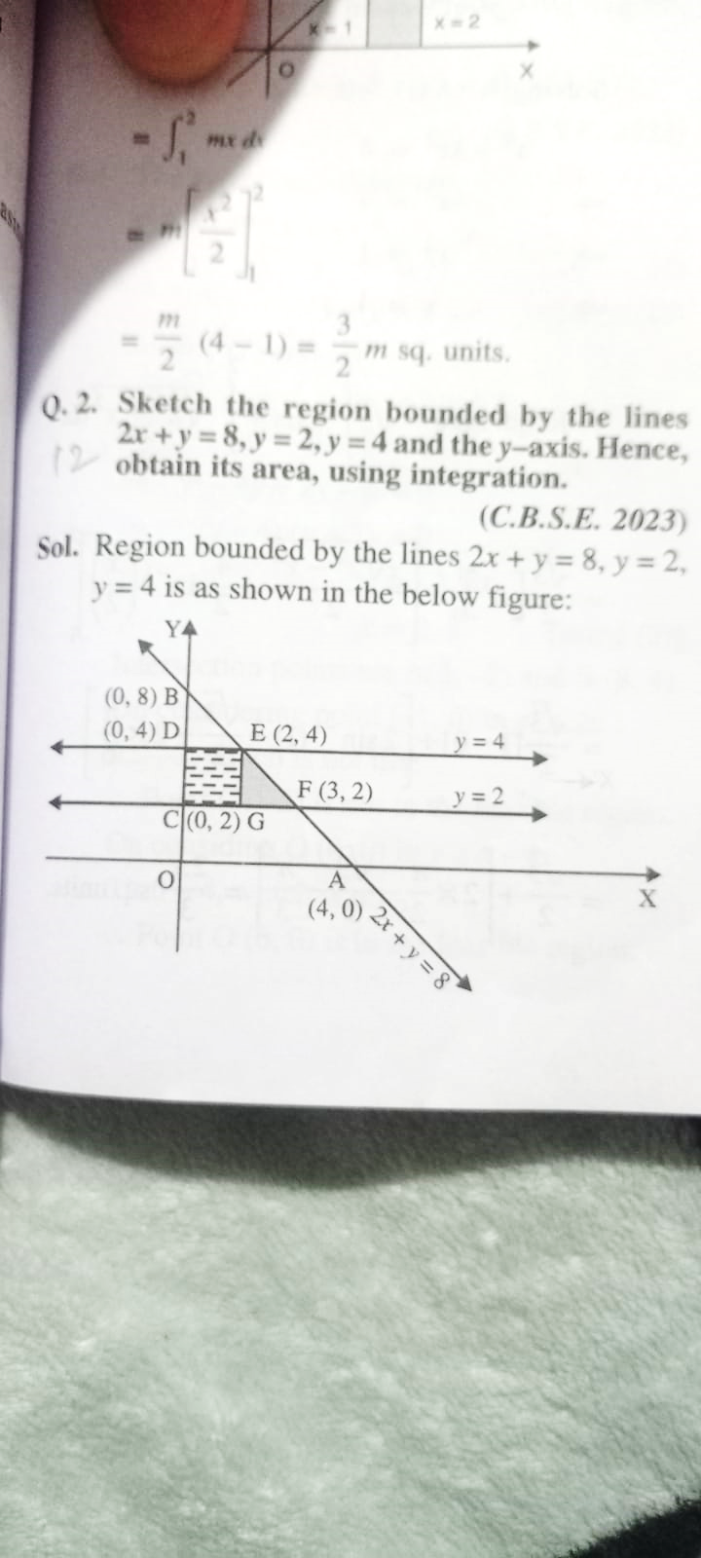  Reqd. area = ar(CDEG) + ar(∆GEF)  = 2×2 + $\int_{2}^{3}{}\left(8-2x\right)dx$  = 7 sq units | 2
2 | Reqd. area = $\int_{-1}^{1}{}x^{2} dx$  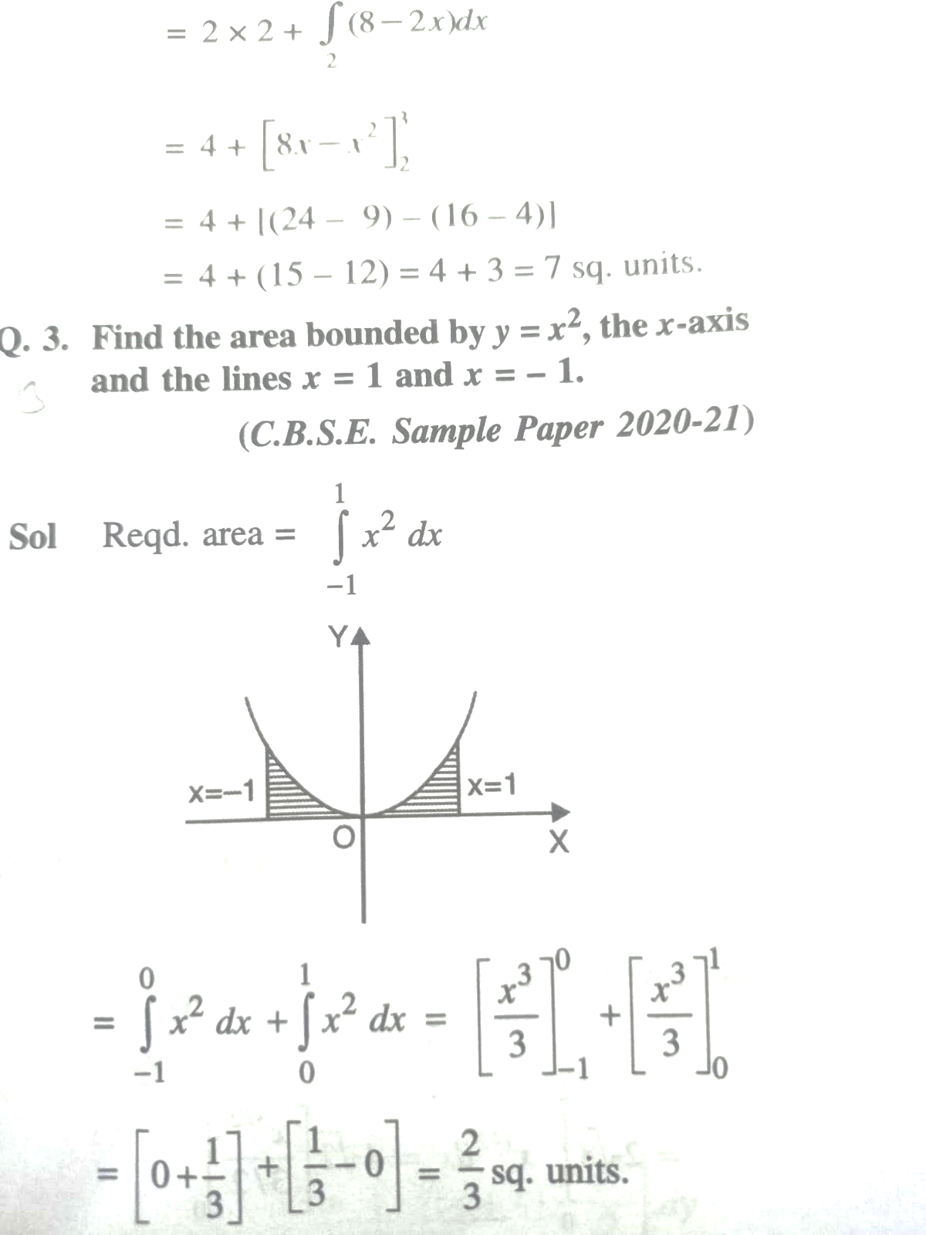  = $\frac{2}{3}$ sq. units | 2
3 | We have y = x³  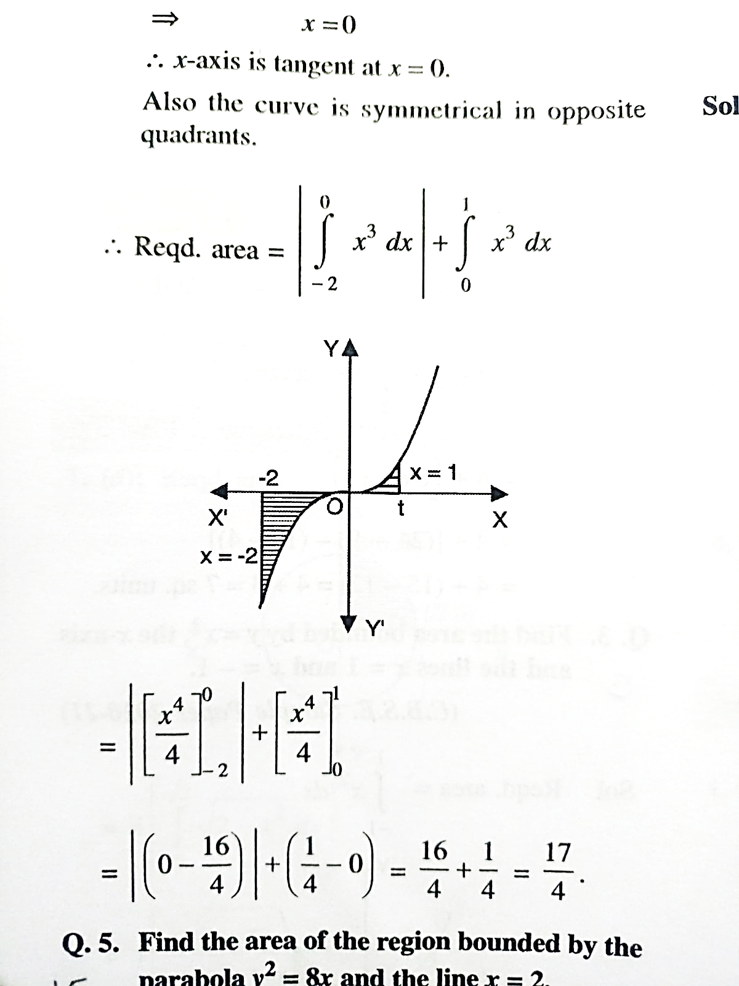 | 2
4 | Reqd. area = 2 $\int_{0}^{2}{}\sqrt{8x}dx$  = $\frac{8}{3}$ $\sqrt{2}$ [$2^{\frac{3}{2}}-0]$  = 32/3 sq. units | 2
5 | 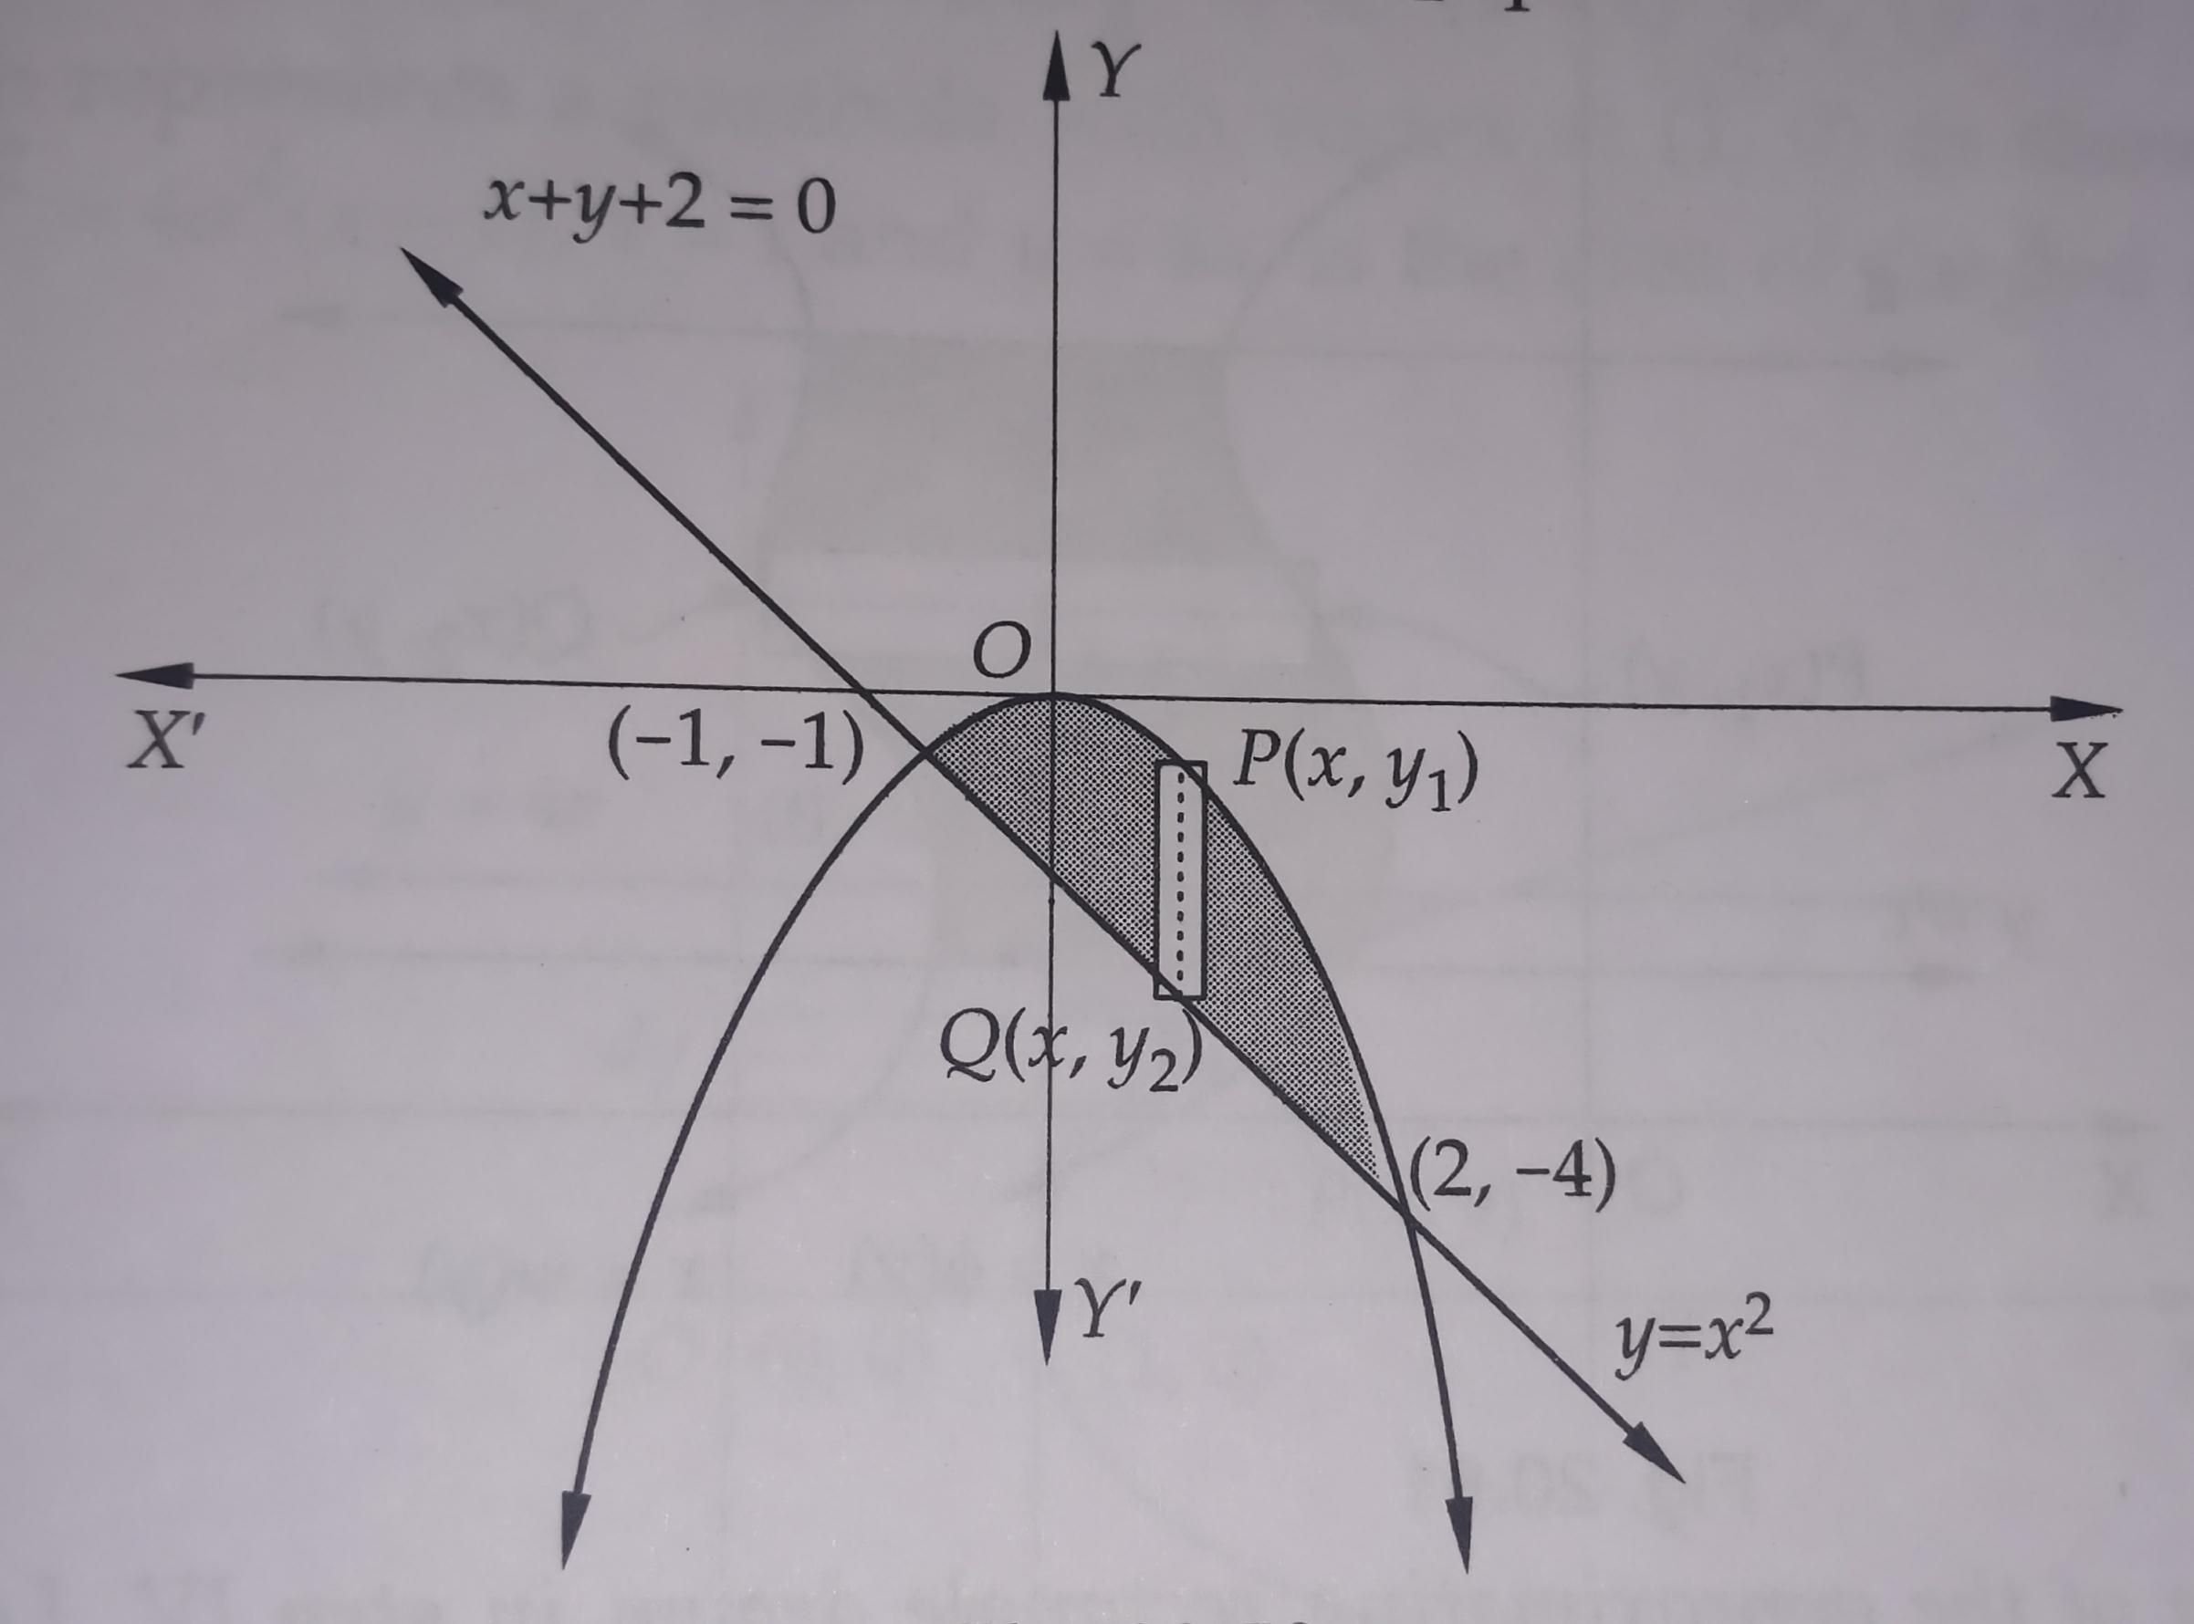  Required area = $\left(\int_{-1}^{2}{}\left(y_{1}-y_{2}\right)dx \right)$  =$\int_{-1}^{2}{}-x^{2}-x-2dx$  =$\int_{-1}^{2}{}-x^{2}+x+2dx$  =${\left[-\frac{x^{3}}{3}+\frac{x^{2}}{2}+2x\right]}_{-1}^{2}$  =$\left(-\frac{8}{3}+6\right)-\left(\frac{1}{3}+\frac{1}{2}-2\right)$  =$\frac{9}{2}sq.units$ | 2
6 | 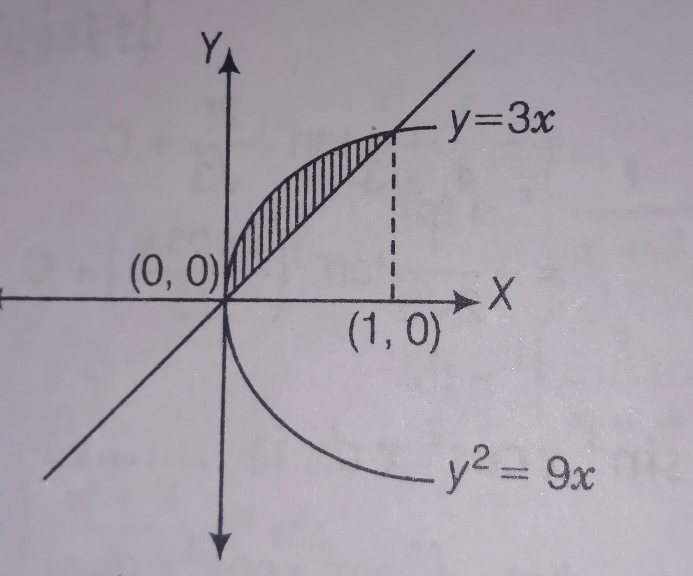  We have $y^{2}=9x and y=3x$  .$⇒{\left(3x\right)}^{2}=9x$  .${⇒9x}^{2}=9x$  .$⇒9x\left(x-1\right)=0$  .$⇒x=0,1$  $∴$ Required bounded area  =$\int_{0}^{1}{}\sqrt{9x}dx-\int_{0}^{1}{}3xdx$  =$3{\left[\frac{x^{\frac{3}{2}}}{\frac{3}{2}}\right]}_{0}^{1}-3{\left[\frac{x^{2}}{2}\right]}_{0}^{1}$  =$3\left(\frac{2}{3}-0\right)-3\left(\frac{1}{2}-0\right)$  =$2-\frac{3}{2}$  =$\frac{1}{2}sq units$ | 2
7 | $∴$ Required bounded area between three houses  = $\int_{-1}^{0}{}\left(4x+5\right)dx-\int_{0}^{3}{}\left(5-x\right)dx-\frac{1}{4}\int_{-1}^{3}{}\left(x+5\right)dx$  =${\left[\frac{4x^{2}}{2}+5\right]}_{-1}^{0}+{\left[5x-\frac{x^{2}}{2}\right]}_{0}^{3}-\frac{1}{4}{\left[x^{2}+5x\right]}_{-1}^{3}$  =$\left[0-2+5\right]+\left[15-\frac{9}{2}-0\right]-\frac{1}{4}\left[\frac{9}{2}+15-\frac{1}{2}+5\right]$  =$3+\frac{21}{2}-\frac{1}{4}.24$  =$-3+\frac{21}{2}=\frac{15}{2} sq units$ | 2
8 | The graph is as follows  y=3x  x=1 x=b  The required area is given by  $$=\int_{1}^{b}{}y dx=\int_{1}^{b}{}3x dx=12$$  $$\frac{{3b}^{2}}{2}=\frac{27}{2}$$  b = 3 | 2
9 | The required area is given by the figure  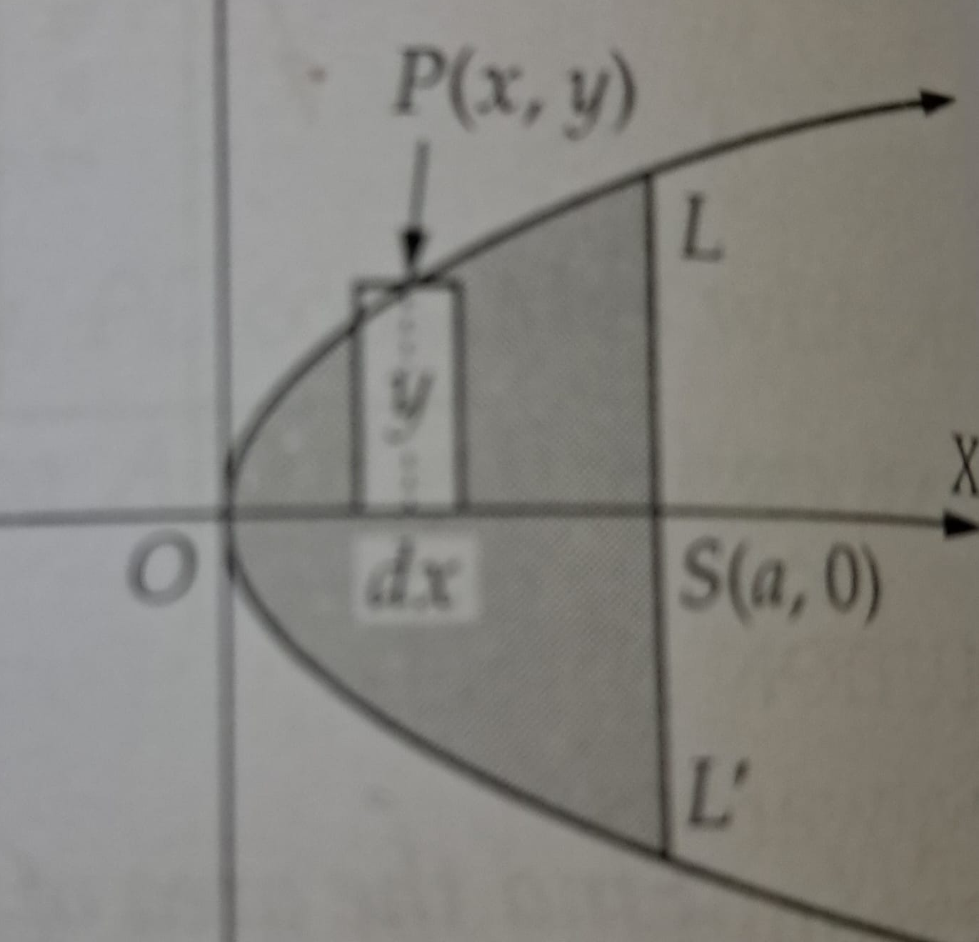  So,  The required area is given by  $$A=2\int_{0}^{a}{}y dx=2\int_{0}^{a}{}\sqrt{16x} dx$$  $$\frac{128}{3}=8\int_{0}^{a}{}x^{1/2} dx=\frac{16}{3} a^{3/2}$$  a = 4 | 2
10 | The region is given by the figure  (1,0)  So, the area is  $$A=4\int_{0}^{1}{}y dx=4\int_{0}^{1}{}\sqrt{(1}-x^{2}) dx$$  $$A= π$$  (False) | 2
 | 3 – MARKS TYPE QUESTIONS
1 | Find the area of ∆ ABC, the coordinates of whose vertices are A (2, 5), B(4, 7) and C(6, 2) by using integration. | 3
2 | If y= 2 sin x + sin 2x for 0$≤x≤2π$ find the area enclosed by the curve and the x-axis. | 3
3 | Find the area of the region bounded by the ellipse $\frac{y2}{16} + \frac{x2}{25}$ =1. | 3
4 | Find the area of the region bounded by the curve  $y=\sqrt{16-x^{2}}$ and $x-axis$ . | 3
5 | Find the area of the region bounded by the curve  $y=x^{2} and y=16$. | 3
6 | Find the area under the curve $y=x^{2}$ and the lines  $$x=-1,x=2 and x-axis$$ | 3
7 | Find the area bounded by the curve y = cos x, x-axis and the ordinates x = -5π/6 and x = π | 3
8 | Find the area of larger portion of the circle x² + y² = 4 cut off by the line x=1 | 3
9 | If the area of the region enclosed by the parabola  y² = 4ax and the line y = mx is 3/8, then find a relation between a and m. | 3
10 | In a classroom, the teacher explains the properties of a particular curve by saying that this particular curve has beautiful ups and downs. It starts at 1 and heads down until π radian, and then heads up again as shown in the figure 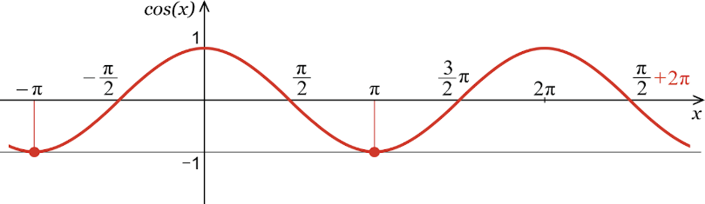  Then find the area enclosed by the curve, x = -π and x = π. | 3
 | ANSWERS
1 | Vertices of the given triangle are A(2,5) B(4,7) and C(6,2)  Equation of AB  y-5 = $\frac{7-5}{4-2}$(x-2)  - y – 5 = x-2  - y = x+3  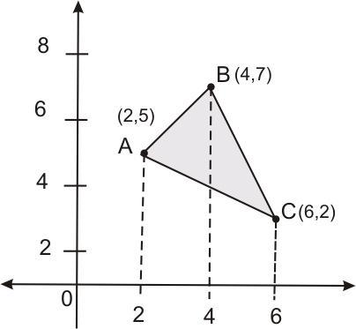  The equation of side BC,  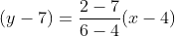  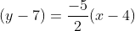  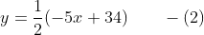  The equation of side AC,  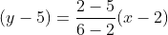  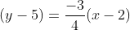  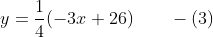  Area of  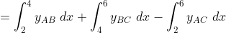 | 3
2 | To find the area enclosed by the curve and the x-axis, we need to integrate the absolute value of the function y with respect to x, between the limits 0 and 2π.  The function y = 2 sin x + sin 2x is always non-negative for 0 ≤ x ≤ 2π, so we can simply integrate it as is.  A=2 (2sin x + sin 2x)dx=2∫ (2sin x + sin 2x) dx  =4 $\int_{0}^{π}{}sin x$ dx+2$\int_{π}^{2π}{}sin2x$ dx= 8 + 0 = 8 | 3
3 | 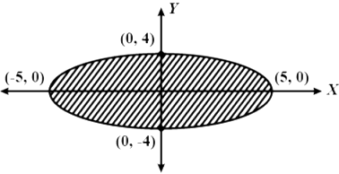  Given the equation of the ellipse is $\frac{y2}{16} + \frac{x2}{25}$ =1  - $\frac{y2}{16}$=1 - $\frac{x2}{25}$  - Y = $\frac{4}{5}$ $\sqrt{25+x^{2}}$  Since ellipse is symmetrical about the axes,  So, required area = 4* $\int_{0}^{5}{}(4/5)\sqrt{25 -x^{2}}$ dx  = 20 π sq. units | 3
4 | 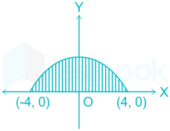  $y=\sqrt{16-x^{2}}$  At x-axis y will be 0  $0=\sqrt{16-x^{2}}$  $$x=±4$$  Area of the curve =$\int_{-4}^{4}{}ydx$  =$\int_{-4}^{4}{}\sqrt{16-x^{2}}dx$  =8$π$ sq. unit | 3
5 | Given equation of the curve are  $y=x^{2}$-------(1)  $y=16$ -------(2)  From (1) and (2)  $$x=±4$$  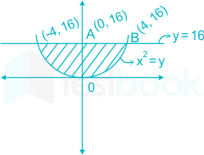  Required area=$\int_{-4}^{4}{}ydx$  =$\int_{-4}^{4}{}(16-x^{2})dx$  =2$\int_{0}^{4}{}(16-x^{2})dx$ =$\frac{256}{3}$ sq. units | 3
6 | 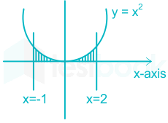  Given equation of the curve are  $y=x^{2}$-------(1)  $x=-1$ -------(2)  $x=2$ --------(3)  Required area=$\int_{-1}^{2}{}ydx$  =$\int_{-1}^{2}{}x^{2}dx$  =3 sq. units | 3
7 | The graph of the function is as follows  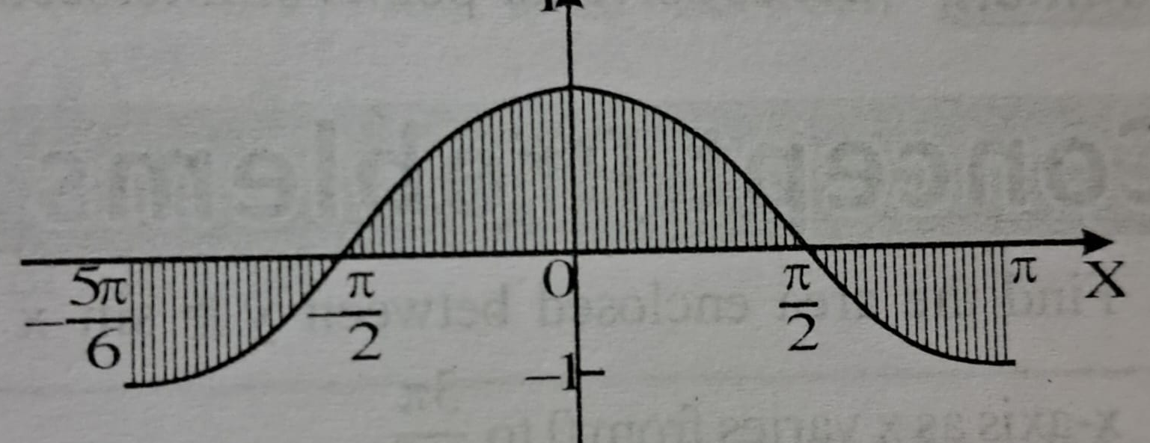  Solving equation cos x =0 between [-5π/6 ,π] we get that  the graph of function intersect x-axis at two points x = -π/2 and x = π/2  so, the required area is given by  $$=\int_{-5π/6}^{π}{}\left|cosx\right|dx$$  $$=-\int_{-5π/6}^{-π/2}{}cosx dx+ \int_{-π/2}^{π/2}{}cosx dx+ \int_{π/2}^{π}{}cosx dx=7/2$$ | 3
8 | The graph of the function cut off by line is as follows  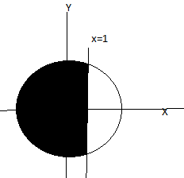  As per figure the area of small portion is given by  =area ABCA  $$=2\int_{1}^{2}{}y dx=2 \int_{1}^{2}{}\sqrt{(4}-x^{2}) dx$$  $$=2[\frac{x\sqrt{2^{2}-x^{2}}}{2}+ \frac{2^{2}}{2}\sin^{-1}\frac{x}{2}]_{1}^{2}$$  $=\frac{4π-3√3}{3}$  So Required area is  $$=π({1)}^{2}-\frac{4π-3\sqrt{3}}{3}= \frac{3\sqrt{3}-π}{3}$$ | 3
9 | The figure is as follows  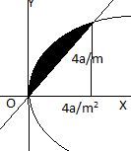  Solving y²=4ax and y = m x gives point of intersection  (4a/m², 4a/m)  $A= \int_{0}^{4a/m^{2}}{}\left(2\sqrt{ax}-mx\right)dx=[\frac{4}{3}\sqrt{ax^{\frac{3}{2}}}-\frac{mx^{2}}{2}]_{0}^{4a/m^{2}}$  $$\frac{3}{8}= \frac{8a^{2}}{3m^{3}}$$  $$m^{3}=a^{2}$$ | 3
10 | Reqd. area = 4$\int_{0}^{π/2}{}coscos x dx$  = 4 [sin x]₀^{π/2}  =4 × 1 = 4 sq. units | 3
 | 4 – MARKS TYPE QUESTIONS (CASE BASED QUESTIONS)
1 | A mirror in the shape of an ellipse $\frac{x2}{9}$ + $\frac{y2}{4}$ =1 was hanging on the wall. Arun and his sister were playing with ball inside the house, even their mother refused to do so. All of a sudden, ball hit the mirror and got scratch in the shape of line represented by $\frac{x}{3} +$ $\frac{y}{2}$= 1.  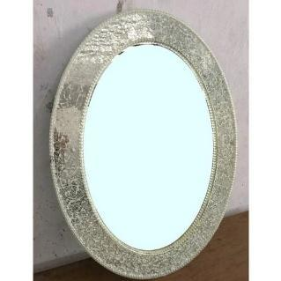  Based on the above information, answer the following question.  - Points of intersection of ellipse and the scratch are  - (0,2), (3,0)  - (2,0), (0,3)  - (2,3), (0,0)  - (0,3), (3,0)  - The area of the smaller region bounded by the mirror and scratch is  - 3($\frac{π}{2}$+1) sq. unit  - ($\frac{π}{2}$+1) sq. unit  - ($\frac{π}{2} -$1) sq. unit  - 3($\frac{π}{2} -$1) sq. unit  - The value of the integration $\int_{-1}^{0}{}(x+1)$dx is  - $\frac{1}{2}$  - $\frac{2}{3}$  - $\frac{3}{4}$  - $\frac{1}{3}$  - If the mirror is replaced by a circular mirror x²+y²=1 the new area of the mirror is  - 2π  - π  - π/4  - 1/π | 4
2 | Pratik cut pizza with a knife .the shape of pizza is represented by the equation x² + y² = 4 and the sharpe edge of the knife represented by the straightline x=$√3$ y .  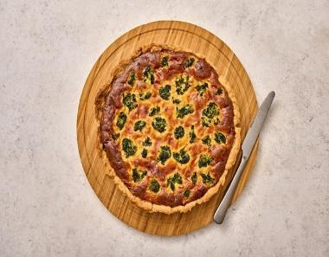  - The point of intersection of the edge of knife (line) and the pizza shown in the figure are  - (1,$√3$), (-1,-$√3$)  - ($√3$,1), (-$√3,-1$)  - ($√2$,0),(0,$√3$)  - (-$√3$,1), (1,$-√3$)  - Value of the area of the region bounded by circular pizza and edge of knife in 1st quadrant is  - π/2 sq. unit  - π/3 sq. unit  - π/5 sq. unit  - πsq. Unit  - Area of each slice of pizza when cut in to 4 pieces is  - π. sq. Unit  - π/2 sq. unit  - 3π sq. unit  - 2π sq. unit  - Area of whole pizza is  - 3π sq. unit  - 2π sq. unit  - 5π sq. unit  - 4π sq. unit | 4
3 | In a partial solar eclipse when the moon and sun look overlapped as shown in the figure. The equation of the image of moon represented by the equation (x-1)² + y² =1 and the image of sun is represented by the equation x² + y² =1  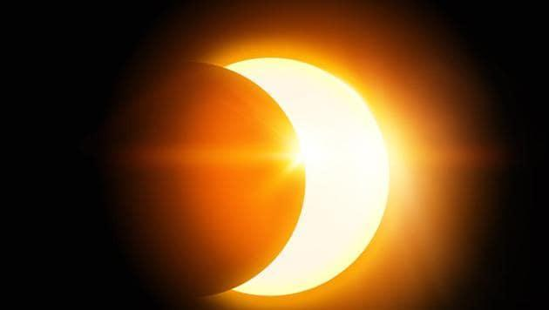  - The moon and sun meet each other at  - 1  - ½  - 1/3  - ¼  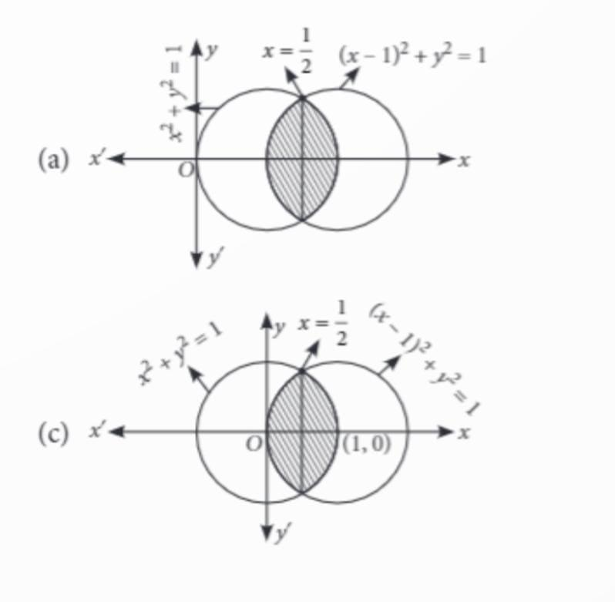  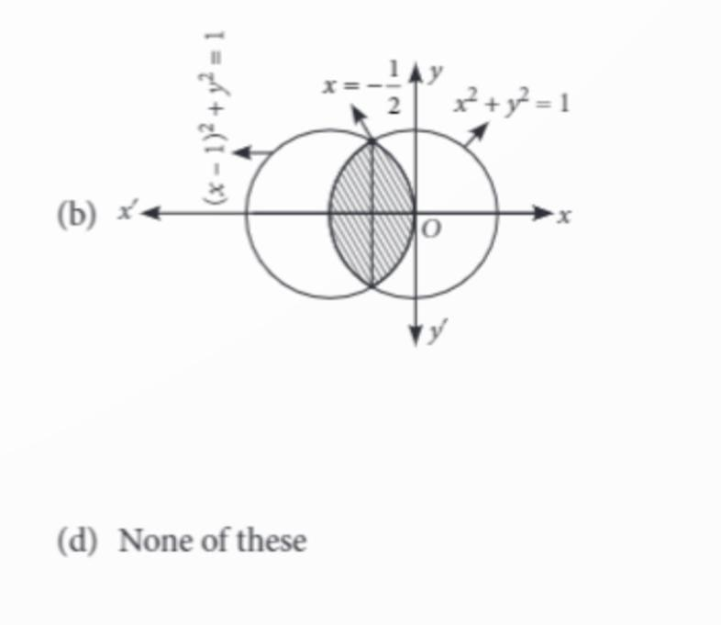  - Value of $\int_{1/2}^{1}{}√$(1-x²) dx is  - $\frac{π}{2}$ +$\frac{\sqrt{3}}{4}$  - $\frac{π}{6}$ +$\frac{√3}{8}$  - $\frac{π}{6}$ -$\frac{√3}{8}$  - $\frac{π}{2}$ -$\frac{√3}{4}$  - Area of hidden portion of the lower circle is  - ($\frac{2π}{3}$ + $\frac{√3}{2})$ sq. unit  - ($\frac{π}{3}$ + $\frac{√3}{8})$ sq. unit  - ($\frac{π}{3}$ - $\frac{√3}{8})$ sq. unit  - ($\frac{2π}{3}$ - $\frac{√3}{2})$ sq. unit | 4
4 | Read the following text and answer the following questions on the basis of the same:  In the figure O (0, 0) is the centre of the circle. The line y = x meets the circle in the first quadrant at the point B.  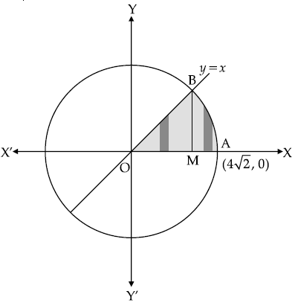  (i) The equation of the circle is _________.  - $x^{2}+y^{2}=4\sqrt{2}$ (b) $x^{2}+y^{2}=16$  (c) $x^{2}+y^{2}=32$ (d) None of these  (ii) The co-ordinates of B are _________.  - (1,1) (b) (2,2) (c) ( $4\sqrt{2}$,4$\sqrt{2}$) (d) (4,4)  (iii) Find the area of the shaded region. | 4
5 | 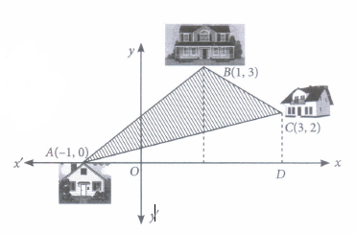  Location of three houses of a society is represented by the points A(-1, 0), B(1, 3) and C(3, 2) as shown in figure. Based on the above information, answer the following question  - Equation of line AB is  - $y=\frac{3}{2}(x+1)$ (b) $y=\frac{3}{2}(x-1)$  (c) $y=\frac{1}{2}(x+1)$ (d) $y=\frac{1}{2}(x-1)$  - Equation of line BC is  - $y=\frac{1}{2}x-\frac{7}{2}$ (b) $y=\frac{3}{2}x-\frac{7}{2}$  (c)$y=\frac{-1}{2}x+\frac{7}{2}$ (d)$y=\frac{3}{2}x+\frac{7}{2}$  - Equation of line AC is  - $2y=x+1$ (b) $2y=x-1$  (c)$y=2x+1$ (d) $y=2x-1$  (iv) Find ar($∆ACD)$  - 4sq. units (b) 8sq. units  (c)12sq. units (d) 2sq. units | 4
6 | Rajendra, a farmer had two sons and two daughters. He decided to divide his property among his sons and daughters .So he wrote a “WILL” about distribution of his property. According to his “WILL”, he desired to give 3/5 th of the property to his sons in equal proportion, 1/3 rd to his daughters in equal proportion and rest to a charitable trust. After his death his “WILL” was opened and read out by the Advocate in the presence of all villagers. He stated in his WILL that my agriculture field is in the shape of triangle with vertices A(2,5), B(4,7) and C(6,2)and all will find the solution following questions based on the field. Those who will find the solution, will be given the stated share of my property  - Find the equations of each side of triangular field.  - Find the area of field using integration. | 4
7 | 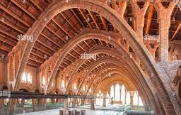  Construction of airport is multi-disciplinary project and in it involves the pooling of various engineering disciplines, agencies, experts, contractors, executives and the end users. Before entering into the real case studies of construction of runways and application of supply chain management technique it is essential to frame a construction plan and a map. The map shows parabolic entry curvatures in which distance between the legs of entry curvature is 60 feet and height of entry curvature is 15 feet. Based on the following information answer the following questions-  - Find the equation of parabolic curvature.  - Find the area within the entry curvature | 4
 | ANSWERS
1 | - i  - iv  - i  - ii | 4
2 | - ii  - ii  - i  - iv | 4
3 | - ii  - iii  - iii  - iv | 4
4 | - (c)  - (d)  - Given curve  $y=x$-----(1)  $x^{2}+y^{2}=32$ -------(2)  Required area = Area of OABO  = ar($∆$OBM)+ar(MABM)  = $\frac{1}{2}×OM×BM$ + $\int_{4}^{4\sqrt{2}}{}\sqrt{32-x^{2}dx}$  = 8+4$π$-8  = 4$π$ | 4
5 | - a  - c  - a  - a | 4
6 | Figure of field is as follows  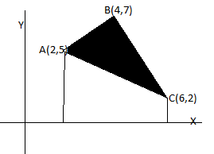  The equation of sides can be obtained using result  $$y- y_{1}= \frac{y_{2}-y_{1}}{x_{2}-x_{1}}(x- x_{1})$$  Equation of AB: x-y+3=0  Equation of BC: 5x+2y=34  Equation of AC: 3x+4y-26=0  Area is given by  $$A= \int_{2}^{4}{}\left(x+3\right)dx+\int_{4}^{6}{}\frac{34-5x}{2}dx-\int_{2}^{6}{}\frac{26-3x}{4}dx$$  $$A=7 sq units$$ | 4
7 | The figure is as follows  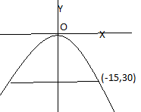  - Let equation of entry curvature x² = -4ay  Point (-15,30) satisfies the equation , so  (30)² = -(4a).(-15) gives a=15  So, the equation of entry curvature is x² = -60y  - Area under entry curvature is given by  $$A=2\int_{0}^{30}{}\left|y\right| dx=2\int_{0}^{30}{}\frac{x^{2}}{60} dx=2/60[\frac{x^{3}}{3}]_{0}^{30}=300 sq units$$ | 4

CHAPTER – 9
DIFFERENTIAL EQUATIONS

SYLLABUS:
Definition, order and degree, general and particular solutions of a differential equation. Solution of differential equations by method of separation of variables, solutions of homogeneous differential equations of first order and first degree. Solutions of linear differential equation of the type: dy /dx + py = q, where p and q are functions of x or constants. d𝑥/ d𝑦 + px = q, where p and q are functions of y or constants.

SL NO | QUESTION | MARK
 | MULTIPLE - CHOICE QUESTIONS
1 | Solution of differential equation$xdy-ydx=Q$ represents:  - a rectangular hyperbola  - parabola whose vertex is at the origin  - straight line passing through the origin  - a circle whose centre is at the origin | 1
2 | Given the differential equation $\frac{dy}{dx}=\frac{6x^{2}}{2y+cosy}$ y(1) = π  - Solution is $y^{2}-siny=-2x^{3}+c$  - Solution of $y^{2}+siny=2x^{3}+c$  - $C=π^{2}+2$  - $C=π^{2}-2$ | 1
3 | The differential equation of all parabolas whose axis of symmetry is along the axis of the x-axis is of order  (a) 3 (b) 1 (c) 2 (d) none of these | 1
4 | The degree of the equation satisfying the relation  $$\sqrt{1+x^{2}}+\sqrt{1+y^{2}} = λx(\sqrt{1+y^{2}}- y(\sqrt{1+x^{2}}$$  (a) 1 (b) 2 (c) 3 (d)4 | 1
5 | The order and degree of the differential equation$\left(\frac{d^{2}y}{dx^{2}}\right)+{\left(\frac{dy}{dx}\right)}^{\frac{1}{4}}+x^{\frac{1}{5}}=0$  Respectively are  (a) 2 and not defined (b) 2 and 2 (c)2 and 3 (d)3 and 3 | 1
6 | Integrating factor of the differential equation$\frac{dy}{dx}+ytanx-secx=0 is$  - $cosx$  - $secx$  - $e^{cosx}$  - $e^{secx}$ | 1
7 | The number of arbitrary constants in the particular solution of a differential equation of third order is:  - 3  - 2  - 1  - 0 | 1
8 | The differential equation satisfied by $y =\frac{A}{x} + B$is (A, B are parameters)  - $x^{2}y_{1}=y$  - $xy_{1}+2y_{2}=0$  - $xy_{2}+2y_{1}=0$  - none | 1
9 | The curve for which the slope of the tangent at any point is equal to the ratio of the abscissa to the ordinate of the point is:  (a)Ellipse (b)Parabola (c) Circle (d) Rectangular hyperbola | 1
10 | The order of differential equations of all circles of given radius 4  (a) 3 (b) 2 (c) 1 (d) 0 | 1
11 | The differential equation y log y dx – x dy =0 is  (i) variable separable differential equation (ii) homogeneous differential equation  (iii)First order linear differential equation (iv) none of these | 1
12 | The integrating factor of the differential equation 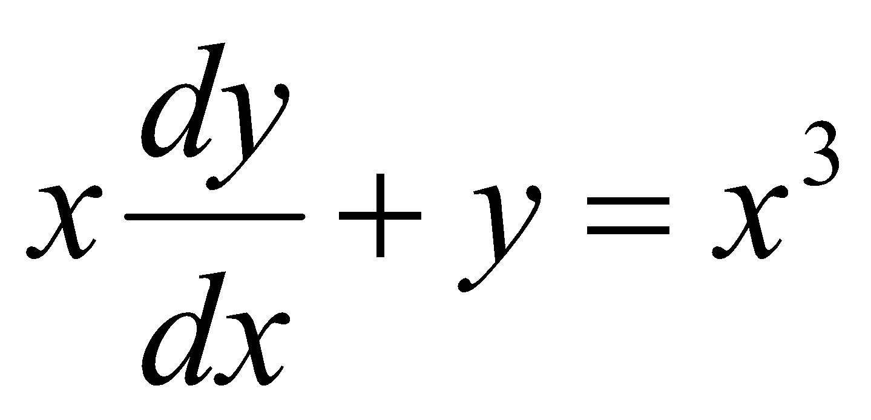is  (i) x (ii) logx (iii) i/x (iv0 none of these | 1
13 | The degree of the differential equation x²+$(\frac{dy}{dx}$)²=5 i  (i) 2 (ii) 3 iii) 1 (iv)none of these | 1
14 | A solution of the differential equation $(\frac{dy}{dx}$)²-x$\frac{dy}{dx}$+ y = 0 is  (i)y=2 (ii) y=2x (iii) y=2x-4 (iv)none of these | 1
15 | The integrating factor of $\frac{dy}{dx}$- y=1 is  (i) e^{x} (ii) e^{-x}(iii) -e^{-x} (iv) none of these | 1
16 | The sum of the order and degree of the differential equation $\frac{d^{2}y}{dx^{2}}$+$\left(\frac{dy}{dx}\right)$³ =siny is  (i)1 (ii)2 (iii) 3 (iv) 4 | 1
17 | What is the product of the order and degree of the differential equation  $\frac{d^{2}y}{dx^{2 }}siny$+$\left(\frac{dy}{dx}\right)$³cosy = $\sqrt{y}$  (i)3 (ii) 2 (iii) 6 (iv) not defined | 1
18 | The solution of the differential equation 2x$\frac{dy}{dx}$- y = 3 represents a family of  - Straight lines (ii) circles (iii) parabolas (iv) ellipses | 1
19 | The general solution of the differential equation xdy –(1+x²) dx=x is  (i)y= 2x+ x³/3 + C (ii) y= 2logx+ x³/2 + C  (iii)y= 2x+ x²/3 + C y= x²/2 + C (iv) none of these | 1
20 | The solution of $\frac{dy}{dx}$- y = 1 , y(0) = 1 is given by  (i)xy=-e(ii)xy=-e^{-x} (iii)xy=-1 (iv) y=2e^{x} – 1 | 1
21 | The degree of the differential equation  ${\left(\frac{d^{2}y}{dx^{2}}\right)}^{3}$+${\left(\frac{dy}{dx}\right)}^{2}$+sin $\left(\frac{dy}{dx}\right)$ + 1=0 , is  a)3 b)2 c)1 d)not defined | 1
22 | The degree of the differential equation  x=1 + $\frac{dy}{dx}$ +$\frac{1}{2!}{\left(\frac{dy}{dx}\right)}^{2}$ +$\frac{1}{3!}{\left(\frac{dy}{dx}\right)}^{3}$ + …………,is  a)3 b)1 c)not defined d)none of these | 1
23 | The order of the differential equation ${\left(\frac{d^{2}r}{dt^{2}}\right)}^{2}$+3${\left(\frac{dr}{dt}\right)}^{3}$+4=0 is  a)2 b)1 c)3 d)4 | 1
24 | The differential equation ${\left(\frac{d^{2}y}{dx^{2}}\right)}^{\frac{2}{3}}$=${\left(y+\frac{dy}{dx}\right)}^{\frac{1}{2}}$ is of  a) second order, fourth degree b) first order, fourth degree  c)second order, third degree d) second order, second degree | 1
25 | The number of arbitrary constants in the general solution of a differential equation of fourth order are  a)0 b)2 c)3 d)4 | 1
 | ANSWERS | 1
1 | c | 1
2 | b | 1
3 | c | 1
4 | a | 1
5 | a | 1
6 | b | 1
7 | d | 1
8 | c | 1
9 | d | 1
10 | b | 1
11 | i | 1
12 | i | 1
13 | iii | 1
14 | iii | 1
15 | ii | 1
16 | iii | 1
17 | ii | 1
18 | i | 1
19 | iv | 1
20 | iv | 1
21 | d | 1
22 | c | 1
23 | a | 1
24 | a | 1
25 | d | 1
 | ASSERTION & REASON QUESTIONS
Choose the correct option in the following questions of Assertion – Reason Questions.
(a) Both A and R are correct; R is the correct explanation of A.
(b) Both A and R are correct; R is not the correct explanation of A.
(c) A is true but R is false
(d) A is false but R is true
1 | Assertion: Order of the differential equation $\frac{d^{2}y}{dx^{2}}$ + ($\frac{dy}{dx})$^{1/3}+ x^{1/4}=0  Reason: The order of a differential equation is the order of highest derivative occurring in the differential equation. | 1
2 | Assertion: The degree of the differential equation $\frac{d^{2}y}{dx^{2}}$ + ($\frac{dy}{dx})$^{1/3}+ x^{1/4}=0 is 3.  Reason: The order of the differential equation is equal to the number of arbitrary constant present in the solution of that differential equation. | 1
3 | Assertion: Differential equation $\frac{dy}{dx}$ =$\frac{xy+ y}{xy +x}$ is homogeneous equation.  Reason: A function(x,y) is called homogeneous of degree n if f(kx,ky)=k^{n}f(x,y). | 1
4 | Assertion: Integrating factor of (dy/dx) – y tan x = - y²sec x is cos x  Reason: Integrating factor I.F. = $e^{\int{}Pdx}$ for linear differential equation  (dy/dx) + Py = Q. | 1
5 | Assertion: The degree of the differential equation $y^{''''}+sinsin y^{'''} =0$ is not defined.  Reason: Degree of a given differential equations is not defined if the given differential equation is not a polynomial equation in its derivatives. | 1
6 | Assertion: The function y = e^{-3x} is a solution of the differential equation $\frac{d^{2}y}{dx^{2}}+\frac{dy}{dx}-6y=0$  Reason: The solution which contains arbitrary constants is called the particular solution (primitive) of the differential equation. | 1
7 | Assertion: The differential equation $\frac{dx}{dy}+ x=coscos y$ is first order linear differential equation.  Reason: Order and degree (if defined) of a differential equation are always positive integers. | 1
8 | Assertion: The order of the differential equation $\frac{d^{2}y}{dx^{2}}+\frac{dy}{dx}-6y=0$ is 1.  Reason: Order of a differential equation is defined as the order of the highest order derivative of the dependent variable with respect to the independent variable involved in the given differential equation. | 1
9 | Assertion: The differential equation $\left(x-y\right)\frac{dy}{dx}=x+2y$ is homogenous differential equation.  Reason: A differential equation of the form $\frac{dy}{dx}=F \left(x, y\right)$ is said to be homogenous if F(x, y) is a homogenous function of degree zero. | 1
10 | Assertion:$x\frac{d^{2}y}{{dx}^{2}}+coscos x\frac{dy}{dx}+tanx=0$ is not a linear differential equation because  Reason: A differential equation is said to be linear if dependent variable and its differential coefficients occurs in first degree and are not multiplied together. | 1
 | ANSWERS
1 | a | 1
2 | b | 1
3 | d | 1
4 | a | 1
5 | a | 1
6 | c | 1
7 | b | 1
8 | d | 1
9 | a | 1
10 | d | 1
 | 2 MARKS TYPE QUESTIONS
1 | Find the differential equation representing the family of curves $y=ae^{2x}$+ 5 constant. | 2
2 | Form the differential equation of the family of hyperbolas having foci On x-axis and center at origin. | 2
3 | Form the differential equation representing the family of curves y = a sin (x + b), where a, b are arbitrary constant. | 2
4 | Find the solution of $\frac{dy}{dx}$=$2^{y-x}$ | 2
5 | Find the sum of the order and the degree of the differential equation  $$\frac{d^{2}y}{{dx}^{2}}+{\left(\frac{dy}{dx}\right)}^{3}=sin y$$ | 2
6 | Find the sum of the order and the degree of the differential equation  $$y^{'''}+2y^{''}+y^{'}=0$$ | 2
7 | Find the solution of the differential equation  Log($\frac{dy}{dx}$) = ax + by | 2
8 | Find the solution of the differential equation  $\frac{dy}{dx}$=x+$\frac{y}{x}$satisfying the condition y(1) = 1. | 2
9 | Solve the differential equation  (e^{x} +1)ydy = e^{x}(y + 1)dx. | 2
10 | Solve $\frac{dy}{dx}$+ 2xy = y | 2
 | ANSWERS | 2
1 | dy/dx=2y-10 | 2
2 | Equation of a hyperbola is given by  $$\frac{x^{2}}{a^{2}}+\frac{y^{2}}{b^{2}}=1…………(1)$$  Differentiating both the sides, we get  $$\frac{2x}{a^{2}}-\frac{2yy}{b^{2}}=0$$  By solving this equation we get  $$xy\left(\frac{d^{2}y}{dx^{2}}\right)+ xy^{2}-yy^{'}=0$$ | 2
3 | Y=asin(x+b)  Differentiating w.r.t. x, we get,  $$\frac{dy}{dx}=\left(x+b\right) .1$$  Again differentiating and by solving we get $\frac{d^{2}y}{dx^{2}}+ y=0$ | 2
4 | Rewriting the equation as $\frac{dy}{dx}=\frac{2^{y}}{2^{x}}$  $$\frac{dy}{2^{y}}=\frac{dx}{2^{x}}$$  Integrating both sides  $$\int{}\frac{dy}{2^{y}}=\int{}\frac{dx}{2^{x}}$$  $$-\frac{2^{-y}}{loglog 2 }=-\frac{2^{-x}}{loglog 2 }+C_{1}$$  $$2^{-x}-2^{-y}=C$$  Which is the general solution of given equation. | 2
5 | Order =2, Degree = 1, Sum of order and degree = 3 | 2
6 | Order =3, Degree = 1, Sum of order and degree = 4 | 2
7 | . Given, log($\frac{dy}{dx}$) = ax + by  $\frac{dy}{dx}$ = e^{ax + by} [჻log_{b} a=c= a=b^{c} ]  - $\frac{dy}{dx}$ = e^{ax .} e^{by} = $\frac{dy}{e^{by}}$ = e^{ax}dx  - e^{-by}dy = e^{ax}dx  On integrating both sides, we get  $\int{}e$^{-by}dy = $\int{}e$^{ax}dx  - $\frac{e^{-by}}{-b}$ = $\frac{e^{ax}}{a}$ + C [჻$\int{}e$^{ax + b}dx = $\frac{e^{ax}+ b}{a}$ + C ]  - $\frac{e^{ax}}{a}$ + $\frac{e^{-by}}{b}$ + C = 0  Which is required solution | 2
8 | Given, equation can be rewritten as  $\frac{Dy}{dx}$ = $\frac{1}{x}$ .y =1  Here, P = -$\frac{1}{x}$ and Q =1  ჻ IF = e${}^{\int{}Pdx}$ = e^ -$\int{}\frac{1}{x}$dx = e^{-logx} = $\frac{1}{x}$  ჻ Required solution is  Y$\left(\frac{1}{x}\right)$ = $\int{}\frac{1}{x}$dx = logx + C [჻y·IF = $\int{}(Q·$IF)dx+C]  Since, y(1) =1 and C = 1  ჻ y = xlogx + x | 2
9 | We have, (e^{x} + 1)ydy = e^{x}(y + 1)dx  On separating the variables , we get  $\frac{y}{y+1}$dy = $\frac{e^{x}}{e^{x}+1}$dx  On integrating both sides, we get  $\int{}\frac{y}{y+1}dy$ = $\int{}\frac{e^{x}}{e^{x}+1}$dx  - $\int{}y+1-\frac{1}{y}+1$dy = $\int{}\frac{e^{x}}{e^{x}+1}$dx  - $\int{}(1-\frac{1}{y+1}$)dy = $\int{}\frac{e^{x}}{e^{x}+1}$dx  - y – log(y+1) = log(e^{x} + 1) + C  which is required solution. | 2
10 | Given that,  xdx-ye^{y}$\sqrt{1+x}$²dy=0 =>xdx = ye^{y}$\sqrt{1+x}$²dy  - $\frac{x}{\sqrt{1+x^2}}$dx = ye^{dy}  Integrating both sides,we get  $\int{}x/\sqrt{1+x}$²dx = $\int{}y·$e^{y}dy  $=>\frac{1}{2}\int{}2x/\sqrt{1+x}$²dx = [y·$\int{}e^y$dy -$\int{}(\frac{d}{dy}$(y)·$\int{}e^y$dy)dy]  Let I₁ ₌$\int{}2x$/$\sqrt{1+x}$²dx  Putting 1 + x² = t => 2x dx = dt [on differentiating]  ჻ I₁ = $\int{}dt/t$^{1/2} =$\int{}t$^{-1/2}dt  = t^{-1/2+1}/-$\frac{1}{2}$+1 = t^{-1/2}/$\frac{1}{2}$ =2t^{1/2}  =2(1+x²)^{½}  Now, ½.2(1+x²)^{½} = y·e^{y}– e^{y} + C  => (1+x²)^{1/2} =e^{y}(y-1) + C  When x = 0, then y = 1  ჻ (1+0)^{1/2} = e¹(1-1) + C  C = 1  So, required solution is given by  (1+x²)^{1/2} = e^{y}(y-1) + 1 | 2
 | 3 – MARKS TYPE QUESTIONS
1 | Find the equation of a curve passing through the point (0,2), given that the sum of the coordinates of any point on the curve exceeds the magnitude of the slope of the tangent to the curve at that point by 5. | 3
2 | Solve the differential equation $\left(y+3x^{2}\right)\frac{dx}{dy}=x.$ | 3
3 | Find the particular solution of the differential equation $\frac{dy}{dx}=1+x^{2}+y^{2}+x^{2}y^{2}$, given that $y=0$ when $x=1.$ | 3
4 | Solve the differential equation $\left(1+x^{2}\right)dy+2xydx=cot x dx.$ | 3
5 | Verify that the function $y=x+bsinsin x$, where $a , b ∈R$ is a solution of the differential equation  $\frac{d^{2}y}{{dx}^{2}}+y=0$ | 3
6 | Find the general solution of the differential equation  $$\frac{dy}{dx}=e^{x+y}$$ | 3
7 | Find the equation of a curve passing through the point (-2,3), given that the slope of the tangent to the curve at any point (x,y) is $\frac{2x}{y^{2}}$  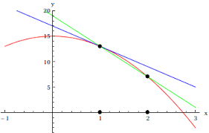 | 3
8 | Find the particular solution of the differential equation  X dx -ye^{y}$\sqrt{1+x}$²dy=,given that y=1,when x=0 | 3
9 | For the differential equation given below , find a particular solution satisfying the given condition (x+1)$\frac{dy}{dx}$= 2e^{-y} + 1; y =0 when x =0. | 3
10 | Solve the differential equation (1+x²)$\frac{dy}{dx}$+2xy -4x² = 0  Subject to the initial condition y(0) = 0. | 3
 | ANSWERS
1 | y =4-x-2$e^{x}$ | 3
2 | $$\left(y+3x^{2}\right)\frac{dx}{dy}=x$$  $$⟹\frac{dy}{dx}=\frac{y+3x^{2}}{x}$$  $$⟹\frac{dy}{dx}-\frac{y}{x}=3x…\left(i\right)$$  $$\frac{dy}{dx}+Py=Q…\left(ii\right)$$  $$On comparison, we get$$  $$P=-\frac{1}{x}, Q=3x$$  $$Integrating Factor \left(I.F\right)=e^{\int{}pdx}=e^{\int{}-\frac{dx}{x}}=e^{-loglog \left|x\right| }=e^{loglog \left|\frac{1}{x}\right| }=\frac{1}{x}$$  $$Hence, the {sol}^{n} is :$$  $$y×I.F=\int{}Q×I.F dx$$  $$⟹\frac{y}{x}=\int{}3x.\frac{1}{x}dx$$  $$⟹\frac{y}{x}=\int{}3dx ⟹\frac{y}{x}=3x+c$$ | 3
3 | $$\frac{dy}{dx}=1+x^{2}+y^{2}+x^{2}y^{2}$$  $$⟹\frac{dy}{dx}=\left(1+x^{2}\right)+y^{2}\left(1+x^{2}\right)$$  $$⟹\frac{dy}{dx}=\left(1+x^{2}\right)\left(1+y^{2}\right)$$  $$⟹\frac{dy}{1+y^{2}}=\left(1+x^{2}\right)dx$$  $$⟹\int{}\frac{dy}{1+y^{2}}=\int{}\left(1+x^{2}\right)dx$$  $$⟹y =x+\frac{x^{3}}{3}+c$$  $$It is given that y=0 when x=1$$  $$∴0=1+\frac{1}{3}+c$$  $$⟹c=-\frac{4}{3}$$  $$Hence, the complete {sol}^{n} is : y =x+\frac{x^{3}}{3}-\frac{4}{3}$$ | 3
4 | $$\left(1+x^{2}\right)dy+2xydx=cotcot x dx$$  $$⟹\left(1+x^{2}\right)\frac{dy}{dx}+2xy=cotcot x$$  $$⟹\frac{dy}{dx}+\frac{2xy}{1+x^{2}}=\frac{cotcot x }{1+x^{2}}…\left(i\right)$$  $$\frac{dy}{dx}+Py=Q…\left(ii\right)$$  $$On comparison, we get$$  $$P=\frac{2x}{1+x^{2}}, Q=\frac{cotcot x }{1+x^{2}}$$  $$Integrating Factor \left(I.F\right)=e^{\int{}pdx}=e^{\int{}\frac{2xdx}{1+x^{2}}}=e^{loglog \left|1+x^{2}\right| }=e^{loglog \left|1+x^{2}\right| }=1+x^{2}$$  $$Hence, the {sol}^{n} is :$$  $$y×I.F=\int{}Q×I.F dx$$  $$⟹y\left(1+x^{2}\right)=\int{}\frac{cotcot x }{\left(1+x^{2}\right)}.\left(1+x^{2}\right)dx$$  $$⟹y\left(1+x^{2}\right)=\int{}cotcot x dx$$  $$⟹y\left(1+x^{2}\right)=loglog \left|sinsin x \right|+c$$ | 3
5 | $$y=x+bsinsin x$$  On differentiating both sides with respect to x, we get  $$\frac{dy}{dx}=-asinsin x+bcoscos x$$  $$\frac{d^{2}y}{{dx}^{2}}=-acoscos x-bsinsin x$$  Now we get $\frac{d^{2}y}{{dx}^{2}}+ y=-acoscos x-bsinsin x +x+bsinsin x =0$  Therefore, the given function is a solution of the given differential equation. | 3
6 | Given differential equation can be rewritten as  $\frac{dy}{dx}=e^{x}$. $e^{y}$  $$e^{-y}dy=e^{x}dx$$  On integrating both sides, we get  $$\int{}e^{-y}dy=\int{}e^{x}dx$$  $${-e}^{-y}=e^{x}+C_{1}$$  $${e^{x}+e}^{-y}=C$$ | 3
7 | We know that the slope of the tangent to the curve is given by $\frac{dy}{dx}$  Hence, as per condition $\frac{dy}{dx}=\frac{2x}{y^{2}}$  The above equation can be rewritten as  $$y^{2}dy=2x dx$$  On integrating both sides, we get  $$\int{}y^{2}dy=\int{}2x dx$$  $$\frac{y^{3}}{3}=x^{2}+C$$  Substituting x=-2 and y=3 we get C=5  Hence the equation of the required curve is  $\frac{y^{3}}{3}=x^{2}+5$ ⇒ y$={\left(3x^{2}+15\right)}^{\frac{1}{3}}$ | 3
8 | Given that,  xdx – ye^{y}$\sqrt{1+x}$² dy = 0 =>xdx =ye^{y}$\sqrt{1+x}$²dy  =>$\frac{x}{\sqrt{1+x^2}}$dx = ye^{y}dy  Integrating both sides, we get  $\int{}x/\sqrt{1+x}$²dx = $\int{}y·$e^{y}dy  =>$\frac{1}{2}\int{}\frac{2x}{\sqrt{1+x^2}}$dx = [ y·$\int{}e^y$dy -$\int{}(d/dy$(y)·$\int{}e^2$dy)dy]  Let I₁ = $\int{}2x/\sqrt{1+x}$²dx  Putting 1 + x² = t => 2x dx = dt [on differentiating]  ჻ I₁ = $\int{}\frac{dt}{t^{1/2}}$ = $\int{}t^{-1}/2$dt  = $\frac{t^-1/2+1}{-\frac{1}{2}+1}$ = $\frac{t^{1}/2}{\frac{1}{2}}$ = 2t^{^1/2}  = 2(1+x²)^{^1/2}  Now, $\frac{1}{2}$·2(1+x²)^{^1/2} =y·e^{y} – e^{y} + C  => (1+x²)^{^1/2} = e^{y}(y-1) + C  When x = 0, then y = 1  ჻ (1+0)^{^1/2} = e¹(1-1) + C  => C = 1  So, required solution is given by (1+x²)^{1/2} = e^{y}(y-1) + 1 | 3
9 | Given, differential equation is  (x+1)$\frac{dy}{dx}$ = 2e^{-y} + 1  => (x+1)$\frac{dy}{dx}$ =$\frac{2+e^y}{e^y}$  =>$\frac{e^y}{e^{y}+2}$dy = $\frac{dx}{x+1}$  On integrating both sides,we get  $\int{}\frac{e^{y}}{e^{y+2}}$dy = $\int{}\frac{dx}{x}+1$  => log(e^{y} + 2) = log(x+1) + logC  => log(e^{y} + 2) = logC(x+1) …(i)  =>e^{y} + 2 = C(x+1)  Also given y = 0, when x = 0  On putting x = 0 and y = 0 in Eq.(i) we get  e⁰ + 2 = C(0 + 1)  => C = 1 + 2 =3  On putting C in Eq. (i) we get  =>e^{y} + 2 = 3(x+1)  =>e^{y} = 3x +3 -2  =>e^{y} = 3x + 1 => y = log(3x + 1) | 3
10 | Given, differential equation is  (1+ x²)$\frac{dy}{dx}$ + 2xy – 4x² = 0  =>$\frac{dy}{dx}$ + $\frac{2x}{1+x^2}$y = $\frac{4x^2}{1+x^2}$  Which is the equation of the form  $\frac{dy}{dx}$ + Py = Q  Where P = $\frac{2x}{1+x^2}$ and Q = $\frac{4x^2}{1+x^2}$  Now, IF = e$\int{}\frac{2x}{1}+x$² = e^{log(1+x^2)} = 1 + x²  The general solution is  Y(1+x²) = $\int{}(1+x^{2})\frac{4x^2}{(1+x^{2})}$dx +C  => (1+ x²)y = $\int{}4x^2$dx + C  => (1+ x²)y = $\frac{4x^3}{3}$ + C  => y = $\frac{4x^3}{3(1+x^{2})}$ + C(1+x²)⁻¹ …(i)  Now, y(0) = 0 => 0 = $\frac{4·0^3}{3(1+0^{2})}$ + C(1+0²)⁻¹  => C = 0  Put the value of C in Eq. (i), we get  Y =$\frac{4x^3}{3(1+x^{2})}$, which is the required solution. | 3
 | 4 – MARKS TYPE QUESTIONS (CASE BASED QUESTIONS)
1 | A Veterinary doctor was examining a sick cat brought by a pet lover. When it was brought to the hospital, it was already dead. The pet lover wanted to find its time of death. He took the temperature of the cat at 11:30pm which was 94.6$∘F.$He took the temperature again after 1h; the temperature was lower than the first observation. It was 93.4$∘F$. The room in which the cat was put is always at 70$∘F$.The normal temperature of the cat is taken as 98.6$∘F$when it was alive.  The doctor estimated the time of time of death using Newton law of cooling which is governed by the differential equation:$\frac{dT}{dt}∝(T$ – 70), where 70$∘F$is the room temperature and Tis the temperature of object at time t.  Substituting the two different observations of Tand t made, in the solution of the differential equation $\frac{dT}{dt}$ = k(T – 70), where k is a constant ofproportion, time of death is calculated.  Answer the following questions using the above information.  (i)The degree of the above given differential equation is  (a)0 (b)1 (c)2 (d)3  (ii)If the temperature was measured 2h after 11:30pm, will time of death change?  (a)Yes (b)No (c)Can’t say (d)None of these  (iii)The solution of the differential equation  $\frac{dT}{dt}$= k(T- 70)is given by,  (a)log$|T$-70| =kt + C  (b)log|T-70| = log|kt| + C  (c)T-70 = kt + C  (d) t- 70 = kT + C  (iv)If t =0 when T is 72, then the value of C is  (a)-2 (b)0 (c)2 (d)log2 | 4
2 | Consider the differential equation $\frac{dy}{dx}$ + 2ytanx = sinx.  Answer the following questions which are based on above information.  (i)Find the values of Pand Q , if the given differential equation can be written in the form of $\frac{dy}{dx}$ +Py = Q.  (ii)Find the integrating factor of the differential equation.  (iii)Find the solution of the differential equation.  (iv)If y$\left(\frac{π}{3}\right)$= 0,then write the relation between x and y. | 4
3 | 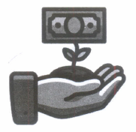  It is known that, if the interest is compounded continuously, the principal changes at the rate equal to the produd’ of the rate of bank interest per annum and the principal. Let P denotes the principal at any time t and rate of interest be r % per annum  Based on the above information, answer the following questions.  - Find the value of $\frac{dp}{dt}$  (a)$\frac{pr}{1000} \left(b\right) \frac{pr}{100} \left(c\right)\frac{pr}{20} \left(d\right)\frac{pr}{20}$  (ii). If $P_{0}$ be the initial principal, then find the solution of differential equation formed in given situation.  (a)log $\frac{p}{p_{0}}=\frac{rt}{100} \left(b\right)loglog \left(\frac{p}{p_{0}}\right) =\frac{rt}{10} \left(c\right) loglog \left(\frac{p}{p_{0}}\right) =\frac{r}{20} \left(d\right)none$  (iii)If the interest is compounded continuously at 5% per annum, in how many years will Rs.100 double itself?  (a) 12.728 years (b) 14.789 years (c) 13.862 years (d) 15.872 years  (iv)How much will Rs.1000 be worth at 5% interest after 10 years? (e0.5 = 1.648).  (a) Rs.1648 (b) Rs 1500 (c) Rs 1664 (d) Rs 1572 | 4
4 | 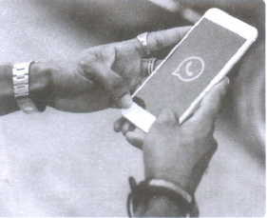  A rumor on WhatsApp spreads in a population of 5000 people at a rate proportional to the product of the number of people who have heard it and the number of people who have not. Also, it is given that 100 people initiate the rumor and a total of 500 people know the rumor after 2 days.  (i)If yet denote the number of people who know the rumor at an instant t, then maximum value of y(t) is  (a) 500 (b) 100 (c) 5000 (d) none of these  (ii) $\frac{dy}{dt} is proprtional to$  (a)(y – 5000) (b) y(y – 500) (c) y(500 – y) (d) y(5000 – y)  (iii) The value of y(0) is  (a)100 (b) 500 (c) 600 (d) 200  (iv) The value of y(2) is  (a)100 (b) 500 (c) 600 (d) 200 | 4
5 | Polio drops are delivered to 50K children in a district. The rate at which polio drops are given is directly proportional to the number of children who have not been administered the drops. By the end of 2nd week half the children have been given the polio drops. How many will have been given the drops by the end of 3rd week can be estimated using the solution to the differential equation 𝑑𝑦𝑑𝑥 = K (50 − y) where x denotes the number of weeks and y the number of children who have been given the drops.  1. State the order of the above given differential equation.  2. Which method of solving a differential equation can be used to solve 𝑑𝑦𝑑𝑥 = k (50 − y)  a) Variable separable method  b) Solving Homogeneous differential equation  c) Solving Linear differential equation  d) All of the above  3. The solution of the differential equation 𝑑𝑦𝑑𝑥 = k (50 − y) is given by,  a) log | 50 – y| = kx + C  b) - log | 50 – y| = kx + C  c) log | 50 – y| = log| kx |+ C  d) 50 – y = kx + C  4. The value of c in the particular solution given that y(0)=0 and k = 0.049 is :  a) log 50  b) log 1 50  c) 50  d) -50  5. Which of the following solutions may be used to find the number of children who have  been given the polio drops?  a) y = 50 – 𝑒𝑘𝑥  b) y = 50 − 𝑒 −𝑘𝑥  c) y = 50 (1 – 𝑒 −𝑘 )  d) y = 50 (𝑒𝑘𝑥– 1) | 4
6 | A Veterinary doctor was examining a sick cat brought by a pet lover. When it was brought to the hospital, it was already dead. The pet lover wanted to find its time of death. He took the temperature of the cat at 11.30 pm which was 94.6 ○F. He took the temperature again after one hour; the temperature was lower than the first observation. It was 93.4 ○F. The room in which the cat was put is always at 70 ○F. The normal temperature of the cat was 98.6 ○F when it was alive. The doctor estimated the time of death using Newton law of cooling which is governed by the differential equation: 𝑑𝑇𝑑𝑡∝ (T − 70), where 70 ○F is the room temperature and T is the temperature of the object at time t. Substituting the two different observations of T and t made, in the solution of the differential equation 𝑑𝑇𝑑𝑡 = 𝑘(T − 70) where k is a constant of proportion, time of death is calculated.  1) State the degree of the above given differential equation.  2) Which method of solving a differential equation helped in calculation of the time of death?  - Variable separable method b) Solving Homogeneous differential equation  c) Solving Linear differential equation d) all of the above  3) If the temperature was measured 2 hours after 11.30pm, will the time of death change? (Yes/No)  4) The solution of the differential equation 𝑑𝑇𝑑𝑡 = 𝑘(T − 70) is given by,  a) log | T – 70| = kt + C b) log | T – 70| = log |kt |+ C  c) T – 70 = kt + C d) T – 70 = kt C  5) If t = 0 when T is 72, then the value of c is  a) -2 b) 0 c) 2 d) Log 2 | 4
 | ANSWERS
1 | Given, differential equation can be rewritten as  F(x,y) = $\frac{dy}{dx}$ = $\frac{y}{2x-x log⁡(\frac{y}{x})}$  Verify F($λ$x, $λ$y) = F(x,y)  On putting y = vx and $\frac{dy}{dx}$ = v + x$\frac{dv}{dx}$, then given equation becomes  => v + x$\frac{dv}{dx}$ = $\frac{vx}{2x-xlog(\frac{vx}{x})}$  => x $\frac{dv}{dx}$ = $\frac{v}{2-logv }$ - v  =>$\int{}2-logv/v(logv-1)$dv = $\int{}dx/x$  On putting log v = t and $\frac{1}{v}$dv = dt, we get  $\int{}2-t$/t-1dt = log|x| + C  =>$\int{}(\frac{1}{t-1}$- - 1)dt = log|x| + C  => log(t-1) – t = log|x| + C  => log[log4)-1] – log4 = log|x| + C  => log[(log$\frac{y}{x}$) -1] -log($\frac{y}{x}$) = logx + C  => log[(log$\frac{y}{x}$) – 1] -logy = C  ჻ log$|\frac{\frac{logy}{x}-1}{y}$ | = C | 4
2 | (i) Given , differential equation is  $\frac{dy}{dx}$ + 2ytanx = sinx  Which is a linear differential equation of the form  $\frac{dy}{dx}$ + Py = Q.  Here,P = 2tanx and Q = sinx  (ii) IF =$e^{\int{}Pdx}= e^{\int{}2tanx dx}$  =$e^{\int^{tanx dx }{}}$ = e^{2log|sec x|}  = $e^{logsec^{2}x }$= sec² x [჻$e^{log⁡(x)}$ = f(x)]  (iii) The solution of differential equation is given by  y·sec² x = $\int{}sec$²x·sinxdx + C  => y·sec² x = $\int{}sinx/cos⁡^2xd$x·sinxdx + C  Put cosx = t , then -sinxdx =dt  ჻ y·sec²x = -$\int{}dt/t^2$ + C  => y·sec²x = -$\int{}t$⁻²dt + C  => y·sec²x = -1$\frac{t-^1}{(-1)}$ + C  y·sec²x =$\frac{1}{t}$ + C  y·sec²x =$\frac{1}{cosx}$ + C  y·sec²x =secx + C  => y =$\frac{1}{secsec x }$ + $\frac{C}{sec⁡^2x}$ [dividing each term by sec² x]  => y = cosx + C·cos²x  (iv) It given that y = 0, when x = $\frac{π}{3}$  ჻ 0 = cos$\frac{π}{3}$ + C·cos²$\frac{π}{3}$  => 0 =$\frac{1}{2}$ + C·$\frac{1}{4}$ [჻cos$\frac{π}{3}$ =$\frac{1}{2}$]  =>$\frac{-1}{2}$ = $\frac{C}{4}$ => C = -2  ჻ The required particular solution is  =>y = cosx – 2cos²x | 4
3 | i)(b)Here, P denotes the principal at any time t and the rate of interest be r% per annum compounded continuously, then according to the law given in the problem, we get $\frac{pr}{100}$  (ii) (a). (iii) (c). (iv) (d) | 4
4 | i)c)Since, size of population is 5000.  Hence, Maximum value of y(t) is 5000.  ii) (d) : Clearly, according to given information  $$\frac{dy}{dt}=ky(5000-y)$$  ,where k is the constant of proportionality.  iii)(a) y(0)=100  iv)(b) y(2)=500 | 4
5 | 1) Degree is 1  2) (a) Variable separable method  3) No  4) (a) log | T –70| = kt + C  5) (d)log 2 | 4
6 | 1) Order is 1  2) (a) Variable separable method  3. (b)- log | 50– y| = kx + C  4. (b) log 1 50  5. (c) y = 50 ((1 – 𝑒^{−𝑘}) | 4
 | 5 – MARKS TYPE QUESTIONS
1 | $\frac{dy}{dx}+\frac{y}{x}=0$where 'x' denotes the percentage population in a city and 'y' denotes the area for living healthy life of population. Find the particular solution when x=100,y=1.  Is higher density of population harmful? Justify your answer | 5
2 | Solve the differential equation  (xdy-ydx )y sin(y/x) = (ydx+xdy)x cos(y/x). | 5
3 | Find the equation of a curve passing through (0,$\frac{π}{4}$)and satisfying the differential equation  Sinx.cosy dx + cosx.siny dy=0 | 5
4 | Find the particular solution of the differential equation $\frac{dy}{dx}$ +ycotx =2x+x²cotx (x$≠$0) given that y=0 when x=$\frac{π}{2}$. | 5
5 | Show that the differential equation  2y$e^{\frac{x}{y}}$dx+$\left(y-2xe^{\frac{x}{y}}\right)$dy=0 is homogeneous and find its particular solution, given that, x= 0 when y = 1 | 5
 | ANSWERS
1 | $$\frac{dy}{dx}+\frac{y}{x}=0$$  $$\frac{dy}{dx}=-\left(\frac{y}{x}\right)$$  Differentiating and by solving we get xy=100 | 5
2 | sec(y/x) = cxy | 5
3 | cosy = secx/$\sqrt{2}$ | 5
4 | The given equ. is a L.D.E. of the type $\frac{dy}{dx}$+Py=Q ,where P=cotx and Q=2x+x²cotx.  IF= $e^{\int{}cotxdx}$= sinx,  General solution is given by ysinx=$\int{}\left(2x+x^{2}cotx\right)sinxdx+c$  Gives ysinx=x²sinx+c,  Substituting y=0 and x=$\frac{π}{2}$ we get c=$\frac{-π^{2}}{4}$  Particular solution y=x² - $\frac{π^{2}}{4sinx}$ | 5
5 | This is of the form $\frac{dx}{dy}$=g$\left(\frac{x}{y}\right)$.  Put x=vy ,then $\frac{dx}{dy}$=v+y$\frac{dv}{dy}$  Gives 2e^{v}dv=$\frac{-dy}{y}$  Integrate it, we get 2e^{v}= - log|y|+c  Put v=$\frac{x}{y}$ ,we get  General solution 2$e^{\frac{x}{y}}$+log|y|=c,  Substituting x=0 and y=1 we get c=2 Particular solution 2$e^{\frac{x}{y}}$+log|y|=2. | 5

CHAPTER – 10
VECTORS

SYLLABUS:
Vectors and scalars, magnitude and direction of a vector. Direction cosines and direction ratios of a vector. Types of vectors (equal, unit, zero, parallel and collinear vectors), position vector of a point, negative of a vector, components of a vector, addition of vectors, multiplication of a vector by a scalar, position vector of a point dividing a line segment in a given ratio. Definition, Geometrical Interpretation, properties and application of scalar (dot) product of vectors, vector (cross) product of vectors.

SL NO | QUESTION | MARK
 | MULTIPLE - CHOICE QUESTIONS
1 | If points A (60 î+ 3 ĵ), (40 î– 8 ĵ) and C ( aî- 52ĵ) are collinear, then ‘a’ is equal to  a) 40 b) -40 c) 20 d) -20 | 1
2 | The value of î. (ĵx k̂) + ĵ. (îx k̂) + k̂. (îx ĵ) is  a) 0 b) -1 c) 1 d) 3 | 1
3 | If |a⃗ | = 2, |b⃗ | = 5 and |a⃗ x b⃗ | = 8 , find a⃗ . b⃗  a) 6 b)1 c)7 d)0 | 1
4 | Find the area of the ||gm whose adjacent sides are represented by the vectors  a⃗ = 3 î+ ĵ-2 k̂ , b⃗ = î-3 ĵ+4 k̂  a)10 b) 10√3 c)8 d)12 | 1
5 | a⃗ is a unit vector and ( x⃗ − a⃗ ) ( x⃗ + a⃗ ) = 8, then find |x⃗ |  a)2 b)5 c)3 d)1 | 1
6 | The vector in the direction of the vector $\vec{a}$$\hat{i}-\hat{2j}+2\hat{k}$ that has a magnitude 9 is:  (a) $\hat{i}-\hat{2j}+2\hat{k}$ (b)$\frac{1}{3}(\hat{i}-\hat{2j}+2\hat{k})$  (c) 3($\hat{i}-\hat{2j}+2\hat{k}$) (d)9 $\hat{i}-\hat{2j}+2\hat{k}$ | 1
7 | The position vectors of the points A, B, C are $2\hat{i}+\hat{j}-\hat{k}, 3\hat{i}-2\hat{j}+\hat{k}$ $and \hat{i}+4\hat{j}-3\hat{k}$respectively. These points :  (a) form an isosceles triangle (b) form a right triangle  (c) are collinear (d) form a scalene triangle | 1
8 | The projection of the vector $\vec{a}=$ $2\hat{i}-\hat{j}+\hat{k}$ on $\vec{b}=\hat{i}-2\hat{j}+\hat{k}$ is:  (a) $\frac{\sqrt{5}}{2}$ (b) $\frac{5}{\sqrt{2}}$ (c) $\frac{\sqrt{5}}{6}$ (d) $\frac{\sqrt{6}}{5}$ | 1
9 | If  is the angle between any two vectors $\vec{a} and \vec{b}$ , then $\left|\vec{a}×\vec{b}\right|=\left|\vec{a}.\vec{b}\right|$ when  is:  (a) $\frac{π}{3}$ (b)$\frac{π}{4}$ (c) $\frac{2π}{3}$ (d) none of these | 1
10 | If $\hat{a},\hat{b},\hat{c}$ are mutually perpendicular unit vectors, then value of $\left|\hat{a}+\hat{b}+\hat{c} \right|$ is:  (a) 1 (b) $\sqrt{2}$ (c) $\sqrt{3}$ (d) $2$ | 1
11 | The vector $\vec{b}$ 3$\hat{i}$4$\hat{k}$ is to be written as the sum of a vector  parallel to $\vec{a}$ $\hat{i}+\hat{j}$ and a vector $\vec{β}$ perpendicular to $\vec{a}$. Then $\vec{α}$ is:  (a) $\frac{3}{2}\left(\hat{i}+\hat{j} \right)$ (b)$\frac{2}{3}$ ($\hat{i}+\hat{j}$ ) (c)$\frac{1}{2}$ ( $\hat{i}+\hat{j}$ ) (d) $\frac{1}{3}$( $\hat{i}+\hat{j}$) | 1
12 | If the position vectors of P and Q are $\hat{i}+3\hat{j}-7\hat{k} and 5\hat{i}-2\hat{j}+4\hat{k}$ then cosine of the angle between $\vec{PQ}$ and y-axis is:  (a)$\frac{5}{\sqrt{162}}$ (b) $\frac{4}{\sqrt{162}}$ (c) $\frac{11}{\sqrt{162}}$ (d) $- \frac{5}{\sqrt{162}}$ | 1
13 | $\vec{a}$ and $\vec{b}$ are two unit vectors and $θ$ is the angle between them then $cos\frac{θ}{2}=$  (a)$\frac{1}{2}\left| \vec{a}+\vec{b}\right|$ (b) $\left| \vec{a}+\vec{b}\right|$ c) $\left| \vec{a}-\vec{b}\right|$ (d) $\frac{1}{2}\left| \vec{a}-\vec{b}\right|$ | 1
14 | $\vec{a}$, $\vec{b},$ and $\vec{c}$ are three unit vectors such that $\vec{a}+\vec{b}+\vec{c}=\vec{0}$, then $\vec{a}$.$\vec{b}+\vec{b.}\vec{c}+\vec{c}. \vec{a}=$  3 (b)$-\frac{3}{2}$ (c) $\frac{3}{2}$ (d) 3 | 1
15 | The value of expression $\left| \vec{a} ×\vec{b} \right|$² $+(\vec{a} . \vec{b})$² is  $\left(a\right)\vec{a} . \vec{b}$ (b) $\left| \vec{a} \right|$ .$\left| \vec{b} \right|$ (c) $\left| \vec{a} \right|$²$\left| \vec{b} \right|$² (d) $(\vec{a} . \vec{b}$) | 1
16 | If is any non zero vector then ($\vec{a} . \hat{i}$)$\hat{i}$ +$(\vec{a} . \hat{j}$)$\hat{j}+$($\vec{a} . \hat{k}$)$\hat{k}$ is equal to  - $\vec{a} . \vec{b}$ (b) $\vec{a}$ (c) 0 (d) None of these | 1
17 | The vector in the direction of the vector $\hat{(i}-2\hat{j}+2\hat{k})$ has the magnitude 9 is  - ($\hat{i}-2\hat{j}+2\hat{k})$ (b) $\frac{\hat{i}-2\hat{j}+2\hat{k}}{3}$ (c) 3($\hat{i}-2\hat{j}+2\hat{k})$ (d) 9( $\hat{i}-2\hat{j}+2\hat{k})$ | 1
18 | The direction cosine of vector $\vec{BA}$,where the coordinates of A and B are (1,2,-1) and (3,4,0) respectively, are  - -2,-2,-1 (b) $-\frac{2}{3},-\frac{2}{3},-\frac{1}{3}$ (c) 2,2,1 (d) $\frac{2}{3}$ ,$\frac{2}{3}$ ,$\frac{1}{3}$ | 1
19 | Angle between two vectors $\vec{a}$ and $\vec{b}$ with magnitude $√3$ and 4 respectively and $\vec{a} . \vec{b}$ = 2 $√3$ is  $(a) \frac{π}{6}$ (b) $\frac{π}{3}$ (c) $\frac{π}{2}$ (d) $\frac{5π}{2}$ | 1
20 | The value of p for which the vectors $2\hat{i}+p\hat{j}+\hat{k}$ and -4$\hat{i}-6\hat{j}+26\hat{k}$ are perpendicular to each other, is  (a) 3 (b) -3 (c) $\frac{-17}{3}$ (d) $\frac{17}{3}$ | 1
21 | Two vectors $\vec{a}$ =A $\hat{i}+B\hat{j}+C\hat{k}$ and $\vec{b}$=L$\hat{i}+M\hat{j}+N\hat{k}$are collinear if  (a)AL + BM + CN= 0 (b) $\frac{A}{L}$ = $\frac{B}{M}$ = $\frac{C}{N}$ (c) A=L ,B=M , C=N (d) None of these | 1
22 | The value of ($\hat{i}× \hat{j})∙ \hat{j}$ + ($\hat{j} ×\hat{i}$) $∙\hat{k}$ is  (a) 2 (b) 0 (c) 1 (d) -1 | 1
23 | If $\left| \vec{a} \right|$ = 4 and -3$≤δ≤$ 2 then the range of $\left| δ\vec{a} \right|$ is  $(a)\left[0 , 8\right]$ (b) $\left[-12 , 8\right]$ (c) $\left[0 , 12\right]$ (d) $\left[8 , 12\right]$ | 1
24 | In $∆ABC$, $\vec{AB}$ = $\hat{i}+\hat{j}+2\hat{k}$ and $\vec{AC}$ = $3\hat{i}-\hat{j}+4\hat{k}$ .If D is mid- point of BC ,then , $\vec{AD}$ is equal to  $(a)4\hat{i}+6\hat{k}$ (b) $2\hat{i}-2\hat{j}+2\hat{k}$ (c) $\hat{i}-\hat{j}+\hat{k}$ (d) $2\hat{i}+3\hat{k}$ | 1
25 | If $\left|\vec{a}×\vec{b}\right|$² + $\left|\vec{a}.\vec{b}\right|$² = 144 and $\left|\vec{a}\right|$ = 4, then $\left|\vec{b}\right|$ is equal to  (a)1 (b)2 (c)3 (d)4 | 1
 | ANSWERS | 1
1 | b | 1
2 | d | 1
3 | a | 1
4 | b | 1
5 | c | 1
6 | C. 3($\hat{i}-\hat{2j}+2\hat{k}$) | 1
7 | A. form an isosceles triangle | 1
8 | C. $\frac{\sqrt{5}}{6}$ | 1
9 | B. $\frac{π}{4}$ | 1
10 | C. $\sqrt{3}$ | 1
11 | A. $\frac{3}{2}\left(\hat{i}+\hat{j} \right)$ | 1
12 | D. $- \frac{5}{\sqrt{162}}$ | 1
13 | A. $\frac{1}{2}\left| \vec{a}+\vec{b}\right|$ | 1
14 | B. $-\frac{3}{2}$ | 1
15 | (c) | 1
16 | (b) | 1
17 | (c) | 1
18 | (b) | 1
19 | (b) | 1
20 | (a) | 1
21 | (b) | 1
22 | (d) | 1
23 | (c) | 1
24 | (d) | 1
25 | c | 1
 | ASSERTION & REASON QUESTIONS
Choose the correct option in the following questions of Assertion – Reason Questions.
(a) Both A and R are correct; R is the correct explanation of A.
(b) Both A and R are correct; R is not the correct explanation of A.
(c) A is true but R is false
(d) A is false but R is true
1 | Assertion(A): The area of parallelogram with diagonals $\vec{a}$ and$\vec{b}$ is $\left|\vec{a} × \vec{b} \right|.$  Reason(R): If $\vec{a}$ and$\vec{b}$ represent the adjacent sides of a triangle, then the area of a triangle, then the area of triangle can be obtained by evaluating $\left|\vec{a} × \vec{b} \right|$. | 1
2 | Assertion: $\vec{a} × \vec{b} is perpendicular to both \vec{a}+\vec{b} and \vec{a}-\vec{b}$.  Reason: Both $\vec{a}+\vec{b} and \vec{a}-\vec{b}$lie in the plane containing $\vec{a} and \vec{b}$  But$\vec{a} × \vec{b} is perpendicular to$ plane containing $\vec{a} and \vec{b}$ . | 1
3 | Assertion: If $\vec{a}+\vec{b} = \vec{a}-\vec{b}$then angle between $\vec{a} and \vec{b}$ is 900.  Reason: $\vec{a}+\vec{b} = \vec{b} + \vec{a}$ | 1
4 | Assertion: Negative acceleration of a body is associated with slowing down of a body.  Reason: Acceleration is a vector quantity. | 1
5 | Assertion: If $θ$ is the angle between $\vec{a} and \vec{b}$ then $tanθ= \frac{\vec{a} × \vec{b}}{\vec{a} . \vec{b}}$  Reason: $\vec{a} × \vec{b}$is perpendicular to $\vec{a} and \vec{b}$ | 1
6 | Assertion: Angle between $\hat{i}+\vec{j} and \hat{i}$ is 450.  Reason: $\hat{i}+\vec{j}$is equally inclined to both $\hat{i} and \vec{j}$. | 1
7 | Assertion: Two vectors are said to be like vectors if they have the same direction but different magnitude.  Reason: Vector quantities do not have a specific direction. | 1
8 | Assertion: A⃗ ×B⃗ is perpendicular to both A⃗ +B⃗ as well as A⃗ −B⃗.  Reason : A⃗ +B⃗ as well as A⃗ −B⃗ lie in the plane containing A⃗ and B⃗ , but A⃗ ×B⃗ lies perpendicular to the plane containing A⃗ and B⃗ . | 1
9 | Assertion :The position of a particle in a rectangular coordinate system is(3,2,5).then its position vector be 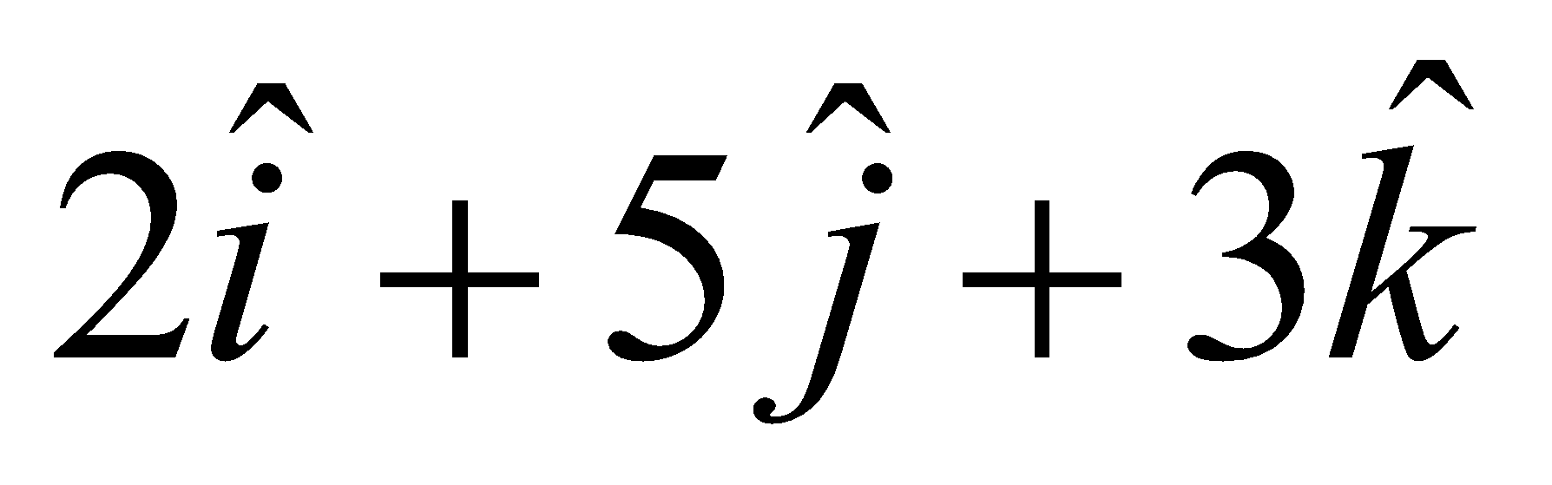  Reason : The displacement vector of the particle that moves from point P(2,3,5) to the point Q(3,4,5) is 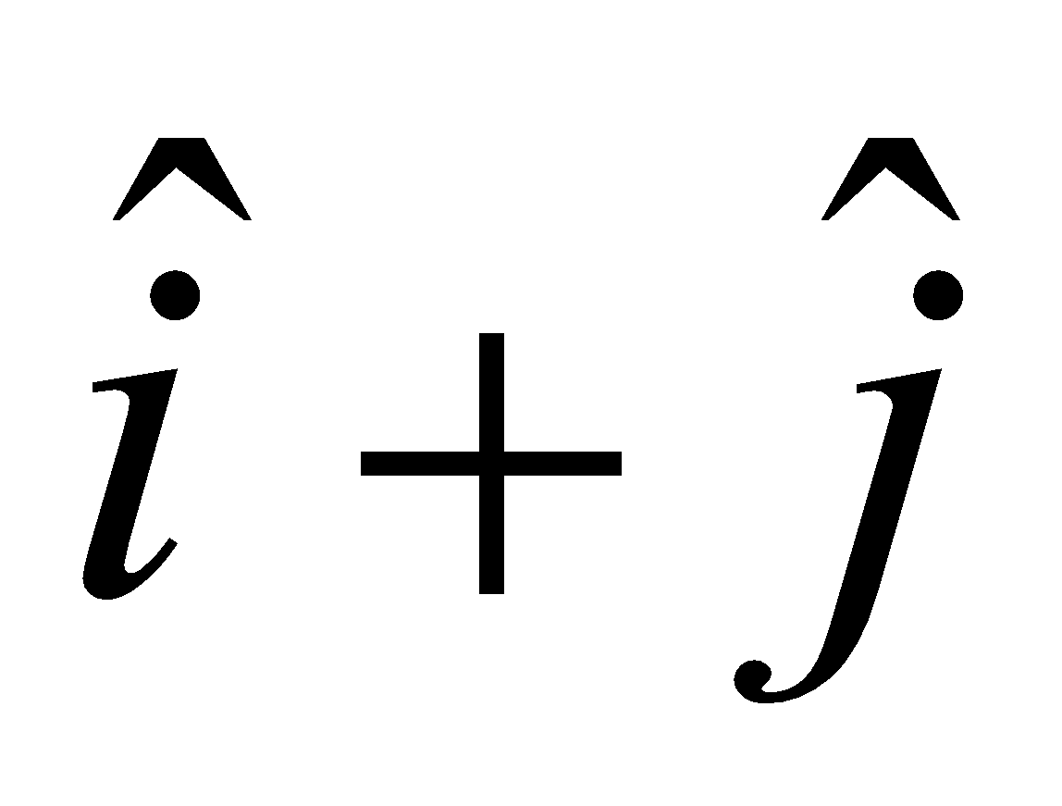 | 1
10 | Assertion: The sum of two vectors can be zero.  Reason: The vector cancel each other, when they are equal and opposite. | 1
 | ANSWERS
1 | c | 1
2 | a | 1
3 | b | 1
4 | b | 1
5 | d | 1
6 | a | 1
7 | c | 1
8 | a | 1
9 | d | 1
10 | a | 1
 | 2 MARKS TYPE QUESTIONS
1 | Find a unit vector perpendicular to each of the vectors $\vec{a}+\vec{b}$ and $\vec{a}-\vec{b}$, where $\vec{a}=\hat{i}+\hat{j}+\hat{k}$, $\vec{b}=\hat{i}+2\hat{j}+3\hat{k}.$ | 2
2 | Prove that the points A,B and C with position vectors $\vec{a} , \vec{b} and \vec{c}$ respectively are collinear if and only if $\vec{a}×\vec{b}+\vec{b}×\vec{c}+\vec{c}×\vec{a}=0.$ | 2
3 | Prove that $\left(\vec{a}-\vec{b}\right)×\left(\vec{a}+\vec{b}\right)=2(\vec{a}×\vec{b})$ | 2
4 | If $\vec{a}=\hat{i}+\hat{j}+\hat{k}$ and $\vec{b}=4\hat{i}-2\hat{j}+3\hat{k}$ and $\vec{c}=\hat{i}-2\hat{j}+\hat{k}$ find a vector of magnitude 6 units which is parallel to the vector $2\vec{a}-\vec{b}+3\vec{c}$. | 2
5 | Show that the points A,B and C with position vectors $\vec{a}=3\hat{i}-4\hat{j}-4\hat{k}, \vec{b}=2\hat{i}-\hat{j}+\hat{k} and \vec{c}=\hat{i}-3\hat{j}-5\hat{k}$ respectively from the vertices of a right angled triangle. | 2
6 | For what value of a, the vectors 2 $\hat{i}-3\hat{j}+4\hat{k}$ and $a\hat{i}+6\hat{j}-8\hat{k}$ are collinear? | 2
7 | Find unit vector perpendicular to both the vectors $\vec{a}$ =$\hat{i}+\hat{j}+\hat{k}$ and $\vec{b}=$ $\hat{i}+\hat{j}$ . | 2
8 | If $\vec{a}$ = 2,$\vec{b}$ = $√3$ and $\vec{a} . \vec{b}$ = $√3$ find the angle between $\vec{a}$ and $\vec{b}$ . | 2
9 | If $\vec{p}$ is unit vector and ($\vec{x}$ - $\vec{p}$) $∙$ ($\vec{x}$ + $\vec{p}$) = 80 ,then find $\left| \vec{x} \right|$ . | 2
10 | Show that the points A($-2\hat{i}+3\hat{j}+5\hat{k}$),B($\hat{i}+2\hat{j}+3\hat{k}$), and C($7\hat{i}-\hat{k})$ are collinear. | 2
 | ANSWERS | 2
1 | $$-\frac{1}{\sqrt{6}}\hat{i}+\frac{2}{\sqrt{6}}\hat{j}-\frac{1}{\sqrt{6}}\hat{k}$$ | 2
2 | Proving $\vec{AB}×\vec{BC}=0, \left(\vec{b}-\vec{c}\right)×\left(\vec{c}-\vec{b}\right)=0$ and proceeding further to prove. | 2
3 | Expanding and solving. | 2
4 | $$2\hat{i}-4\hat{j}+4\hat{k}$$ | 2
5 | $\left|\vec{AB}\right|=\sqrt{35} ,\left|\vec{BC}\right|=\sqrt{41} and \left|\vec{CA}\right|=\sqrt{6}$ and apply Pythagoras theorem. | 2
6 | Let $\vec{A}$ = 2 $\hat{i}-3\hat{j}+4\hat{k}$  $\vec{B}$ = $a\hat{i}+6\hat{j}-8\hat{k}$  $\vec{A}$ and $\vec{B}$ are collinear so , $\vec{A}$= $λ\vec{B}$  $\frac{2}{a}$ =$\frac{-3}{6}$ = $\frac{4}{-8}$  a= -4 | 2
7 | Unit vector perpendicular to $\vec{a}$ =$\hat{i}+\hat{j}+\hat{k}$ and $\vec{b}$ = $\hat{i}+\hat{j}$ is  $\hat{n}$ =$\frac{ \vec{a} ×\vec{b}}{ \left| \vec{a} ×\vec{b} \right|}$ … (i)  $\vec{a} ×\vec{b}$ =$\left[ \hat{i} \hat{j} \hat{k} 1 1 1 1 1 0 \right]$ = -$\hat{i}$ + $\hat{j}$  $\left| \vec{a} ×\vec{b} \right|$=$\sqrt{1+1}$ =$\sqrt{2}$  From equation (i)  $\hat{n}$ =$\frac{ \vec{a} ×\vec{b}}{ \left| \vec{a} ×\vec{b} \right|}$ = $\frac{1}{2}$ ( -$\hat{i}$ + $\hat{j}$) | 2
8 | We know that angle between $\vec{a}$ and $\vec{b}$ is given by  $coscos θ$ =$\frac{\vec{a} . \vec{b}}{\left| \vec{a} \right|\left| \vec{b} \right|}$  $coscos θ$= $\frac{\sqrt{3}}{2\sqrt{3}}$  $coscos θ$= $\frac{1}{2} =>θ=$ $\frac{π}{3}$ | 2
9 | It is given that $\vec{p}$ is unit vector and  ($\vec{x}$ - $\vec{p}$) $∙$ ($\vec{x}$ + $\vec{p}$) = 80  ${\left|\vec{x} \right|}^{2}$ - ${\left|\vec{p} \right|}^{2}$=80  ${\left|\vec{x} \right|}^{2}=$80+1=81 => $\left|\vec{x} \right|$ = 9 | 2
10 | Given points A($-2\hat{i}+3\hat{j}+5\hat{k}$)  B($\hat{i}+2\hat{j}+3\hat{k}$)  C($7\hat{i}-\hat{k})$  $\vec{AB }$=P.V. of B – P.V. OF A  =($\hat{i}+2\hat{j}+3\hat{k}$) - ($-2\hat{i}+3\hat{j}+5\hat{k}$) =($3\hat{i}-\hat{j}-2\hat{k}$)  $\vec{ BC}$=P.V. of C – P.V. of B  =($7\hat{i}-\hat{k})-$ ($\hat{i}+2\hat{j}+3\hat{k}$) =($6\hat{i}-2\hat{j}-4\hat{k}$)  $\vec{ BC}$=2$\vec{ AB}$  $\vec{ BC}$ is parallel to $\vec{ AB}$. B is common.  Hence A,B,C are collinear. | 2
 | 3 – MARKS TYPE QUESTIONS
1 | Using vector show that the points A(-2,3,5), B(7,0,-1), C(-3,-2,-5) and D(3,4,7) are such that AB and CD intersect at P(1,2,3). | 3
2 | $\vec{a}=$ $\hat{i}+2\hat{j}-\hat{k}$ , $\vec{b}=3\hat{i}+\hat{j}-5\hat{k}$. Find a unit vector parallel to $\vec{a}-\vec{b}$ | 3
3 | Find the area of a parallelogram whose adjacent sides are given by vectors  $\vec{a}=$ $\hat{i}-\hat{j}+3\hat{k}$ , $\vec{b}=2\hat{i}-7\hat{j}+\hat{k}$. | 3
4 | $p\hat{i}-5\hat{j}+6\hat{k}$ and $2\hat{i}-3\hat{j}-q\hat{k}$ are collinear, find $p,q$ | 3
5 | Let the vectors $\vec{a},\vec{b},\vec{c}$ be given as $a_{1}\hat{i}+a_{2}\hat{j}+a_{3}\hat{k} , b_{1}\hat{i}+b_{2}\hat{j}+b_{3}\hat{k} , c_{1}\hat{i}+c_{2}\hat{j}+c_{3}\hat{k}$ . then show that $\vec{a}×\left(\vec{b}+\vec{c}\right)=\vec{a}×\vec{b}+\vec{a}×\vec{c}.$ | 3
6 | If the position vectors of the vertices of a triangle are $\hat{i}+2\hat{j}+3\hat{k}, 2\hat{i}+3\hat{j}+\hat{k} and 3\hat{i}+\hat{j}+2\hat{k},$show that the triangle is an equilateral triangle. | 3
7 | If vectors $\vec{a}=2\hat{i}+2\hat{j}+3\vec{k}, \vec{b}=-\hat{i}+2\hat{j}+\hat{k} and \vec{c}=3\hat{i}+\hat{j}$ are such that $\vec{a}+λ\vec{b}$ is perpendicular to $\vec{c}$, then find the value of $λ$. | 3
8 | If vectors vectors $\vec{a}$ =2$\hat{i}+2\hat{j}+3\hat{k}$ , $\vec{b}$= -$\hat{i}+2\hat{j}+\hat{k}$and $\vec{c}3\hat{i}+\hat{j}$= are such that $\vec{a}$ + $λ\vec{b}$ is perpendicular to $\vec{c}$ ,then find the value of $λ$. | 3
9 | For any vector $\vec{a}$ ,show that  $\vec{a}$ =($\vec{a}$ $∙\hat{i}) \hat{i}$ + ($\vec{a}∙$ $\hat{j}$)$\hat{j}$ +($\vec{a}∙\hat{k}$ ) $\hat{k}$ | 3
10 | Using vectors find the area of triangle ABC with vertices A(1,2,3),B(2,-1,4) and C(4,5,-1). | 3
 | ANSWERS
1 | To prove P intersects $\vec{AB}$ and $\vec{CD}$, we have to show that A,P,B are collinear and C,P,D are collinear  $\vec{AP}$ = (1+2)$\hat{i}$ + (2-3)$\hat{j}$ + (3-5)$\hat{k}$ = 3$\hat{i}$ – $\hat{j}$ - 2$\hat{k}$  $\vec{PB}$ = (7-1)$\hat{i}$ + (0-2)$\hat{j}$ + (-1-3)$\hat{k}$ = 6$\hat{i}$ - 2$\hat{j}$ - 4$\hat{k}$  $⇒\vec{PB}$ = 2(3$\hat{i}$ – $\hat{j}$ - 2$\hat{k}$) = 2AP  $⇒$the vectors $\vec{AP}$ and $\vec{PB}$ are collinear.  Since P is a common point to $\vec{AP}$ and $\vec{PB}$, the points A, P, B are collinear.  Similarly,  $\vec{CP}$ = (1+3)$\hat{i}$ + (2+2)$\hat{j}$ + (3+5)$\hat{k}$ = 4$\hat{i}$ + 4$\hat{j}$ + 8$\hat{k}$  $\vec{PD}$ = (3-1)$\hat{i}$ + (4-2)$\hat{j}$ + (7-3)$\hat{k}$ = 2$\hat{i}$ + 2$\hat{j}$ + 4$\hat{k}$  $⇒$ $\vec{CP}$ = 2(2$\hat{i}$ + 2$\hat{j}$ + 4$\hat{k}$) = 2$\vec{PD}$  $⇒$ the vectors $\vec{CP}$ and $\vec{PD}$ are collinear  Since P is a common point to $\vec{CP}$ and $\vec{PD}$, the points C, P, D are collinear.  i.e., P is a common point to $\vec{AB}$ and $\vec{CD}$ and so $\vec{AB}$ and $\vec{CD}$ intersect at P. | 3
2 | $\vec{a}-\vec{b}=$ $-2\hat{i}+\hat{j}+4\hat{k}$  $req. vector parallel to$ $\vec{a}-\vec{b}=\frac{ \vec{a}-\vec{b}}{\left| \vec{a}-\vec{b}\right|}=\frac{-2\hat{i}+\hat{j}+4\hat{k}}{\sqrt{21}}$ | 3
3 | $\vec{a}×\vec{b}=\left|\hat{i} \hat{j} \hat{k} 1 -1 3 2 -7 1 \right|=20\hat{i}+\hat{5j}-5\hat{k}$  $\left| \vec{a}×\vec{b}\right|=15\sqrt{2}$ | 3
4 | $p\hat{i}-5\hat{j}+6\hat{k}=α(2\hat{i}-3\hat{j}-q\hat{k})$  $α=\frac{5}{3}$on comparing  $p=\frac{10}{3}, q=-\frac{18}{5}$ | 3
5 | For correct proof | 3
6 | $$\left|\vec{AB}\right|=\sqrt{6}=\left|\vec{BC}\right|= \left|\vec{CA}\right|$$ | 3
7 | $λ=8$. | 3
8 | As $\vec{a}$ + $λ\vec{b}$ is perpendicular to $\vec{ c}$  ($\vec{a}$ + $λ\vec{b})∙\vec{c}$ =0  ((2-$λ$)$\hat{i}$ +(2+2$λ)\hat{j}$+(3+$λ$)$\hat{k)∙}$($3\hat{i}+\hat{j})$ = 0  3(2-$λ$)+(2+$2λ$) =0 => $λ$ =8 | 3
9 | Let $\vec{ a}$ =$l\hat{i}+$ $m\hat{j}+n\hat{k}$  $\vec{a}$ $∙\hat{i}$ =$(l\hat{i}+$ $m\hat{j}+n\hat{k}$)$∙ \hat{i}$= l  $\vec{a}$ $∙\hat{j}$ =$(l\hat{i}+$ $m\hat{j}+n\hat{k}$)$∙ \hat{j}$= m  $\vec{a}$ $∙\hat{k}$ =$(l\hat{i}+$ $m\hat{j}+n\hat{k}$)$∙ \hat{k}$= n  RHS= ($\vec{a}$ $∙\hat{i}) \hat{i}$ + ($\vec{a}∙$ $\hat{j}$)$\hat{j}$ +($\vec{a}∙\hat{k}$ ) $\hat{k}$ =$l\hat{i}+$ $m\hat{j}+n\hat{k}$= $\vec{ a}$=LHS | 3
10 | We know that Area of triangle =$\frac{1}{2}\left|\vec{BC }×\vec{BA}\right|$  $\vec{BC}$=(4-2)$\hat{i}$ +(5+1)$\hat{j}$ + (-1-4)$\hat{k}$  =2$\hat{i}$ + 6$\hat{j}$ -5$\hat{k}$  $\vec{BA}=-\hat{i}$ + 3$\hat{j}$ - $\hat{k}$  $\vec{BC} ×\vec{BA}$ =$\left[ \hat{i} \hat{j} \hat{k} 2 6 -5 -1 3 -1 \right]=9\hat{i}$ + 7$\hat{j}$ +12 $\hat{k}$  $\left| \vec{BC} ×\vec{BA} \right|$ =$\sqrt{81+49+144}$ =$\sqrt{274}$  Area of triangle =$\frac{1}{2}\left|\vec{BC }×\vec{BA}\right|$=$\frac{1}{2}\sqrt{274}$ sq. units | 3
 | 4 – MARKS TYPE QUESTIONS (CASE BASED QUESTIONS)

1 | Sai Chandan starts walking from his house to bring his daughter from her school. Instead of walking to the school directly, he first goes to a ATM to withdraw some money, from there to a library to lend some books and then reaches the school. In the diagram A, B , C and D represents the coordinates of house, ATM, library and school respectively.  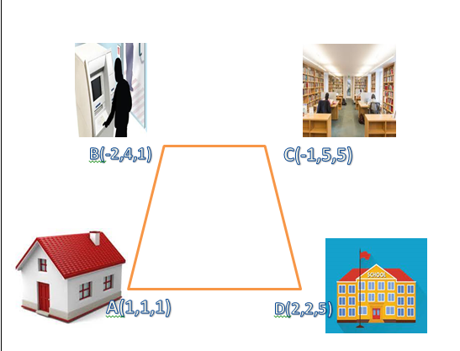  Based on the above information, answer the followings:  (i)Distance between the house and the school is  (a) 3$\sqrt{2}$ unit (b) 2 $\sqrt{3}$ unit (c) 2 unit (d) 3 unit  (ii) Total distance travelled by Sai Chandan to reach the school is  (a) 3$\sqrt{2}$ unit (b) 2 $\sqrt{3}$ unit (c) 9$\sqrt{2}$ unit (d) 6 $\sqrt{3}$ unit  (iii) Area of the quadrilateral ABCD is  (a) 36$\sqrt{2}$ sq.unit (b) 32 $\sqrt{3}$ sq.unit (c) 18 sq. unit (d) 36 sq. unit  (iv) Angle between $\vec{AB} and \vec{BC}$ is  - 30⁰ (b) 60⁰ (c) 45⁰ (d) 90⁰ | 4
2 | If two vectors are represented by the two sides of a triangle taken in order, then their sum is represented by the third side of the triangle taken in opposite order and this is known as triangle law of vector addition.  Based on the above information, answer the following questions.  (i) If 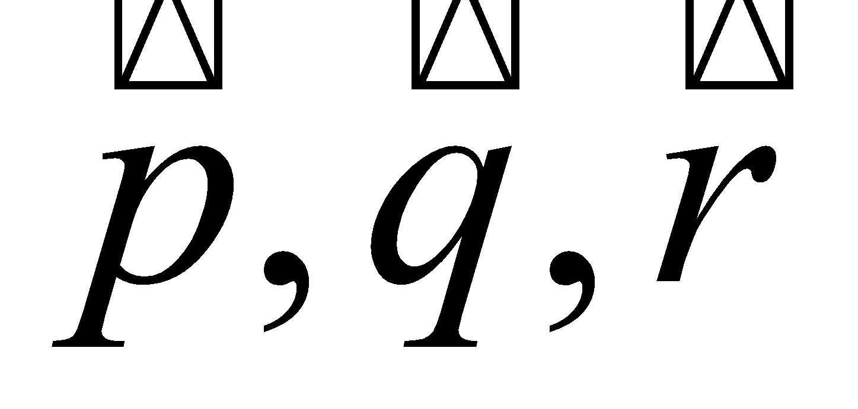are the vectors represented by the sides of a triangle taken in order, then 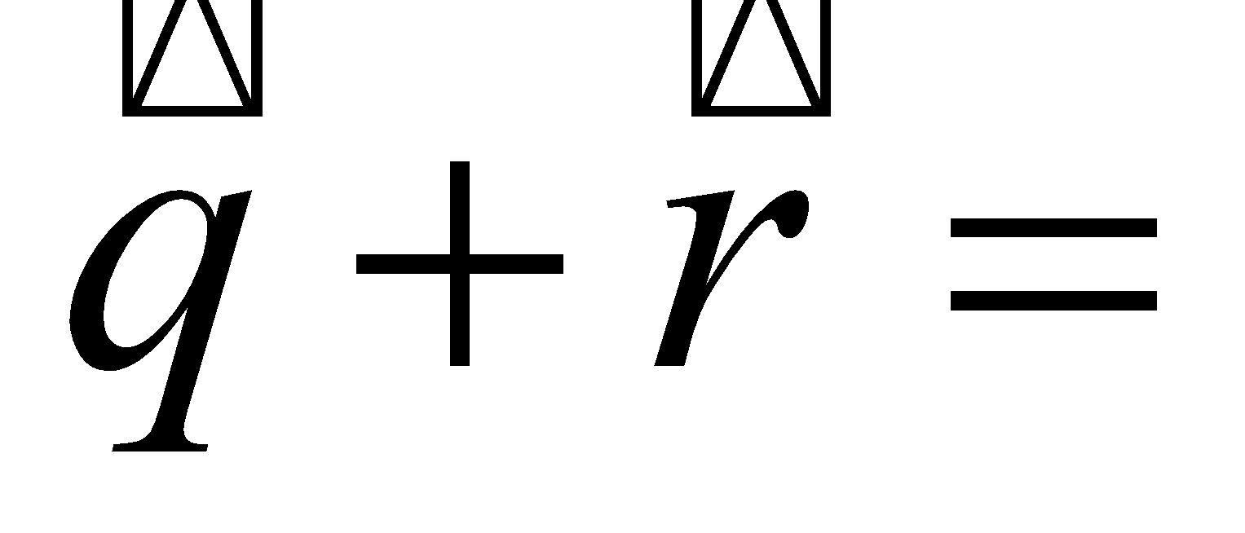  (a)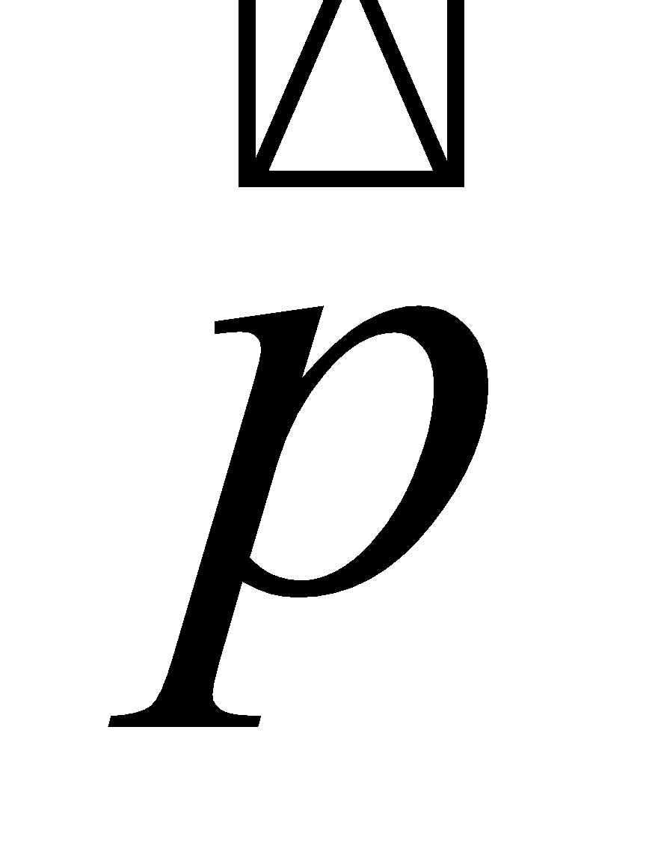 (b)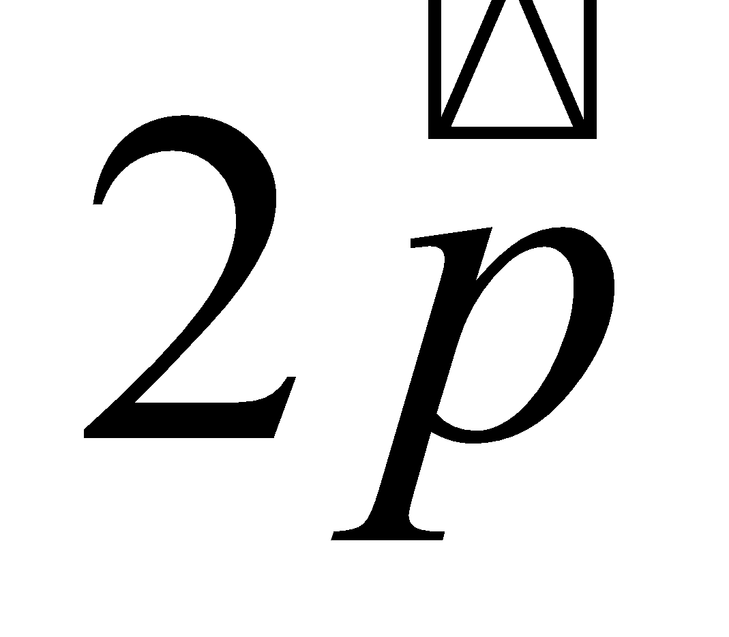 (c)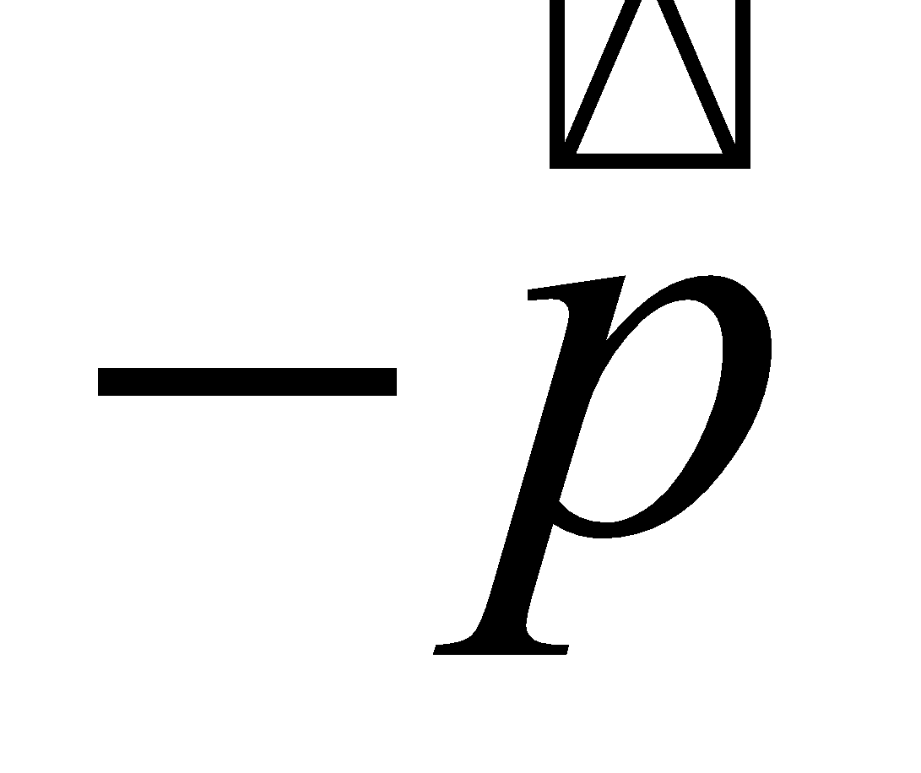(d) None of these  (ii) If ABCD is a parallelogram and AC and BD are its diagonals, then 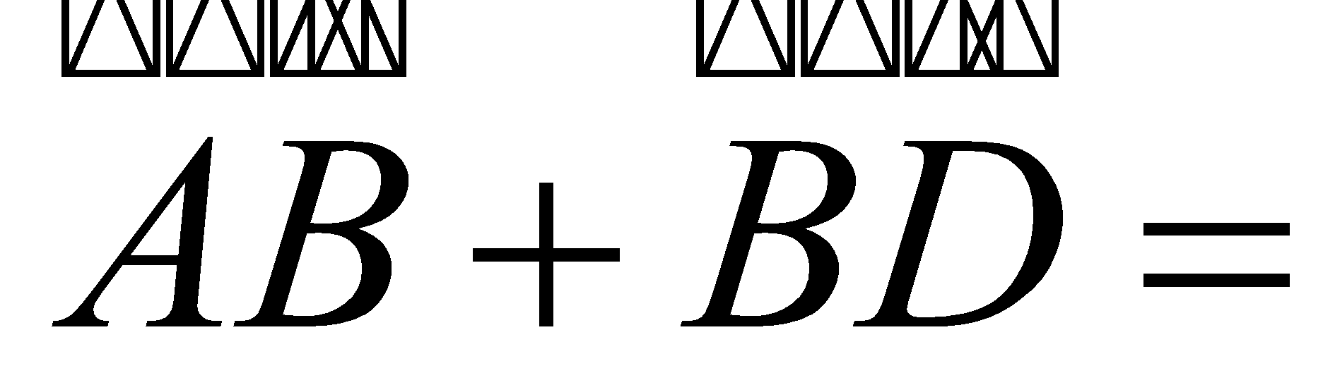  (a) 2(b) 2(c) 2(d) 2  (iii) If ABCD is a parallelogram, where 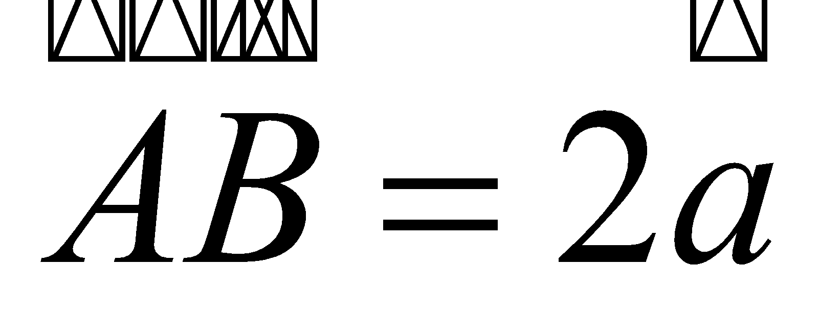 and 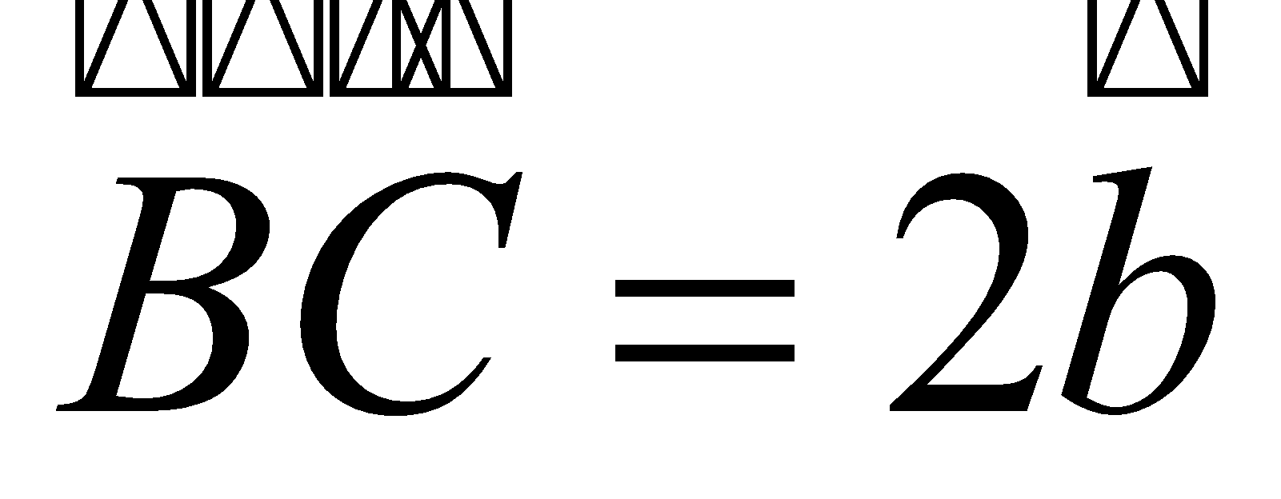 ,then 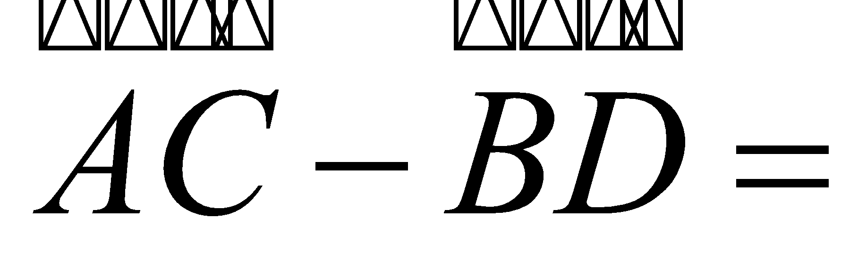  (a)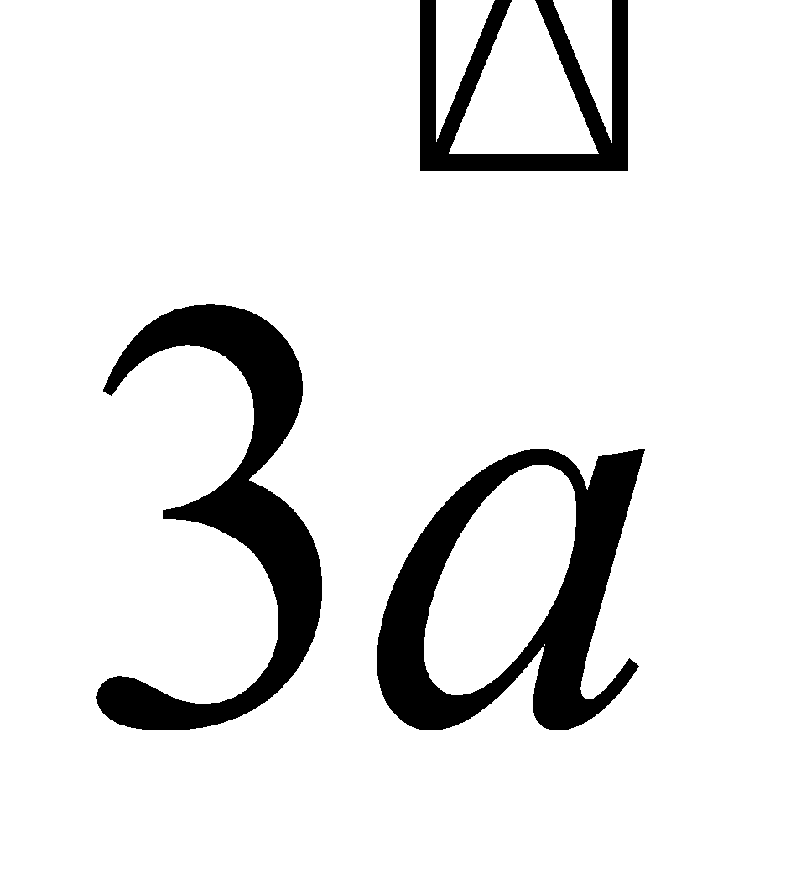 (b)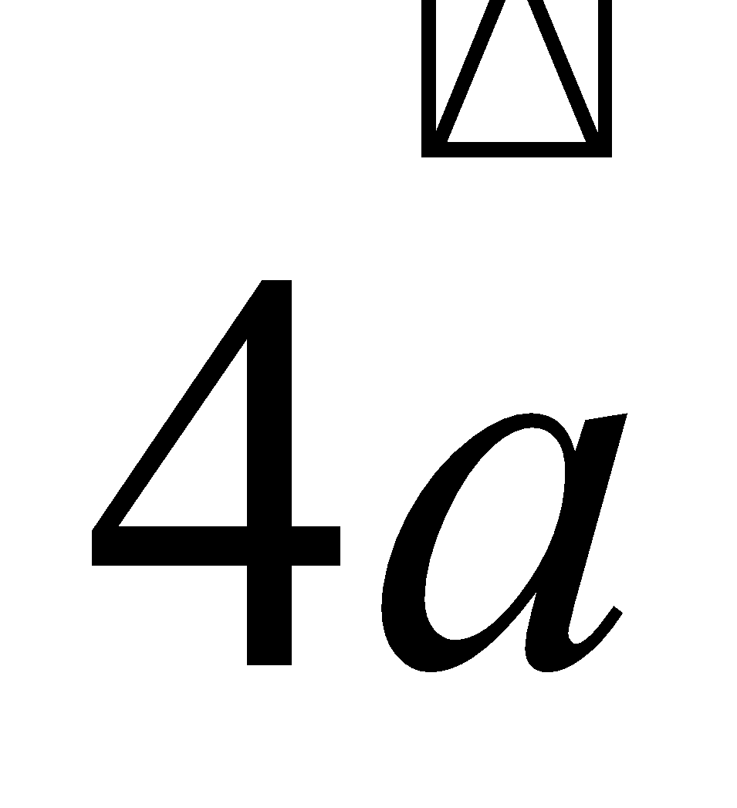 (c) 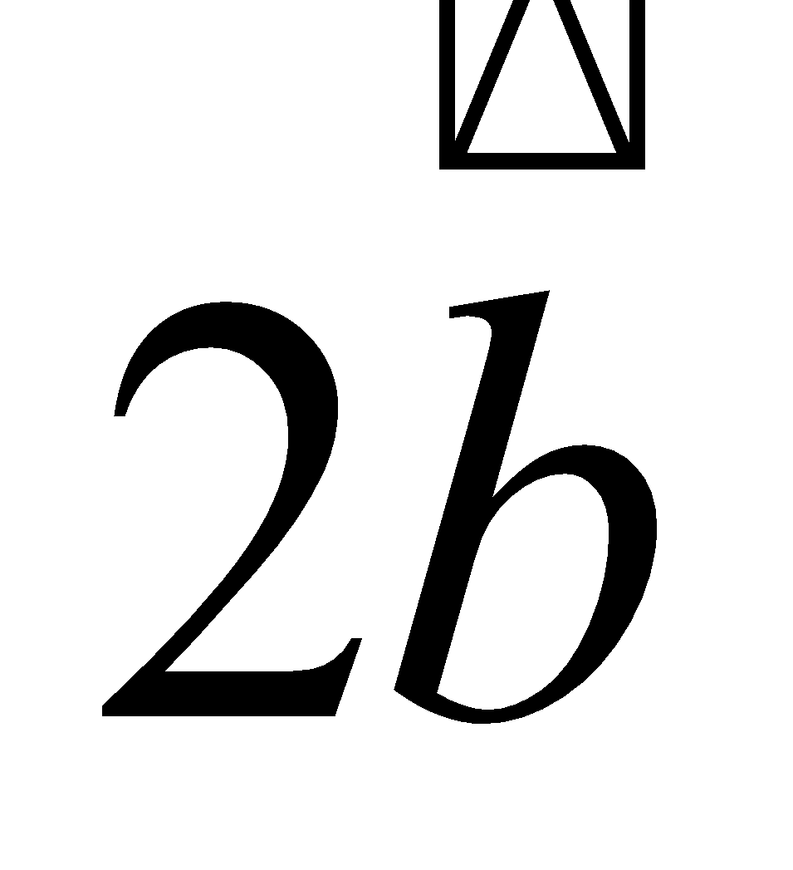(d) 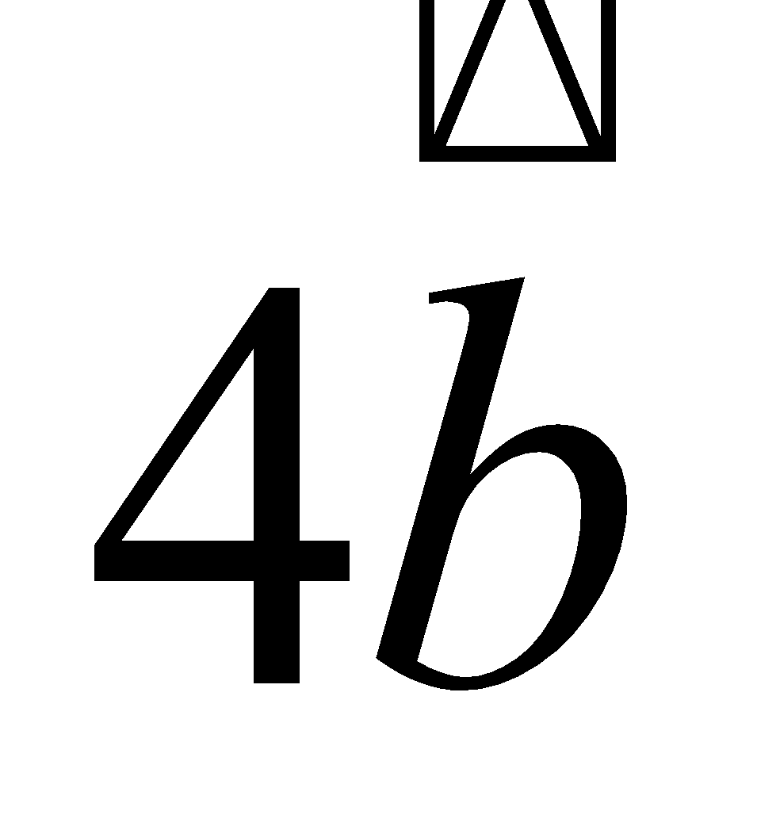  (iv) If ABCD is a quadrilateral whose diagonals are and then =  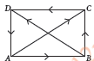  (a) (b) (c)(d)   (v) If T is the mid-point of side YZ of XYZ, then 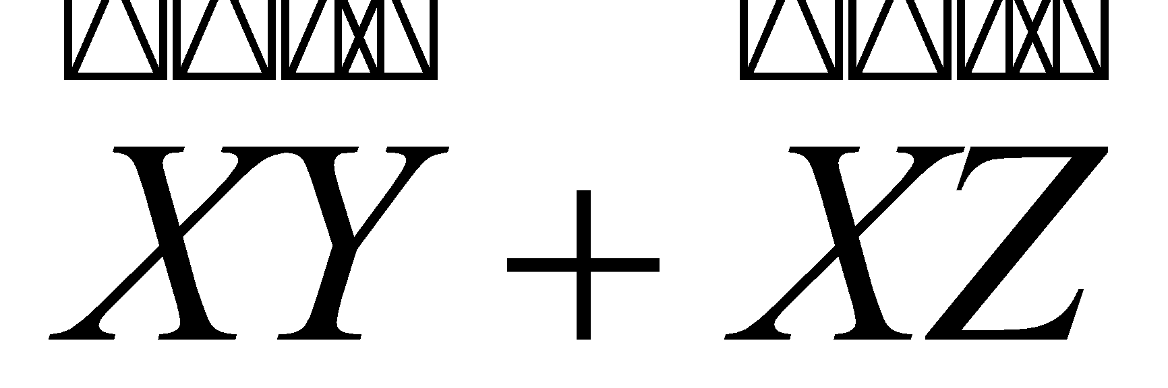=  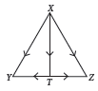  (a) 2(b) 2(c) 2(d) None of these | 4
3 | Geetika’s house is situated at Shalimar Bagh at point O, for going to Alok’s house she first travels 8 km by bus inthe East. Here at point A, a hospital is situated. From Hospital, Geetika takes an auto and goes 6 km in the North, here at point B school is situated. From school, she travels by bus to reach Alok’s house which is at 30° East,6 km from point B.  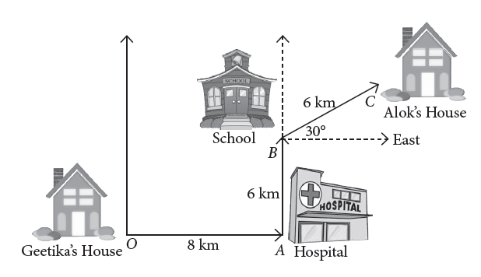  Based on the above information, answer the following questions.  (i) What is the vector distance between Geetika’s house and school?  (a)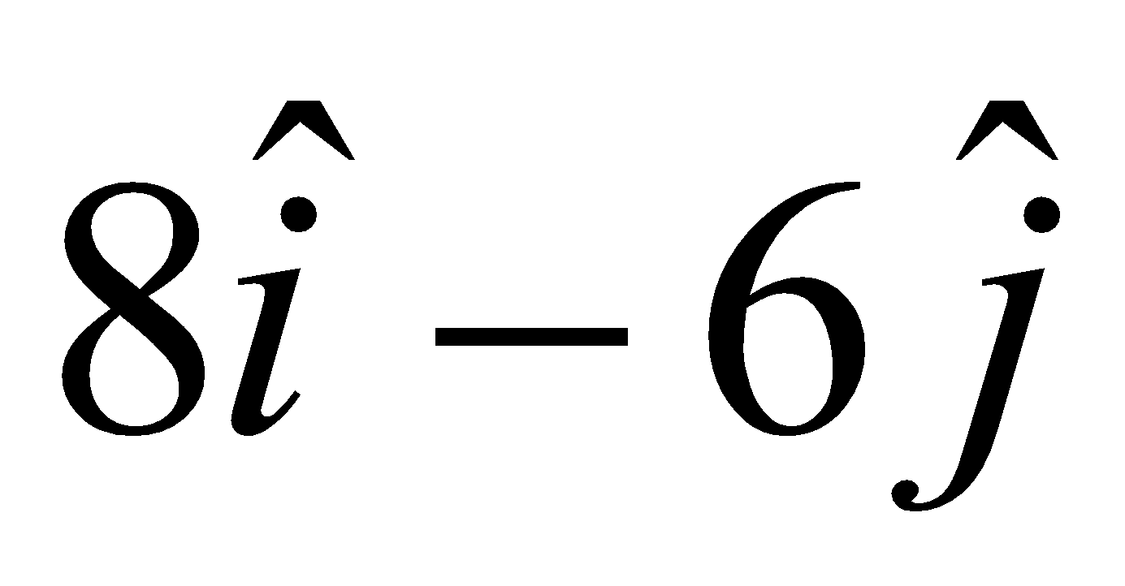(b) 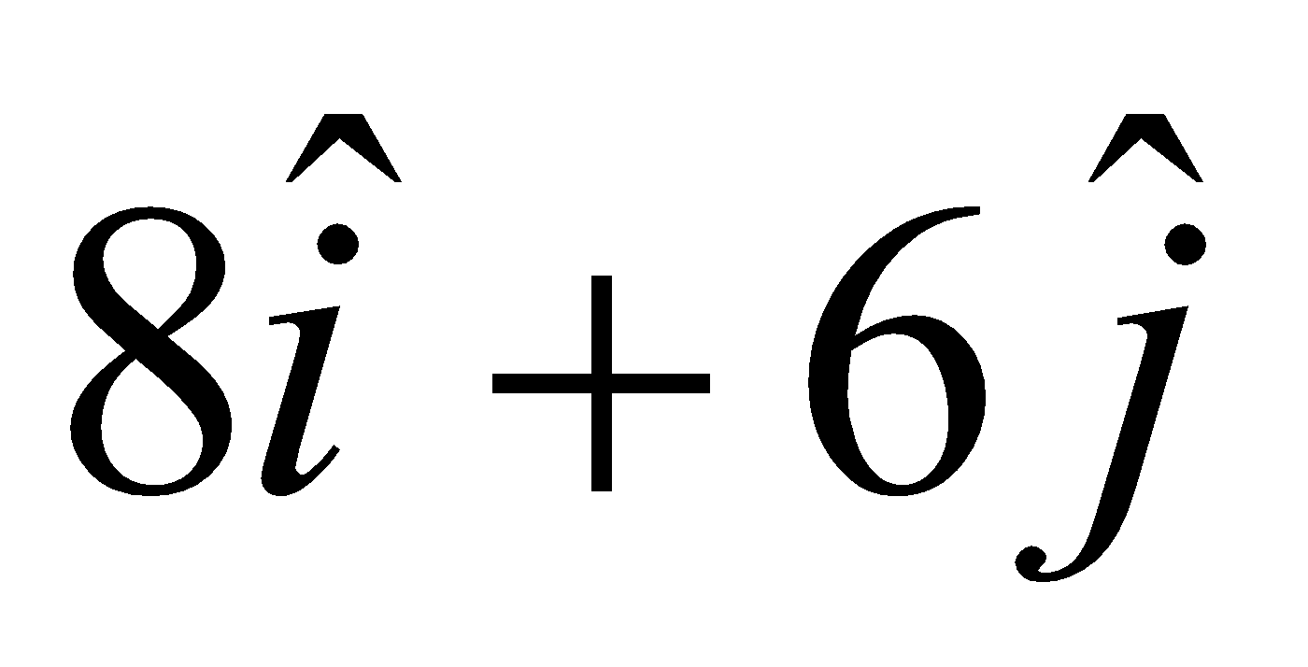(c)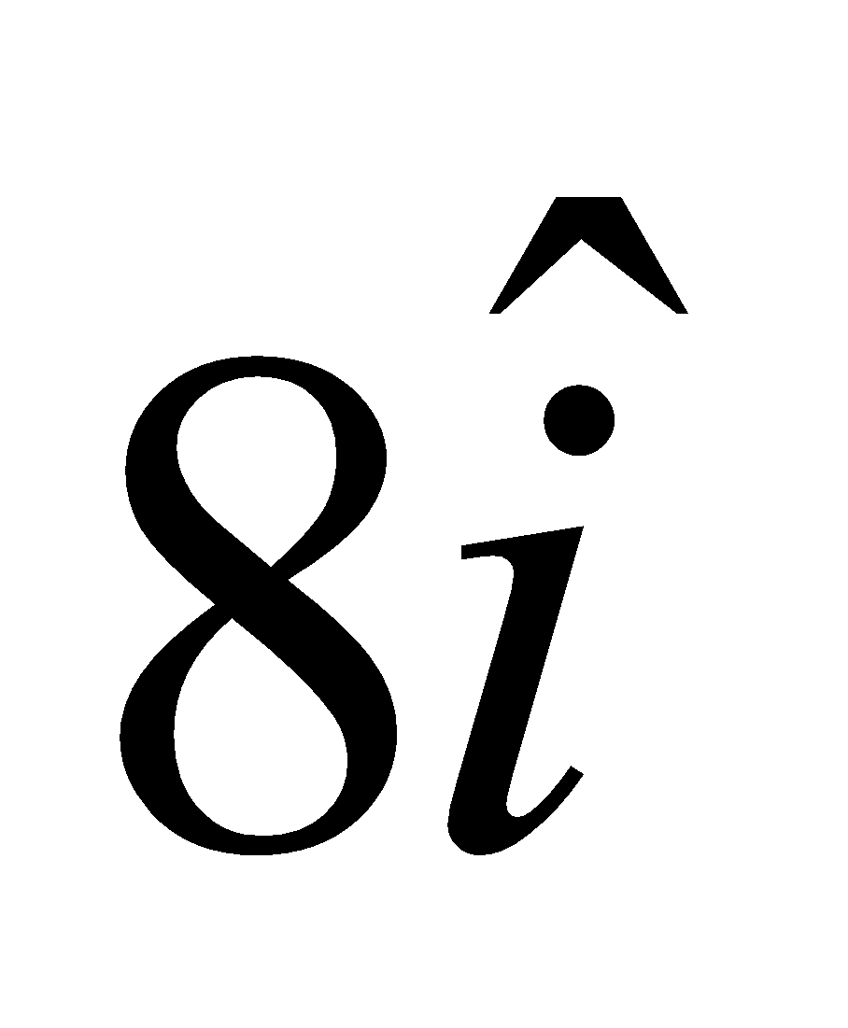 (d)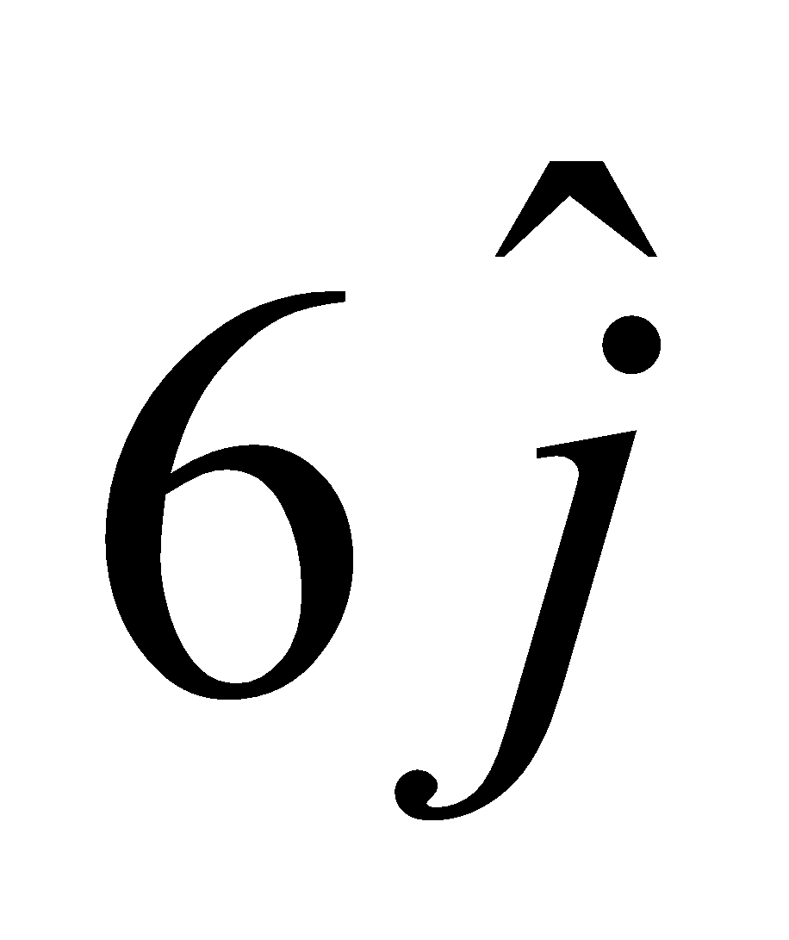  (ii) How much distance Geetika travels to reach school?  (a) 14 km (b) 15 km (c) 16 km (d) 17 km  (iii) What is the vector distance from school to Alok’s house?  (a) 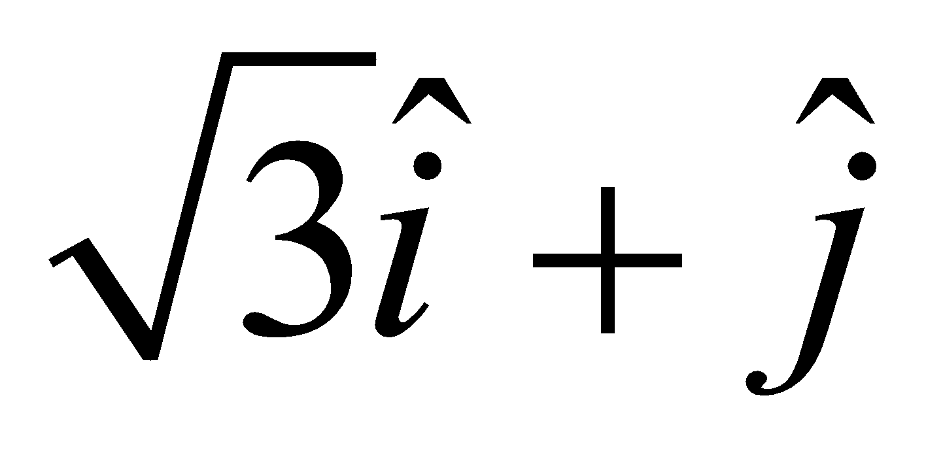(b)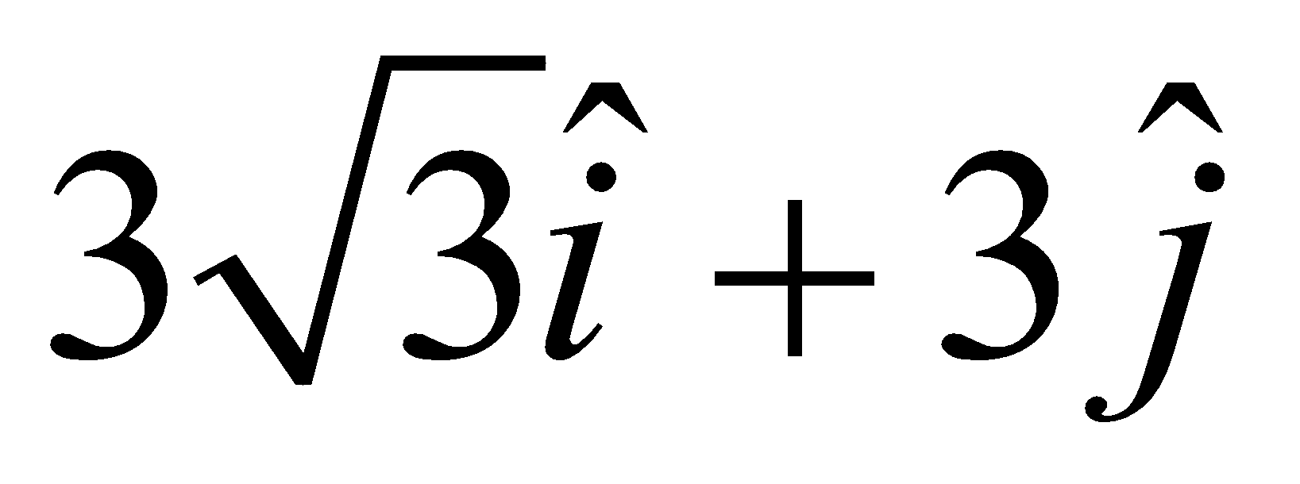 (c) 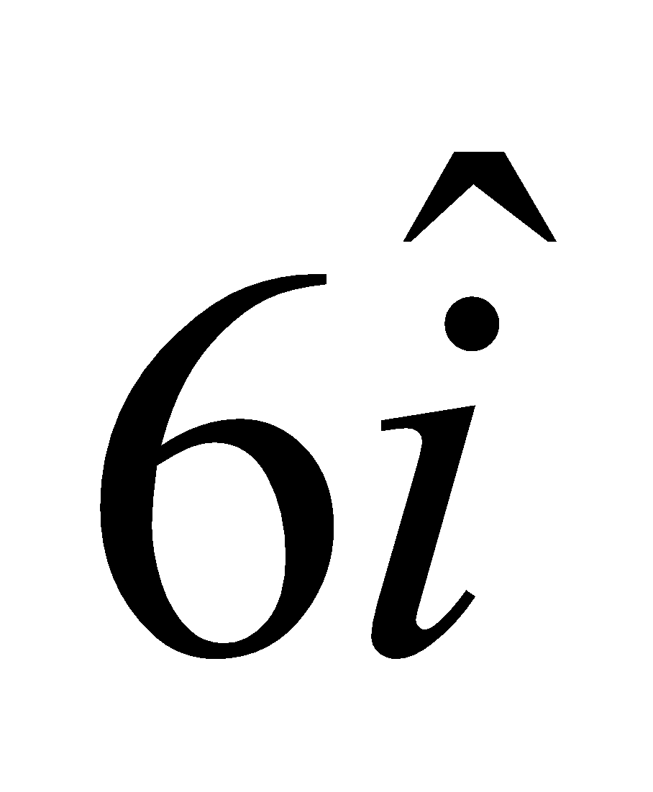 (d)  (iv) What is the vector distance from Geetika’s house to Alok’s house?  (a) 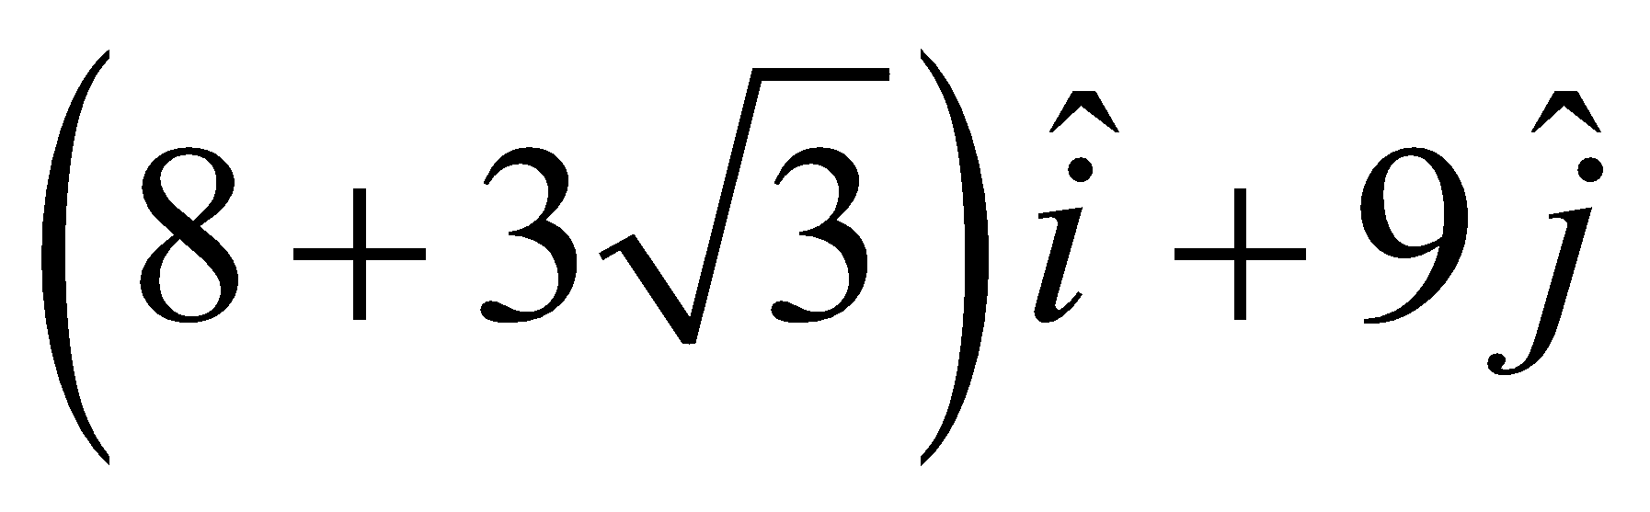(b)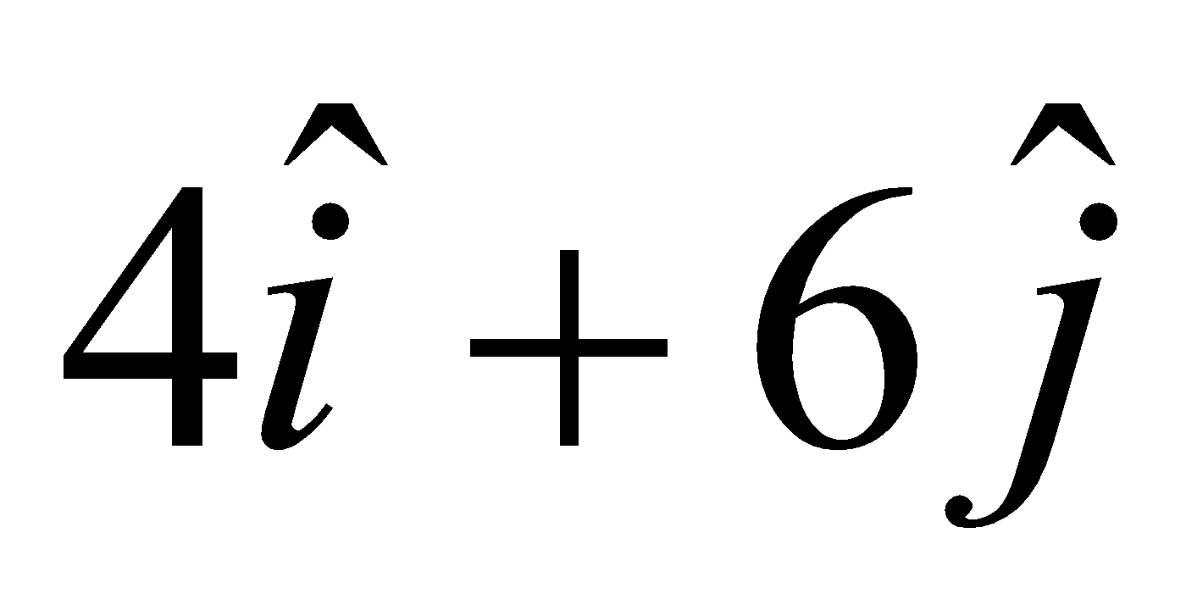( c)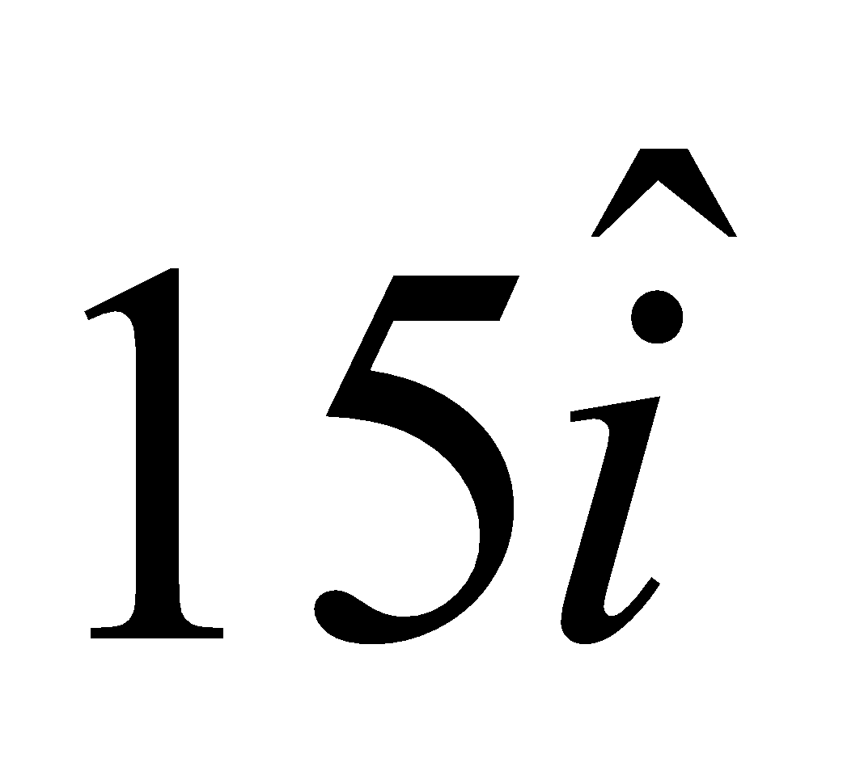(d)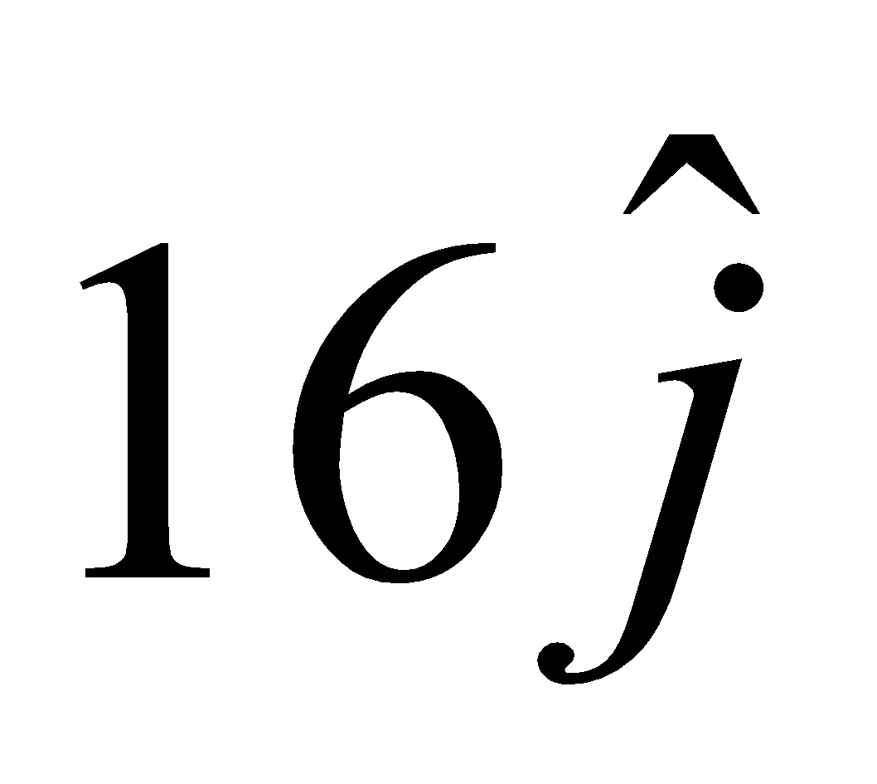  (v) What is the total distance travelled by Geetika from her house to Alok’s house?  (a) 19 km (b) 20 km (c) 21 km (d) 22 km | 4
4 | Solar Panels have to be installed carefully so that the tilt of the roof, and the direction to the sun, produce the largest possible electrical power in the solar panels.  A surveyor uses his instrument to determine the coordinates of the four corners of a roof where solar panels are to be mounted. In the picture , suppose the points are labelled counter clockwise from the roof corner nearest to the camera in units of meters P₁ (6,8,4) , P₂ (21,8,4), P₃(21,16,10) and P₄ (6,16,10)  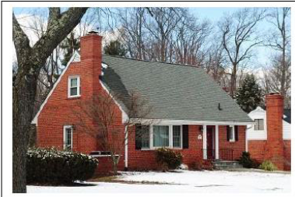  Answer the following questions using the above information.  1. What are the components to the edge vector $\vec{A}$ defined by $\vec{A}$ = PV of P2 – PV of P1? (where PV stands for position vector)  a. 0,0,15  b. 0,15,0  c.15,0,0  d. None of these  2.What are the components to the edge vector $\vec{B}$ defined by$\vec{B}$ = PV of P4 – PV of P1? (where PV stands for position vector)  a.0,0,8  b. 0,8,6  c. 6,0,8  d. 6,8,6  3.What is the magnitude of the vectors $\vec{A}$ and in what units?  a. 10  b. 15  c. 225  d. 100  4.What is the magnitude of the vector $\vec{B}$ and in what units?  a.36  b.7  c. 64  d.10  5. What are the components to the vector $\vec{N}$ , perpendicular to$\vec{A}$ and$\vec{ B}$ and the surface of the roof?  a. -90,120  b. -90,0,120  c. 120,0,90  d. 120,90,0 | 4
5 | There was a competitive examination. A group of students went appearing for a competitive examination was asked to attempt the following questions. Read carefully the question and choose correct answer.  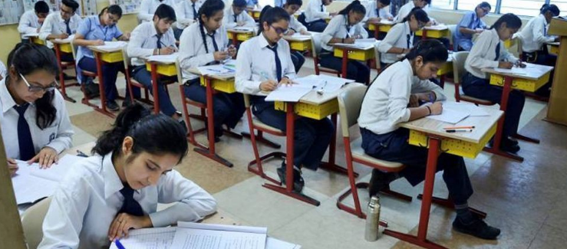  Let $\vec{a}$ ,$\vec{b}$and $\vec{c }$𝑏𝑒𝑡ℎ𝑟𝑒𝑒 non-zero vectors.  1. If $\vec{a}$and$\vec{b}$are such that|𝑎 +𝑏⃗ |=|𝑎 −𝑏⃗ | then  a.$\vec{a}$perpendicular to $\vec{b}$  b. $\vec{a}$ is parallel to $\vec{b}$  c. $\vec{a}$ = $\vec{b}$  d. None of these  2. If $\vec{a}$ = 𝑖̂−2𝑗̂ , $\vec{b}$ =2𝑖̂+𝑗̂+3𝑘̂ then value (2$\vec{a}$ +$\vec{b}$ )∙[$(\vec{a}$+$\vec{b}$ )×($\vec{a}$ −2$\vec{b}$ )] is:  a. 0  b. 4  c. 3  d. 2  3. If $\vec{a}$ and $\vec{b}$are unit vectors and be the angle between them then |$\vec{a}$ −$\vec{b}$ | is  a. 𝑠𝑖𝑛𝜃/2  b. 2𝑠𝑖𝑛𝜃/2  c. 2𝑐𝑜𝑠𝜃/2  d. 𝑐𝑜𝑠𝜃/2  4. Let $\vec{a}$, $\vec{b}$ and $\vec{c}$be unit vectors such that $\vec{a}$ ∙$\vec{b}$ =$\vec{a}$ ∙$\vec{c}$ =0 and angle between $\vec{b}$ and $\vec{c}$ is 𝜋/6 then $\vec{a}$ =  a. 2($\vec{b}×\vec{c}$)  b. -2($\vec{b}×\vec{c }$)  c. $±$2($\vec{b}×\vec{c }$)  d. 2($\vec{b}±\vec{c }$ ) | 4
 | ANSWERS
1 | - a  - c  - c  - d | 4
2 | - _{(c)}  - _{(c)}  - _{(b)}  - _{(d)} | 4
3 | - _{(b)}  - _{(a)}  - _{(b)}  - _{(a)} | 4
4 | 1-c, 2-b, 3-b, 4-d, 5-a | 4
5 | 1-a, 2-a, 3-b, 4-c. | 4
 | 5 – MARKS TYPE QUESTIONS
1 | Ishaan left from his village on weekend. First, he travelled up to temple. After this, he left for the zoo. After this he left for shopping in a mall. The positions of Ishaan at different places is given in the following graph.  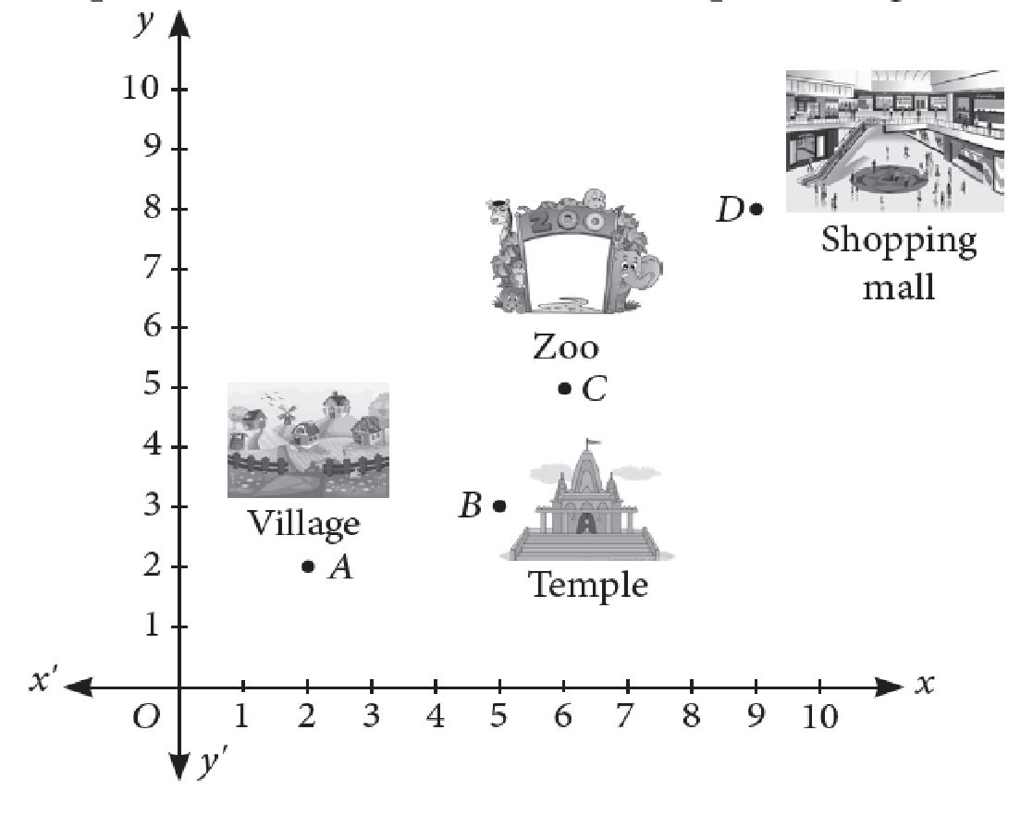  Based on the above information, answer the following questions.  (i) Position vector of B is  (a) $3\hat{i}+5\hat{j}$(b) $5\hat{i}+3\hat{j}$ (c) $-5\hat{i}-3\hat{j}$ (d) $-5\hat{i}+3\hat{j}$  (ii) Position vector of D is  (a) $5\hat{i}+3\hat{j}$ (b) $3\hat{i}+5\hat{j}$ (c) $8\hat{i}+9\hat{j}$ (d) $9\hat{i}+8\hat{j}$  (iii) Find the vector $\vec{BC}$ in terms of $\hat{i},\hat{j}$  (a) $\hat{i}-2\hat{j}$ (b) $\hat{i}+2\hat{j}$ (c) $\hat{2i}+\hat{j}$ (d) $2\hat{i}-\hat{j}$  (iv) Length of vector $\vec{AD}$ is  (a) $\sqrt{67}$ units (b) $\sqrt{85}$ units (c) 90 units (d) 100 units  (v) If $\vec{M}$ = 4 j + 3k, then its unit vector is  (a) $\frac{4}{5}\hat{i}+\frac{3}{5}\hat{j}$ (b) $\frac{4}{5}\hat{i}-\frac{3}{5}\hat{j}$ (c) $-\frac{4}{5}\hat{i}+\frac{3}{5}\hat{j}$ (d) $-\frac{4}{5}\hat{i}-\frac{3}{5}\hat{j}$ | 5
2 | A building is to be constructed in the form of a triangular pyramid, ABCD as shown in the figure.  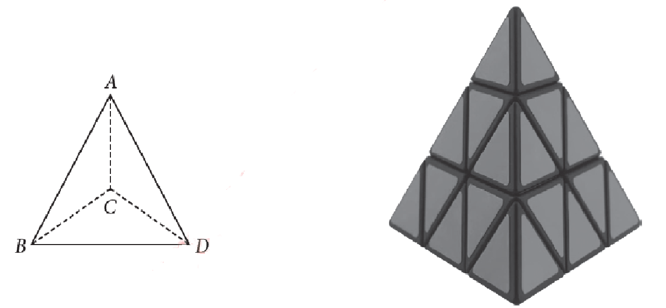  Let its angular points are A(0, 1, 2), B(3, 0, 1), C(4, 3, 6) and D(2, 3, 2) and G be the point of intersection of the medians of ΔBCD.  Based on the above information, answer the following questions.  (i) The coordinates of point G are  (a) (2, 3, 3) (b) (3, 3, 2) (c) (3, 2, 3) (d) (0, 2, 3)  (ii) The length of vector $\vec{AG}$is  (a) $\sqrt{17}$ units (b) $\sqrt{11}$ units (c) $\sqrt{13}$ units (d) $\sqrt{19}$ units  (iii) Area of ΔABC (in sq. units) is  (a) $\sqrt{10}$ (b) 2 $\sqrt{10}$ (c) 3 $\sqrt{10}$ (d) 5 $\sqrt{10}$  (iv) The sum of lengths of $\vec{AB}$ and $\vec{AC}$ is  (a) 5 units (b) 9.32 units (c) 10 units (d) 11 units  (v) The length of the perpendicular from the vertex D on the opposite face is  (a) $\frac{6}{\sqrt{10}}$ units (b) $\frac{2}{\sqrt{10}}$units (c) $\frac{3}{\sqrt{10}}$ units (d) 8 $\sqrt{10}$ units | 5
3 | Find the position vector of the point which divides the join of the points (2$\vec{a}$-3$\vec{b}$) and (3$\vec{a}$-2$\vec{b}$) in the ratio, (i) internally, (ii) externally. | 5
4 | Find the area of the parallelogram whose diagonals are represented by the vectors $\vec{d}$₁ = 3$\hat{i}$+$\hat{j}$-2$\hat{k}$ and $\vec{d}$₂ = $\hat{i}$-3$\hat{j}$+4$\hat{k}$ | 5
 | ANSWERS
1 | (i) b (ii)d (iii) b (iv)b (v)a | 5
2 | (i) c (ii)b (iii) c (iv)b (v)a | 5
3 | $\vec{A}$ = 2$\vec{a}$-3$\vec{b}$  $\vec{B}$ = 3$\vec{a}$-2$\vec{b}$  The point dividing a line joining points a and b in a ratio m:n internally or externally is given by $\frac{m\vec{b}+n\vec{a}}{m+n}$ and $\frac{m\vec{b}-n\vec{a}}{m-n}$ respectively.  $∴$ The position vector of the point dividing the line internally in the ratio 2:3 is  $\frac{2×\left(3\vec{a}-2\vec{b}\right) + 3×(2\vec{a}-3\vec{b})}{2+3}$  = $\frac{12}{5}\vec{a}$ - $\frac{13}{5}\vec{b}$  And the position vector of the point dividing the line internally in the ratio 2:3 is  $\frac{2×\left(3\vec{a}-2\vec{b}\right) - 3×(2\vec{a}-3\vec{b})}{2-3}$  = $-5\vec{b}$ | 5
4 | Diagonals are represented by the vectors $\vec{d}$₁ = 3$\hat{i}$+$\hat{j}$-2$\hat{k}$ and $\vec{d}$₂ = $\hat{i}$-3$\hat{j}$+4$\hat{k}$.  Let $\vec{a}$ and $\vec{b}$ be two adjacent sides of the parallelogram.  Thus, $\vec{a}$+$\vec{b}$ = 3$\hat{i}$+$\hat{j}$-2$\hat{k}$ and $\vec{a}$-$\vec{b}$ = $\hat{i}$-3$\hat{j}$+4$\hat{k}$  Which gives $\vec{a}$ = 2$\hat{i}$-$\hat{j}$+$\hat{k}$ and $\vec{b}$ = $\hat{i}$+2$\hat{j}$-3$\hat{k}$  The area of the parallelogram  $\left|\vec{a}× \vec{b} \right|$ = (a₂b₃-b₂a₃)$\hat{i}$ + (a₃b₁-a₁b₃)$\hat{j}$ + (a₁b₂-a₂b₁)$\hat{k}$  Here a₁=2, a₂=-1, a₃=1, b₁=1, b₂=2, b₃=-3  $∴$ $\vec{a}× \vec{b}$ = ($3$-$2$)$\hat{i}$ + ($1$+6)$\hat{j}$ + ($4$+1)$\hat{k}$ = $\hat{i}$ + 7$\hat{j}$ + 5$\hat{k}$  $⇒$ $\left|\vec{a}× \vec{b} \right|$ = $\sqrt{1+49+25}$ = $\sqrt{75}$ = 5$\sqrt{3}$  Hence area = 5$\sqrt{3}$ sq. units | 5

CHAPTER – 11
THREE-DIMENSIONAL GEOMETRY

SYLLABUS:
Direction cosines and direction ratios of a line joining two points. Cartesian equation and vector equation of a line, skew lines, shortest distance between two lines. Angle between two lines.

SL NO | QUESTION | MARK
 | MULTIPLE - CHOICE QUESTIONS
1 | If a line makes angles 90$°$,60º and 130º with the positive direction of x, y and z axis respectively, then its direction cosines.  (a)0, $\frac{1}{2 ,}$ ,$\frac{√3}{2}$ (b) 1, $\frac{1}{2 ,}$ ,$\frac{√3}{2}$ (c) 1, $\frac{√3}{2}$, $\frac{1}{2 ,}$ (d) 1, $\frac{√3}{2}$, - $\frac{1}{2 ,}$ | 1
2 | Two lines with direction ratios a_{1 ,}b₁ ,c₁ and a₂ ,b₂ , c₂ are parallel if  - $\frac{a1}{a2}$ = $\frac{b1}{b2}$ =$\frac{c1}{c2}$ (b) $\frac{a1}{a2}$ = $\frac{b1}{b2}$ $≠$ $\frac{c1}{c2}$  (c) $\frac{a1}{a2}$ $≠$ $\frac{b1}{b2}$ =$\frac{c1}{c2}$ (d) $\frac{a1}{a2}$ $≠$ $\frac{b1}{b2}$ $≠$ =$\frac{c1}{c2}$ | 1
3 | The distance 0f a point (2 ,5,7 ) from the X axis is  (a) 2 (b) $\sqrt{74}$ (c) $\sqrt{29}$ (d) $\sqrt{53}$ | 1
4 | If the direction cosines of a given line are $\frac{1}{k}$ ,$\frac{1}{k}$ $,\frac{1}{k}$ then the value of k is  (a) $\frac{1}{√2}$ (b) $± \frac{1}{√3}$ (c) 1 (d) $±\sqrt{3}$ | 1
5 | What are the direction cosines of a line, which makes equal angles with  the coordinate axes.  (a) $± \frac{1}{√3}$ , $± \frac{1}{√3}$ , $± \frac{1}{√3}$ (b) $± \frac{1}{√2}$ , $± \frac{1}{√2}$ , $± \frac{1}{√2}$  (c) $± \frac{1}{√5}$ , $± \frac{1}{√5}$ , $± \frac{1}{√5}$ (d) $±\sqrt{3}$, $±\sqrt{3}, ±\sqrt{3}$ | 1
6 | The equation of y axis in space are  x=0 , y =0 (b) $x=0 , z =0$ (c) y=0 , z =0 (d) $y$ =0 | 1
7 | Find the direction cosines of the line  $\frac{4-x}{2}$ =$\frac{y }{6}$ =$\frac{1-z}{3}$  (a) $\frac{-2}{7}$ , $\frac{6}{7},\frac{-3}{7}$ (b) $\frac{2}{7}$ , $\frac{6}{7},\frac{-3}{7}$ (c) $\frac{-2}{7}$ , $\frac{6}{7},\frac{3}{7}$ (d) $\frac{-2}{7}$ , $\frac{-6}{7},\frac{-3}{7}$ | 1
8 | Angle between the lines with direction ratios 2,1,2 and 3,2,-6 is  - cos⁻¹(-4) (b) $\frac{-4}{21}$ (c) $\frac{-4}{21}$ (d) none of these | 1
9 | Find the vector equation of a line $\frac{x-1}{1}$ =$\frac{4-y}{2}=\frac{z+1}{3}$  - $\vec{r}$ = $\frac{i -4j-k }{√14}$ (b) $\frac{i -4j-k }{√6}$ (c) $\frac{i+4j+k }{√14}$ (d) none of these | 1
10 | Find the vector equation of the line passing through the points A(3,4,-7) and  B(1,-1,6).  - $\vec{r}$ = 3 $i+4j-7k +μ(-2 i -5j+13k )$  (b) $\vec{r}$ = $3i+4j-7k +μ( i -j+6k )$  (c) $\vec{r}$ = $i -4j-k +μ( i -4j-k )$  (d) none of these | 1
11 | If a bullet shot from the gun travels a straight line path which makes angles 90$°$, 60$°$and 30$°$ with the positive direction of x-axis, y-axis and z-axis respectively, find its direction cosines.  - 1, $\frac{\sqrt{3}}{2}$, $\frac{1}{2}$ (b) $\frac{\sqrt{3}}{2}$, $\frac{1}{\sqrt{2}}$, $\frac{1}{2}$  (c) 0,$\frac{1}{2}, \frac{\sqrt{3}}{2}$ (d) none of these | 1
12 | An electricity straight wire has direction ratios  2,–3, 4, determine its direction cosines.  - 2, -3, 4 (b) 4, -6, 8  (c) $\frac{2}{\sqrt{29}}$, $\frac{-3}{\sqrt{29}}$, $\frac{4}{\sqrt{29}}$ (d) $\frac{4}{\sqrt{29}}$, $\frac{-6}{\sqrt{29}}$, $\frac{8}{\sqrt{29}}$ | 1
13 | Three stars in sky are positioned at A (2, -4, 6),  B (4, 6, -8) and C (6, 16, -22) with respect to a common reference point O (0, 0, 0). A student is confused whether those three stars are in same line or not. He asks his teacher to help him to solve this problem. Help him to answer this question.  - Three stars are collinear  - Three stars are not in a same line  - Only A and B are collinear, not C  - None of these | 1
14 | Find the direction ratios of a ray of light passing through the points (1, 2, 3) and (-1, -3, 5).  - -2, 5, 2 (b) -2, -5, 2 (c) -2, -5, 8 (d) 2, -5, 8 | 1
15 | What are direction ratios of the line  $\vec{r}$ = (3$\hat{i}$ + 4$\hat{j}$ - 5$\hat{k}$) + m (0$\hat{i}$ + 7$\hat{j}$ + 3$\hat{k}$)?  - 3, 4, -5 (b) -3, -4, 5 (c) 3, 11, -2 (d) 0, 7, 3 | 1
16 | What are the direction cosines of the line having direction ratios 0, -3, 4?  - 0, -3, 4 (b) 0, -8, 10 (c) 0, 3/5, 4/5 (d) 0, -3/5, 4/5 | 1
17 | Find the Cartesian equation of a line parallel to  y-axis and passing through the point (1, -2, 7)  (a) $\frac{x-1}{1}$ = $\frac{y+2}{-2}$ = $\frac{z-7}{7}$ (b) $\frac{x-1}{1}$ = $\frac{y+2}{0}$ = $\frac{z-7}{1}$  (c) $\frac{x+1}{1}$ = $\frac{y-2}{-2}$ = $\frac{z+7}{7}$ (d) $\frac{x-1}{0}$ = $\frac{y+2}{1}$ = $\frac{z-7}{0}$ | 1
18 | Write down the vector form of the following equation of line $\frac{x-6}{2}$ = $\frac{y-4}{1}$ = $\frac{z-1}{-3}$  - $\vec{r}$ = (6$\hat{i}$ + 4$\hat{j}$ +1$\hat{k}$) + $α$ (2$\hat{i}$ + $\hat{j}$ - 3$\hat{k}$)  - $\vec{r}$ = (2$\hat{i}$ + $\hat{j}$ - 3$\hat{k}$) + $α$ (6$\hat{i}$ + 4$\hat{j}$ +1$\hat{k}$)  - $\vec{r}$ = (-2$\hat{i}$ - $\hat{j}$ + 3$\hat{k}$) + $α$ (6$\hat{i}$ + 4$\hat{j}$ +1$\hat{k}$)  - $\vec{r}$ = (-6$\hat{i}$ - 4$\hat{j}$ -1$\hat{k}$) + $α$ (2$\hat{i}$ + $\hat{j}$ - 3$\hat{k}$) | 1
19 | Two lines with direction ratios a, b, c and p, q, r respectively are said to be ……… if ap + bq + cr = 0.  - Parallel (b) Perpendicular (c) coincident (d) Skew | 1
20 | For what value of p, given two lines are parallel?  $\frac{x-1}{1}$ = $\frac{y+2}{-2}$ = $\frac{z-7}{7}$ and $\frac{x-8}{2}$ = $\frac{y-2}{p}$ = $\frac{z+2}{14}$  - p = -2 (b) p = 4 (c) p = -4 (d) can’t be determined | 1
21 | P is a point on the line joining the points A (1,5,-2) and B (3,-1,2). If the X co-ordinates of P is 5 , then its Y co-ordinate is  (a) -5 (b) -6 (c) -7 (d) -8 | 1
22 | The sum of the direction cosines of X-axis is  (a) 0 (b) 1 (c) 2 (d) 3 | 1
23 | The cartesian equation of a line is given by  $\frac{3x-1}{\sqrt{3}}$ = $\frac{y+2}{2}$ = $\frac{z-3}{3}$ , the direction cosines of the line is  (a) $\frac{\sqrt{3}}{2\sqrt{30}}$ , $\frac{3}{\sqrt{30}}$ , $\frac{9}{2\sqrt{30}}$ (b) $\frac{\sqrt{3}}{2\sqrt{30}}$ , $\frac{\sqrt{5}}{2\sqrt{30}}$ , $\frac{\sqrt{3}}{\sqrt{30}}$  (c) $\frac{\sqrt{3}}{2\sqrt{30}}$ , $\frac{3}{2\sqrt{30}}$ , $\frac{9}{2\sqrt{30}}$ (d) $\frac{\sqrt{3}}{2\sqrt{30}}$ , $\frac{\sqrt{3}}{2\sqrt{30}} ,$ $\frac{\sqrt{5}}{2\sqrt{30}}$ | 1
24 | The point where the line joining the points (2,5,4) and (1,3,6) meets YZ- plane  (a)(0,2,7) (b) (0,3,8) (c) (1,2,8) (d)(0,1,8) | 1
25 | The co-ordinates of the point where the line $\frac{x+4}{4}$ = $\frac{y-3}{-3}$ = $\frac{z-5}{-5}$cuts the XZ plane is  (a) (0,0,0) (b) (1,1,1) (c)(2,2,2) (d) (3,3,3) | 1
 | ANSWERS | 1
1 | a) 0, $\frac{1}{2 ,}$ ,$\frac{√3}{2}$ | 1
2 | a) $\frac{a1}{a2}$ = $\frac{b1}{b2}$ =$\frac{c1}{c2}$ | 1
3 | (b) $\sqrt{74}$ | 1
4 | (d) $±\sqrt{3}$ | 1
5 | ( a) $± \frac{1}{√3}$ , $± \frac{1}{√3}$ , $± \frac{1}{√3}$ | 1
6 | (b) $x=0 , z =0$ | 1
7 | (a) $\frac{-2}{7}$ , $\frac{6}{7},\frac{-3}{7}$ | 1
8 | (b) $\frac{-4}{21}$ | 1
9 | a) $\vec{r}$ = $\frac{i -4j-k }{√14}$ | 1
10 | (a) $\vec{r}$ = 3 $i+4j-7k +μ(-2 i -5j+13k )$ | 1
11 | (c) | 1
12 | (c) | 1
13 | (a) | 1
14 | (b) | 1
15 | (d) | 1
16 | (d) | 1
17 | (d) | 1
18 | (a) | 1
19 | (b) | 1
20 | (c) | 1
21 | c | 1
22 | b | 1
23 | a | 1
24 | d | 1
25 | a | 1
 | ASSERTION & REASON QUESTIONS
Choose the correct option in the following questions of Assertion – Reason Questions.
(a) Both A and R are correct; R is the correct explanation of A.
(b) Both A and R are correct; R is not the correct explanation of A.
(c) A is true but R is false
(d) A is false but R is true
1 | Assertion: Equation of line Passing through the point (1,2,3) and ( 2,-1,5) is  $\frac{x-1}{1}$ = $\frac{y-2}{-3}$ = $\frac{z-3}{2}$  Reason : Equation of line passing through the point (x₁,y₁,z₁) and (x₂,y₂,z₂) is $\frac{x-x_{1}}{x_{2}-x_{1}}$ =$\frac{y-y_{1}}{y-y_{1}}$ =$\frac{z-z_{1}}{z_{2}-z_{1}}$ | 1
2 | Assertion: Equation of plane cuts intercepts 2,3 and 4 on the x-axis,y-axis and z- axis respectively then its equation is 6x+4y+3z = 1  Reason: Ifplane cuts intercepts a, b and c on the x-axis,y-axis and z- axis respectively then its equation is$\frac{x}{a}$ + $\frac{y}{b}$+$\frac{z}{c}$ = 1 | 1
3 | Assertion: Lines $\frac{x+1}{3}$ = $\frac{y+3}{5}$ = $\frac{z+5}{7}$ and $\frac{x-2}{1}$ = $\frac{y-4}{3}$ = $\frac{z-6}{5}$ intersects to each other  Reason: Two non-parallel lines $\vec{r}$ = $\vec{a_{1}}$ + λ$\vec{b_{1}}$ and $\vec{r}$ = $\vec{a_{2}}$ + μ $\vec{b_{2}}$ will intersect iff  $\vec{{( a}_{2}}-\vec{a_{1}}$ ).$\vec{{( b}_{1}}X\vec{b_{2}}$ ) = 0 | 1
4 | Assertion: Lines $\frac{x-1}{2}$ = $\frac{y-2}{3}$ = $\frac{z-3}{4}$ and $\frac{x-4}{5}$ = $\frac{y-1}{2}$ = z are skew line  Reason: Two lines are called Skew iff they are neither parallel nor intersecting | 1
5 | Assertion: The length of perpendicular from the origin to the plane$\vec{ r}.\vec{n}=d$ is given by $\frac{\left|d\right|}{\left|\vec{n}\right|}$.  Reason: The distance of the plane 2x-3y+4z-6=0 from the origin is given by $\frac{6}{\sqrt{23}}$ | 1
6 | Assertion:The equation of plane passing through intersection of two planes$\vec{r}.\vec{n_{1}}=d_{1} and \vec{r}.\vec{n_{2}}=d_{2}$ is given by $\vec{r}.(\vec{n_{1}}+λ\vec{n_{2})}$=$d_{1}+{λd}_{2}$  Reason: Two lines $\vec{r}={\vec{a}}_{1}+λ\vec{b_{1}}$ and $\vec{r}={\vec{a}}_{2}+ μ\vec{b_{2}}$ are coplaner if $\left({\vec{b}}_{1}×{\vec{b}}_{2}\right).\left(\vec{a_{2}}-\vec{a_{1}}\right)$=0 | 1
7 | Assertion: the direction cosines of the line passing through the two points (– 2, 4, – 5) and (1, 2, 3) are $\frac{3}{\sqrt{77}},\frac{-2}{\sqrt{77}},\frac{8}{\sqrt{77}}$  Reason: We know the direction cosines of the line passing through two points P(x1, y1, z1) and Q(x2, y2, z2) are given by  $$\frac{x_{2}-x_{1}}{PQ},\frac{y_{2}-y_{1}}{PQ},\frac{z_{2}-z_{1}}{PQ}$$ | 1
8 | Assertion: direction cosine of line whose direction ratios are 2, -1, -2 are 2/3, -1/3, -2/3.  Reason: direction ratios and direction cosine are proportional to each other. | 1
9 | Assertion: equation of line through the point (5,2,-4) and parallel to the vector $\left(3\hat{i}+2\hat{j}-8\hat{k}\right)$ is $\frac{x-5}{3}=\frac{y-2}{2}=\frac{z+4}{-8}$  Reason: equation of a line the point whose position vector is $\vec{a}$ and parallel to the vector $\vec{b}$ is $\vec{r}=\vec{a}+λ\vec{b}$ | 1
10 | Assertion: If a,b and c are the direction ratio of a line then ka,kb and kc is also a set of direction ratios.  Reason: two sets of direction ratios of a line are in proportion. | 1
 | ANSWERS
1 | a | 1
2 | d | 1
3 | a | 1
4 | d | 1
5 | c | 1
6 | b | 1
7 | a | 1
8 | a | 1
9 | a | 1
10 | a | 1
 | 2 MARKS TYPE QUESTIONS
1 | If the lines $\frac{x-1}{-3}$ =$\frac{y-2}{2k}$ =$\frac{z-3}{2}$ and $\frac{x-1}{3k}$ =$\frac{y-1}{1}$ =$\frac{z-6}{-5}$  are perpendicular, find the value of k. | 2
2 | Find the foot of perpendicular drawn from the point (4,2,3) to the line  joining (1,-2,3) and (1,1,0). | 2
3 | Check whether the given two lines are coincident, skew, parallel or perpendicular?  $\vec{r}$ = (6$\hat{i}$ + 4$\hat{j}$ +1$\hat{k}$) + $β$ (2$\hat{i}$ + $\hat{j}$ - 3$\hat{k}$)  $\vec{r}$ = (-2$\hat{i}$ - $\hat{j}$ + 3$\hat{k}$) + $α$ (6$\hat{i}$ + 3$\hat{j}$ - 9$\hat{k}$) | 2
4 | Find the direction cosines of the sides of the triangle with vertices A (1, 3, 5), B (2, 5, 7) and C (-1, -4, 3) | 2
5 | Show that the line passing through two points  (2, 3, 5) and (5, 6, 8) is parallel to the line through the points (1, 6, -5) and (4, 9, -2). | 2
6 | Find the angle between the pair of lines:  $\vec{r}$ = (8$\hat{i}$ + 4$\hat{j}$ +9$\hat{k}$) + $β$ (2$\hat{i}$ + $\hat{j}$ - 3$\hat{k}$)  $\vec{r}$ = (7$\hat{i}$ - $3\hat{j}$ + 1$\hat{k}$) + $α$ (6$\hat{i}$ + 3$\hat{j}$ - 9$\hat{k}$) | 2
7 | Find the value of ‘m’ so that the given lines are perpendicular.  $\frac{-x+1}{1}$ = $\frac{y+2}{2}$ = $\frac{z-7}{4}$ and $\frac{x-8}{2}$ = $\frac{y-2}{m}$ = $\frac{z+2}{6}$ | 2
8 | Find the acute angle which the line with direction cosines 1/$\sqrt{2}$ , ½ , n makes with positive direction of Z-axis. | 2
9 | Find the direction cosine of a line equally inclined to the three co-ordinate axes. | 2
10 | The cartesian equation of motion of a rocket is $\frac{ x-2}{5} = \frac{ y + 4}{7} = \frac{6 - z }{2}$  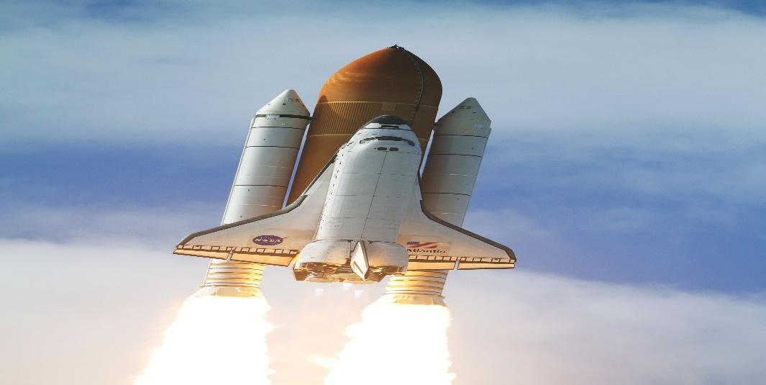  Write the vector equation of the line. | 2
 | ANSWERS | 2
1 | k = $\frac{-10}{7}$ | 2
2 | (1,0,1) | 2
3 | These are parallel lines because their direction ratios are proportional. | 2
4 | Direction cosines of AB are: $\frac{1}{3},\frac{2}{3},\frac{2}{3}$  Direction cosines of BC are:$\frac{-3}{\sqrt{106}},\frac{-9}{\sqrt{106}},\frac{-4}{\sqrt{106}}$  Direction cosines of CA are:$\frac{2}{\sqrt{57}},\frac{7}{\sqrt{57}},\frac{2}{\sqrt{57}}$ | 2
5 | Direction ratios of 1st line: 3, 3, 3  Direction ratios of 2nd line:3, 3, 3  Since direction ratios of both lines are same/ proportional, hence the lines are parallel. | 2
6 | These are parallel lines because their direction ratios are proportional. So, angle between the given lines is 0$°$ | 2
7 | m = -11, using condition of perpendicularity i.e. sum of product of direction ratios of two perpendicular lines is zero. | 2
8 | l² + m² + n² = 1  (1/2)² + (1/$\sqrt{2}$)² + n²= 1  ¼ +1/2 + n² = 1  n² = 1-3/4  n² = ¼  n = ½  cos $γ$ = ½ = cos 60⁰  $γ$ = 60⁰ | 2
9 | Let direction cosine of a line equally inclined to co-ordinate axes are l,l,l  So, l² + l² +l² = 1  Or, 3 l² = 1  Or, l² = 1/3  Or, l = $±\frac{1}{3}$  So, Direction cosines are + $\frac{1}{\sqrt{3}}$ , + $\frac{1}{\sqrt{3}}$ , + $\frac{1}{\sqrt{3}}$ or - $\frac{1}{\sqrt{3}}$ , - $\frac{1}{\sqrt{3}}$ , - $\frac{1}{\sqrt{3}}$ | 2
10 | The cartesian equation of motion of a rocket is  $\frac{ x -2}{5} = \frac{ y + 4}{7} = \frac{6 - z }{2}$  Or, $\frac{ x-2}{5} = \frac{ y + 4}{7} = \frac{z-6 }{- 2}$  The standard form of line of equation is  (x – x₁)/a = (y-y₁)/b = (z-z₁)/c  By comparing Point is (2, -4,6) and direction ratios are (5, 7, -2).  So, vector equation of motion of rocket  $\vec{r}$ = 2$\hat{i}$ -4 $\hat{j}$ +6 $\hat{k}$ + $λ$ (5$\hat{i}$ +7 $\hat{j}$ -2 $\hat{k}$ ) | 2
 | 3 – MARKS TYPE QUESTIONS
1 | Find the shortest distance between the following lines:  $\vec{r}$ = (2$\hat{i}$ + 4$\hat{j}$ - 8$\hat{k}$) + $β$ (2$\hat{i}$ + $3\hat{j}$ + 6$\hat{k}$)  $\vec{r}$ = ($\hat{i}$ - $2\hat{j}$ - 4$\hat{k}$) + $α$ (4$\hat{i}$ + 6$\hat{j}$ +12$\hat{k}$) | 3
2 | Find the shortest distance between the following lines whose vector equation are given:  $\vec{r}$ = (2$\hat{i}$ + 4$\hat{j}$ - 8$\hat{k}$) + $β$ (2$\hat{i}$ + $3\hat{j}$ + 6$\hat{k}$)  $\vec{r}$ = ($\hat{i}$ - $2\hat{j}$ - 4$\hat{k}$) + $α$ ($\hat{i}$ + 2$\hat{j}$ +4$\hat{k}$) | 3
3 | Find the angle between the pair of lines:  $\vec{r}$ = (6$\hat{i}$ + 4$\hat{j}$ - 8$\hat{k}$) + $γ$ (2$\hat{i}$ + $4\hat{j}$ + 4$\hat{k}$)  $\vec{r}$ = ($10\hat{i}$ - $4\hat{j}$) + $δ$ ($\hat{6i}$ + 4$\hat{j}$ +12$\hat{k}$) | 3
4 | 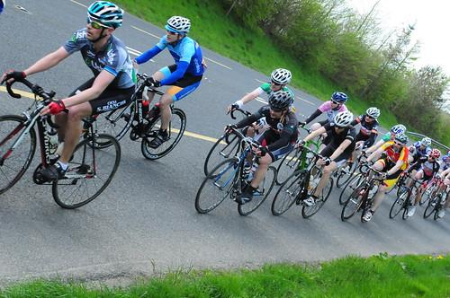  Read the following text and answer the question on the basis of the same.  A cycle race was organized in a town , where the maximum speed limit was set by the organizers . No participant are allowed to cross the specified speed limit, but two cycles A and B are running at the speed more than allowed speed on the road along the lines$\vec{r}$ = $\hat{i}$ + $\hat{j}$ – $\hat{k}$ + $λ$ ($\hat{i}$ +2 $\hat{j}$ – 2 $\hat{k}$ ) and $\vec{r}$ = $\hat{i}$ +2 $\hat{j}$ + 2k + $μ$ ($2\hat{i}$ + $\hat{j}$ + $\hat{k}$)  Find the angle between two lines. | 3
5 | 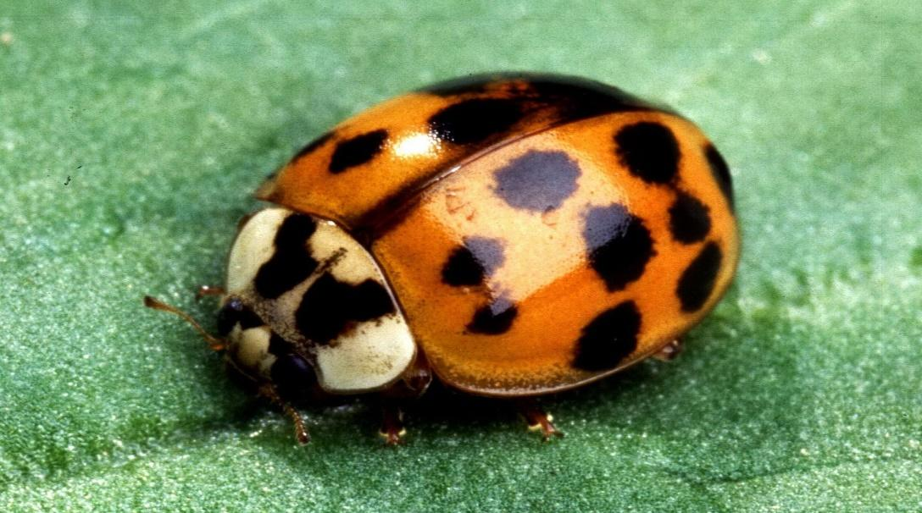  An insect is crawling along the line $\frac{1 - x}{3} = \frac{7 y - 14}{2p} = \frac{5z - 10}{11}$ and another insect is crawling along the line $\frac{7 - 7x }{3p}$ = $\frac{y - 5 }{1}$ = $\frac{6 - z }{5}$ .Find the value of p so that the lines are perpendicular to each other. | 3
6 | 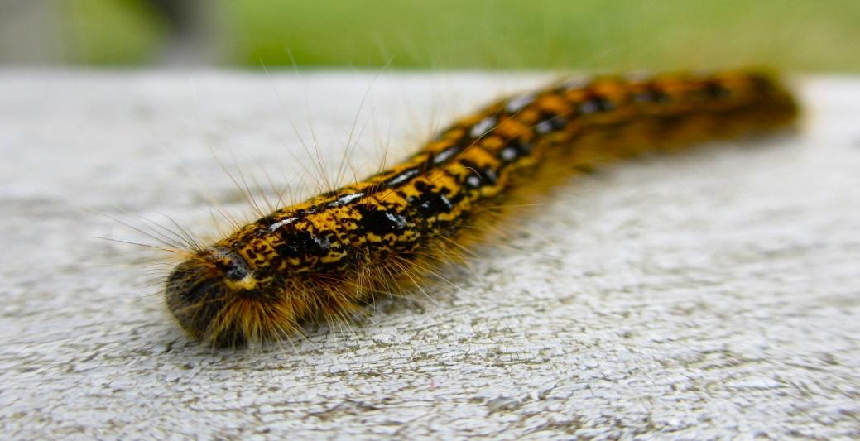  An insect is crawling along the line which passes through the point  (-2,4,-5) and parallel to the line given by $\frac{ x+3}{3} = \frac{ y - 4}{5} = \frac{z +8}{6}$ then find the cartesian equation of of the line. | 3
7 | Find the distance of the point P $(-2, 4, -5)$ from the line  $\frac{x+3}{3}=\frac{y-4}{5}=\frac{z+8}{6}$. | 3
8 | Find the co-ordinates of the foot of perpendicular drawn from the point A (1, 8, 4) to the line joining the points B (0, –1, 3) and C (2, –3, –1). | 3
9 | Find the image of the point (1, 6, 3) in the line $\frac{x}{1}=\frac{y-1}{2}=\frac{z-2}{3}$. | 3
10 | Find the point on the line $\frac{x+2}{3}=\frac{y+1}{2}=\frac{z-3}{2}$ at a distance of 3$\sqrt{2}$ from the point (1,2,3). | 3
 | ANSWERS
1 | Since, the given lines are parallel as their direction ratios are proportional, so shortest distance between these lines is given by;  d = $\left|\frac{\vec{b} X (\vec{a_{2}}-\vec{a_{1}})}{\left|\vec{b}\right|}\right|$ , where $\vec{a_{1}}$ = (2$\hat{i}$ + 4$\hat{j}$ - 8$\hat{k}$)  $\vec{a_{2}}$ = ($\hat{i}$ - $2\hat{j}$ - 4$\hat{k}$)  $\vec{b}$ = (2$\hat{i}$ + $3\hat{j}$ + 6$\hat{k}$) d = $\frac{\sqrt{2581}}{7}$ | 3
2 | Since, the given lines are not parallel as their direction ratios are not proportional, so shortest distance between these lines is given by;  d = $\left|\frac{(\vec{b_{1}} X \vec{b_{2}}) . (\vec{a_{2}}-\vec{a_{1}})}{\left|\vec{b_{1}} X \vec{b_{2}}\right|}\right|$, where $\vec{a_{1}}$ = (2$\hat{i}$ + 4$\hat{j}$ - 8$\hat{k}$)  $\vec{a_{2}}$ = ($\hat{i}$ - $2\hat{j}$ - 4$\hat{k}$)  $\vec{b_{1}}$ = (2$\hat{i}$ + $3\hat{j}$ + 6$\hat{k}$)  $\vec{b_{2}}$ = ($\hat{i}$ + 2$\hat{j}$ +4$\hat{k}$)  d = $\frac{16}{\sqrt{5}}$ | 3
3 | The angle between the two given lines is given by:  $θ$ = $\left|\frac{\vec{b_{1}}.\vec{b_{2}}}{\left|b_{1}\right|\left|b_{2}\right|}\right|$, where $\vec{b_{1}}$ = (2$\hat{i}$ + $4\hat{j}$ + 4$\hat{k}$)  $\vec{b_{2}}$ = ($\hat{6i}$ + 4$\hat{j}$ +12$\hat{k}$)  $θ$ = $\frac{19}{21}$ | 3
4 | b₁= ($\hat{i}$ +2 $\hat{j}$ – 2 $\hat{k}$ )  and b₂ = ($2\hat{i}$ + $\hat{j}$ + $\hat{k}$)  b₁ . b₂ = ($\hat{i}$ +2 $\hat{j}$ – 2 $\hat{k}$ ). ($2\hat{i}$ + $\hat{j}$ + $\hat{k}$)  = 2+2-2  = 2  I b₁I = $\sqrt{1+4+4}$ = 3  I b₂ I = $\sqrt{4+1+1}$ = $\sqrt{6}$  the angle between two lines, cos $θ$ = 2/3$\sqrt{6}$  So, $θ$ = cos⁻¹ (2/3$\sqrt{6}$ ) | 3
5 | The given lines $\frac{1 - x}{3} = \frac{7 y - 14}{2p} = \frac{5z - 10}{11}$ and $\frac{7 - 7x }{3p}$ = $\frac{y - 5 }{1}$ = $\frac{6 - z }{5}$  OR, $\frac{x-1}{-3} = \frac{y - 2}{2p/7} = \frac{z - 2}{11/5}$ and $\frac{x-1 }{-3p/7}$ = $\frac{y - 5 }{1}$ = $\frac{z-6 }{-5}$  Direction ratios of the lines are -3,2p/7, 11/5 and -3p/7 , 1 ,-5  As the lines are perpendicular  So, -3 X -3p/7 + 2p/7 X 1 + 11/5 X (-5) = 0  9p/7 + 2p/7 -11 = 0  11p -77 = 0  11 p = 77  So, p = 7. | 3
6 | The equation of given line is $\frac{ x+3}{3} = \frac{ y - 4}{5} = \frac{z +8}{6}$  Direction ratios of the line are 3,5 and 6  Now, the equation of the line passing through point (-2,4,5) and having direction ratios 3,5,6 is $\frac{ x+2}{3} = \frac{ y - 4}{5} = \frac{z +5}{6}$ | 3
7 | Any general point on the line $\frac{x+3}{3}=\frac{y-4}{5}=\frac{z+8}{6}$………(1)  is given by Q ($-3+3λ, 4+5λ, -8+6λ)$……….(2)  If this point Q is to be foot of the perpendicular drawn to the line (1) from the point P$(-2, 4, -5)$, then  Direction ratios of line $\vec{PQ}$ are given by ($3λ-3+2, 5λ+4-4, 6λ-8+5)=(3λ-1, 5λ, 6λ-3)$  Now, as $\vec{PQ}$ is perpendicular to the line (1) hence, we have  $$3.\left(3λ-1\right)+5.\left(5λ\right)+6.\left(6λ-3\right)=0$$  $$⇒70λ-21=0⇒λ=\frac{21}{70}=\frac{3}{10}$$  Hence, $\vec{PQ}=\left(-1+\frac{9}{10}\right)\hat{i}+\frac{15}{10}\hat{j}\left(-3+\frac{18}{10}\right)\hat{k}=\frac{1}{10}\hat{i}+\frac{15}{10}\hat{j}-\frac{12}{10}\hat{k}$  Therefore, $\left|\vec{PQ}\right|=\frac{1}{10}\sqrt{1+225+144}=\sqrt{\frac{37}{10}}$. | 3
8 | Let Q be the foot of perpendicular drawn from the points A (1, 8, 4) to the line passing through B and C as shown in the Fig. 11.2. The equation of line BC by using the formula, $\vec{r}=\vec{a_{1}}+λ(\vec{a_{2}}-\vec{a_{1}})$  Here, $\vec{a_{1}}=-\hat{j}+3\hat{k}, \vec{a_{2}}=2\hat{i}-3\hat{j}-\hat{k}$  So that equation of $\vec{BC}=-\hat{j}+3\hat{k}+λ(2\hat{i}-2\hat{j}-4\hat{k})$………(1)  Any general point Q on line (1) is given by Q ($2λ, -1-2λ, 3-4λ)$…..(2)  If this point Q is to be foot of the perpendicular drawn to the line (1) from the point P$(1, 8, 4)$, then  Direction ratios of line $\vec{PQ}$ are given by $2λ-1, -1-2λ-8, 3-4λ-4)=(2λ-1, -2λ-9, -4λ-1)$  Now, as $\vec{PQ}$ is perpendicular to the line (1) hence, we have  $$2.\left( 2λ-1\right)-2.\left(-2λ-9\right).-4.\left(-4λ-1\right)=0⟹24λ+20=0⟹λ=\frac{-5}{6}$$  The required point is obtained by putting value of $λ$ in (2) which is Q ($\frac{-5}{3}, \frac{2}{3}, \frac{19}{3})$ | 3
9 | Any general point on the line $\frac{x}{1}=\frac{y-1}{2}=\frac{z-2}{3}$………(1)  is given by Q ($λ, 1+2λ, 2+3λ)$……….(2)  Let P (1, 6, 3) be the given point and let Q be the foot of perpendicular from point P to the line (1)  Direction ratios of line $\vec{PQ}$ are given by ($λ-1, 1+2λ-6, 3λ+2-3)=(λ-1, 2λ-5, 3λ-1)$  Now, as $\vec{PQ}$ is perpendicular to the line (1) hence, we have  $$1.\left(λ-1\right)+2.\left(2λ-5\right)+3.\left(3λ-1\right)=0$$  $$⇒14λ-14=0⇒λ=1$$  Hence, co – ordinates of point Q are : Q ($1, 3, 5)$  Now, if R ($x, y, z)$ be image point of the point P (1, 6, 3) then, Q (1, 3, 5) will be mid – point of line – segment PR.  So that, $\frac{x+1}{2}=1, \frac{y+6}{2}=3, \frac{z+3}{2}=5$  Hence, $x=1, y=0, z=7.$  So that image point is : (1, 0, 7). | 3
10 | A ($\frac{56}{17},\frac{43}{17},\frac{111}{17})$ | 3
 | 4 – MARKS TYPE QUESTIONS (CASE BASED QUESTIONS)
1 | The equation of motion of a missile are x = 2t, y = 3t, z = t, where the time ‘t’ is given in seconds and distance is measured in kilometers. Based on it, answer the following question;  - What is the path of the missile?  (a) Straight line (b) Parabola (c) Circle (d) Ellipse  - Which of the following points lie on the path of missile?  (a) (1, 2, 3) (b) (2, 3, 1)  (c) (4, 1, -2) (d) (1, -2, 3)  - At what distance will the missile be in 10 seconds from the starting point (0, 0, 0)?  $\left(a\right) 10\sqrt{14}$ km (b) $20\sqrt{14}$ km  (c) $10\sqrt{7}$ km $\left(d\right)20\sqrt{14}$ km  - The position of missile at a certain instant of time is (2,-8, 15) then what will be height of the missile from the ground if ground is considered as xy-plane?  (a) 2 km (b) 8 km  (c) 15 km (d) 7 km | 4
2 | In a class, teacher asks students what they know about space or three dimensional system, he asks students some basic questions. Help students to answer the following;  - What is the equation of x-axis in space?  - x = 0, y = 0 (b) y = 0, z = 0  (c) x = 0 (d) none of these  - What are direction ratios of y-axis?  - 0,0,1 (c) 0,1,0  - 1,0,0 (d) 1,0,1  - DC of a line are < m, m, m >, then  - m > 0 (c) m < 1  - m < 0 (d) m = $\frac{1}{\sqrt{3}}$ or $\frac{-1}{\sqrt{3}}$  - Which of the following statement is correct?  - Direction ratios of a line are equal to its direction cosines.  - Direction ratios of two perpendicular lines are proportional.  - Direction ratios of two parallel lines are proportional.  All of these are correct. | 4
3 | 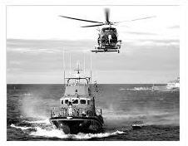  The Indian coast guard, while patrolling, saw a suspicious boat with people. They were nowhere looking like fishermen. The coast guard were closely observing the movement of the boat for an opportunity to seize the boat. They observed that the boat is moving along a planar surface. At an instant of time, the coordinates of the position of the coast guard helicopter and the boat is (1, 3, 5) and (2, 5, 3) respectively.  Based on the above answer the following:  - If the line joining the positions of the helicopter and the boat is perpendicular to the plane in which the boat moves, then the equation of the plane is  a. -x + 2y – 2z = 6  b. x + 2y + 2z =6  c. x + 2y – 2z =6  d. x - 2y – 2z = 6  - If the coast guard decide to shoot the boat at that given instant of time, then what is the distance (in meters) that the bullet has to travel?  - 5m  - 3m  - 6m  - 4m  - If the coast guard decides to shoot the boat at that given instant of time, when the speedofbulletis36m/sec, then what is the time taken for the bullet to travel and hit the boat?  - $\frac{1}{8}$ seconds  - $\frac{1}{14}$ seconds  - $\frac{1}{10}$ seconds  - $\frac{1}{12}$ seconds  - At that given instant of time, the equation of line passing through the positions of the helicopter and boa tis  - $\frac{x-1}{1}$ = $\frac{y-3}{2}$ = $\frac{z-5}{-2}$  - $\frac{x-1}{2}$ = $\frac{y+3}{1}$ = $\frac{z-5}{-2}$  - $\frac{x+1}{1}$ = $\frac{y-3}{-2}$ = $\frac{z+5}{-2}$  - $\frac{x-1}{2}$ = $\frac{y-3}{-2}$ = $\frac{z+5}{2}$ | 4
 | ANSWERS
1 | - (a)  - (b)  - (a)  - (c) | 4
2 | - (b)  - (c)  - (d)  - (c) | 4
3 | - c. x + 2y – 2z =6  - b. 3 m  - d. $\frac{1}{12}$ seconds  a. $\frac{x-1}{1}$ = $\frac{y-3}{2}$ = $\frac{z-5}{-2}$ | 4
 | 5 – MARKS TYPE QUESTIONS
1 | Find the Vector equation of the line passing through the point P ($1, 2, -4)$and perpendicular to the two lines :  $\frac{x-8}{3}=\frac{y+19}{-16}=\frac{z-10}{7}$ and $\frac{x-15}{3}=\frac{y-29}{8}=\frac{z-5}{-5}$. | 5
2 | Find the angle between the lines whose direction cosines are given by the equations :  $3l+m+5n=0$ and $6mn-2nl+5lm=0$ | 5
3 | Show that the lines $r→= 3î+2ĵ-4\hat{k}+λ\left(î+2ĵ+2\hat{k}\right); r→= 5î-2ĵ+µ\left(3î+2ĵ+6\hat{k}\right)$ are intersecting. Hence, find their points of intersection. | 5
4 | If a variable line in two adjacent positions has direction cosines l, m, n and $l+δl,m+δm,n+δn,$ show that the small angle ${\left(δθ\right)}^{2}={\left(δl\right)}^{2}+{\left(δm\right)}^{2}+{\left(δn\right)}^{2}.$ | 5
5 | Find the coordinates of the image of the point  (2, 3, 4) with respect to the line $\vec{r}$ = ($2\hat{j}$ + 4$\hat{k}$) + $γ$ (2$\hat{i}$ + $4\hat{j}$ + 1$\hat{k}$); where $γ$is a scalar. Also, find the distance of the image from the origin. | 5
 | ANSWERS
1 | Let, the direction ratios of the line be ($a, b, c)$then the equation of the line will be $\vec{r}=\hat{i}+2\hat{j}-4\hat{k}+(a\hat{i}+b\hat{j}+c\hat{k})$ ……………(i)  Equations of the given lines are : $\frac{x-8}{3}=\frac{y+19}{-16}=\frac{z-10}{7}$ and $\frac{x-15}{3}=\frac{y-29}{8}=\frac{z-5}{-5}$.  Line given in equation (i) is perpendicular to these lines so that  $$3a-16b+7c=0 \& 3a+8b-5c=0.$$  Solving above by cross – multiplication method we get,  $$\frac{a}{80-56}=\frac{b}{21+15}=\frac{c}{24+48}$$  $$\frac{a}{24}=\frac{b}{36}=\frac{c}{72}=k(let)$$  Hence, $a=2k, b=3k , c=6k$  So that required vector equation of line is:  $\vec{r}=\hat{i}+2\hat{j}-4\hat{k}+(2\hat{i}+3\hat{j}+6\hat{k})$. | 5
2 | The relation between direction – cosines are given by  $3l+m+5n=0$ ……..(1)  $6mn-2nl+5lm=0$ ………(2)  From, (1) we get, $m=-3l-5n$ …………..(3)  Putting this value in (2) we get, $6\left(-3l-5n\right)n-2nl+5l\left(-3l-5n\right)=0$  $$⟹l^{2}+3ln+2n^{2}=0⟹\left(l+n\right).\left(l+2n\right)=0$$  $$⟹l=-n or l=-2n$$  Now, if $l=-n, then m=-2n$ using (3)  and if $l=-2n, then m=n.$ using (3)  Thus the direction ratios of two lines are proportional to $-n, -2n, n$ and $-2n, n, n$ i.e.  $1, 2, -1$ and $-2, 1, 1$  Hence, angle between these lines are given by $coscos θ=\frac{1×\left(-2\right)+2×1+(-1)×1}{\sqrt{1+4+1}×\sqrt{4+1+1}}=\frac{-1}{6}$  $⟹θ=\frac{-1}{6})$. | 5
3 | $$\left|\frac{-3+6}{3√2}\right|=\left|\frac{3√2}{2}\right|$$ | 5
4 | $${\left(δθ\right)}^{2}={\left(δl\right)}^{2}+{\left(δm\right)}^{2}+{\left(δn\right)}^{2}$$ | 5
5 | Let P(2, 3, 4) be the given point, L be the foot of perpendicular from ‘P’ to the given line AB  P(2, 3, 4)  A B  L  Q  The coordinates of the general point on the given line are given by:  $\frac{x-0}{2}$ = $\frac{y-2}{4}$ = $\frac{z-4}{1}$ = $γ$ , where $γ$ is a scalar  Let coordinates of L be ($2γ, 4γ+2, γ+4$)  Direction ratios of PL are 2$γ-2, 4γ-1, γ$  Direction ratios of given line are 2, 4, 1 which is perpendicular to PL  So, 2(2$γ-2)+4(4γ-1)+ γ$ = 0  i.e. $γ=$8 /21  so coordinates of L are (16/21, 74/21, 92/21)  let Q(a, b ,c) be the image of P(2, 3, 4), then L is mid-point of PQ.  So, $\frac{a+2}{2}$ = $\frac{16}{21},$ $\frac{b+3}{2}$ = $\frac{74}{21},$ $\frac{c+4}{2}$ =$\frac{92}{ 21}$  i.e. a = $\frac{-10}{21}$, b = $\frac{85}{21}$, c = $\frac{100}{21}$  so, image of P in the given line is ($\frac{-10}{21}$, $\frac{85}{21}$, $\frac{100}{21}$)  Distance of point ($\frac{-10}{21}$, $\frac{85}{21}$, $\frac{100}{21}$) from origin is 6.27 approximately using distance formula. | 5

CHAPTER – 12
LINEAR PROGRAMMING PROBLEMS

SYLLABUS:
Introduction, related terminology such as constraints, objective function, optimization, graphical method of solution for problems in two variables, feasible and infeasible regions (bounded or unbounded), feasible and infeasible solutions, optimal feasible solutions (up to three non-trivial constraints).

SL NO | QUESTION | MARK
 | MULTIPLE - CHOICE QUESTIONS
1 | The feasible region for an LPP is shown shaded in the figure. Let Z = 3x-4y be objective function. Maximum value of Z is:  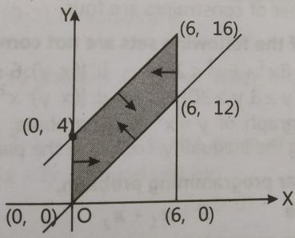  - 0 (B) 8 (C) 12 (D) -18 | 1
2 | Objective function of an LPP is …..  - a constraint  - a function which is to be optimized.  - A relation between variables.  - none of these. | 1
3 | Which of the following is correct?  - LPP always has a unique solution.  - every LPP has a unique solution.  - LPP admits two optimal solution.  if an LPP admits two optimal solution, then it has infinitely many optimal solution. | 1
4 | The feasible region of an LPP is shown in figure. If Z = 3x + 9y, then the minimum value of Z occurs at  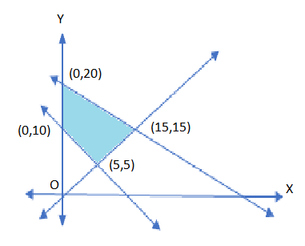  - (5,5)  - (0,5)  - (0,20)  - (15,15) | 1
5 | The corner points of the feasible region determined by the system of linear constraints are and . The objective function is  The minimum value of occurs at  - only  - only  - the mid-point of the line segment joining the points and  - any point on the line segment joining the points and | 1
6 | The restrictions on the variables in linear programming problem are known as  (A) optimal values  (B)constraints  (C) feasible region  (D)none | 1
7 | Which of the following points is not in the feasible region of the constraints :  (0 , -1) (B) ( 0 ,1) (C) (2 , 2) (D) (4 , 0) | 1
8 | If the feasible region for an LPP is ___________, then the optimal value of the objective function may or may not exist.  - bounded.  - unbounded.  - in circle form.  - in pentagon form. | 1
9 | The solution set of the inequation is …..  - half plane containing the origin.  - open half plane not containing the origin.  - first quadrant  - none of these. | 1
10 | Corner points of the feasible region determined by the system of linear constraints are and . The objective function is , where Condition on and so that the minimum of occurs at and is | 1
11 | The solution set of the inequality $3x+4y <4$is  - An open half-plane not containing the origin  - An open half-plane containing the origin  - The whole $xy$plane not containing the line $3x+4y=4$  - A closed half-plane containing the origin | 1
12 | The corner points of the shaded unbounded feasible region of an LPP are $\left(0,4\right), \left(0.6,1.6\right)$ and $\left(3,0\right)$ as shown in the figure. The minimum value of the objective function $Z=4x+6y$ occurs at  - $\left(0.6, 1.6\right)$only  - $\left(3,0\right)$only  - $\left(0.6, 1.6\right)$and $\left(3,0\right)$ only  - At every point of the line segment joining the points $\left(0.6, 1.6\right)$and $\left(3,0\right)$ | 1
13 | The corner points of the feasible region determined by the system of linear constraints are $\left(0,3\right), \left(1,1\right)$ and $\left(3,0\right)$. Let $Z=px+qy,$ where $p,q >0.$Conditions on $p$and $q$ so that the minimum of $z$occurs at $\left(3,0\right)$and $(1,1)$.  - $p=3q$ (c) p = 3q  $\left(b\right)2p=q$ (d) p = q | 1
14 | In the given graph, the feasible region for a LPP is shaded. The objective function  Z = 2x – 3y, will be minimum at:  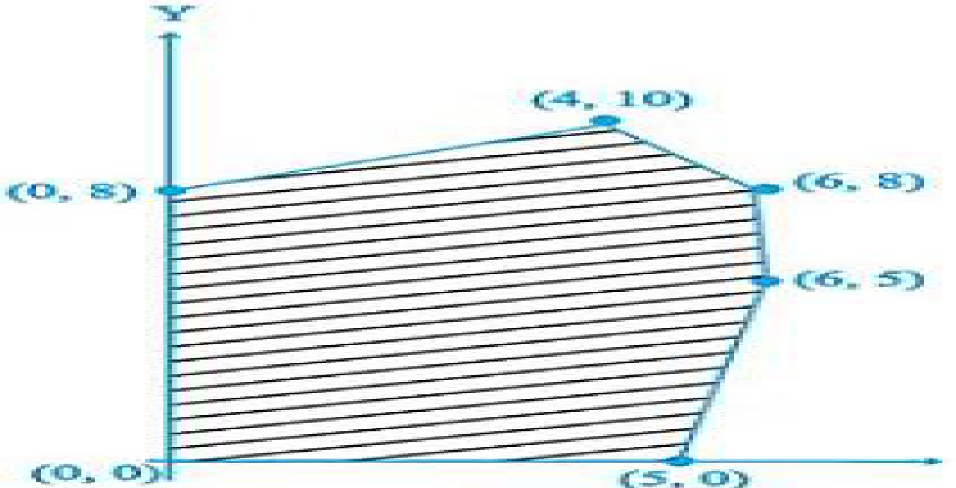  (A) (4, 10) (B) (6,8) (C) (0,8) (D) (6,5) | 1
15 | Let $X_{1}$ and $X_{2}$ are optimal solutions of a LPP, then  - $X=λX_{1}+\left(1-λ\right)X_{2},$where $λ∈R$is also an optimal solution.  - $X=λX_{1}+\left(1-λ\right)X_{2},$ where $0≤λ≤1$gives an optimal solution.  - $X=λX_{1}+\left(1+λ\right)X_{2},$ where $0≤λ≤1$gives an optimal solution.  - None of these | 1
16 | For the LP problem Minimize z = 2x + 3y the coordinates of the corner points of the bounded feasible region are $A(3, 3), B(20,3),$ $C(20, 10), D(18, 12)$ and $E(12, 12)$. The minimum value of $Z$ is  (a) 49  (b) 15  (c) 10  (d) 05 | 1
17 | For the LP problem maximize z = 2x + 3y. The coordinates of the corner points of the bounded feasible region are $A(3, 3), B(20,3),$ $C(20, 10), D(18, 12)$and E$(12, 12).$The minimum value of z is  (a) 72  (b) 80  (c) 82  (d) 70 | 1
18 | Solution of following LP problem Maximize z$=2x+6y$subject to $-x+y≤1, 2x+y≤2 , x,y≥0$  - $\frac{4}{3}$  - $\frac{1}{3}$  - $\frac{26}{3}$  - No feasible region | 1
19 | Solution of the following LP problem Minimize $z=-3x+2y$  subject to $0≤x≤4, 1≤y≤6, x+y≤5$is  - -10 (b) 0 (c) 2 (d) 10 | 1
20 | For the LP problem Minimize $z= 2x+3y$ the coordinates of the corner points of the bounded feasible region are $A(3,3), B(20,3), C(20,10),$ $D(18,12)$ and $E(12,12)$. The minimum value of $z$ is_____  - 49  - 15  - 10  - 05 | 1
21 | Objective function of a linear programming problem is  (A) constant  (B) A relation between variables  (C) function to be optimized  (D) none | 1
22 | The maximum value of the objective function  Z =5x+10y  subject to constraints  x+2y $≤$ 120  x+y≥60  x-2y ≥0  x,y≥ 0 is  A) 300 (B)600 (C) 400 (D)none | 1
23 | Observe the following :  3x-y≥ 3 and 4x -4y > 4 .  Choose the correct option. Both  ( A) have solution for positive x and y  (B) have no solution for positive x and y  (C) have solution for all x  (D) have solution for all y | 1
24 | The maximum value of Z =3x + 4y  subject to constraints  x+y≤ 40  x+2y ≤ 60 ,  x and y both positive is  (A) 120 (B)140 (C)100 (D) none | 1
25 | The minimum value of the objective function Z =x+2y  subject to constraints  x+2y ≥ 100$,$  2x-y ≤ 0,  2x+y≤ 200  x,y≥ 0 is  A) 100 (B)600 (C) 400 (D)none | 1
 | ANSWERS | 1
1 | A | 1
2 | B | 1
3 | D | 1
4 | A | 1
5 | D | 1
6 | B | 1
7 | A | 1
8 | B | 1
9 | B | 1
10 | B | 1
11 | (b) | 1
12 | (d) | 1
13 | (b) | 1
14 | C | 1
15 | (b) | 1
16 | (a) | 1
17 | (a) | 1
18 | (c) | 1
19 | (a) | 1
20 | (b) | 1
21 | B | 1
22 | B | 1
23 | A | 1
24 | B | 1
25 | A | 1
 | ASSERTION & REASON QUESTIONS
Choose the correct option in the following questions of Assertion – Reason Questions.
(a) Both A and R are correct; R is the correct explanation of A.
(b) Both A and R are correct; R is not the correct explanation of A.
(c) A is true but R is false
(d) A is false but R is true
1 | Assertion (A): Feasible region is the set of points which satisfy all of the given constraints.  Reason (R): The optimal value of the objective function is attained at the points on X-axis only. | 1
2 | Assertion (A): It is necessary to find objective function value at every point in the feasible region to find optimum value of the objective function.  Reason(R):For the constrains2x+3y6, 5x+3y 15, x 0 and y 0 corner points of the feasible region are (0,2), (0,0) and (3,0). | 1
3 | Assertion (A):If an LPP attains its maximum value at two corner points of the feasible region then it attains maximum value at infinitely many points.  Reason (R): if the value of the objective function of a LPP is same at two corners then it is same at every point on the line joining two corner points | 1
4 | Assertion (A): The region represented by the set {(x,y): 4 x²+y²9} is a convex set.  Reason (R): The set {(x,y): 4 x²+y²9} represents the region between two concentric circles of radii 2 and 3. | 1
5 | Assertion: Bounded region of constraint lies in the first quadrant of x+y≤20,3x+2y≤48, x≥0, y≥0  Reason: x≥0, y≥0 are non-negative constraints. | 1
6 | Assertion: Objective function is the linear function.  Reason: it can be maximized or minimized. | 1
7 | Assertion: Linear Programming Problems help to solve the problem of manufacturing and diet  problems  Reason: LPP may use in traffic signal problems | 1
8 | Assertion: The set of all feasible solution of a LPP is a convex set.  Reason: Bounded region form a polygon whose each interior angle would be less than 180⁰. | 1
9 | Assertion: A LPP admits unique optimal solution.  Reason: The solution set of the inequation 2x+y> 5 is open half plane not containing the origin. | 1
10 | Assertion (A) Maximum value of $Z=11x+7y ,$ subject to constraints $2x+y≤6, x≤2 , x≥0 , y≥0$ will be obtained at (0,6) .  Reason (R)In a bounded feasible region, it always exist a maximum and minimum value. | 1
 | ANSWERS
1 | C | 1
2 | D | 1
3 | A | 1
4 | D | 1
5 | A | 1
6 | B | 1
7 | C | 1
8 | A | 1
9 | A | 1
10 | B | 1
 | 2 MARKS TYPE QUESTIONS
1 | Write the linear inequations for which the shaded area in the following figure is the solution set.  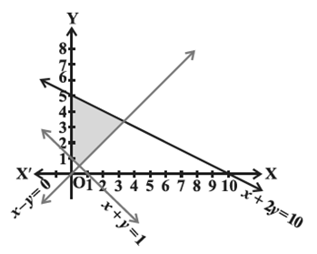 | 2
2 | The feasible region for an LPP is shown in the given figure. Let, be the objective function. Find the Maximum value of  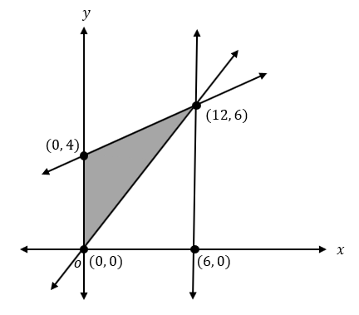 | 2
3 | Determine the minimum value of Z = 6x + 16y, in which the constraints are x , y 20 and x, y 0 | 2
4 | . Feasible region for an LPP is shown shaded in the following figure. Find the point where minimum of Z = 4 x + 3 y occurs.  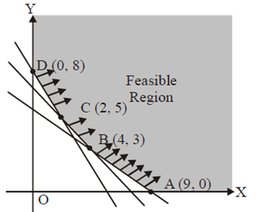 | 2
5 | Maximize $Z=3x+4y$subject to the constraints: $x+y ≤4, x,y≥0$. | 2
6 | Solve the following LPP graphically:  Minimize $Z = 5x + 10y$ subject to the constraints  $$x + 2y ≤ 120$$  $$x + y ≥ 60,$$  $x - 2y > 0$ and $x, y ≥ 0$ | 2
7 | Solve the following LPP graphically:  Maximize $Z = 40x + 50y$ subject to the constraints  $$3x + y ≤ 9$$  $$x + 2y≤ 8,$$  $x, y ≥ 0$ | 2
8 | Solve the following linear programming problem graphically:  Minimize Z = 200 x + 500 y subject to the constraints:  x + 2y ≥ 10  3x + 4y ≤ 24  x ≥ 0, y ≥ 0 | 2
9 | Minimize $Z=3x+2y$subject to the constraints  $$x+y≥8, 3x+5y≤15, x≥0, y≥0$$ | 2
10 | Find the Corner points of the following LPP:  To maximize $Z=2x+5y$  Subject to $0≤x≤4$,  $0≤y≤3$,  $x+y≤6$ | 2
 | ANSWERS | 2
1 | x + 2y ≤ 10, x + y ≥ 1, x – y ≤ 0, x , y≥ 0 | 2
2 |  | 2
3 | 320 | 2
4 | (2,5) | 2
5 | Table of values for line $x+y=4$  Feasible region of the LPP is as shown in the figure  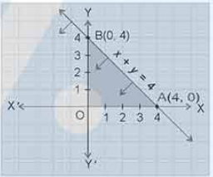  Corner point of the LPP is $(0,0), (0,4), (4,0)$  Hence max value of Z is 16 at point $\left(0,4\right)$. | 2
  $$x$$ | 0 | 4
  $$y$$ | 4 | 0
  Corner Point | $$z=3x+4y$$
  $$\left(0,0\right)$$ | 0
  $$(4,0)$$ | 12
  $$(0,4)$$ | 16= M
6 | 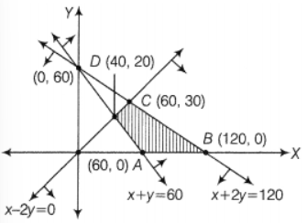  The feasible region of the LPP is shown in the figure  Hence the minimum value of the $Z$is $300$ at the point $\left(60,0\right)$. | 2
  Corner Points | $$Z=5x+10y$$
  $$\left(60,0\right)$$ | 300(minimum)
  $$\left(120,0\right)$$ | 600
  $$\left(60,30\right)$$ | 600
  $$(40,20)$$ | 400
7 | The feasible region of the LPP is shown in the figure  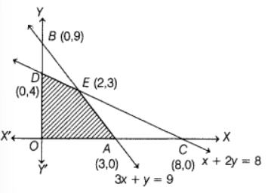  Hence the maximum value of $Z$is 230 at point $\left(2,3\right)$. | 2
  Corner Points | $$Z=40x+50y$$
  $$(0,0)$$ | $$0$$
  $$(3,0)$$ | $$120$$
  $$(2,3)$$ | $$230$$
  $$(0,4)$$ | $$200$$
8 | 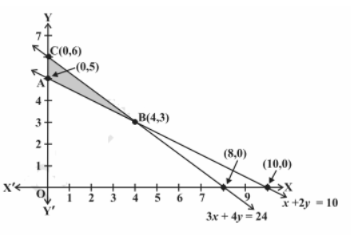  The feasible region of the given LPP is as shown below  Hence the minimum value of $Z$is $2300$at point $\left(4,3\right).$ | 2
  Corner Points | $$Z$$
  $$\left(0,5\right)$$ | $$2500$$
  $$(4,3)$$ | $2300$ Minimum
  $$(0,6)$$ | $$3000$$
9 | The region made by the given linear constrains as given in the figure  It is observed that there is no point which satisfies all the linear constrains simultaneously. Thus, there is no feasible region.  Hence, there is no feasible solution.  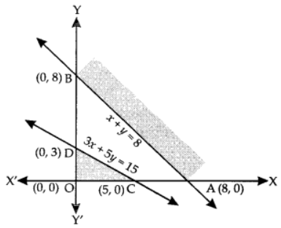 | 2
10 | 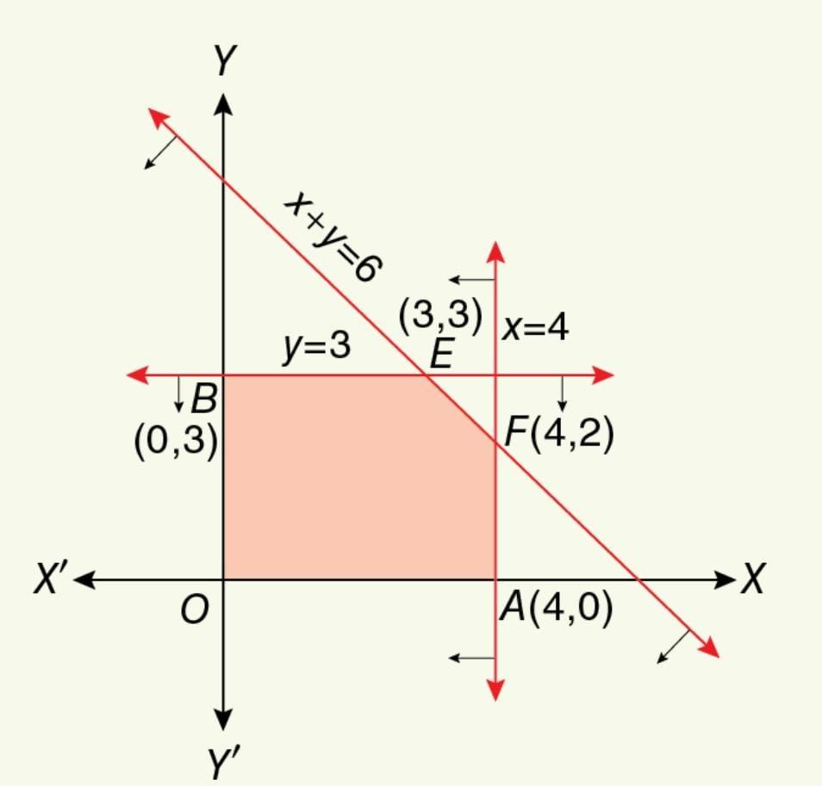  In the feasible region OAFEB  The Corner points are O$(0,0)$, A$(4,0)$,F$(4,2)$, E$(3,3)$, B$(0,3)$ | 2
 | 3 – MARKS TYPE QUESTIONS
1 | If The corner points of the feasible region of an LPP are (0, 0) (0, 8) , (2, 7), (5,4) and (6,0). Then at what point the maximum profit occurs . | 3
2 | A health enthusiast wishes to mix two types of foods in his diet, in such a way that vitamin content of the mixture contains at least 10 units of vitamin B and 13 units of vitamin C. Food (F1) contains 1 unit/kg of vitamin B and 2 units/kg of vitamin C. Food (F2) contains 2 unit/kg of vitamin B and contains 1 unit/kg of vitamin C. F1 costs Rs 60/kg and F2 costs Rs 80/kg. Frame his diet plan making a linear programming problem in order to minimize the cost of the mixture. | 3
3 | A small firm manufacturers gold rings and chains. The total number of rings and chains manufactured per day is atmost 24. it takes 1 hour to make ring and 30 minutes to make a chain. The maximum number of hours available per day is 16. If the profit on a ring is Rs.300 and that on a chain is Rs.190. Firm is concerned about earning maximum profit on the number of rings and chains that have to be manufactured per day.  Using the above information formulate the LPP. | 3
4 | Maximize $Z=3x+2y$subject to $x+2y≤10, 3x+y≤15, x, y≥0$. | 3
5 | Minimize $Z=x+2y$  Subject to $2x+y≥3, x+2y≥6, x,y≥0$.  Show that the minimum of Z occurs at more than two points. | 3
6 | Minimize and maximize $Z=x+2y$subject to $x+2y≥100, 2x-y≤0, 2x+y≤200, x, y≥0$ | 3
7 | Minimize Z=150x +200y  subject to constraints  3x +5y ≥30  x+y≥8  and for positive x and y | 3
8 | If Z=24x+18y with the constraints The maximum value of the objective function  Z =x+2y  subject to constraints  x+2y ≥ 100$,$  2x +3y ≤ 10,  3x+2y ≤ 10  x,y≥ 0 .  Can we get (0,2 ) as a corner point? | 3
9 | Given that  Z=7x +4y  Constraints  3x+2y ≤12,  3x+y ≤ 9,  x,y≥ 0  Find the corner points. | 3
 | ANSWERS
1 | (5,4) | 3
2 | Solution: Let x and y represent the number of units of vitamin B and C, respectively.  Subject to constraints:  x, y ≥ 0 (Non-negative constraints)  x + 2y ≥ 10 (Vitamin B constraint)  2x + y ≥ 13 (Vitamin C constraint)  - Objective function: Z = 60x + 80y (objective is to minimize cost) | 3
  Resources | Food (F1) | Food (F2)
  Vitamin (B) | 1 | 2
  Vitamin (C) | 2 | 1
  Total Cost | Rs 60/kg | Rs 80/kg
3 | - Objective function, maximize Z=  s.t | 3
4 | The feasible region the given LPP is as shown in the figure  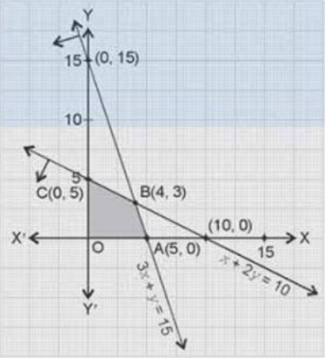  Hence maximum value of $Z=18$at point$\left(4,3\right).$ | 3
  Corner Point | $$z=3x+2y$$
  $$\left(0,0\right)$$ | 0
  $$(5,0)$$ | 15
  $$\left(4,3\right)$$ | 18= M
  $$(0,5)$$ | 10
5 | Feasible region of the following LPP is as shown in the figure  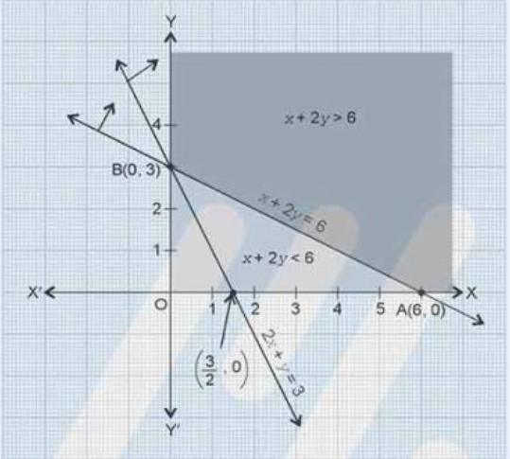  Now note that the feasible region is unbounded and has two corner points.  Since feasible region is unbounded. To decide whether $6$is the minimum or not we draw $Z<m$ i.e., $x+2y<6$.  The line $x+2y=6$for this constraint $Z<m$is the same as the line $AB$for constraint. Put $\left(0,0\right)$in $Z<m$ $⟹0<6$hence there in no point common to the feasible line and $Z<m.$  Hence $6$is the minimum value of Z occur at least two different points.  Hence minimum of $Z$Occur at two corner points $\left(6,0\right)$and $\left(0,3\right)$. | 3
  Corner Points | $$Z=x+2y$$
  $$(6,0)$$ | $$6$$
  $$(0,3)$$ | $$6$$
6 | The feasible region of the following LPP is as shown in the following figure  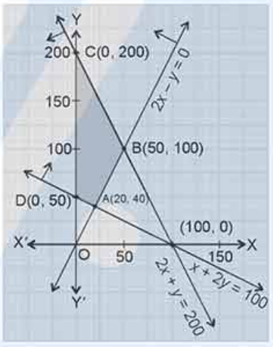  Hence the maximum value of $Z$is $400$and minimum value of $Z$is 100 at each and every point of the line segment joining the points $\left(20,40\right)$and $\left(0,50\right)$. | 3
  Corner Point | $$Z=x+2y$$
  $$\left(20,40\right)$$ | $$100=m$$
  $$(50,100)$$ | $$250$$
  $$(0,200)$$ | $$400=M$$
  $$(0,50)$$ | $$100=m$$
7 | Z =1350 at x=5 and y =3 | 3
8 | Yes | 3
9 | (0,0) (3,0) (2,3) and (0,6) | 3
 | 4 – MARKS TYPE QUESTIONS (CASE BASED QUESTIONS)
1 | A bullet train can carry a maximum of 200 people. A profit of Rs 600 is made on each of YELLOW ticket and a profit of Rs 1000 is made on each BLUE ticket The bullet train reservation executive reserves 20 BLUE ticket seats .However, at least four times as many people prefer to travel by YELLOW ticket, than by BLUE ticket. If the number of BLUE tickets is x and that of YELLOW ticket is y .Now ,answer the following questions  (i)The maximum value of x + y is  (A) 200 (B) 100 (C) 80 (D)20  (II) What is the relation between x and y?  (A) y > 80 (B) x>4y (C) y≥4x (D) None | 4
2 | A bakery shop prepares two types of cakes type one and type two: type one cake requires 200 g of flour and 25 g of fat, type two cake requires 100 g of flour and 50 g of fat.  (I)What is the maximum number of cakes which can be made from 5 kg of flour and 1 kg of fat , assuming that there is no shortage of other ingredients.  (A) 20 (B) 50 (C) 40 (D) 30  (ii) Choose the correct constraint  (A) x+ 2y ≤40 (B) x+2y < 40 (C) x+2y > 40 (D) none | 4
3 | A train can carry a maximum of 300 passengers. A profit of Rs. 800 is made on each executive class and Rs. 200 is made on each economy class. The IRCTC reserves at least 40 tickets for executive class. However, atleast 3 times as many passengers prefer to travel by economy class, than by executive class. It is given that the number of executive class ticket is Rs. x and that of economy class ticket is Rs. y.  Optimize the given problem.  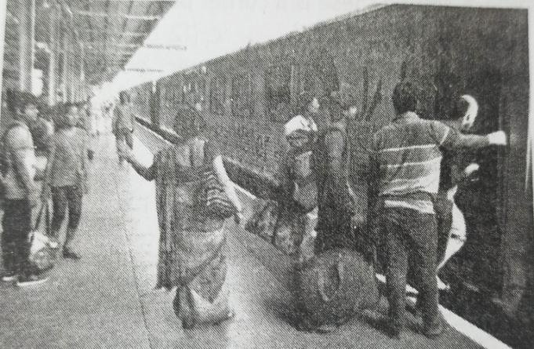  Based on the above information, answer the following questions.  (1) The objective function of the LPP is:  (a) Maximise Z = 800x + 200y (b) Maximise Z = 200x + 800y  (c) Minimise Z = 800x + 200y (d) Minimise Z = 200x + 800y  (2) Which among these is a constraint for this LPP?  (a) x+y $≥$ 300 (b) y $≥$ 3x  (c) x $≤$ 40 (d) y$≤$ 3x  (3) Which among these is not a corner point for this LPP?  (a) (40,120) (b) (40,260)  (c) (30,90) (d) (75,225)  (4) The maximum profit is:  (a) Rs.56000 (b) Rs. 84000  (c) Rs. 205000 (d) Rs. 105000  (5) Which corner point the objective function has minimum value?  (a) (40,120) (b) (40,260)  (c) (30,90) (d) (75,225) | 4
4 | After retirement Mr.A.K Barik wants to invest at most Rs 12,000 in two type of shares X and Y .According to the rule he has to invest at least Rs 2000 in “X” and at least Rs 4000 in “Y” .If the rate of interest on “X” is 8% p.a and on share “B” is 10% p.a .  i. If Mr. Barik invests Rs $x in share A ,then which of the following is correct?$  - $x=2000$  - $x<2000$  - $x≤2000$  - $x≥2000$  ii.If he invested Rs y in share “Y”, then which of the following is correct?  - $y=4000$  - $y≥4000$  - $y>4000$  - $y≤4000$  iii.If the total interest received by Mr. Barik from both type of shares is represented by Z, then Z is equal to Rs  - $Z=2x+y$  - $Z=x+2y$  - $Z=\frac{2x}{25}+\frac{y}{10}$  - $Z=\frac{2x}{10}+\frac{y}{25}$  iv.The maximum interest received by him is  - Rs1040  - Rs3000  - Rs1160  - Rs1200 | 4
5 | Kalpana starts a bakery shop . She makes chocolate cakes blue berry cakes for children . Chocolate cake requires 200gm of flour and 25gm of fat and Blue berry cake requires 100gm of flour and 50gm of fat.If bakery makes $x chocolate cake and y blue berry cake$and it can use maximum 5kg flour ,then i. Which of the following constraint is correct.  - $2x+y≥50$  - $x+y≤50$  - $2x+y≤50$  - $2x+y=50$  ii.If Bakery can use maximum 1kg fat , then which of the following is correct.  - $x+2y≥40$  - $x+y≥40$  - $x+2y=40$  - $x+2y≤40$  iii. If total number of cakes made by bakery is represented by Z ,then Z is equal to  - $Z=2x+y$  - $Z=x+2y$  - $Z=x+y$  - $Z=2x+3y$  iv. The maximum number of total cakes which can be made by bakery, assuming that there is no shortage of ingredients used in making the cakes is  - 40  - 30  - 20  - 25 | 4
 | ANSWERS
1 | (I) …….. A (II) ………. C | 4
2 | (I) …….. (D) 30 cakes : 20 of type one and 10 cakes of type two  (II)……. (A) ) x+ 2y ≤40 | 4
3 | (i) c (ii) b (iii) c (iv) c (v) b | 4
4 | (i) d (ii) b (iii) b (iv) c | 4
5 | (i) c (ii) d (iii) c (iv) b | 4
 | 5 – MARKS TYPE QUESTIONS
1 | A company produces two types of TVs, one is black and white, while the other is colour. The company has the resources to make at most 200 sets a week. Creating a black and white set costs Rs. 2700 and Rs. 3600 to create a colored set. The business should spend no more than Rs. 648000 a week producing TV sets. If it benefits from Rs. 525 per set of black and white and Rs. 675 per set of colours, How many sets of black/white and colored sets should it produce in order to get maximum profit? Formulate this using LPP. | 5
2 | A jet fuel company has two X and Y depots with 7000 L and 4000 L capacities, respectively. The firm is distributing fuel to three jet fuel pumps, D, E and F, respectively in three cities containing 4500L, 3000L, and 3500L. In the following table, the distances (in km) between the depots and jet fuel pumps are given within the following desk:  If the transport cost of 10 litres of jet fuel is Re. 1 per km, how should the distribution be planned to mitigate the transport cost? What’s the lowest cost? | 5
  DISTANCE (KM)
  From/To | X | Y
  D | 7 | 3
  E | 6 | 4
  F | 3 | 2
 | ANSWERS
1 | Let x and y be the number of black/white and colored TVs, respectively  Subject to constraints:  x, y ≥ 0 (Non-negative constraint)  x + y ≤ 200 (Quantity constraints)  2700x + 3600y ≤ 648000 (Cost constraints)  Objective function: Z = 525x + 675y (objective is to maximize profit)  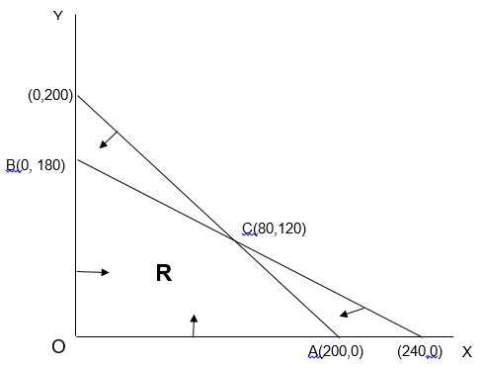  Feasible region R are bounded as shown in the figure above.  Thus maximum value of Z occurs at C(80,120), i.e., 123000. So the company should manufacture 80 black/white and 120 colored TV sets to get maximum profit. | 5
  Corner Point | Objective Function(Z)
  O(0,0) | 525(0) + 675(0) = 0
  A(200,0) | 525(200) + 675(0) = 105000
  C(80,120) | 525(80) + 675(120)= 123000
  B(0,180) | 525(0) + 675(180) = 121500
2 | 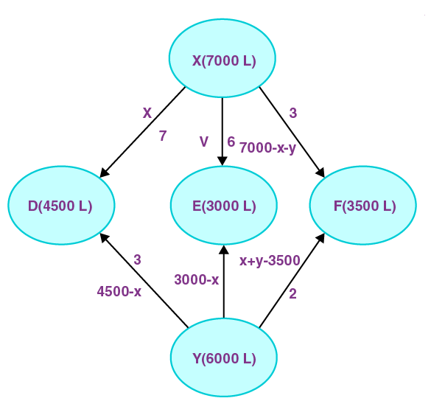  Let X supply the fuel pumps, D and E with x and y litres of jet fuel.  So, (7000 − x − y) from X to fuel pump F will be delivered. At fuel pump D, the requirement is 4500 L.  The remaining (4500 − x) L will be transferred from fuel pump Y while L is transported from depot X.  Similarly, (3000 − y) L and 3500 − (7000 − x − y) = (x + y − 3500) L will be transported from depot Y to F fuel pump.  Subject to constraints:  x, y ≥ 0  7000 – x – y ≥ 0 (XF constraint)  4500 – x ≥ 0 (YD constraint)  3000 – y ≥ 0 (YE constraint)  x + y – 3500 ≥ 0 (YF constraint)  Cost of transporting 10 L of jet fuel is 1 rupee.  Objective function:  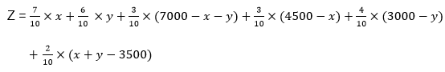  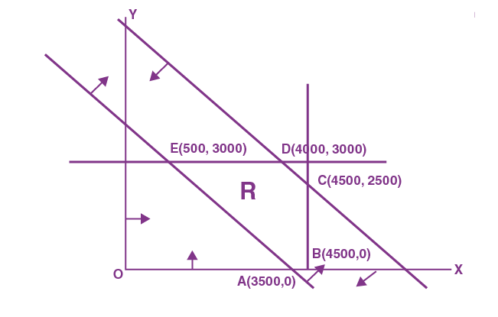  The minimum value of Z is 4400 at E (500, 3000).  Thus, the jet fuel supplied from depot A is 500 L, 3000 L, and 3500 L and from depot B is 4000 L, 0 L, and 0 L to fuel pumps D, E, and F, respectively.  Therefore, the minimum transportation cost is Rs. 4400. | 5
  Corner Points | Z = 0.3x + 0.1y + 3950
  A(3500, 0) | 5000
  B(4500, 0) | 5300
  C(4500, 2500) | 5550
  D(4000, 3000) | 5450
  E(500, 3000) | 4400 (Minimum)

CHAPTER – 13
PROBABILITY

SYLLABUS:
Conditional probability, multiplication theorem on probability, independent events, total probability, Bayes’ theorem, Random variable and its probability distribution, mean of random variable.

SL NO | QUESTION | MARK
 | MULTIPLE - CHOICE QUESTIONS
1 | To teach the application of probability a maths teacher arranged a surprise game for 5 of his students namely Archit, Aadya, Mivaan, Deepak and Vrinda. He took a bowl containing tickets numbered 1 to 50 and told the students go one by one and draw two tickets simultaneously from the bowl and replace it after noting the numbers.  Based on the above information, answer the following question.  Teacher ask Vrinda, what is the probability that both tickets drawn by Archit shows even number?  (a) 1/50  (b) 12/49  (c) 13/49  (d) 15/49 | 1
2 | Probability that Raman speaks truth is $\frac{3}{5}$. A die is rolled. Raman reports that an even number appears. The probability that there is an even number.  $\frac{3}{5}$ (b) $\frac{2}{5}$ (c) $\frac{1}{5}$ (d) None of these | 1
3 | Ramesh is playing with a dice, and he supposed that event A is getting a number greater than 6 and event B is getting a odd prime number. Further he finds that $P\left(A\right)=0 and P\left(B\right)=\frac{1}{3} ,$then $P\left(\frac{B}{A}\right) is$  - 0  - $\frac{1}{3}$  - $1$  - not defined | 1
4 | 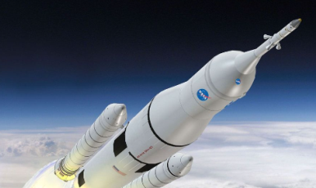  A rocket has 8 engines out of which 3 are not working. If the two engines are selected without replacement and tested, the probability that both are not working.  - $33/56$ (b) 9/64 (c) 1/14 (d) 3/28 | 1
5 | 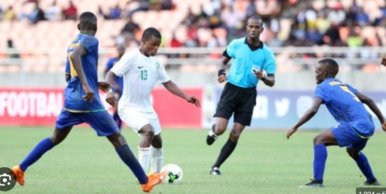  In a boy’s college, 30% students play Cricket, 25% play Football and 10% students play both Cricket and Football. One student is selected at random. The probability that he likes Cricket if he also like Football is  - 1/10 (b) 2/5 (c) 9/20 (d) 1/3 | 1
6 | 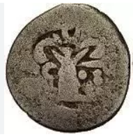  Archaeological Survey of India has found coins at one of the sites of Indus Valley civilization. While studying these coins for historical evidence faces of the one of coin is labelled as head and tail. These coins are flipped in the air and result is noted. If events A and B are defined as A= two heads come, B= last should be head. Then, A and B are  - Independent (b) Not independent  (c) mutually exclusive (d) none of these | 1
7 |   A box contains 6 pens and 10 pencils. Half of the pens and half of the pencils are of blue colour. If one of the items is chosen at random, the probability that it is of blue colour or is a pen is  - 3/16 (b) 5/16 (c) 11/16 (d) 14/16 | 1
8 | 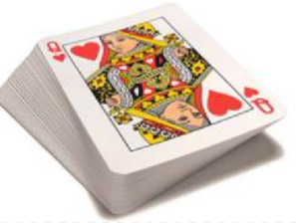  Suppose that two cards are drawn at random from a deck of cards. Let X be the number of kings obtained. Then the expected value of E is  - 37/221 (b) 5/13 (c) 1/13 (d) 2/13 | 1
9 | 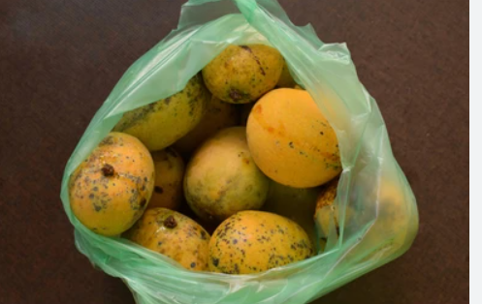  A bag contains 10 good and 6 bad mangoes. One of the mangoes is selected. The probability that it is either good or bad  - $\frac{64}{64}$  - $\frac{49}{64}$  - $\frac{40}{64}$  - $\frac{24}{64}$ | 1
10 | Two dice are thrown once. If it is known that the sum of the numbers on the dice was less than 6 the probability of getting a sum 3 is  (a) 1/18 (b) 5/18 (c) 1/5 (d) 2/5 | 1
11 | In a box, there are 8 orange, 7 white, and 6 blue balls. If a ball is picked up randomly, what is the probability that it is neither orange nor blue?  (a) 1/3 (b) 2/3 (c) 1/21 (d) 5/21 | 1
12 | An urn contains 9 balls, two of which are red, three blue and four black. Three balls are drawn at random. The probability that they are of same colour is  (a) 5/84 (b) 3/9 (c) 3/7 (d) 7/17 | 1
13 | A box contains 15 oranges out of which 12 are good. It is inspected by examining three randomly selected oranges drawn without replacement. If all the three oranges are good, the box is approved for sale. Then the probability that the box will be approved for sale is ----  $\left(a\right) \frac{3}{455}$ (b) $\frac{12}{455}$ (c) $\frac{44}{91}$ (d) $\frac{22}{91}$ | 1
14 | One card is drawn from a well shuffled pack of 52 cards. If E is the event “the card drawn is a king or a queen” and F is the event “the card drawn is an ace or a queen,” then P(E/F) is----  (a) $\frac{3}{4}$ (b) $\frac{1}{2}$ (c) $\frac{1}{13}$ (d) $\frac{4}{13}$ | 1
15 | A black and a red die are rolled. Find the conditional probability of obtaining a sum greater than 9, given that the black die resulted in 5.  (a) $\frac{4}{7}$(b) $\frac{1}{5}$(c) $\frac{1}{3}$(d) none of these | 1
16 | A husband and his wife appear for an interview for two posts. The probability of husband’s selection is 1/7 and that of wife’s selection is 1/5. What is the probability that only one of them is selected?  (a) $\frac{2}{7}$(b) 0 (c) $\frac{2}{3}$(d) $\frac{1}{4}$ | 1
17 | A and B throw a die alternately till one of them gets 6 and wins the game. If A starts the game. Find their respective probability of winning if A starts the game.  (a) $\frac{1}{2}$ , $\frac{1}{5}$(b) $\frac{6}{11}$ , $\frac{5}{11}$(c) $\frac{11}{30}$ , $\frac{19}{30}$(d) $\frac{11}{26}$ , $\frac{15}{26}$ | 1
18 | A die is tossed thrice. Find the probability of getting an odd number at least once.  (a) $\frac{1}{10}$(b) $\frac{1}{5}$(c) $\frac{1}{30}$(d) none of these | 1
19 | Three coins are tossed once. Find the probability of getting at most two heads  (a) $\frac{3}{8}$(b) $\frac{1}{8}$(c) $\frac{7}{8}$(d) $\frac{5}{8}$ | 1
20 | Out of 30 consecutive integers, 2 are chosen at random. The probability that their sum is odd, is  (a) 14/29 (b) 16/29 (c) 15/29 (d) 10/29 | 1
21 | The probability that a leap year will have 53 Fridays or 53 Saturdays is  (a) 2/7 (b) 3/7 (c) 4/7 (d) 1/7 | 1
22 | A speaks truth in 75% cases and B speaks truth in 80% cases. Probability that they contradict each other in statement is  (a) 7/20 (b) 13/20 (c) 3/5 (d) none of these | 1
23 | Three integers are chosen at random from the first 20 integers. The probability that their product is even is  (a) 2/19 (b) 3/29 (c) 17/19 (d) 4/19 | 1
24 | Let A and B be two given events such that P(A) = 0.6, P(B) = 0.2 and P(A/B) = 0.5. Then P(A’/B’) is  (a) 1/10 (b) 3/10 (c) 3/8 (d) 7/8 | 1
25 | If P(A ∩ B) = 70% and P(B) = 85%, then P(A/B) is equal to  (a) 14/17 (b) 17/20 (c) 7/8 (d) 1/8 | 1
 | ANSWERS | 1
1 | (b) | 1
2 | (a) | 1
3 | (d) | 1
4 | (d) | 1
5 | (b) | 1
6 | (b) | 1
7 | (c) | 1
8 | (d) | 1
9 | (a) | 1
10 | c | 1
11 | a | 1
12 | a | 1
13 | c | 1
14 | b | 1
15 | c | 1
16 | a | 1
17 | b | 1
18 | c | 1
19 | c | 1
20 | (c) | 1
21 | (b) | 1
22 | (a) | 1
23 | (c) | 1
24 | (c) | 1
25 | (a) | 1
 | ASSERTION & REASON QUESTIONS
Choose the correct option in the following questions of Assertion – Reason Questions.
(a) Both A and R are correct; R is the correct explanation of A.
(b) Both A and R are correct; R is not the correct explanation of A.
(c) A is true but R is false
(d) A is false but R is true
1 | A: f $A$and $B$two events, then $P\left(A∩B\right)=P\left(A\right)P\left(\frac{B}{A}\right)$.  R: Two events are said to be exhaustive if probability of the one of the events is zero. | 1
2 | A: The probability of getting either a king or an ace from a pack of 52 playing cards is $\frac{2}{13}$.  R: For any two events $A$and $B, P\left(A∪B\right)=P\left(A\right)+P\left(B\right)-P\left(A∩B\right)$. | 1
3 | Assertion (A): P(E) = 0.2, P(F) = 0.3 and P(E ∩ F) = 0.1, then $P(E/F)=\frac{1}{3}$  Reason (R):P(E/F). P(E) =$P(E∩F)$ | 1
4 | Assertion (A): If a family has two children and it is given that the youngest is a girl. Then probability that both are girls is $\frac{1}{4}$.  Reason (R):P(E/F) =$\frac{P(E∩F)}{P(F)}$. | 1
5 | Assertion (A): Let {E₁, E₂, E₃} be a partition of the sample space S and A be any event associated with S, then P(A) = P(E₁) P(A|E₁) + P(E₂) P(A|E₂) + P(E₃) P(A|E₃).  Reason (R): Three events E₁, E₂ and E₃are said to be mutually independent, if  P(E₁ ∩ E₂ ∩ E₃) = P(E₁) P (E₂) P (E₃) | 1
6 | Assertion (A): Three persons E, F and G fire a target in turn. Their probabilities of hitting the target are 0.2, 0.3 and 0.5 respectively. The probability that target hit is 0.72.  Reason (R): P(E ∩ F ∩ G) = P (E) P (F|E) P(G|(E ∩ F)) | 1
7 | Assertion: if A and B are any two disjoint events of a sample space S and F is an event such that P(F) ≠ 0, then  P((AUB)/F) = P(A/F) + P(B/F)  Reason: when A and B are disjoint, P((A$∩$B)/F) ≠ 0. | 1
8 | Assertion: if A and B are any two independent events then  P(A$U$B) = P(A).P(B)  Reason: for two independent events,  P(A/B) = P(A) Provided P(B) ≠ 0,  P(B/A) = P(B) Provided P(A) ≠ 0. | 1
9 | Assertion: if A and B are any two independent events then the probability of occurrence of at least one of A and B is given by  1 $-$P(A').P(B')  Reason: P(At least one of A or B) = P(AUB) | 1
10 | Assertion: The following is not the probability distribution of a random variable.  Reason: for probability distribution of a random variable  Probability of each variable P_{i} $>$0 and $\sum_{i=1}^{n}{}p$_{i} = 1 | 1
  Y | -1 | 0 | 1
  P(Y) | 0.6 | 0.1 | 0.2
 | ANSWERS
1 | c | 1
2 | a | 1
3 | c | 1
4 | d | 1
5 | b | 1
6 | b | 1
7 | c | 1
8 | d | 1
9 | a | 1
10 | a | 1
 | 2 MARKS TYPE QUESTIONS
1 | The probability distribution of a random variable X is given below:  Find the value of k. | 2
  X | 0 | 1 | 2 | 3
  P(X) | k | k/2 | k/4 | k/8
2 | A box contains 12 black and 24 white balls. Two balls are drawn from the box one after the other without replacement. What is the probability that both drawn balls are black? | 2
3 | Two cards are drawn successively, without replacement from a pack of 52 well shuffled cards. What is the probability that first card is king, and the second card drawn is an ace? | 2
4 | Bag one contains 3 red and 4 black balls second another Bag II contains 5 red and 6 black balls. One ball is drawn at random from one of the bags and it is found to be red. Find the probability that it was drawn from second Bag. | 2
5 | A group consists of an equal number of girls and boys. Out of this group 20% of boys and 30% of the girls are unemployed. If a person is selected at random from this group, then find the probability of the selected person being employed.   | 2
6 | Abraham speaks truth in $80\%$cases and Bhavesh speaks truth in 90% cases. In What percentage of cases are they likely to agree with each other in stating the same fact?   | 2
7 | If P(A) =0.4, P(B)=0.8 and P(B/A) = 0.6 then find P(A$∪$ B). | 2
8 | Probability of solving specific problem independently by A and B are $\frac{1}{2}$ and $\frac{1}{3}$ respectively if both are trying to solve the problem independently then find the probability of that  - The problem is solved  (ii) Exactly one of them solves the problem | 2
9 | A speaks truth in 80% cases and B speaks truth in 90% cases. In what percentage of cases are they likely to agree with each other in stating the same fact? | 2
10 | Assume that each born child is equally likely to be a boy or a girl. If a family has two children, what is the conditional probability that both are girls given that  - the youngest is a girl?  - at least one is a girl? | 2
 | ANSWERS | 2
1 | We know, ∑$p_{i}=1$  Or, $k+\frac{k}{2}+\frac{k}{4}+\frac{k}{8}=1$  Or, $k=\frac{8}{15}$ | 2
2 | Let$E$ and $F$ denote respectively the events that first and second ball drawn are black. We have to find $P(EF$).  Now $P(E) =\frac{12}{36}$  and  $$P(F|E) =\frac{11}{35}$$  By multiplication rule of probability, we have  $$P (E ∩ F) = P (E) P \left(\frac{F}{E}\right)$$  $$=\frac{12}{36}×\frac{11}{35}$$  $$=\frac{11}{105}$$ | 2
3 | Let K denote the event that the card drawn is king and A be the event that the card drawn is an ace. Clearly, we have to find P (KA)  Now $P(K) =\frac{4}{52}$  and  $$P(A|K) =\frac{4}{51}$$  By multiplication rule of probability, we have  $$P (KA) = P (K) P \left(\frac{A}{K}\right)$$  $$=\frac{4}{52}×\frac{4}{51}$$  $$=\frac{4}{663}$$ | 2
4 | Let $E_{1}$ be the event of choosing the first bag I, $E_{2}$the event of choosing the second bag and $A$ be the event of drawing a red ball.  Then $P\left(E_{1}\right)=P\left(E_{2}\right)=\frac{1}{2}$  Note that $P\left(\frac{A}{E_{1}}\right)=\frac{3}{7}$and $P\left(\frac{A}{E_{2}}\right)=\frac{5}{11}$  Now the required probability is $P\left(\frac{E_{2}}{A}\right)$. By using Bayes’ theorem, we have  By using Bayes' theorem, we have  $$P\left(\frac{E_{2}}{A}\right)=\frac{P\left(E_{2}\right)P(\frac{A}{E_{2}})}{P\left(E_{1}\right)P\left(\frac{A}{E_{1}}\right)+P\left(E_{2}\right)P(\frac{A}{E_{2}})}$$  $$=\frac{\frac{1}{2}×\frac{5}{11}}{\frac{1}{2}×\frac{3}{7}+\frac{1}{2}×\frac{5}{11}}$$  $$=\frac{35}{58}$$ | 2
5 | $$P(girls)=\frac{1}{2}$$  $$P(boys)=\frac{1}{2}$$  $$P\left(\frac{unemployed}{boys}\right)=\frac{20}{100}=\frac{2}{10}$$  $$P\left(\frac{unemployed}{girls}\right)=\frac{30}{100}=\frac{3}{10}$$  $P\left(unemployed\right)=P$(boys)$P\left(\frac{unemployed}{boys}\right)+ P$(girls) $P\left(\frac{unemployed}{girls}\right)$  $$=\frac{1}{2}×\frac{2}{10}+\frac{1}{2}×\frac{3}{10}=\frac{5}{20}=\frac{1}{4}$$  Therefore  $$P\left(employed\right)=1-\frac{1}{4}=\frac{3}{4}$$ | 2
6 | $$P\left(A\right)=\frac{80}{100}=\frac{4}{5}, P\left(B\right)=\frac{90}{100}=\frac{9}{10}$$  $P$(agree)$=P$(both speaking truth or both speaking lie)  $$=P\left(AB or \underline{A}\underline{B}\right)$$  $$=\frac{4}{5}×\frac{9}{10}+\frac{1}{5}×\frac{1}{10}$$  $$=\frac{37}{50}=\frac{74}{100}=74\%$$ | 2
7 | P(B/A) = $\frac{P(A∩B)}{P(A)}$  P (A ∩ B)$=0.6×0.4=0.24$  ∴ P(A $∪$ B) = P(A) + P(B) – P (A∩B)  = 0.4 + 0.8 $-$ 0.24  = 1.2 – 0.24  = 0.96 | 2
8 | (i) P $\left(\underline{A}\right)$P(B) + P(A) P $\left(\underline{B}\right)$ + P(A). P(B)  $=\frac{1}{2}$ x $\frac{1}{3}$ + $\frac{1}{2}$ x $\frac{2}{3}$ + $\frac{1}{2}$ x $\frac{1}{3}$  = $\frac{2}{3}$  (ii) P $\left(\underline{A}\right)$P(B) + P(A). P$\left(\underline{B}\right)$  $=\frac{1}{2}$ x $\frac{1}{3}$ + $\frac{1}{2}$ x $\frac{2}{3}$  = $\frac{1}{2}$ | 2
9 | Given $P\left(A\right)=\frac{80}{100}=\frac{4}{5}$ and $P\left(B\right)=\frac{90}{100}=\frac{9}{10}$  P( Agree) = P(both speaking truth or both telling lie)  $=$ P(AB or $\underline{A}\underline{B}$)  $=$ P(A). P(B) or P $\left(\underline{A}\right)$ P$\left(\underline{B}\right)$  $=$ $\frac{4}{5}×\frac{9}{10}+\frac{1}{5}×\frac{1}{10}$  $=\frac{37}{50}=\frac{74}{100}=74 \%.$ | 2
10 | Sample space S = {BB, BG, GB,GG}  - Let A and B be two events such that  A = Both are girls ={GG}  B = The youngest is a girl = {BG, GG}  P($\frac{A}{B})= \frac{P(A∩B)}{P(B)}=\frac{\frac{1}{4}}{\frac{2}{4}}=\frac{1}{2}$  - Let C be the event such that  C = at least one is a girl ={BG, GB, GG}  Now , P($\frac{A}{C})= \frac{P(A∩C}{P(C)}=\frac{\frac{1}{4}}{\frac{3}{4}}=\frac{1}{3}$ | 2
 | 3 – MARKS TYPE QUESTIONS
1 | In a bilateral cricket series between India and South Africa, the probability that India wins the first match is 0.6. If India wins any match, then the probability that it wins the next match is 0.4, otherwise the probability is 0.3. Also, it is given that there is no tie in any match.  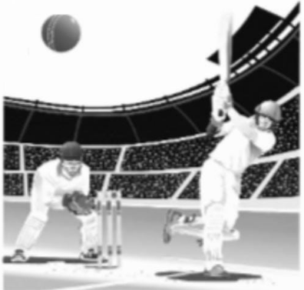  Based on the above information answer the following questions:  (i) What is the probability that India won the second match, if India has already loosed the first match?  (ii) What is the probability that India losing the third match, if India has already loosed the first two matches?  (iii) Find the probability that India is losing the first two matches. | 3
2 | A factory has three machines A, B and C to manufacture bolts. Machine A manufacture 30%, machine B manufacture 20% and machine C manufacture 50% of the bolts respectively. Out of their respective outputs 5%, 2% and 4% are defective. A bolt is drawn at random from total production and it is found to be defective.  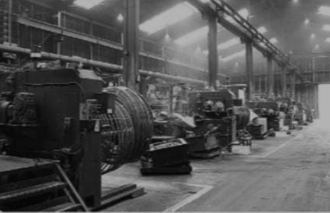  Based on the above information, answer the following questions:  What is the probability that defective bolt drawn is manufactured by machine A? | 3
3 | A coin is biased so that the head is three times as likely to occur as tail. If the coin is tossed twice, find the probability distribution of number of tails. Hence find the mean of the number of tails. | 3
4 |   A bag contains $\left(2n+1\right)$coins. It is known that $\left(n-1\right)$of these coins have a head on both sides, whereas the rest of the coins are fair. A coin is picked up at random from the bag and is tossed. If the probability that the toss results in a head is $\frac{31}{42},$  determine the value of $n$. | 3
5 | The probability that $Abraham$hits the target is $\frac{1}{3}$and the probability that $Bhavesh$hits it, is $\frac{2}{5}.$If both try to hit the target independently, find the probability that target is hit.  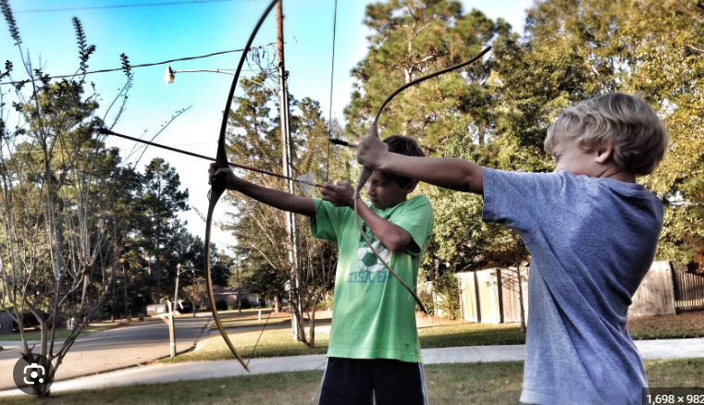 | 3
6 | An electric shop has two types of LED bulbs of equal quantity. The probability of an LED bulb lasting more than 6 months given that it is of type 1 is 0.7 and is given that it is of type 2 is 0.4. Then find the probability that on LED bulb chosen uniformly at random lasts more than 6 months.  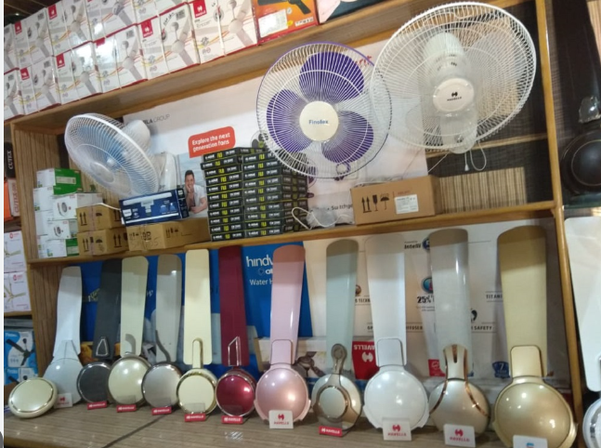 | 3
7 | A die marked 1,2,3 in red and 4,5,6 in green is tossed.  Let A be the event “numbers even” and  B be the event” numbers are marked red”.  Find whether the event A and B are independent or not. | 3
8 | Suppose that 5 men out of 100 and 25 women out of 1000 are good orators assuming that there are equal nos. of men and women, find the probability of choosing a good orator. | 3
9 | Suppose a girl throws a die. If she gets a 5 or 6, she tosses a coin 3 times and notes the number of heads. If she gets 1, 2,3 or 4 she tosses a coin once and notes whether a head or tail is obtained. If she obtained exactly one head, what is the probability that she threw 1, 2, 3 or 4 with the die? | 3
 | ANSWERS
1 | (i)It is given that if India lose any match, then the probability that it wins the next match is 0.3.  Required probability= 0.3  (ii) It is given that if India lose any match, then the probability that it wins the next match is 0.3.  Required probability= 1-0.3=0.7  (iii)Required probability= P(India loosing first match).P(India loosing second match when India has already lost first match) = 0.4$×$0.7 = 0.28 | 3
2 | Let $E_{1},E_{2},E_{3}$ be the events of drawing a bolt produced by machine A, B and C.  Then $P\left(E_{1}\right)=\frac{3}{10}, P\left(E_{2}\right)=\frac{1}{5}, P\left(E_{3}\right)=\frac{1}{2}$  Let, E be the event of drawing a defective bolt.  Probability that defective bolt drawn is manufactured by machine A =  $$P\left(E\right)=\frac{P(E|E_{1})×P(E_{1})}{P\left(E_{1}\right)P\left(\frac{E}{E_{1}}\right)+P\left(E_{2}\right)P\left(\frac{E}{E_{2}}\right)+P\left(E_{3}\right)P\left(\frac{E}{E_{3}}\right)}=\frac{\frac{1}{20}×\frac{3}{10}}{\frac{3}{10}×\frac{1}{20}+\frac{1}{5}×\frac{1}{50}+\frac{1}{2}×\frac{1}{25}}=\frac{5}{13}$$ | 3
3 | $$P\left(Head\right)=\frac{3}{4} , P\left(Tail\right)=\frac{1}{4}$$  Let, X = Number of tails.  Probability distribution is given by  Mean = ∑ X.P(X) = $\frac{6}{16}+\frac{2}{16}=\frac{1}{2}$ | 3
  X | 0 | 1 | 2
  P(X) | $$\frac{9}{16}$$ | $$\frac{6}{16}$$ | $$\frac{1}{16}$$
4 | No of coins with head on both sides $=(n-1)$  No of fair coins $=\left(n+2\right)$  Let $E_{1}=$picking a coin with head on both sides and $E_{2}=$Picking a fair coin.  $A=$Getting a head on tossing the coin  Now by total probability theorem  $$P\left(A\right)=P\left(E_{1}\right)P\left(\frac{A}{E_{1}}\right)+P\left(E_{2}\right)P\left(\frac{A}{E_{2}}\right)$$  $$=\frac{n-1}{2n+1} ×1+\frac{\left(n+2\right)}{2n+1}×\frac{1}{2}=\frac{3n}{2\left(2n+1\right)}$$  ATQ  $$\frac{3n}{2\left(2n+1\right)}=\frac{31}{42} ⇒n=31$$ | 3
5 | $P\left(A\right)=P$(A hits target)$=\frac{1}{3}$  $P\left(B\right)=P$(B hits target)$=\frac{2}{5}$  Now, $P\left(A∪B\right)=P\left(A\right)+P\left(B\right)-P\left(A∩B\right)$  $$=\frac{1}{3}+\frac{2}{5}-\frac{1}{3}×\frac{1}{5}=\frac{3}{5}$$ | 3
6 | $$P\left(LED of type 1\right)=\frac{1}{2}=0.5$$  $$P\left(LED of type 2\right)=\frac{1}{2}=0.5$$  Also note that  $$P\left(\frac{LED lasting more than 6 months}{LED of type 1}\right)=P\left(\frac{A}{T_{1}}\right)=0.7$$  $$P\left(\frac{LED lasting more than 6 months}{LED of type 2}\right)=P\left(\frac{A}{T_{2}}\right)=0.4$$  $$P\left(H\right)=P\left(T_{1}\right)P\left(\frac{H}{T_{1}}\right)+P\left(T_{2}\right)P\left(\frac{H}{T_{2}}\right)$$  $$= 0.5×0.7+0.5×0.4$$  $$=0.35+0.22$$  $$=0.55$$ | 3
7 | $$A=\left\{2,4,6\right\} B=\left\{1,2,3\right\}$$  $$P\left(A\right)=\frac{3}{6}=\frac{1}{2} P\left(B\right)=\frac{1}{2}$$  $$P\left(A\right)×P\left(B\right)=\frac{1}{4}$$  $$n\left(A∩B\right)=\left\{2\right\} P\left(A∩B\right)=\frac{1}{6}$$  $$.∙. P\left(A∩B\right)≠P\left(A\right)×P\left(B\right).$$  $$.∙. Given two events are not independent$$ | 3
8 | Let, A = good orator  $E_{1}=$no. of men good orator  $$E_{2}= no. of women good orator$$  .∙. $P\left(E_{1}\right)=P\left(E_{2}\right)=\frac{1}{2},$  $$P\left(\frac{A}{E_{1}}\right)=\frac{5}{100}, P\left({\frac{A}{E}}_{2}\right)=\frac{25}{1000}$$  .∙.$P\left(\frac{E_{1}}{A}\right)= \frac{P\left(E_{1}\right) × P\left(\frac{A}{E1}\right)}{P\left(E_{1}\right) × P\left(\frac{A}{E1}\right)+P\left(E_{2}\right)×P\left({\frac{A}{E}}_{2}\right)}=\frac{2}{3}$ | 3
9 | Let $E_{1 }$: the die shows 1, 2, 3 or 4  ${ E}_{2 }$: the die shows 5 or 6  and A: the girl obtained exactly one head  P ( $E_{1 })=\frac{4}{6}=\frac{2}{3}$ and P( $E_{2 }$)$=\frac{2}{6}=\frac{1}{3}$  P ($\frac{A}{E_{1}}$) $=\frac{1}{2}$ P ($\frac{A}{E_{2}}$) $=\frac{3}{8}$  From Baye’s theorem  .∙.$P\left(\frac{E_{1}}{A}\right)= \frac{P\left(E_{1}\right) × P\left(\frac{A}{E1}\right)}{P\left(E_{1}\right) × P\left(\frac{A}{E1}\right)+P\left(E_{2}\right)×P\left({\frac{A}{E}}_{2}\right)}=\frac{8}{11}$ | 3
 | 4 – MARKS TYPE QUESTIONS (CASE BASED QUESTIONS)
1 | Read the following text and answer the following question on the basis of the same:  A coach is training 3 players. He observes that the player A can hit a target 4 times in 5 shots, player B can hit 3 times in 4 shots and the player C can hit 2 times in 3 shots.  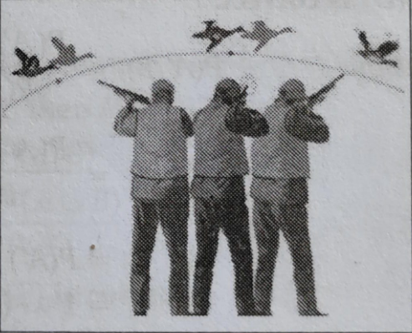  - Let the target is hit by A,B,C. Then the probability that A, B and C all will hit is  - $\frac{4}{5}$ (b) $\frac{3}{5}$ (c) $\frac{2}{5}$ (d) $\frac{1}{5}$  - What is the probability that B,C will hit and A will lose?  - $\frac{1}{10}$ (b) $\frac{3}{10}$ (c) $\frac{7}{10}$ (d) $\frac{4}{10}$  - What is the probability that any two of A,B and C will hit?  - $\frac{1}{30}$ (b) $\frac{11}{30}$ (c) $\frac{17}{30}$ (d) $\frac{13}{30}$  - What is the probability that none of them will hit the target?  - $\frac{1}{30}$ (b) $\frac{1}{60}$ (c) $\frac{1}{15}$ (d) $\frac{2}{15}$ | 4
2 | In answering a question on a multiple-choice test for class XII, a student either knows the answer or guesses. Let $\frac{3}{5}$ be the probability that he knows the answer and $\frac{2}{5}$ be the probability that he guesses. Assume that a student who guesses at the answer will be correct with probability $\frac{1}{3}$. Let, E₁, E₂, E be the events that the student knows the answer, guesses the answer and answers correctly respectively.  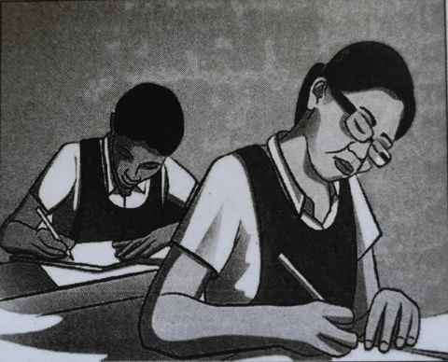  - Value of P(E|E₁) is  - $\frac{1}{3}$ (b) 1 (c) $\frac{2}{3}$ (d) $\frac{4}{5}$  - $\sum_{k=1}^{k=2}{}P(E_{k})P(E|E_{k})$ equals  - $\frac{11}{15}$ (b) $\frac{4}{15}$ (c) $\frac{1}{5}$ (d) 1  - Value of $\sum_{k=1}^{k=2}{}P(E_{k})$ is  - $\frac{1}{3}$ (b) $\frac{1}{5}$(c) 1 (d) $\frac{3}{5}$  - What is the probability that the student knows the answer given that he answered it correctly?  $(a)\frac{2}{11}$(b) $\frac{5}{3}$ (c) $\frac{9}{11}$ (d) $\frac{13}{3}$ | 4
3 | Read the following passage and answer the questions given below:    The reliability of a COVID PCR test is specified as follows:  Of people having COVID, 90% of the test detects the disease but 10% goes undetected. Of people free of COVID, 99% of the test is judged COVID negative but 1% are diagnosed as showing COVID positive. From a large population of which only $0.1\%$have COVID, one person is selected at random, given the COVID PCR test, and the pathologists reports him/her as COVID positive.  (a) What is the probability of the ‘person to be tested as COVID positive’ given that ‘he is actually having COVID’?  (b) What is the probability of the ‘person to be tested as COVID positive’ given that ‘he is actually not having COVID’?  (c) What is the probability that the person is actually not having COVID’? | 4
4 | Read the following passage and answer the questions given below:  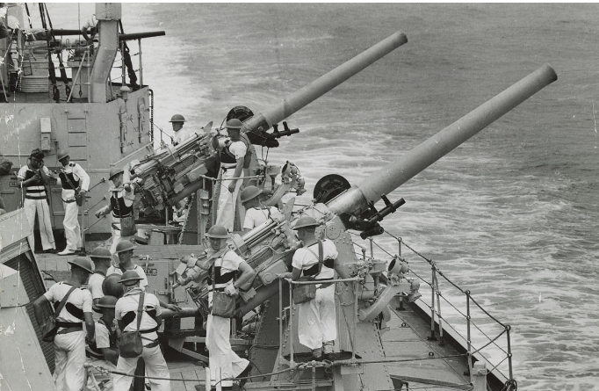  There are two antiaircraft guns, named A and B. The probabilities that the shell fired from them hitting an airplane are 0.3 and 0.2 respectively. Both of them fired one shell at an airplane at the same time.  (a) What is the probability that the shells fired from, exactly one of them hit the plane?  (b) If it is known that the shell fired from exactly one of them hit the plane, then what is the probability that it was fired from B? | 4
5 | Anand, Samanyu and Shah of shortcut classes were given a problem in mathematics whose respective probability of solving it are $\frac{1}{2}, \frac{1}{3}$ and $\frac{1}{4}$. They were asked to solve it independently.  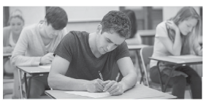  Using the information given above, answer the following :  (i) The probability that Anand alone solves it is  $(A) \frac{1}{4}$ (B) $\frac{3}{4} \left(C\right)\frac{11}{24} (D)\frac{17}{24}$  (ii) The probability that the problem is solved is  $\left(A\right)\frac{1}{4} (B)\frac{3}{4}$ (C) $\frac{17}{24}$ (D) $\frac{11}{24}$  (iii)The probability that exactly one of them solves the  problem is  - $\frac{1}{4} (B)\frac{3}{4}$ (C) $\frac{17}{24}$ (D) $\frac{11}{24}$  (iv) The probability that exactly two of them solves the problem is  - $\frac{1}{4} (B)\frac{3}{4}$ (C) $\frac{17}{24}$ (D) $\frac{11}{24}$ | 4
6 | In an office three employees Aman, Aryan and Biswajit process incoming copies of a certain form. Aman processes 50% of the forms, Aryan processes 20% and Biswajit the remaining 30% of the forms. Aman has an error rate of 0.06, Aryan has an error rate of 0.04 and Biswajit has an error rate of 0.03.    Based on the above information answer the following:  (i) The conditional probability that an error is committed in processing given that Aryan processed the form is:  (A) 0.0210  (B) 0.04  (C) 0.47  (D) 0.06  (ii) The probability that Aryan processed the form and committed an error is:  (A) 0.005  (B) 0.006  (C) 0.008  (D) 0.68  (iii) The total probability of committing an error in processing the form is:  (A) 0  (B) 0.047  (C) 0.234  (D) 1  (iv) The manager of the company wants to do a quality check. During inspection he selects a form at random from the days output of processed forms. If the form selected at random has an error, the probability that the form is not processed by Aman is:  (A) 1  (B) $\frac{30}{47}$  (C) $\frac{20}{47}$  (D) $\frac{17}{47}$ | 4
 | ANSWERS
1 | - C  - a  - d  - b | 4
2 | - b  - a  - c  - c | 4
3 | E= person selected has COVID  F=person selected hasn’t COVID  G= test is judged COVID positive  (a) $P\left(\frac{G}{E}\right)=\frac{90}{100}=0.9$  (b) $P\left(\frac{G}{F}\right)=\frac{1}{100}=0.01$  (c) Required probability = 1$-0.001=0.999$ | 4
4 | $E=$Gun A hits the plane, $F=$ Gun B hits the plane  $P\left(E\right)=0.3$and $P\left(F\right)=0.2$  (a) Let G be the event that exactly one of two shells fired from guns A and B hits the plane. Then,  $$P\left(G\right)=P\left(E\right)+P\left(F\right)-2P\left(EF\right)$$  $$=0.3+0.2-2×0.3×0.2=0.38$$  (b) Required Probability= $P\left(\frac{F}{G}\right)=\frac{PF∩G)}{P(G)}=\frac{P(F∩\underline{E})}{P(G)}=\frac{P(F)P(\underline{E})}{P(G)}=\frac{0.2×0.7}{0.38}=\frac{7}{19}$ | 4
5 | - (A) $\frac{1}{4}$  - (B) $\frac{3}{4}$  - (D) $\frac{11}{24}$  - (A) $\frac{1}{4}$ | 4
6 | - (B) 0.04  - (C) 0.008  - (B) 0.047  - (D) $\frac{17}{47}$ | 4
 | 5 – MARKS TYPE QUESTIONS
1 | There are different types of Yoga which involve the usage of different poses of Yoga Asanas, Meditation and Pranayam as shown in the figure below:  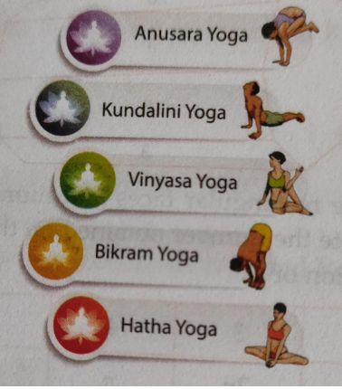  The Venn diagram below represents the probabilities of three different types of Yoga A, B and C performed by the people of a society. Further, it is given that probability of a member performing type C Yoga is 0.44.  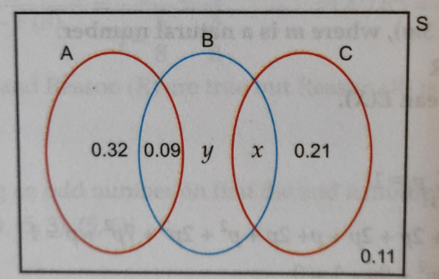  - Find the value of x  - Find the value of y  - Find $P(\frac{C}{B})$  Find the probability that a randomly selected person of the society does Yoga of type A or B but not C. | 5
2 | Ramesh is going to play a game of chess against one of four opponents in an inter school sports competition. Each opponent is equally likely to be paired against him. The table below shows the chances of Ramesh losing, where paired against each opponent.  If the probability that Ramesh loses the game that day is $\frac{1}{2},$find the probability for Ramesh to be losing when paired against opponent 3. | 5
  Opponent | Chance of losing
  Opponent 1 | 12%
  Opponent 2 | 60%
  Opponent 3 | $x$%
  Opponent4 | 84%
3 | In a factory, machine A produces $30\%$of total output, machine B produces $25\%$and the machine C produces the remaining output. The defective items produced by machines A, B and C are 1%, 1.2%, 2% respectively. An item is picked at random from a day’s output and found to be defective. Find the probability that it was produced by machine B?  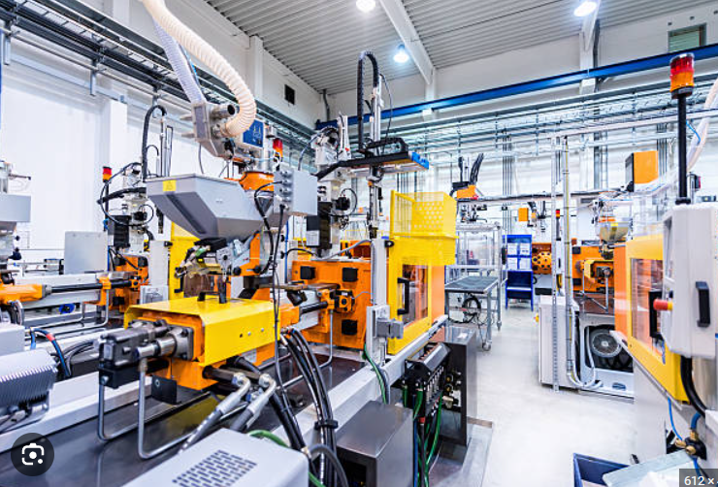 | 5
4 | Probability that A speaks truth is$\frac{4}{5}$. A coin is tossed, A reports the head appears. What is the probability that actually it was head? | 5
5 | A bag I contains 5 red and 4 white balls and a bag II  contains 3 red and 3 white balls. Two balls are transferred from the bag I to the bag II and then one ball is drawn from the bag II. If the ball drawn from the bag II is red, then find the probability that one red and one white ball are transferred from the bag I to the bag II. | 5
 | ANSWERS
1 | - Given that probability of a member performing type C yoga is 0.44  $$x+0.21=0.44$$  $$x=0.23$$  - $0.32+0.09+y+x+0.21=1-0.11$  $$y=0.04$$  - $P\left(B\right)=\frac{P(C∩B)}{P(B)}=\frac{x}{0.09+y+x}=\frac{23}{36}$  - Required probability=$0.32+0.09+y=0.45$ | 5
2 | Note that  $$P\left(E_{1}\right)=P\left(E_{2}\right)=P\left(E_{3}\right)=P\left(E_{4}\right)=\frac{1}{4}$$  Given $P\left(A\right)=\frac{1}{2}$  $$P\left(\frac{A}{E_{1}}\right)=12\%=\frac{12}{100}$$  $$P\left(\frac{A}{E_{2}}\right)=60\%=\frac{60}{100}$$  $$P\left(\frac{A}{E_{3}}\right)=x\%=\frac{x}{100}$$  $$P\left(\frac{A}{E_{4}}\right)=84\%=\frac{84}{100}$$  Using total probability theorem, we have  $$P\left(A\right)=P\left(E_{1}\right)P\left(\frac{A}{E_{1}}\right)+P\left(E_{2}\right)P\left(\frac{A}{E_{2}}\right)+P\left(E_{3}\right)P\left(\frac{A}{E_{3}}\right)+P\left(E_{4}\right)P\left(\frac{A}{E_{4}}\right)$$  $$⇒\frac{1}{2}=\frac{1}{4}×\frac{12}{100}+\frac{1}{4}×\frac{60}{100}+\frac{1}{4}×\frac{x}{100}+\frac{1}{4}×\frac{84}{100}$$  $$⇒x=44$$  $$P\left(\frac{A}{E_{3}}\right)=44\%$$ | 5
3 | Consider the following events  $E_{1}=$item picked is produced by machine A  $E_{2}=$item picked is produced by machine B  $E_{3}=$item picked is produced by machine C  $A=$ producing a defective output  Given,  $$P\left(E_{1}\right)=30\%=\frac{30}{100}=0.3$$  $$P\left(E_{2}\right)=25\%=\frac{25}{100}=0.25$$  $$P\left(E_{3}\right)=45\%=\frac{45}{100}=0.45$$  And  $$P\left(\frac{A}{E_{1}}\right)=1\%=\frac{1}{100}=0.01$$  $$P\left(\frac{A}{E_{2}}\right)=1.2\%= \frac{1.2}{100}=0.12$$  $$P\left(\frac{A}{E_{3}}\right)=2\%=\frac{2}{100}=0.02$$  Required Probability is $P \left(\frac{E_{2}}{A}\right)$  $$P \left(\frac{E_{2}}{A}\right)=\frac{P\left(E_{2}\right)P\left(\frac{A}{E_{2}}\right)}{P\left(E_{1}\right)P\left(\frac{A}{E_{1}}\right)+P\left(E_{2}\right)P\left(\frac{A}{E_{2}}\right)+P\left(E_{3}\right)P\left(\frac{A}{E_{3}}\right)}$$  $$=\frac{0.25×0.012}{0.3×0.01+0.25×0.012+0.45×0.02}=\frac{300}{1500}$$  $$=\frac{1}{5}$$ | 5
4 | $E_{1}$​: A speaks truth  $E_{2}$: A speaks false  Let X be the event that a head appears.  P ($E_{1}$​) = $\frac{4}{5}$  P ($E_{2}$:​) = 1− P($E_{1}$​) = $1-\frac{4}{5}=\frac{1}{5}$​  If a coin is tossed, then it may result in either head (H) or tail (T).  The probability of getting a head is $\frac{1}{2}$​ whether A speaks truth or not.  P (X/$E_{1}$) = P(X/$E_{2}$ ​) = $\frac{1}{2}$  The probability that there is actually a head is given by P (E₁​∣X).  $$P\left(\frac{E_{1}}{X}\right)= \frac{P\left(E_{1}\right) × P\left(\frac{X}{E1}\right)}{P\left(E_{1}\right) × P\left(\frac{X}{E1}\right)+P\left(E_{2}\right)×P\left({\frac{X}{E}}_{2}\right)}$$  $$=\frac{\frac{4}{5}×\frac{1}{2}}{\frac{4}{5}×\frac{1}{2}+\frac{1}{5}×\frac{1}{2}}$$  = $\frac{4}{5}$ | 5
5 | ${ Let E}_{1}$, $E_{2}$, $E_{3}$ and $A$ are event such that  ${ E}_{1}=$ Both transferred balls from bag I to bag II are red  ${ E}_{2}=$ Both transferred balls from bag I to bag II are white  ${ E}_{3}=$ Out of two transferred balls one is red and other is white  $A=$ Drawing a red ball from bag II  P (${ E}_{1})=\frac{5_{C_{2}}}{9_{C_{2}}}=\frac{5 × 4}{9 × 8}=\frac{20}{72}=\frac{5}{18}$  P (${ E}_{2})=\frac{4_{C_{2}}}{9_{C_{2}}}=\frac{4 × 3}{9 × 8}=\frac{12}{72}=\frac{3}{18}$  P (${ E}_{3})=\frac{5_{C_{1}} × 4_{C_{1}}}{9_{C_{2}}}=\frac{5×4 × 2}{9 × 8}=\frac{40}{72}=\frac{10}{18}$  $P\left(\frac{A}{{ E}_{1}}\right)=\frac{5}{8}$ , $P\left(\frac{A}{{ E}_{2}}\right)=\frac{3}{8}$ ,$P\left(\frac{A}{{ E}_{3}}\right)=\frac{4}{8}$  $$P\left(\frac{E_{3}}{A}\right)= \frac{P\left(E_{3}\right) × P\left(\frac{A}{{ E}_{3}}\right) }{P\left(E_{1}\right) × P\left(\frac{A}{E1}\right)+P\left(E_{2}\right)×P\left({\frac{A}{E}}_{2}\right)+P\left(E_{3}\right) × P\left(\frac{A}{{ E}_{3}}\right)}$$  $=\frac{\frac{10}{18}×\frac{4}{8}}{\frac{5}{18}×\frac{5}{8}+\frac{3}{18}×\frac{3}{8}+\frac{10}{18}×\frac{4}{8}}$= $\frac{20}{37}$ | 5

